(SLIDE 1: Lesson Improvement and School Reform through Action Research in Canada.

Date: 9th November, 2013
13:00-17:30
Place: Mejiro Campus at JWU, Tokyo)

Konnichi wa. My husband, Bill, and I are positively delighted to be in your beautiful country. I want to thank the organizers of the conference from the Department of Education and Research and Development Center for Teacher Education at Japan Women’s University (JWU) and particularly, Prof. Shizuo Yoshizaki, for giving me this opportunity to talk with you today about Lesson Improvement and School Reform through Action Research in Canada. I also want to thank Miwa Takeuchi for her work in the translation of this lecture and for her willingness to help me to improve it for this audience today.

My last trip to Japan Women’s University was in March of 2004 when I had the pleasure of working with colleagues from this University as well as other universities in Japan on the development of action research approaches to professional development.

How many of you were at my lecture here in 2004? Well, plenty has happened in my part of the world in the intervening years!

Here is the world.

(SLIDE 2: MAP OF WORLD)

Here is my part of the world.///Canada is second only to Russia in land area but has a much smaller population, 35.1 million compared to Japan’s 127.4 million.

(SLIDE 3: MAP OF CANADA)

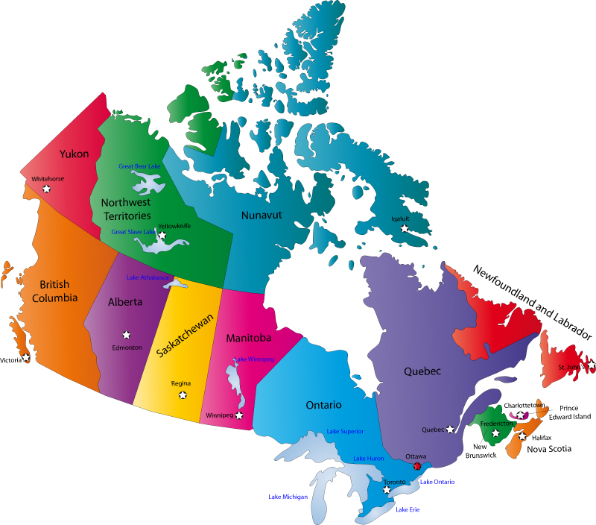

Here is my province, Ontario.

(SLIDE 4: MAP OF ONTARIO)

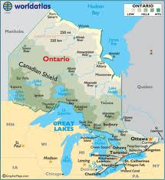

And here is where I live: I will point to my town, Paris, in southern Ontario, one hour west of Toronto.

First I start with:
A. Framing the lecture: Background and context

At the start of the lecture I want to be clear that I am thinking of action research as a methodology:/// a methodology created by Jack Whitehead from Bath, UK that is based on the field activities related to answering questions of the kind, “How do I improve what I am doing?” I repeat: “How do I improve what I am doing?”

For the sake of clarity, I want to share how we do this living action research. By living I mean conducting action research as we try to live according to our values.

(SLIDE 5: A LIVING-THEORY ACTION RESEARCH METHODOLOGY)

- Say what you want to improve.
- Produce an action-plan on how you are going to improve it.
- Act on your plan and gather the data you need to judge the effectiveness of your actions.
- Judge your effectiveness (Evaluation).
- Modify what you want to improve, modify your plan and modify your actions in response to your evaluations.
- Produce a description and explanation for your own professional learning and test the validity of your explanation with others.

The research methods used include action-reflection cycles in which practitioners express concerns based on the values they use to give meaning and purpose to their lives. They produce and choose an action plan and act on it. They gather data to enable them to evaluate the influence of their actions, evaluate their effectiveness /// and modify their concerns, plans and actions in the light of their evaluations. They produce a validated, evidence-based explanation of their educational influences in learning. The method of validation involves between 3-8 peers in which questions derived from the ideas of Habermas (1976, pp. 2-3) are put to the researcher /// in order to strengthen the comprehensibility, evidence, awareness of sociocultural and sociohistorical influences and authenticity of the explanation. The method for communicating and clarifying embodied expressions is through the use of digital video data.

This process is about action, not theorizing but doing. Of all the examples that I will use today including younger and older students as well as teachers and other educators, the same action-reflection process is used.

I am very excited to be inviting you into my world and into the collaborative work of myself and my colleagues, all action researchers: /// they are Liz Campbell and Cathy Griffin, Ontario classroom teachers, Lori Barkans, system curriculum leader and Jack Whitehead, professor at Liverpool Hope University and myself. Here is a still photo from our SKYPE conversation last Sunday: here are Cathy, Jack and Liz-you can see the pleasure that we find in each other’s company!

Now I move to:

B. Lesson Improvement and School Reform Through Action Research

This talk today continues the knowledge sharing that has continued over many years, particularly with my friend, professor Kazuko Sawamoto, and with the other professors, led by Shizuo Yoshizaki, professor at Japan Women’s University. They visited classrooms in 2010 in my school district to add to their research project “Improvement and Development of Educational Methods for Primary, Secondary and Higher Education in Japan”.

In this lecture I will focus on three significant aspects of the evidential base of action research:

1) Evidence of primary and secondary students as action researchers and co-researchers

2) Evidence of democratic evaluation for students and teachers in a culture of inquiry

3) Evidence of action research as sustained, self-directed professional learning across systems

Let me begin with the first aspect of the evidential base of action research: ///primary and secondary students as action researchers and co-researchers.

(SLIDE 6: Primary and secondary students as action researchers and co-researchers

Here, I will provide a window into my world: it is a different approach to learning. You will have to decide how suitable this practice is for your students. In this section you will hear the voices of students as young as 11 years old conducting action research, in the process that I have just described, and taking responsibility for their learning in order to become better students. Cathy Griffin, the teacher, says, “You might not believe that students in Grade 6 and 7 would be able to articulate questions of such deep and profound moral quality.”

Let’s watch one of the 11-year old, primary students in her action-reflection cycle: Show clip.

(PRIMARY STUDENT-DIRECTED ACTION RESEARCH

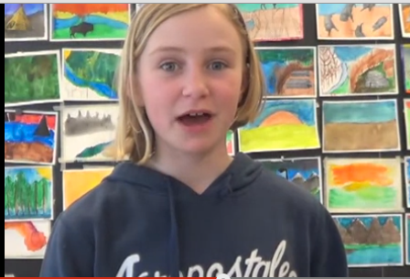

http://youtu.be/rz2sSUeZlno )

1:05-1:45 SCRIPT: I’m having trouble with giving and receiving feedback, and problems with stress.
My barriers are how to give feedback without feeling mean, negative self-talk and whenever I feel I’m a bad person whenever I don’t do well or whenever I did my best or think I’m right and I’m wrong.
The action I’m taking is working in small groups to mark our own work and then give it to the teacher and also we are asking for feedback from other people than the teacher.
I hope that you can hear her going through the action research process: articulating her concern, sharing the barriers to making improvement and then her plan for action in order to improve.

And now I move to secondary students: here is Liz Campbell, another classroom teacher, talking about co-researching with her grade 12, age 17, philosophy class; ///these are her words:

“I begin by briefly sharing my learning experience with my students as one possible way of identifying embodied knowledge and creating a self-directed learning journey. I invite students to experiment with non-traditional ways of researching, representing, and knowing in order to create a more authentic learning experience. I demonstrate trust and respect for my students when I provide them with opportunities to direct their own learning. Students then begin their own inquiries to identify their values and unveil their embodied knowledge.

A group of students created a project around the concept of vulnerability that encouraged participants to express their inner voices. This project revealed many important ideas to all of us and the recurring theme of fear of judgement resonated with many and became a powerful catalyst for further, deeper, and collaborative reflection”.

Here is one of the clips:

(SLIDE 7: HIGH SCHOOL STUDENT ACTION RESEARCH)
http://www.youtube.com/watch?v=ZmJVN2r6iBQ Out on a Limb Part 1

1:51-2:06 SCRIPT: Expressing emotions – I’m not very good at that because of fear of being rejected is always in the back of your noggin.

What if we connected these children to your children through SKYPE or other on-line communication systems and let them be our cultural ambassadors to create better learning systems?

Next, the second aspect of the evidential base of action research: ///democratic evaluation for students and teachers in a culture of inquiry

(SLIDE 8: Democratic Evaluation For Students And Teachers in a Culture of Inquiry

JACKIE’S DEMOCRATIC EVALUATION)

One transformative learning into the nature and improvement of my life as a superintendent and university professor was that quality relationships can be deepened and strengthened through a willingness to take down the walls of protection to expose my vulnerabilities. Sustained trust is at the heart of my educational relationships and essential to the creating of a culture of inquiry.

When I use the language of “Culture-of-Inquiry”, I am meaning the creation of a safe, supportive space where students and teachers are enabled to make explicit their values and make themselves accountable for living according to those values. They learn to recognize when they are not living according to their espoused values and are what Jack Whitehead calls “living contradictions”. Action-reflection cycles based on asking questions like ‘How can I improve my teaching of these children?’ become as natural as breathing. Experiencing values such as ‘loving kindness’ and ‘loved into learning’ in this democratic, non-hierarchical environment and recognition of their embodied knowledge, encourage students and teachers to take responsibility for their own learning.

As part of trust building, it has been my practice to videotape my practice and to ask for critical feedback on how I might improve. In 2010, I asked the 19 students in the masters cohort group to provide an evaluation of my teaching. I sat in the middle of the circle with the video camera on me and they provided me with some very concrete suggestions for improvement.

It was a difficult process to experience but I had spent time preparing myself as much as I could. Being able to absorb the suggestions afterward by reviewing the videotape of the event was essential to retaining all of the information and making significant changes in my practice. I was modelling a process that I hoped might be adopted in their own way by the members of the group.

In response to this modelling, in an email Cathy Griffin says the following:

“Watching you invite our criticism of your practice with the intention of improving your own practice was a transformative experience for me. This was the first step towards me realizing that vulnerability is strength and pretending to be perfect is a weakness. …Taking part in your democratic evaluation and then watching you publicly make changes to your practice and continue to ask for feedback has had more impact on the way I live my life (and teach) than any other professional or personal development to date. (Griffin, C., email, August 16, 2013)

As a result of my modelling this process of evaluation, Cathy Griffin shared her experience in asking her grade 6-7, age 11-12, students to give her concrete information on how she could teach them better.

In a March 4th, 2013 TVOntario interview, Michael Fullan, professor Emertius, OISE/University of Toronto said:/// “You will not get depth knowledge by going to workshops. Professional learning is part of the day to day job, what you learn together, because it has to be shared for it to be powerful”. http://ww3.tvo.org/video/188858/teaching-towards-future.

So, here is Cathy actually doing it - learning together with her elementary students about how to be a better teacher: show clip

(SLIDE 9: CATHY’S DEMOCRATIC EVALUATION

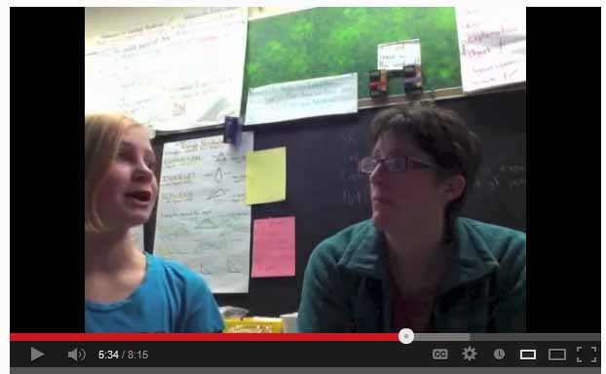

http://youtu.be/nbuQHRhqEOE )

6:14-6:28 SCRIPT: Cathy: Having more time to think about your answer, would that make you more comfortable?
Student: It probably would help.

And last
5. The third aspect of the evidential base of action research:/// action research as sustained, self-directed professional learning across systems

I include in this part references to the sustained influence of action research in my former school district and in Liz and Cathy’s school district.

First, in my own school district. I begin with Lori Barkans who was one of the first group of 5 action researchers with whom I worked in 1996; ///in 2011, I taught her in the Brock University masters cohort;/// and recently she, as a senior administrator in the school district, and I as a senior, senior administrator, presented to a university class of student teachers on the subject of leadership. In this dialogue, it is clear that Lori is a committed action researcher.

Show clip.

(SLIDE 10: Action research as sustained, self-directed professional learning across systems

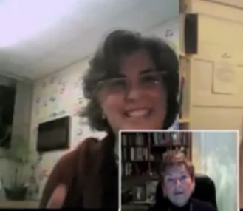
http://youtu.be/92w1aR8Wn_o )
1:10-2:03 SCRIPT: All that goes right back to what Jackie said. What are your values? What are the relationships that you establish in your school? Are you true to those values in your relationships? Can people count on you? Do you say to them, “This matters to me,”? If you can’t say this matters to me then it won’t matter to them. So you have to be prepared to jump in and say I’m going to learn with you. I’m going to research with you. You don’t need to be the expert but you’ve got to be willing to say we’re going to learn together about how to make this happen in our school. And I care about our kids and I care about you and about this process that we’re going to follow to get there.

Second, I will draw on the work of Liz and Cathy in their influence beyond their classrooms in their school district to provide evidence of their expanding influence on system. The first example is from three first year university students who come back to visit Liz, their secondary school teacher, to share how learning in a culture of inquiry had sustained them in their university studies.

(SLIDE 12: ACTION RESEARCH: INFLUENCING SYSTEMS

http://www.youtube.com/watch?v=oqIsET8z0_M
Sabrrea, Brianne, Becki and Liz )

The audio on the clip is difficult to hear so this is Liz speaking in her own words from the AERA 2013 paper that we co-wrote and I quote:

“This clip includes an example of my influence and also examples of the sustainability of living theories and communities of inquiry. Three graduate students who individually contacted me over the December holidays with a desire to reconnect accept an invitation to lunch at my home.

Brianne begins (at 3:46) by commenting on how refreshing and inspiring the alternative environment was for her and the importance of being trusted to direct her own learning. Sabreea comments on how she is still applying the learning that she experienced (at 5:00). In addition to completely changing her program of study to something she is passionate about (media arts) instead of a program that her parents wanted her to complete (business), she talks about how she is far more confident and now goes out on her own. ”

Second, Cathy: With four teacher co-researchers at her elementary school, Cathy shared their action research experience of learning together to improve student learning to senior leaders across her school district. This project was funded by the Ontario Ministry of Education. She shares with these superintendents how she asks her students for their help in improving her teaching. Show clip.

(SLIDE 13: ACTION RESEARCH: INFLUENCING SYSTEMS

http://www.youtube.com/watch?v=1idqwlZSq0o&list=PLj7Kbzs74R-vOt_9VHXE-rz68b2Oj0PNU)

13:03-13:23 SCRIPT: These are my intentions in teaching you. I want you to enjoy Math; I want you to persevere with problem-solving; I want you to learn Math. What am I doing to help you do that. What are the barriers?

In this same presentation, senior administrators heard the teachers’ voices as they described their self-directed professional learning in this ministry-funded project. Show clip.

(SLIDE 14: TEACHERS SHARE THEIR LEARNING IN A CULTURE OF INQUIRY

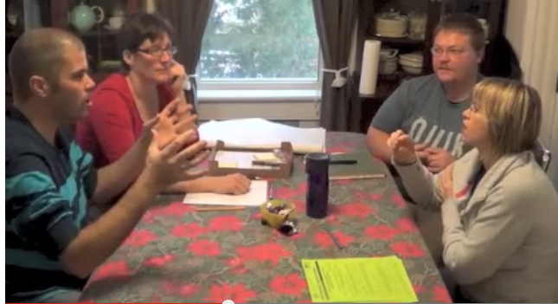

http://www.youtube.com/watch?v=1idqwlZSq0o&list=PLj7Kbzs74R-vOt_9VHXE-rz68b2Oj0PNU)

5:32-5:59 SCRIPT:
That’s the coolest thing about this: watching other people’s way. I can take from that and incorporate some of that into my practice. We never have opportunity for that.
That’s what’s written everywhere about most effective teaching practices is to have this time, this co-teaching, co-planning..
It has to be done with a group with whom you feel comfortable and that’s what I love about us.

Finally,
Part C: Conclusions and Reflections

(SLIDE 15: WILL YOU JOIN ME IN ACTION RESEARCH?)

What I have described and explained today is very much at the forefront of change in lesson improvement and school reform through action research. I do not intend to infer that this activity is happening on all fronts in Ontario Education, nor is it without its challenges. It is exemplary work by these teachers: they are STARS!!! It is my vision of what lesson improvement can be. This lecture and a longer version of it is available under ‘Japan Woman’s University at:
http://www.spanglefish.com/actionresearchcanada/

One of the challenges of this action research process is that each researcher must find his/her own way, be methodologically inventive (Dadds & Hart, 2001). I have shared how my colleagues and I have done it: it can inform what you want to do but cannot be replicated.

I believe that I have shared the importance of the leader in modeling, encouraging and supporting the action research process in a relational dynamic. This process requires time, trust and courage:/// it has enabled me and others to flourish in cultures of inquiry. The teachers and students that I have highlighted in this address are speaking in their own voices and conducting and publishing their own action research: ///they are, in every way, exemplary. I think that you can see in the visual data the massive potential of technology to improve teaching and learning. I hope that you can see that living theory action research is no short-lived idea-///it has longevity, sustainability and critical mass.

This is an invitation: ///If any of these ideas resonate with you and you would like to take the next step, I invite you to collaborate with me and my colleagues.

I look forward to further dialogue in the following symposium with
Professors YOSHIZAKI, KAGE, IKUTA and SAWAMOTO.

Arigato.

Cathy Griffin | Nov 1 (3 days ago)
to jack, me, campbell650clan
Nov 1, 2013

Wow - what a day today! I am finally coming out of the dark after having half my class change the first week of September and basically starting from scratch! We have progress reports due next week so I had my students do a progress report for me today
based on my three goals (love, trust and authenticity). Although many of them were not quite ready to share their thoughts, I got a lot of great feedback about my strengths and next steps. Some examples:
"She gets who I am"
"100% honest 95% of the time"
"Excepting who I am"
"You could let me do it (my project) to you and when I feel safe enough then to do it in front of the class"
"You explain why we can't do it"
"You let us answer when we remember if we forget at first"
"Ms. Griffin is trying to reach her goal"
"Try to have more smaller group conversations"
"You understand that not everyone is perfect and knows how to apologize for herself and admit she was wrong"
"Maybe we could try doing reports or narratives or something like that but we could pick our own topic"
"It helps me feel safe when people don't be rude to me and when you trust me"
Next Step: "More brain engagement and more involvement"
"We could do more goal setting"
"You tell us what you like and enjoy doing" (Athenticity)
"I am a boy. You need to be funny"
"Strengths: fun math activities, design challenges. Next Step: More hands on work"
"Next Step: letting people fully explain"
I showed them the video of the 4 students from last year. There were a lot of, "Yeah! I feel that way too!" One student said, "My brain is talking to me all the time!" after we discussed what the kids meant about negative self talk. It was SO
powerful to see and hear their reactions. And NO, I did not vide tape it! ARGH!!! I meant to but...
So I am very excited about having them do their own progress reports next week. I will use their comments again to write their 'learning skills' section of the report.
The light has returned to my life!
Lots of love to you all!

