I’m wondering if we could develop a shared understanding of our embodied expressions of the energy-flowing values and understandings that we use to give our lives meaning and purpose? I’m seeing the significance of developing a shared understanding, from the ground of our lived experience together, in terms of a new form of knowledge that could be recognised, validated and accredited in universities around the world (the global academy).

I’d like to focus on embodied expressions of life-affirming energy, community feeling and values that carry hope for the flourishing of humanity. I know that Sonia is working on her thesis on a living-theory of caring and that Ari is about to begin her doctoral writings on her living-theory as a developmental economist. Chris is focusing some of her writings on clarifying and expressing her meanings of living inclusive and inclusional empowerment. Joy has sent in a draft of her transfer paper to the University of Cumbria. You can access the draft from http://www.actionresearch.net/writings/mounter/joytransferdraft060118.pdf

Expressions of life-affirming energy.

In the following 41 second clip at https://www.youtube.com/watch?v=d4LLU8gZaSg , Shelagh is using metaphor and lexical understandings in communicating her meaning of an embodied expression of life-affirming energy.

Around 34 seconds I can feel and see myself expressing my own life-affirming enquiry in response to Shelagh’s communication. I’m wondering if everyone is feeling a similar expression of life-affirming energy?

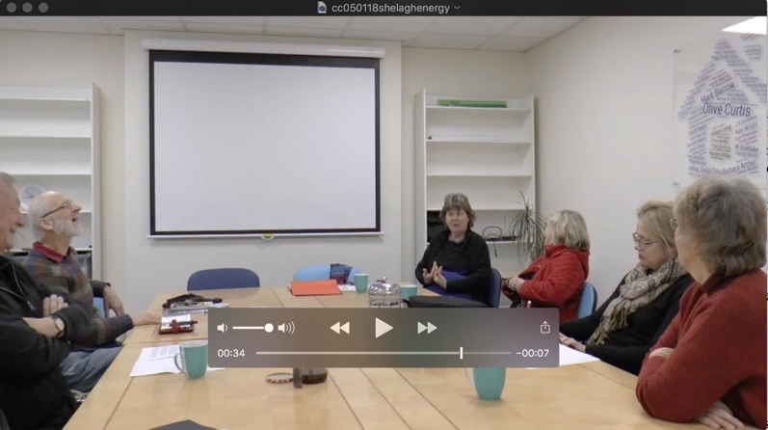

Here is some more digital visual data that I think helps to communicate the lived experience of embodied expressions of life-affirming energy. I believe that you will see/feel this expression around 31 seconds of this 45 second clip at https://www.youtube.com/watch?v=HxqRF2tVLB4 of Pete Mellett leading the celebrations in December 2002 for the award of Ph.D. to Jacqueline Delong earlier in the day.

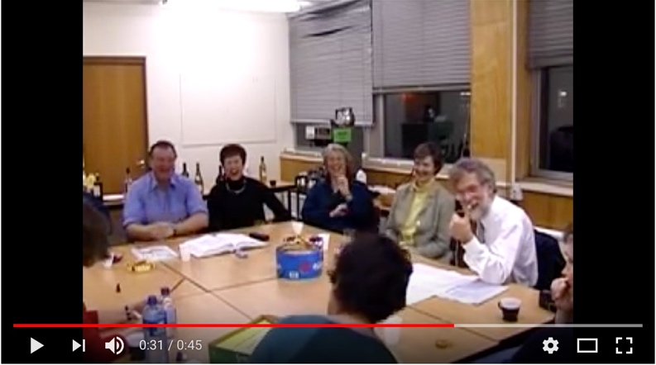

Community Feeling

I like Joy’s doctoral enquiry, ‘How can I contribute to the creation and enhancement of the educational influences of a community of learners, supporting each other and their own development?’

I’m wondering if the Adlerian, Living Theory research group’s understanding of Adler’s idea of community feeling might provide meanings that we can share from our lived experience.

These are unsatisfactory English language translations of Adler’s German term, Gemeinschaftsgefühl. Most accurate of these is community feeling, which encompasses the individual’s awareness of belonging in the human community and the cosmos of which it is a part, and an understanding of his or her responsibility for the way the life of the community is being shaped by his or her actions.

Robyn has produced an 11:44 minute video at:

https://youtu.be/4SOS0EAUDgQ on:

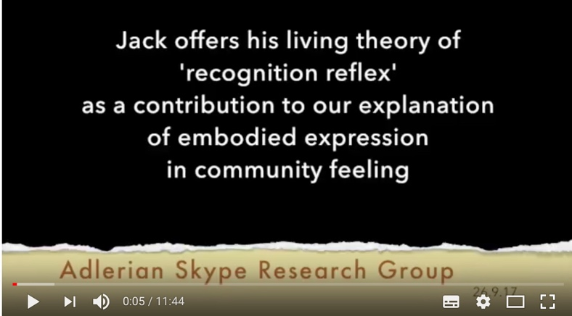

If you do have time to browse through the video we could if you like share responses on Friday.

I also experience community feeling in the Living Theory research support conversations on Sunday evening. Here is a still image which evokes my lived experience of both life-affirming energy and community feeling.

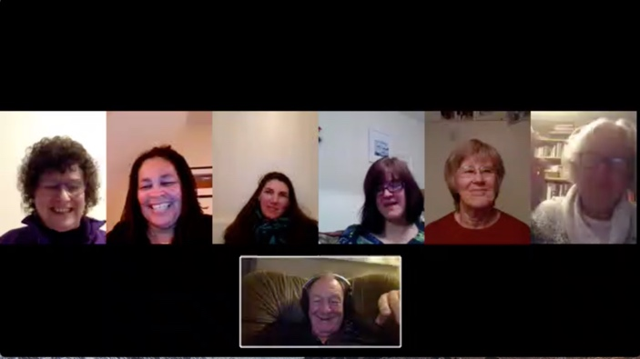
Following William’s point from Friday’s 5th December conversation, about developing a shared, or normative, understanding through conversation, I think you might enjoy, and identify, with Gadamer’s description of the art of conversation:

To conduct a dialogue requires first of all that the partners do not talk at cross purposes. Hence it necessarily has the structure of question and answer. The first condition of the art of conversation is ensuring that the other person is with us. ... To conduct a conversation means to allow oneself to be conducted by the subject matter to which the partners in the dialogue are oriented. It requires that one does not try to argue the other person down but that one really considers the weight of the other's opinion. Hence it is an art of testing. But the art of testing is the art of questioning. For we have seen that to question means to lay open, to place in the open. As against the fixity of opinions, questioning makes the object and all the possibilities fluid. A person skilled in the 'art' of questioning is a person who can prevent questions being suppressed by the dominant opinion. A person who possesses this art will himself search for everything in favour of an opinion. Dialectic consists not in trying to discover the weakness of what is said, but in bringing out its real strength. It is not the art of arguing (which can make a strong case out of a weak one) but in the art of thinking (which can strengthen objections by referring to the subject matter).

The unique and continuing relevance of the Platonic dialogues is due to this art of strengthening, for in this process what is said is continually transformed into the uttermost possibilities of its rightness and truth, and overcomes all opposition that tries to limit its validity. Here again it is not simply a matter of leaving the subject undecided. Someone who wants to know something cannot just leave it a matter of mere opinion, which is to say that he cannot hold himself aloof from the opinions that are in question. The speaker is put to the question until the truth of what is under discussion finally emerges. The maieutic productivity of the Socratic dialogue, the art of using words as a midwife, is certainly directed towards the people who are the partners is the dialogue, but it is concerned merely with the opinions they express, the immanent logic of the subject matter that is unfolded in the dialogue. What emerges in its truth is the logos, which is neither mine nor yours and so far transcends the interlocutors' subjective opinions that even the persons leading the conversation knows that he does not know.

As the art of conducting a conversation, dialectic is also the art of seeing things in the unity of an aspect – i.e. it is the art of forming concepts through working out the common meaning. What characterises a dialogue, in contrast with the rigid form of statements that demand to be set down in writing, is precisely this: that in dialogue, spoken language – in the process of question and answer, giving and taking, talking at cross purposes and seeing each other's point – performs the communication of meaning that, with respect to the written tradition, is the task of hermeneutics. Hence, it is more than a metaphor; it is a memory of what originally was the case, to describe the task of hermeneutics as entering into dialogue with the text. That this interpretation is performed by spoken language does not mean that it is transposed into a foreign medium; rather, being transformed into spoken language represents the restoration of the original communication of meaning. When it is interpreted, written tradition is brought back out of the alienation in which it finds itself and into the living presentation of conversation, which is always fundamentally realised in question and answer. (Gadamer, 1975, 1989 pp. 367-8)
Gadamer, H. G. (1975) Truth and Method, London; Sheed and Ward.

Values that carry hope for the flourishing of humanity

Rachael used the phrase ‘the intangible presence of values’ in our conversation of the 05/01/18. Rachael also drew out attention to the video-clips in Arianna’s EJOLTS 8(2) paper at http://ejolts.net/node/262 on ‘Generating my own living-theory: An interim report’. The video clips are on pages 96 and 97.

If the visual data is helpful in communicating embodied expressions of life-affirming energy and community feeling, I’m wonder if we might also use this kind of data to clarify and communicate our lived experience and embodied expressions of the values that carry hope for the flourishing of humanity?

Love Jack 8th January 2018.

