How do I Evolve Living-Educational-Theory Praxis
in
Living-boundaries?

A thesis submitted by

Marie Huxtable

for the degree of Doctor of Philosophy
University of Bath,
Department of Education
May 2012

COPYRIGHT

Attention is drawn to the fact that copyright of this thesis rests with its author. A copy of this thesis has been supplied on condition that anyone who consults it is understood to recognise that its copyright rests with the author and they must not copy it or use material from it except as permitted by law or with the consent of the author. This thesis may be made available for consultation within the University Library and may be photocopied or lent to other libraries for the purposes of consultation.

Contents
Contents 2
List of Videos 5
List of Figures 11
List of Appendices 13
Acknowledgements 14
Abstract 15
Abbreviations 16
Preamble 17
Chapter 1 Introduction 20
1.1 Setting the scene 22
1.1.1 Contexts 22
1.1.2 Language 35
1.1.3 Evaluative criteria 40
1.2 Contributions to educational knowledge and structure of the thesis 44
1.2.1 Living-Educational-Theory praxis (Chapter 2) 45
1.2.2 Clarification of my ontological and social values in living-boundaries (Chapter 3) 46
1.2.3 The evolution of my living-educational-theory praxis (Chapter 4) 47
1.2.4 The development of inclusive gifted and talented education from an educational perspective. (Chapter 5) 47
1.2.5 A creative use of multimedia narratives in researching the meanings of values in living-boundaries and developing generative and transformational forms of educational evaluation and accountability (Chapter 6) 48
1.2.6 Living-Theory TASC: A relationally-dynamic and multidimensional approach to research and developing praxis (Chapter 7) 48
1.2.7 What have I learned and what now? (Chapter 8) 49
1.3 Postscript 49
Chapter 2 Living-Educational-Theory praxis 51
2.1 Living-boundaries 52
2.2 What is educational practice and research? 57
2.2.1 What is educational about my practice? 58
2.2.2 What is educational about educational research? 63
2.2.3 A question of ethics 68
2.3 Praxis 70
2.4 Living-Educational-Theory and living-educational-theories 72
2.5 Living-Educational-Theory praxis 78
2.6 Postscript 84
Chapter 3 Clarification of my ontological and social values in living-boundaries 86
3.1 My ontological values of loving recognition, respectful connectedness and educational responsibility 86
3.1.1 Visual narratives 87
3.1.2 Text based narratives 92
3.1.3 Multimedia narratives 101
3.2 Ostensive clarification of my inclusive, emancipating and egalitarian social values 111
3.3 Clarifying values in living-boundaries 116
3.4 Postscript 117
Chapter 4 My living-educational-theory praxis 119
4.1 A brief résumé 120
4.2 How do I hold myself accountable to my employer and myself? 124
4.3 What can I do to enable more children and young people to learn to develop as lifelong successful learners? 126
4.4 How can I enable more children and young people to come to know their passions for learning? 127
4.5 How do I enable children, young people and educators to experience themselves as experts developing expertise? 129
4.6 How do I improve support for learners developing as expert enquirers creating and offering valued knowledge? 135
4.7 How do I enhance the educational possibility and influence of educational researching communities and educational space within living-boundaries? 141
4.8 How do I evidence and explain my educational influence in learning? 145
4.8.1 … the learning of others? 146
4.8.2 … in the learning of social formations? 151
4.9 Postscript 153
Chapter 5 The development of inclusive gifted and talented education from an educational perspective 155
5.1 What is my concern and why am I concerned? 156
5.1.1 Language and frames they evoke 156
5.1.2 Normative background 159
5.2 What can I do? 168
5.3 Developing inclusive gifted and talented education from an educational perspective in practice 180
5.3.1 Playful enquiry: experiences, ‘playgrounds’, information, ideas etc to open minds and extend possibilities. 182
5.3.2 Objectives-led learning: courses and masterclasses to develop and enhance skills, understandings 183
5.3.3 Passion-led research: support for knowledge creating enquiries 184
5.3.4 A supportive culture 185
5.4 Summary of APEX 187
5.5 Postscript 190
Chapter 6 A creative use of multimedia narratives in researching the meanings of values in living-boundaries and developing generative and transformational forms of educational evaluation and accountability 191
6.1 Multimedia narratives to research meanings of energy-flowing values 191
6.2 Values researched in living-boundaries 196
6.3 Multimedia narratives contributing to generative and transformational forms of educational evaluation and accountability 198
6.3.1 Evaluating what I do 199
6.3.2 Accounting for what I do 207
6.4 Postscript 221
Chapter 7 Living-Theory TASC: A relationally-dynamic and multidimensional approach to research and developing praxis 222
7.1 Overview 223
7.2 Living-Theory TASC 226
7.3 Creating knowledge of the world, self and self in and of the world 239
7.4 Postscript 241
Chapter 8 What have I learned and what now? 242
8.1 Have I told a good story well? 242
8.2 What are the main points of my learning? 245
8.3 And…? 251
References: 253
APPENDIX 1 268
Chronological thread of my improving practice narrative through publications and presented papers 268

List of Videos
 | Chapter 1
 | 1.1.1.1
Video 1 | What really matters to me ………………………… | p. 23
 | 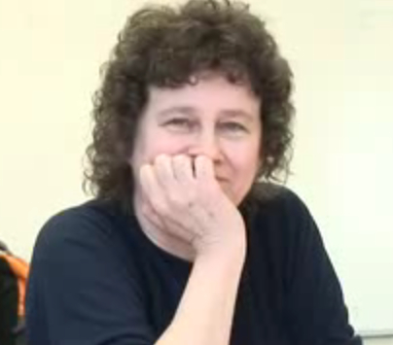
 | http://tinyurl.com/3qz6sls
 | 1.1.1.4
Video 2 | Nelson Mandela on Ubuntu ………………………… | p. 34
 | 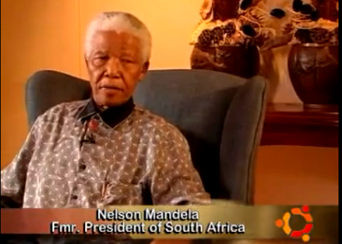
 | http://www.youtube.com/watch?v=ODQ4WiDsEBQ
 | 1.1.2
Video 3 | Alan Rayner’s paper dance introducing inclusionality | p. 38
 | 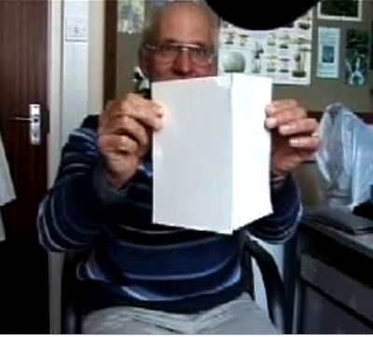
 | http://tinyurl.com/42svmwb
 | 1.1.2
Video 4 | Sharing a sense of flow of life-affirming and life-enhancing energy……………………………………. | p. 40
 | 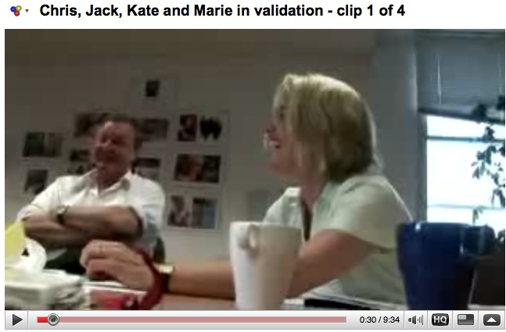
 | http://tinyurl.com/3kxadvt

 | Chapter 2
 | 2.1
Video 5 | WWI Christmas Truce 1914 uploaded by gail242000's…………………………………………. | p. 56
 | 
 | http://www.youtube.com/watch?v=QTXhZ4uR6rs&feature=related
 | 2.5 Page 78.
Video 6 | Babar Ali, India, world’s youngest Head-teacher …... | p. 83
 | 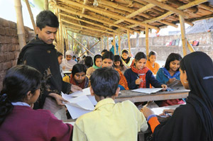
 | http://news.bbc.co.uk/1/hi/8299780.stm
 | Chapter 3
 | 3.1.3.1
Video 7 | Ostensive clarification of ontological values ……… | p. 104
 | 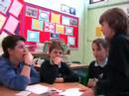
 | http://tinyurl.com/3v7nqb5
 | 3.1.3.2 Page 101
Video 8 | Relationally-dynamic qualities of energy-flowing values ……………………………………………… | p. 106
 | 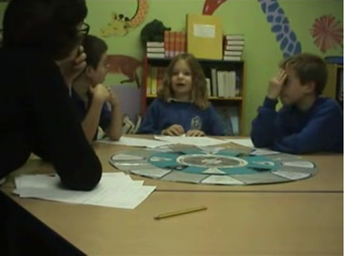
 | http://tinyurl.com/3ogda8w

 | 3.1.3.3
Video 9a | Expressing embodied living values. ………………… | p. 110
 | 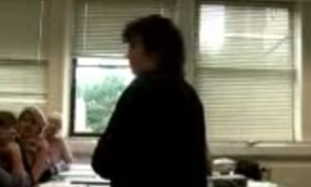
 | http://tinyurl.com/3fg34wy
 | 3.1.3.3
Video 9b | Analysis in the video ………………………………... | p. 111
 | http://tinyurl.com/3pl23um
 | 3.2
Video 10 | An expression of energy-flowing values in relationships and space ……………………………… | p. 114
 | 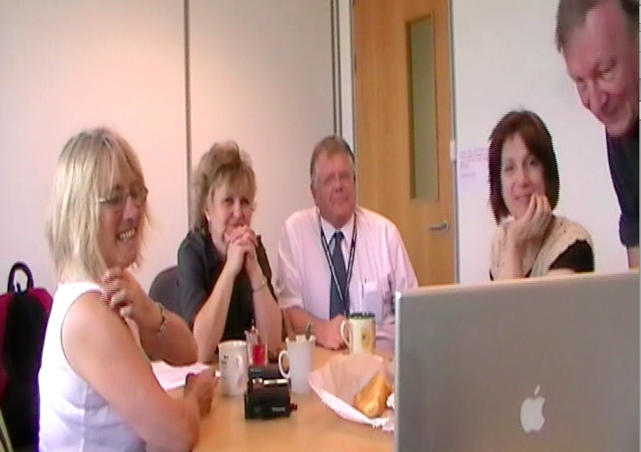
 | http://tinyurl.com/4xzeu8x
 | Chapter 4
 | 4.6
Video 11 | Pleasure and confidence in affirmation of knowledge creators……………………………………………….  Chapter 6 – 6.3.2…………………………………….. | p. 139  p. 213
 | 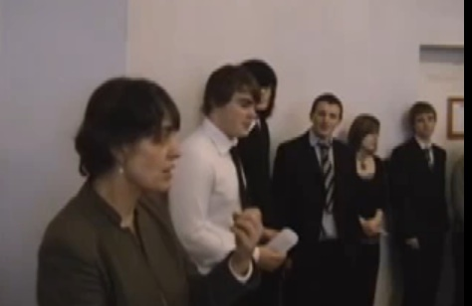
 | 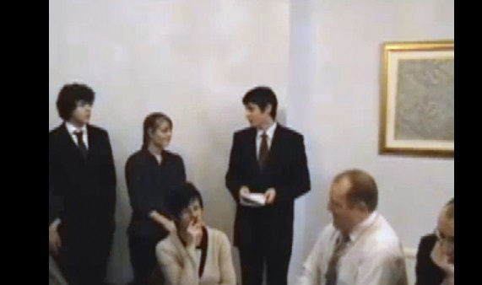
 | http://tinyurl.com/44of77d

 | 4.7
Video 12 | Relationally-dynamic flow of energy in expression of values in a large space……………………………… | p. 145
 | 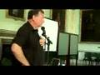
 | http://tinyurl.com/42vjdkh
 | 4.8.1
Video 13 | Young person communicating energy-flowing values | p. 148
 | 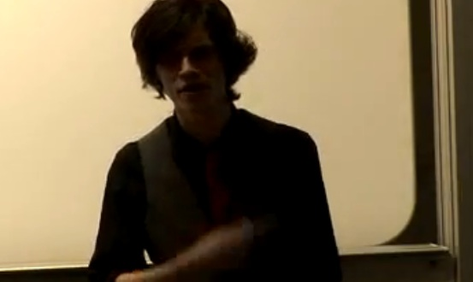
 | http://tinyurl.com/3z6ec8d
 | 4.8.1
Video 14 | Young person sharing her passion-led enquiry with peers in school……………………………………….. | p. 149
 | 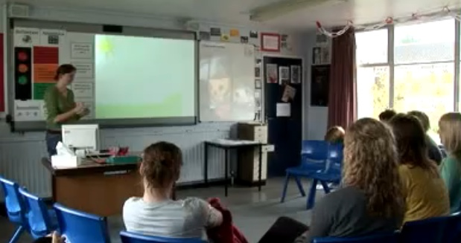
 | http://tinyurl.com/4ygf6o8
 | 4.8.1
Video 15 | Young people offering their talents and knowledge as gifts at APEX Summer 2009 ………………………... | p. 149
 | 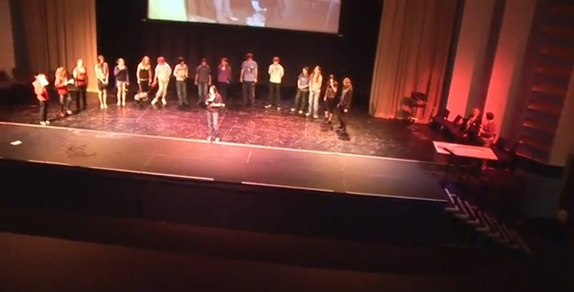
 | http://tinyurl.com/3lb588z
 | 4.8.1
Video 16 | Young people offering their talents and knowledge as gifts at APEX Summer 2010………………………… | p. 150
 | 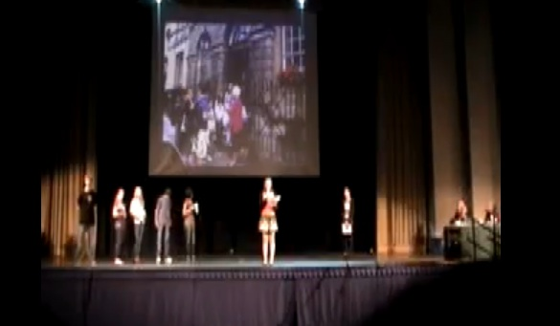
 | http://tinyurl.com/3moff2p
 | Chapter 5
 | 5.2
Video 17 | Loving what you do…………………………………. | p. 176
 | 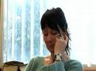
 | http://tinyurl.com/3vxo3zr
 | Chapter 6
 | 6.1
Video 18 | Communicating my thesis…………………………… | p. 195
 | 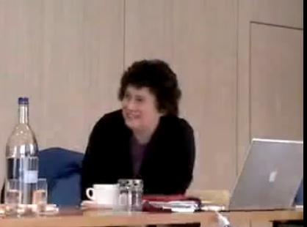
 | http://tinyurl.com/3jr7jla
 | 6.3.2
Video 19 | Extract from BERA 2006 paper……………………... | p. 209
 | 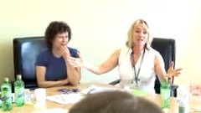
 | http://youtu.be/RIbR0X67DtY
 | Chapter 7
 | 7.2
Video 20 | Andrew Henon creating his Masters………………… | p. 231
 | 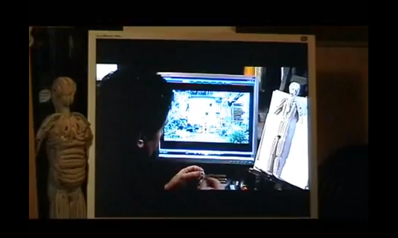
 | http://www.youtube.com/watch?v=7dt2j1DIttE
 | Chapter 8
 | 8.2
Video 21 | Nigel Harrisson at BERA 2006 talking of his loving values……………………………………................... | p. 248
 | 
 | http://tinyurl.com/3hyvv7g

 | 8.2
Video 22 | Randy Pausch’s Last Lecture: Really Living Your Childhood Dreams…………………………………... | p. 249
 | 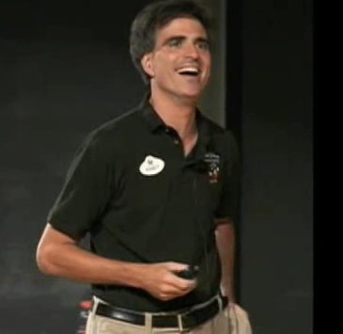
 | http://www.youtube.com/watch?v=ji5_MqicxSo

List of Figures
 | Preamble
Figure 1 | Collage communicating human qualities such as vitality, humour.……………………………………... | p. 19
 | Chapter 1.
Figure 2 | Arrows used to illustrate traditional social science research……………………………………………… | p. 20
Figure 3 | Smoke used to illustrate flows of energy in research as a living process – picture by Salvatore Vuono / FreeDigitalPhotos.net ……………………………………… | p. 20
Figure 4 | Möbius strip …………………………………………. | p. 21
Figure 5 | Summary representation of Renzulli’s three types of learning opportunities………………………………... | p. 28
 | Chapter 2.
Figure 6 | Moving from at a boundary to within a living- boundary……………………………………………... | p. 52
Figure 7 | Sonia Hutchison’s picture of pooling energy………... | p. 53
 | Chapter 3.
Figure 8 | Participants at an APEX Saturday workshop………... | p.87
Figure 9 | Eden Charles and Alan Rayner in conversation……... | p. 89
Figure 10 | Thanks to Ed Harker, Margaret Dobie in Laidlaw (2006), Joy Mounter and Belle Wallace for their photographs………………………………………….. | p. 90
Figure 11 | Pupils of Joy Mounter………………………………... | p. 91
Figure 12 | Children enjoying life………………………………... | p. 92
Figure 13 | Chris, Sandra, Nigel and Kate……………………….. | p. 116
 | Chapter 4.
Figure 14 | Framework for developing APEX…………………… | p. 123  p. 220
Figure 15 | Representation of relationship between teacher, learner and enquiry…………………………………... | p. 131
Figure 16 | Learning to Research: Learning to Make a Difference That Matters, leaflet………………………………….. | p. 134
Figure 17 | Andrew Henon leading a collaborative, creative enquiry as artists……………………………………... | p. 143
Figure 18 | A collaborative, creative enquiry as living-theory action researchers……………………………………. | p. 144
 | Chapter 5
Figure 19 | Photo of child by Belle Wallace……………………... | p. 175  p. 197
 | Chapter 6
Figure 20 | Extract from BERA 2006 paper……………………... | p. 209
Figure 21 | A generally-expected form of plan, do, review formats……………………………………………….. | p. 211
Figure 22 | An example form as required by the Local Education Authority……………………………………………... | p. 218
Figure 23 | An example of a curriculum tree issued by the QCA, which shows that linear, boxlike forms are not the only possible approach………………………………. | p. 219
 | Chapter 7.
Figure 24 | The steps of enquiry in the TASC approach (Wallace et al., 2004)…………………………………………... | p. 224
Figure 25 | Joy Mounter's pupils' model of their learning……….. | p. 225
Figure 26 | Living-Theory TASC Knot (author’s work)………… | p. 225
Figure 27 | Fatcat!........................................................................... | p. 230
Figure 28 | Dali’s sculpture Anthropormorphic cabinet………. | p. 233
Figure 29 | Inter-relationship between organic and systematic phases of research……………………………………. | p. 236
Figure 30 | Dali’s ‘Soft Watch at the Moment of First Explosion.’…………………………………………… | p. 237

List of Appendices
Appendix 1 – Chronological thread of my improving practice narrative through publications and presented papers

Acknowledgements
So many have contributed to my journey there isn’t room to say a personal thank you to everyone. The many members of the Improving Practice Conversation Café and the Tuesday/Thursday groups, the APEX staff and the children and young people whose lives have touched mine, are amongst those I do not individually name but I hope they know how highly I value the gifts they have offered over the years.
Many thanks to Jane Hill, Chris Jones, Nigel Harrisson, Sandra Harris, Sonia Hutchison, Joy Mounter, Sally Cartwright, Barry Hymer, Belle Wallace, Tony Miles, Pete Mellet, Robyn Pound, Alan Rayner, Marian Naidoo and Andrew Henon for sharing their journeys and putting up with mine with good grace and inspiring energy. My thanks to Moira Laidlaw, Mark Latus and Michael Neugarten for their patient attention to my many redrafts. They have improved not only my thinking but also my English, an enterprise that has defeated many over the years.
I would like to say a very special thank-you to Pauline Miles and Jack Whitehead who are life-affirming and life-enhancing energy personified. Their unique gifts of loving wisdom, humour and friendship have made my world, and that of many, a much better place to be. Pauline’s curiosity and persistent interrogations kept me going when I lost heart. I would not have started the journey except for the inspiration of Jack’s academic contribution of Living-Educational-Theory and I wouldn’t have finished without his good-humoured patience and support as one of the most talented educators I have ever known. Last, but by no means least, I would like to thank my Mum, who has been and always will be my inspiration to do the best I can, and my son, who is my inspiration to do things better.

Abstract
My educational practice is concerned with enhancing children and young persons’ abilities to learn to live a loving, satisfying, productive and worthwhile life, for themselves and others. This thesis offers an original contribution to knowledge as a multimedia narrative. It communicates my ontological values of a loving recognition, respectful connectedness and educational responsibility, and social values of an inclusive, emancipating and egalitarian society. I clarify meanings of my values, as they emerge within living-boundaries through the evolution of my living-theory praxis, to form explanatory principles and living standards of judgment in my claim to know my practice.
Working as a senior educational psychologist responsible for implementing policy on high ability learning, I experienced the following concerns: Practice, theory and research often appeared to lose connection with the purpose of education; Theory and practice appeared to be developed independently, and without explanation or evaluation related to values ofeducation; Those involved with education appeared to be in discrete worlds, each vying to exert their hegemony over the totalising development of educational theory, practice and provision.
Emerging from my research I offer four original ideas:
1) Living-Educational-Theory praxis, highlighting the fundamental importance of educators creating ‘values-based explanation of their educational influences in learning’ (Whitehead, 1989a), as they research to develop praxis within living-boundaries.
2) Living-boundaries as co-creative space within which energy-flowing values can be clarified and communicated.
3) Inclusive gifted and talented education developed from an educational perspective, which enables each learner to develop and offer talents, expertise and knowledge as life-affirming and life-enhancing gifts. The knowledge is that created of the world, of self, and self in and of the world.
4) Living-Theory TASC, a relationally-dynamic and multidimensional approach to research and developing praxis, which integrates Living-Theory (Whitehead, 1989a) with Thinking Actively in a Social Context (TASC) (Wallace and Adams, 1993).

Abbreviations
AERA – American Educational Research Association
ALARJ – Action Learning Action Research Journal
APEX - ALL are Able Pupils Extending Opportunities
B&NES Bath and North East Somerset
BERA – British Educational Research Association
BPS – British Psychological Society
CPD - Continuing Professional Development
CRB – Criminal Record Bureau
DCSF – Department for Children, School and Family
DfE – Department for Education
DISTAR (Direct Instruction System for Teaching Arithmetic and Reading, a trademarked program of SRA/McGraw-Hill, a commercial publishing company)
DSG - Dedicated Schools Grant
HPC – Health Professions Council
INSET – In Service Training
LA – Local Authority
LEA – Local Education Authority
NOF – New Opportunities Fund
TASC – Thinking Actively in a Social Context
TED – Technology, Entertainment, Design.
QCA – Qualifications and Curriculum Agency

Preamble
‘We must learn to feel addressed by a book, by the human being behind it, as if a person spoke directly to us. A good book or essay or poem is not primarily an object to be put to use, or an object of experience: it is the voice of You speaking to me, requiring a response’ (Buber, 1970, prologue p.39)
I also take Quinn’s (1997) notion of decentring seriously:
‘It is the achievement whereby I learn what it is that you need to hear or experience in order to share what is in my mind, whether it be a question, an idea or a supportive anecdote.’ (p.86)
To share what is in my mind with you, so you might feel addressed, I first need to have some sense of who you are and why you might be reading this. I am writing thinking of you reading as:
- An academic judging whether my thesis:
  - Makes an original and significant contribution to knowledge
  - Gives evidence of originality of mind and critical judgement
  - Contains material worthy of peer-reviewed publication
  - Is satisfactory in its literary and/or technical presentation and structure
  - Demonstrates an understanding of the context of the research.

and/or as:

- A professional educator and/or a person who shares my passion for improving education and curious to see if there is anything to be learned from the narrative of my learning and research.
I am thinking that you may be more familiar with research rooted in the traditions of the social science disciplines, and with reading texts. However, this is not a traditional thesis: it is a Living-Educational-Theory thesis presented as a multimedia narrative and I am asking you to engage in a particular way. I am asking you to engage critically and analytically, modes of thinking I assume you are very familiar with. I am also asking you to engage creatively through your imagination and emotions. By asking you to engage in this way I want you to appreciate the relationally-dynamic nature of my values, imbued with energy that is life-affirming and life-enhancing, as well as the more traditional academic qualities of my work. I hope that in the process this stimulates some thoughts or indicates paths to explore, which might contribute to your own knowledge-creating ventures.
The way I research conforms to ethical principles such as those set out in the BERA (2011) Ethical Guidelines for Educational Research the BPS (2010) Code of Human Research Ethics and (2009) Code of Ethics and Conduct, and the HPC (2007) Standards of Conduct, Performance and Ethics. As Living-Theory research has at its heart a concern to practice ethically by making explicit the usually implicit embodied values of the practitioner researcher, identifying contradictions in practice and developing ways to improve. My research reflects the multidimensional and relationally-dynamic nature of learning, life and enquiry. I want my thesis to communicate this organic and evolving process – the living nature of educational knowledge. Whitehead, who originated Living-Theory (Whitehead, 1989a), expressed this well in his presidential address to BERA in 1988 (Whitehead, 1989b):
‘I hope that you can now see why I characterise the approach as a living approach to educational theory. It is to distinguish it from a linguistic approach which is contained within propositional relationships and captured texts on library shelves. In contrast to this I am proposing an organic view of educational theory which is living in the public conversations of those constituting professional practice. It is thus growing in the living relationship between teachers, pupils and professional researchers and embodied within their forms of life.’ (p. 9)
I see the relationship between me as writer, and you as reader, in the same light. The interface may be through text or a multimedia narrative on a library shelf, or on the web. Nonetheless, it is a living process that exists in a relationship between human beings, no matter how transitory or mediated, which occurs in a living-boundary, in this case between you, the thesis and me.
At this point it might help if I briefly introduce myself. I created this thesis while working as a senior educational psychologist in an English Local Authority, developing and coordinating a project known as APEX. My work responded to my employer’s inclusive vision statement, and rested on my belief that each person is unique and capable of making a valuable contribution to improving their own well-being and well-becoming, and that of others.
I give primacy to my educational responsibility as I research my practice to improve it. By educational responsibility, I mean my responsibility to enhance educational experiences of children and young persons so that each may improve their ability to bring themselves into their own presence, and live a loving life that is satisfying, productive and worthwhile for themselves and others. As you engage with this thesis I would like you to hold this responsibility in sharp focus.
I find ‘an academic voice’, which is traditionally impersonal, does not communicate the warm inter- and intra- personal, energy-flowing, qualities of love, humanity and humour, I believe should be the central tenets of education, particularly of the young. It is important to me that my research and practice communicate these qualities to you. I will periodically, throughout this account, use ‘persons’ in the place of ‘people’ to remind you and myself that I am concerned with individuals, each with their own unique contribution to make to enhance their own lives and all our lives. To keep the connection between the thesis and the lived experience of my work and practice I ask you to hold this collage (Figure 1) in mind.
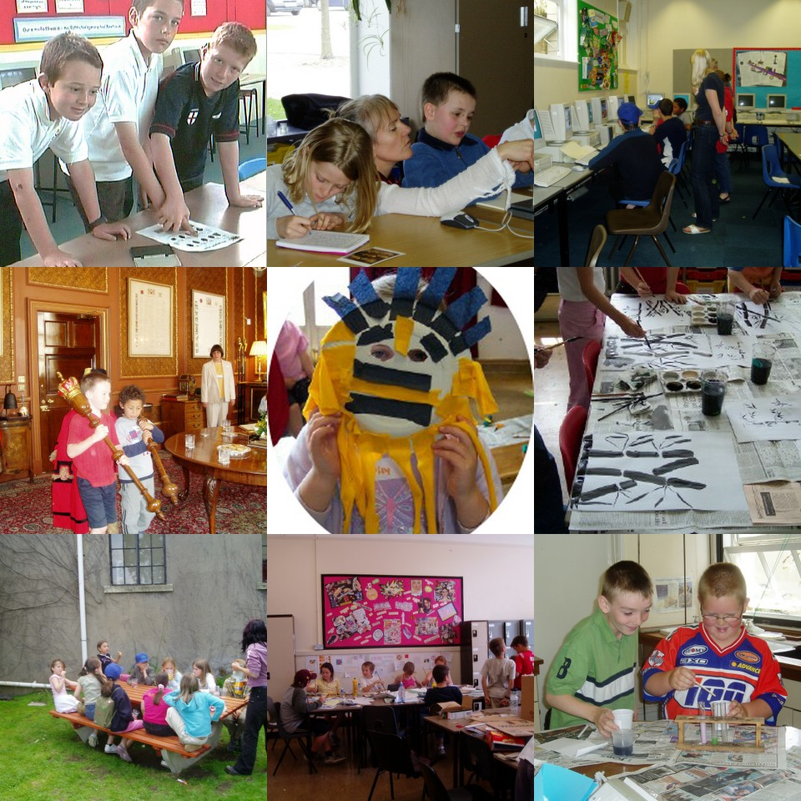
Figure 1 Collage communicating human qualities such as vitality and humour

Figure 1 is a collage of photographs I have selected from the workshops I have organised for children, young people and adults as part of APEX. By bringing this collage into the thesis I am not simply trying to give a window into the world of my work; I am trying to communicate human qualities such as vitality, humour, warmth, love, curiosity, creativity, surprise, enquiry, pride, interconnectedness, sustained effort, a vibrant flow of a loving life-affirming and life-enhancing energy. I ask you to hold the feelings of pleasure and energy that I hope these pictures evoke as you engage with this thesis. These living human qualities and values, so poorly communicated through simple words on a page, are what distinguish the knowledge I seek to offer as educational.

Chapter 1 Introduction
This thesis explicates four key ideas that have emerged through researching my practice to improve it:
- Living-Educational-Theory Praxis
- Living-boundaries
- The development of inclusive gifted and talented education from an educational perspective
- Living-Theory TASC

If the picture of the arrows serves as a metaphor for many social science approaches to researching in education, then the second picture, of the swirling smoke, can be understood as a metaphor for educational research approaches concerned with multidimensional, relationally-dynamic, energy-flowing values.
Figure 2 Arrows used to illustrate traditional social science research

We might agree the energy as explored in physics exists, flows and takes various forms, such as light and heat. It requires small particles distributed as smoke, and energy in the form of light, for us to explore and communicate energy as heat, which is otherwise invisible to the human eye. The smoke and light help us communicate and research the energy present. Particles and flows of energy are distinct but cannot be properly understood if we try to treat them as discrete and independent. So it is with the living process of my enquiry and learning, the key ideas I offer, the form of my communication and your engagement with the thesis. I present my thesis as a multimedia research narrative in the hope of evoking within you an empathetic resonance (Whitehead, 2010a and 2010b) with the values-based aspirations I have for my work and improving practice to stimulate your imagination with possibilities for your own.
Figure 3 Smoke used to illustrate flows of energy in research as a living process – picture by
Salvatore Vuono / FreeDigitalPhotos.net
To understand my thesis, I believe you need to know something of the social, cultural, historical and political backdrop to my life and work, and I think you need to know a something of me. So, I begin the introduction by giving a little background as context.
Even in these few paragraphs I realise I have used words and terms such as ‘Living-Educational-Theory’, ‘praxis’, ‘living-boundaries’, multimedia narrative’, each redolent with my experiences but they may carry different meanings for you. Therefore in this introduction I will clarify some of the language I use to help us develop common understandings.
As I intimated in the preamble, my intention in creating this thesis is to make an original and significant contribution to educational knowledge, legitimated by the Academy. I create and offer this knowledge, not as an esoteric intellectual exercise, but in the hope of making a worthwhile contribution to this world as a better place to be. I am keen to create and contribute a gift of quality so I spell out the evaluative criteria I am applying. In doing so I am placing the thesis within an academic body of knowledge and indicating the nature of the research journey I have been on.
All journeys have to begin and finish but in a narrative of my living-theory it is like trying to define the start and end of a Möbius strip (Figure 4).


Figure 4 Möbius strip (http://www.wpclipart.com public domain)
There are many inter-related and inter-connected stories that comprise this research but only one thread can be narrated at a time, and many interesting nooks and crannies have to be left unexplored. Given an awareness of those limitations I offer in this introduction an outline of the structure of the thesis.
Sections as signposts in this chapter
1.1 Setting the scene
1.1.1 Contexts
1.1.1.1 The normative background of my research
1.1.1.2 The evolution of my thinking
1.1.1.3 The development of my work leading APEX
1.1.1.4 What is important to me
1.1.2 Language
1.1.3 Evaluative criteria
1.2 Contributions to educational knowledge and structure of the thesis
1.2.1 Living-Educational-Theory praxis (Chapter 2)
1.2.2 Clarification of my ontological and social values in living-boundaries (Chapter 3)
1.2.3 The evolution my living-educational-theory praxis (Chapter 4)
1.2.4 The development of inclusive gifted and talented education from an educational perspective (Chapter 5)
1.2.5 A creative use of multimedia narratives in researching the meanings of values in living-boundaries, and developing generative and transformational forms of educational evaluation and accountability (Chapter 6)
1.2.6 Living-theory TASC: A relationally-dynamic and multidimensional approach to research and developing praxis (Chapter 7)
1.2.7 What have I learned and what now? (Chapter 8)
1.3 Postscript

1.1 Setting the scene

1.1.1 Contexts
‘I began by observing that you cannot find out what a man means by simply studying his spoken or written statements, even though he has spoken or written with perfect command of language and perfectly truthful intention. In order to find out his meaning you must also know what the question was (a question in his own mind, and presumed by him to be in yours) to which the thing he has said or written was meant as an answer.’ (Collingwood, 1991, p.31)
I share Collingwood’s view that an answer, or response, can only be understood in the context of the question. To understand the context of the question in this case, includes understanding something of me, as the person asking the question, “How can I improve what I do?” As you engage with the videos, text and images that follow, I hope to give you sufficient understanding of the normative backdrop of my research and practice, what is important to me, the evolution of my thinking and the development of my work, for you to understand the questions to which this thesis offers a response.

1.1.1.1 The normative backdrop of my research
At this point I ask you to watch this short video clip (1.28 mins) recorded at one of the CPD group meetings I support and facilitate with Jack Whitehead. Each person had said a little about what was important to him or her, which was videoed – then came my turn.
http://tinyurl.com/3qz6sls
Video 1 What really matters to me http://tinyurl.com/3qz6sls
By inviting you to engage with this short video I hope you will begin to know something of me that text alone would not accomplish, such as my personal energy and passion for improving education that is the substance of this thesis and my practice. In listening to the words you will gather something about my values, beliefs and aspirations. Depending on your own background, you may also have been alerted to pressures I was under at that time. These pressures came from changes in regulations and are alluded to by another speaker making reference to “CRBs”, and the subsequent laughter. It is this formal backdrop to the practice I have researched to improve, I introduce now.
Since I began this research programme in 2006 Governments have come and gone. Government policies and strategies have come and gone, including a ‘gifted and talented strategy’. Government departments have come and gone, while others have repeatedly changed their names and functions. A similar upheaval has been caused in the functioning of local authorities by changes in national Government demands and impositions. The constants are ever-increasing legislation, targets and constraints. The national Government, irrespective of which one, has increasingly imposed practice, and actuarial forms of accountability on schools, local authorities and other publicly- funded institutions. This has been to the detriment of work to improve education as the House of Lords has acknowledged:
‘Able, brilliant and skilled professionals do not thrive in an environment where much of their energies are absorbed by the need to comply with a raft of detailed requirements...’(House of Lords, 2009, p.15)
While the current Government (a coalition of the Liberal and Conservative parties elected in 2010), appears in places to be reducing the ‘raft of detailed requirements’, the forms of ‘accountability for the delivery of key outcomes’ are filling the space created. I understand that as an educational professional I account to others: to the ethical standards of my professional body; to my employer, and, most importantly, I hold myself to account to me, and to my own values. When I talk of being ‘accountable’ I do so with an understanding that I need to provide a values-based explanation for why I do what I do. I distinguish between evaluation and accountability and elaborate on approaches that are generative and transformational in Chapter 6 (pages 191- 221)
I believe as a professional I am responsible for my practice and I am beholden to continually seek to understand, explain and improve it. To do that I believe I need to research my practice, understanding research in the way Eisner (1993) expresses:
‘We do research to understand. We try to understand in order to make our schools better places for both the children and the adults who share their lives there.’ (p.10)
I go further than Eisner and say that I do research to try to understand in order to make this world, and not just our schools, a better place to be for all.
Since the general election changes continue faster than ever. These problems are not new, nor are they unique to education, public services or this country, as illustrated by this well-known quotation I occasionally find on school staffroom walls:
‘We trained very hard, but it seemed that every time we were beginning to form into teams we would be reorganised. I was to learn later in life that we tend to meet any new situation by reorganising, and a wonderful method it can be for creating the illusion of progress, while producing confusion, inefficiency and demoralisation’ (wrongly attributed to Gaius Petronius Arbiter 210 BCE but possibly dates back to at least the Second World War - http://www.wussu.com/writings/quotes.htm )
Sachs (1999) describes the impact on educators and education in Australia of politically directed changes. She shows the influence of a shift from, what she refers to as ‘democratic professionalism’, to ‘managerialist professionalism’ with the emergence of an ‘entrepreneurial identify’. Her reference to experiences of New Zealand in the late 1980’s serves to re-emphasise that the current social and political upheaval and contradictions, being experienced in England decades later, is not a new phenomenon.
The result is not just increased workloads for everyone who works in education. Stress is created by the demand for compliance with practice that is not values-based, and neither affirms or enhances gifts of talents, expertise or knowledge, created and offered by those with the courage to try. This holds true for children and young persons as much as for adults. I will return to this in more detail in Chapter 4 (pages 119 – 154) when I outline the evolution of my living-theory praxis. Having briefly begun to point to some of the ‘formal’ context of my practice within which I was researching, I now want to give you an insight into something of my intra-personal context.

1.1.1.2 The evolution of my thinking
I graduated with a degree in psychology from Hull University and then, after qualifying and working as a teacher in Sheffield, completed a professional Masters degree in Educational Psychology at Birmingham University. I began my career as an educational psychologist in Birmingham and continued to work for school psychology services in Devon and then Avon. In 1996 Avon Local Authority was abolished and I was transferred to B&NES, one of the four new unitary authorities that replaced Avon. Shortly after transferring I began to develop my ideas concerning ‘high ability’ in children and young people. The more I explored this the more I came to the conclusion that terms such as ‘high ability’, ‘successful learner’, ‘higher order thinking’ were used interchangeably and there was no reason to believe that each child could not make an outstanding contribution to society during their lives given motive, means and opportunity.
As I developed my enquiry as a project, it became increasingly obvious to me that I could describe what I was doing and how I was deciding where to devote time and resources, but I did not have a defensible rationale, underpinned by educational theory, for why I was doing what I was doing. I also knew that the form of reporting and evaluation based on figures and targets did not reflect the difference I was trying to make. This was, and is, important: “You get what you look for”, as I have learned from my experience and background in psychology. So these were two major concerns that I could find no resolution to, although I was becoming clearer about my research questions and their importance.
While working for the Child Guidance and School Psychology Service in Birmingham, I registered for a research degree. I eventually abandoned this as I realised the limitations of the form of research I was using, which was, and is, prevalent in education. Suffice it to say here that while I was drawn to trying to understand academic research and psychology in the context of my work as an educational psychologist, I was continually frustrated by the limitations of the approaches to research that I came across. I will elaborate on those limitations later in Chapter 2 (pages 51 – 85) where I introduce Living-Theory praxis.
As my work in ‘high ability’ developed, so my interest in working towards a research doctorate was renewed. I felt the discipline entailed would help me to develop my understanding and keep it as a priority as I dealt with the day-to-day practicalities of life, which can easily dominate every waking moment. However, it was not until I began to become acquainted in 2004 with Living-Educational-Theory (Whitehead, 1989a) that I was motivated to commit my time, resources and energy to embarking on an academically- disciplined research programme, with an enthusiasm born of an anticipation of something satisfying, productive and worthwhile emerging. The evolution of my thinking and the development of APEX, which had become my fulltime work, came together as I began to research my practice to improve it as a Living-Theory researcher registered on an MPhil/PhD research programme in 2006.

1.1.1.3 The development of my work leading APEX
As I have said, my professional area of influence, during the research programme, has been as senior educational psychologist leading the development and implementation of local authority policy promoting ‘high ability’ learning of children and young people. I give a brief, chronological account here by way of introduction and a more detailed account in Chapter 4 (pages 119 – 154) where I narrate my living-theory praxis.
The project was called APEX. I began developing APEX as part of my work with the school psychology service prior to the National Gifted and Talented Strategy. This is important as it meant that I was not constrained by the impositions of the dominating practices and beliefs emanating from the national Government. The project grew until I was moved from the school psychology service to manage APEX fulltime. APEX finishes August 2012 as a result of changes made by the Government to the roles, responsibilities and funding of local authorities and schools.
I began improving practice while I worked for the school psychology service by organising events for teachers with field leading practitioners and academics, and running workshops myself. This gave me direct access to the ideas of people at the forefront of the field, (examples are given on page 127). This gave rise to my belief that one key area to research was concerned with motivation. I looked for opportunities for children and young people to find a passion for creating knowledge in an area of their personal interest. I found few and as a consequence I developed a programme of workshops to broaden the horizons of children and young people, and the adults that worked with them, beyond school as I illustrate further on page 128. I intended the APEX Saturday workshops to offer opportunities for them to find inspiration for future ambitions, become confident to go to new places, meet and work with others who shared their enthusiasm, and extend their experiences and expertise (Huxtable, 2003). Most importantly I wanted to provide opportunities for children and young people to enjoy learning in an area of personal interest and experience themselves as valued, successful co-learners, capable of creating knowledge of the world, themselves, and themselves in and of the world.
While my focus was on the experience of the young I also wanted to reach adults, as they are the ones who are able to make a long-term difference to young learners. Many workshop providers and assistants were teachers. I wanted them to have the opportunity to be the educator they wanted to be, educationally engaging with enthusiastic learners in an area of their own passion, without the constraints of the ‘given curriculum’. I also wanted parents/carers to have the opportunity to venture beyond their local neighbourhood to extend their knowledge of educational possibilities that exist for their offspring and themselves.
These two threads of my work; improving educational relationships, space and opportunities for and with children and young people, and those for and with educators, provide the work-place context of my research. The threads are distinct, yet inter-related. For instance, application to the workshops was made through the schools on behalf of children and young people. In this way I hoped to provide a motivation for teachers to talk with their pupils/students about aptitudes, interests and enthusiasms beyond the given curriculum and help their young learners to develop their personal(ised) life-long curriculum. Some schools enabled children to share what they learnt on the workshops, which enhanced the child’s learning and that of their classmates (and on occasion, adults as well). Many teachers have been involved with the workshops and as a result they have extended their knowledge and skills and taken ideas back to their classrooms. Vicky Tucker’s account, accredited at Masters level (Tucker, 2008), illustrates the influence this has had in the learning and practice of an educator, working in a school for pupils presenting challenging behaviour, involved in different aspects of APEX,
I developed and ran a self-funded pilot programme of workshops in 1998/9. This provided the basis for a successful bid to be made in 2000 to NOF so there would be no cost to participants. Young people made a presentation to the council about the opportunities they had experienced, so that when NOF funding finished in October 2003 the Authority continued to fund the workshops. As the project grew, the Authority extended financial support until I could develop and manage the whole APEX project, including activities such as school- based INSET and CPD programmes, coherently. When the control of funds shifted from the Authority to schools, the Schools Forum, which managed the allocation of the DSG, continued the financial support for APEX.
APEX became an Authority-wide programme to support and promote inclusive gifted and talented educational theory, practice and provision. During one of the restructurings of the education department, my line management was moved from the school psychology service although I continued as a senior educational psychologist. I gave an account of why I continue to see the work as an expression of improving my practice as an educational psychologist in a paper presented at the 2006 annual conference of BERA (Huxtable, 2006b).
Like Oancea and Pring (2008) I believe that, ‘Deliberations over the aims of education are essentially moral—concerning the qualities and virtues, the capabilities and understandings that, under the banner of ‘education’, are thought worth promoting’ (p.29). What I believe is worth promoting is reflected in the pedagogical assumptions underpinning my practice. I believe that each person, irrespective of age, is capable of:
- Being an expert in their own learning and enhancing their expertise
- Developing and offering talents as life-enhancing gifts
- Creating, offering and accepting knowledge of the world, of themselves, and of themselves in and of the world, as a gift, to enhance their own well-being and well-becoming and that of others
- Coming to know and evolve their own living-theory.
I am taking a belief to be what I believe to be true and a value as that which gives meaning and purpose to my life.
As I was developing my ideas about high ability, inspired by the notion of the ‘sports-approach’ of Freeman (1998), ‘successful intelligence’ by Sternberg (1997), and others, I wanted a rationale for developing APEX. I therefore began to develop a framework drawing on Renzulli’s (1997) notion of three types of learning opportunities.
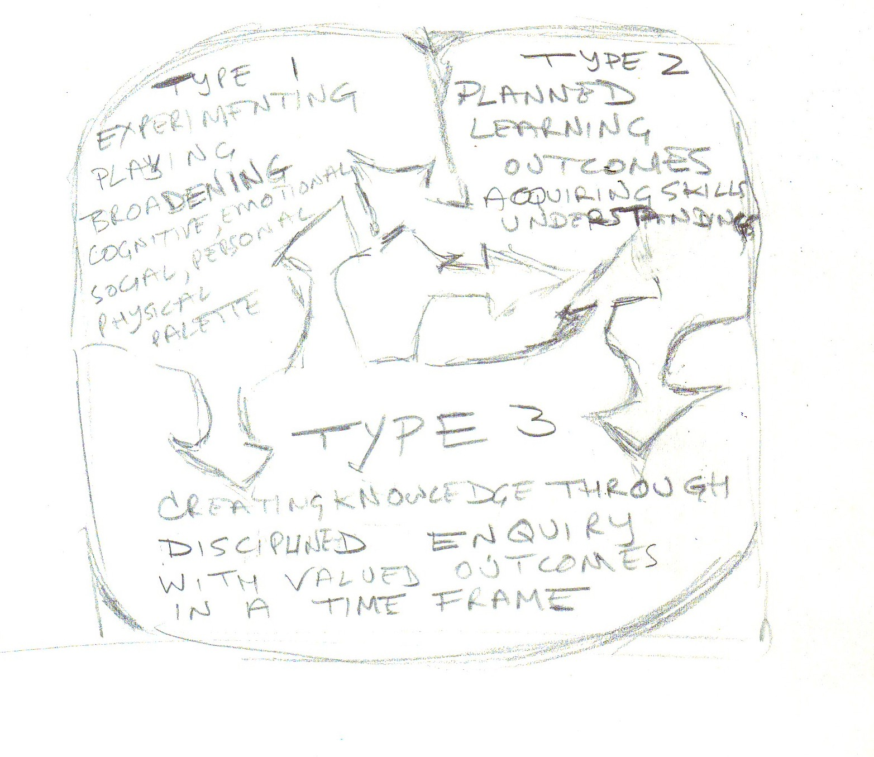
Figure 5 Summary representation of Renzulli’s three types of learning opportunities
In developing a framework for my work I was particularly influenced by the work of Wallace (1993) on TASC (Thinking Actively in a Social Context) and Whitehead’s (1989a) Living-Educational-Theory. The following few slides, which I have used often in presentations to various audiences, summarise key points of the framework I have used to develop relationships, space and opportunities to enhance educational practice and provision.
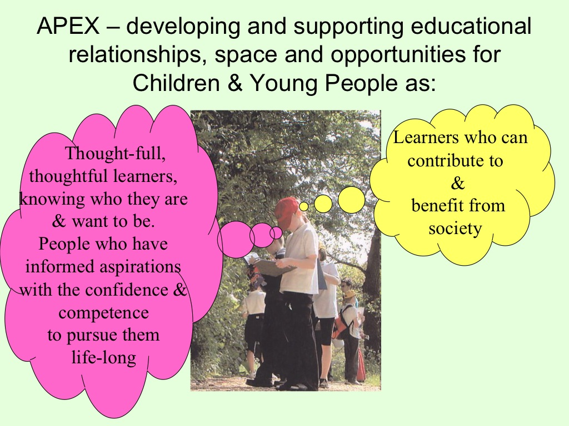
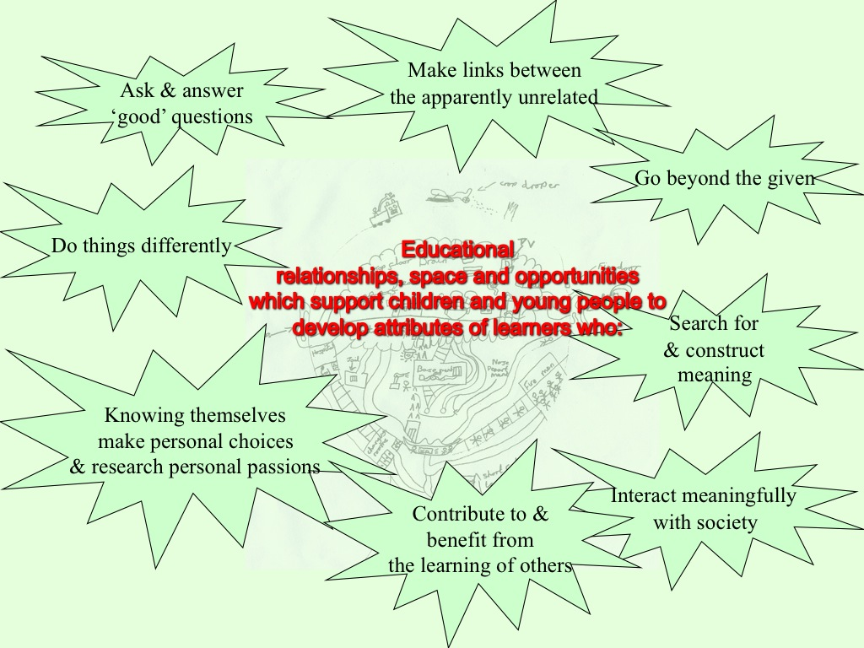
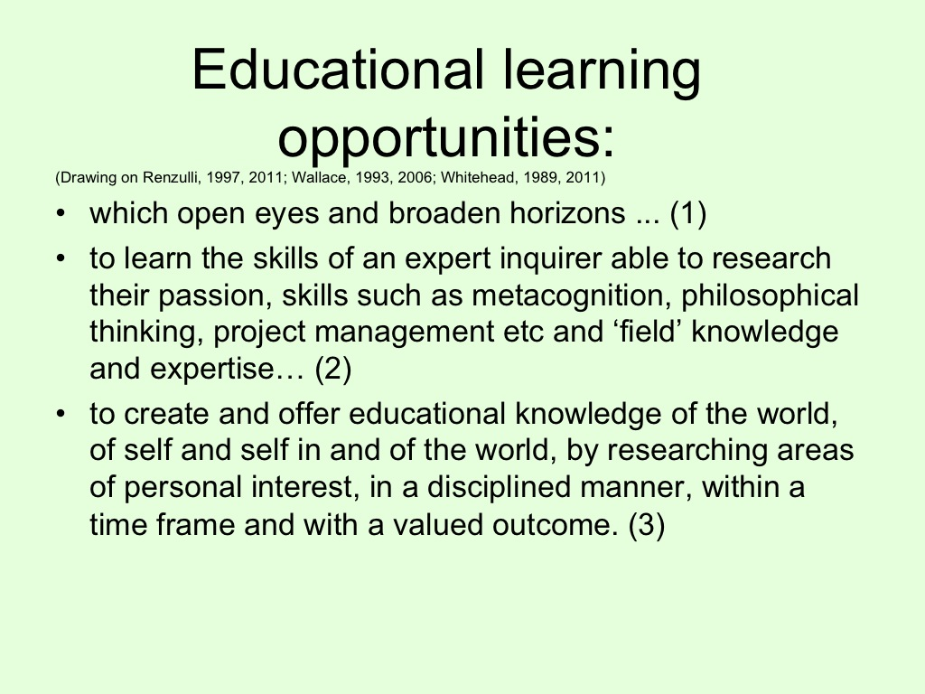
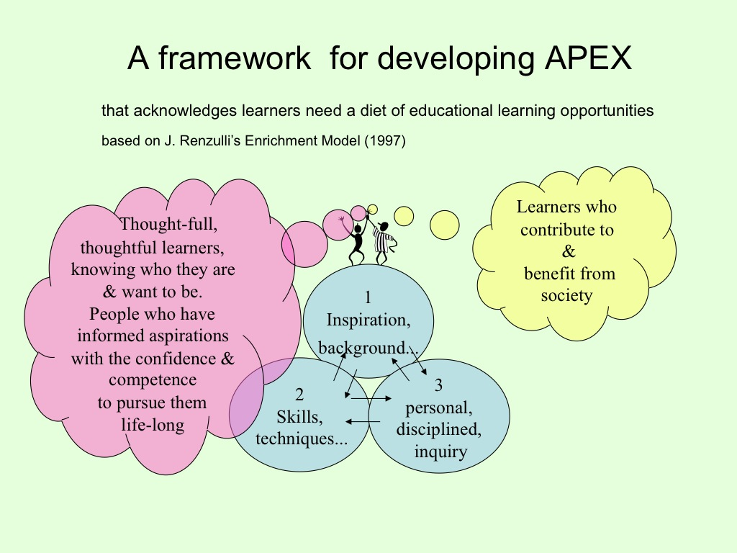
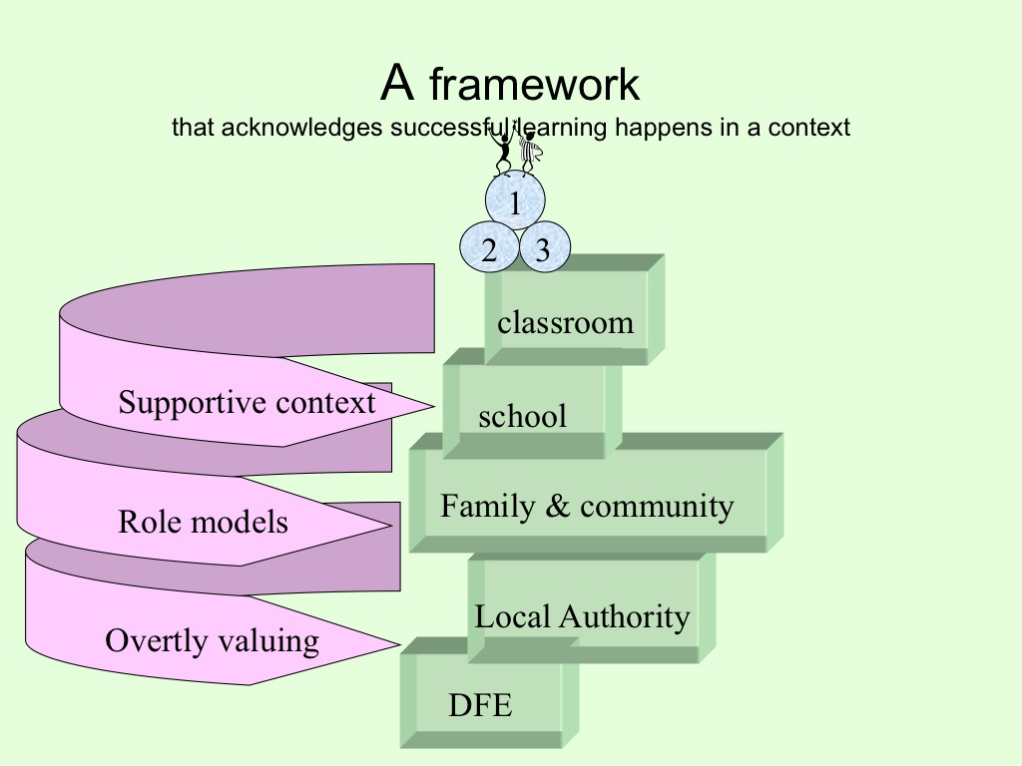
I go into more detail in Chapter 4 (pages 119-154) where I describe the evolution of my living-theory praxis and Chapter 5 (pages 155-190) where I introduce the development of inclusive gifted and talented education from an educational perspective. Here I want to bring the strands of the normative background of my research, the evolution of my thinking and the development of my practice, together with a refocus through the video I invited you to engage with at the beginning http://tinyurl.com/3qz6sls

1.1.1.4 What is important to me
As you engaged with that video I hope you had some sense of my values as an educational professional. I have worked in public (state) education all my working life, first as a teacher and then as an educational psychologist. I am committed to inclusive, emancipating and egalitarian public (state) education and to developing educational policy, provision, practice and theory to benefit all. I believe that education is more than schooling. I understand schooling to be concerned with the efficient transmission of knowledge, skills and understandings. I see the roles and responsibilities of an educational professional requiring more than the skills of an instructor or trainer and someone who maintains the status quo. Education, I believe, is concerned with enhancing the ability of each person to develop, offer, and thoughtfully value, talents and knowledge of the world, themselves, and themselves in and of the world as gifts that contribute to the flourishing of humanity. I like the way Umberto Maturana communicates something of these sentiments in ‘A Student’s Prayer’ (translated and abbreviated from El Sentido de lo Humano. Dolmen Ediciones, Santiago de Chile, 1994 by Marcial F. Losada in a commentary in Maturana and Bunnell, 1999, p.61). In bringing in Maturana’s poem I intend to show that the values that are at the heart of my desire to improve educational practice are not limited by nationality or discipline. Maturana is a Chilean biologist and philosopher.
Don’t impose on me what you know,
I want to explore the unknown
And be the source of my own discoveries.
Let the known be my liberation, not my slavery.
The world of your truth can be my limitation;
Your wisdom my negation.
Don’t instruct me; let’s walk together.
Let my riches begin where yours ends.
Show me so that I can stand
On your shoulders.
Reveal yourself so that I can be
Something different.
You believe that every human being
Can love and create.
I understand, then, your fear
When I ask you to live according to your wisdom.
You will not know who I am
By listening to yourself.
Don’t instruct me; let me be.
Your failure is that I be identical to you.
Although Maturana’s poem is in the voice of a student, I can hear the voice of an educator with a love for each student as someone with a unique and valuable contribution to make, to their own lives and that of others, an educator who wants to express an educational responsibility towards, but not for their student, an educator who wants to enable his student to go beyond the constraints of reimagining the past to realising dreams of better things not yet begun, an educator who recognises the damage of unwittingly being a living contradiction. I can recognise a great deal of that educator in me.
Through my learning adventures and journeys I have progressed from practice focussed on perceiving weakness and creating remediating programmes, to that of a senior educational psychologist with responsibility for leading and coordinating the development of inclusive gifted and talented theory, practice, provision and policy from an educational perspective, in a local authority, with the ambition of enhancing the educational experience of all children and young people.
I continue to believe each person is unique and has a responsibility to contribute to improving their own well-being and well-becoming and that of others. I also continue to give primacy to my educational responsibility, which is to enhance the experiences of children and young persons that enable them to improve their ability to bring themselves into their own presence to enhance their own well-being and well-becoming and that of others.
Through this research programme I want to create, offer and recognise an educational gift of value. Fukuyama (1992) an American political scientist and economist, acknowledges a truth psychologists identify:
‘Human beings seek recognition of their own worth, or of the people, things, or principles that they invest with worth.’ (p. xvii)
He makes me aware that despite my hope to offer knowledge freely as a gift I am aware of living a contradiction in feeling a desire for recognition of my efforts. I know that in offering a gift of the knowledge I have created I can be accused of arrogance and self-aggrandisement by others and myself. I believe such accusations to be ill- founded and am prepared to deal with the emotional turmoil caused in reconciling the recognition of myself as significant and insignificant simultaneously. From a different field Kagan (1998), a Talmudic scholar, says:
‘Our inner connection to an infinity which reaches beyond our individuality is not an incidental attribute or an icon of a particular culture. This connection defines our humanity: it is the only characteristic which distinguishes us… To lose this inner connection is to lose our humanity. It is no accident that as we forget that which makes us human, we come to view ourselves as intelligent animals or machines. …
This transcendent connection is an objective expression of our humanity. Viewing ourselves like animals or machines is not an alternative vision of man; it is his destruction…If we cannot be what we think we are, our existence is devoid of true substance, for we have no basis in reality and no place in the order of being’’ (pp.19-20)
These two couple of paragraphs foreground the source of many of the tensions I experience in being what I think I am: the contradiction between expressing and connecting with a sense of humanity in everything I do, and the dehumanising nature of much of what I am expected to comply with. I also like the way Kagan expresses a notion of infinity. I feel he describes the sense I have of connection with other people, who do not necessarily live in my own time and place, and feeling myself as meaningful in the boundary between my self and other people who share a desire to contribute to a flourishing humanity.
A sense of my self as distinct and unique, but also at one with others in ‘an infinity which reaches beyond’, is important to me. It is the essence of what I want to communicate by ontological values of a loving recognition, respectful connectedness and educational responsibility and inclusive, emancipating and egalitarian social values. The clarification and expression of these values is at the core of the research narrated in this thesis. The conundrum of how to hold ‘i’ and ‘we’ together in an ‘i~we’ relationship (Huxtable and Whitehead, 2006) that flows with these values is expressed for me in the words of Hillel, which have stayed with me since I first read them as a child:
‘If I am not for myself, then who will be for me? And if I am only for myself, then what am I? And if not now, when?’ (Ethics of the Fathers, Pirkei Avot, 1:14)
I am using ‘i’ and ‘we’ to point to self and collective that is neither subordinate nor superordinate, but exist in an egalitarian relationship. It is a similar sense I make of Ubuntu that Nelson Mandela expresses in this brief (1.37) video clip. ‘Respect, helpfulness, sharing, community, caring, trust, unselfishness’, come up on the screen followed by, ‘One word can mean so much.’ At 0.19 Tim Modise introduces the interview with, ‘Many people consider you as a personification of Ubuntu. What do you understand Ubuntu to be?’ It is not just reading the few words that Mandela speaks that I understand Ubuntu but it is through the intonation of his voice, his body and his way of being that communicates Ubuntu personified in these few seconds of video.

Video 2 Nelson Mandela on Ubuntu http://www.youtube.com/watch?v=ODQ4WiDsEBQ

I clarify further this sense of an ‘i~we’ relationship, for instance, in Chapter 2 on page 53 and 54 where I begin to clarify the nature of living-boundaries, and Chapter 6 on page 197 where I illustrate how I make creative use of multimedia narrative to communicate values researched in living-boundaries . A fuller understanding of the complex ecologies (Lee and Rochon, 2009) of my contexts will emerge as this narrative progresses but I wish to leave this for the time being and begin to develop a shared language with you.

1.1.2 Language
‘"When I use a word," Humpty Dumpty said in rather a scornful tone, "It means just what I choose it to mean - neither more or less."’ (Through the Looking-Glass, and What Alice Found There, Lewis Carroll, 1871); I wish he were right. In my experience meanings are slippery and can transmute unnoticed if a shared understanding is taken for granted. Although English has an enormous vocabulary it is still far from precise, with many individual words and phrases carrying a variety of nuanced meanings. This can be a source of considerable misunderstanding as Ginott (1972), an Israeli schoolteacher, child psychologist and psychotherapist, illustrates vividly:
‘On the first day of the new school year, all the teachers in one private school received the following note from their principal:
Dear Teacher,
I am a survivor of a concentration camp. My eyes saw what no man should witness:
- Gas chambers built by learned engineers.
- Children poisoned by educated physicians.
- Infants killed by trained nurses.
- Women and babies shot and burned by high school and college graduates.
So, I am suspicious of education. My request is: help your students become human. Your efforts must never produce learned monsters, skilled psychopaths, educated Eichmanns. Reading, writing and arithmetic are important only if they serve to make our children more human.’ (p.317)
Ginott shows the importance of developing shared meanings of education that reflect values rather than just a superficial lexicon. Biesta (2006), a philosopher in education coming from the continental tradition, alludes to something similar when he writes, ‘Something has been lost in the shift from the language of education to the language of learning’ (p.14) and argues that we need to develop an educational language. I understand an educational language to be one that helps those concerned with improving education to keep connection between ‘learning’ and values that contribute to the flourishing of humanity. So I will begin here the process of clarifying some of the key educational language I use throughout the rest of this thesis. In the process of identifying and clarifying some of the key words and phrases I will also begin to paint the theoretical and practical backdrop of the thesis.
What follows are a few of the words and phrases I use commonly and which are open to various interpretations other than those I am giving them. I want to stress this is a beginning and a fuller meaning will, I hope, emerge through the multimedia narrative where meanings are created ostensively, and through an iterative process. As this is a Living-Educational-Theory thesis I had best begin with what I mean by my living-educational-theory (or living-theory). Whitehead originated Living-Educational-Theory so I want to offer you his words to clarify my meanings initially:
‘I use the idea of living theories (Whitehead, 1989) to distinguish the explanations of action researchers from the general explanations in propositional theories that dominate the refereed international journals. I am thinking particularly of living theories that are constituted by the unique explanations of action researchers of their educational influences in learning. In propositional theories, explanations for the actions and learnings of individuals are derived from conceptual abstractions of relations between propositions. In living theories individuals generate their own explanations of their educational influences in their own learning. The explanatory principles in living-theory explanations are energy-flowing values embodied and expressed in practice.’ (Whitehead, 2009a, pp.85-86)
In my own writings I now use capitals to distinguish Living-Educational-Theory research from an individual’s living-educational-theory. To summarise, I understand Living-Theory research to be concerned with a continual process of the researcher evolving their understanding and offering values-based explanations (the why) of their educational influence as they work to improve their values-based practice. I understand my living-theory as my values-based explanation of why I have sought to bring about change and the nature of the change I am trying to make. My living-theory account includes narratives and explanations of what I have done to enhance the educational influence I have in my learning, the learning of others and social formations, in the process of living my values as fully as I can through my practice. Whitehead and McNiff (2006) elaborate on their use of the word ‘living’:
‘These theories are living in the sense that they are our theories of practice, generated from within our living practices, our present best thinking that incorporates yesterday into today, and which holds tomorrow already within itself.’ (p.3)
They point to a process through which theory is continually evolving with past, present and future existing in a dynamic relationship. As I research my practice to improve it and create a living-theory account, I clarify and develop my ontological and societal values as explanatory principles and living standards of judgment. I understand ontological values to be what it is that gives meaning and purpose to my life. I clarify my ontological and societal values in Chapter 3 (pages 86-118). When I refer to values as living standards of judgment I do so following Laidlaw (1996). I understand my standards of judgment to be ‘living’ in the sense they are evolving and are in a dynamic and reciprocal inter-relationship with my values and the practice through which they emerge. Rather than being seen as a reflection of poor research-design they are recognized here as an inherent and valid feature of Living-Theory research.
This thesis is an educational narrative. By educational narrative I mean a story that offers descriptions with explanations created of a learning journey, which in their creation and offering enhance the learning of the teller and their audience/s. The words ‘narrative’ and ‘story’ are sometimes used interchangeably. I am characterising a narrative as a story with a plot, or a story-line, that takes the reader or listener to an identifiable conclusion, climax or point that the narrator is intending to communicate. I go into more detail about the use of multimedia narratives in researching the meanings of values in living-boundaries in Chapter 6 (pages 191-221).
Educational narratives are generative and transformational. By ‘generative’ I want to communicate a sense of research narratives that carry energy that generates hopeful, productive and life-affirming and life-enhancing activity. By ‘transformational’ I want to communicate forms of storying that evolve new thinking and practice that does not replicate the past but enables us to transcend it.
As an educational psychologist I spent years wondering how to evaluate my work. I was familiar with the approaches built on notions of ‘cause and effect’, which have contributed to the development of such concepts as ‘impact indicators’, and ‘value added’. Yet I was, and am, aware that life is much more complicated and subtle than that, and I do not believe I can ascribe to myself the power that such approaches require. I find Whitehead’s (1989a) notion of ‘educational influence’ far more nuanced and this has enabled me to look at my work in a different way. Like Whitehead, for me to feel I have had an educational influence in the learning of another I need evidence that what I have offered has been transmuted by them to contribute to their progress to giving expression to their best intent, which is informed by their values: I do not believe I have had an educational influence if what I offer is unthinkingly replicated.
For me to feel I have had an educational influence in the learning of a social formation I need to see some evidence that I have contributed to developing a context where humanity can flourish. By educational influence I also mean the contribution I make to learning in the direction of my values with the ‘best intent’ of the other/s in sharp focus. I am using the notion of intent quite specifically and giving it my own meaning. By ‘best intent’ I mean the values-based hope that is the fuel of living a loving, satisfying, productive, worthwhile life, which makes this a better world for us all. That is not the same as what is in a person’s ‘best interest’, which is to do with what might be best for the individual/s and may or may not include consideration for anyone else. It can be challenging to support the other to realise their best intent when it is not in their best interest. Lifton (1988) gives an account of Korczak, a Polish-Jewish children’s author and paediatrician who, during the second world war, chose to accompany the children in his care to Treblinka against the advice of his friends. His actions were an expression of his best intent but as that led to certain death they were by no means in his best interest.
My practice is concerned with the development of opportunities for educational experiences. Educational experiences are those that enhance the possibilities of the learner coming into their own presence; to know the person they are and want to be and contribute to them developing their educational influence in learning and life.
I understand an educational knowledge-base to be that which educators draw on and contribute to, to improve the quality of education as a values-based process and experience. Whitehead (2010a) and Pring (2000) make further distinctions between educational knowledge and the knowledge of education created in the disciplines, which I elaborate on in Chapter 2 (pages 51-85). However the prime distinction that has been useful to me is educational knowledge being distinguished by reference to the researcher, and/or practitioner’s, ontological and societal values and educational intent.
In describing my research as educational I also intend to communicate that I am researching to improve inclusive and inclusional practice. By ‘inclusive’ I mean contexts where each person develops, and values, themselves and other people and the unique and valuable contribution we can each make to evolve a humane world where humanity can flourish. By inclusional I follow Rayner (2005) and mean a dynamic awareness and integration, of receptive, responsive and co-creational space and boundaries, which comprise my complex ecology of being. The following well-known video clip by Alan Rayner, known as ‘the paper dance’, begins to communicate something of what I mean by ‘inclusional’. Having seen the reaction of many teachers, unfamiliar with Rayner’s work and with academia, to this video clip I know that it communicates the notion of inclusionality that has influenced me far more eloquently than many pages of text. Hence I include it here, not simply as reference but to develop an understanding of inclusionality ostensively.
Video 3 Alan Rayner’s paper dance introducing inclusionality 5minutes 9seconds

http://tinyurl.com/42svmwb
A notion of pedagogy is necessarily part of my journey as the word is widely used in English education circles. Zembylas (2007), from Cyprus, expresses a meaning of pedagogy:
‘…broadly speaking, pedagogy may be defined as the relational encounter among individuals through which many possibilities for growth are created’ (p.332)
Unlike some definitions, this makes reference to pedagogy being concerned with real persons and the educational relationship and space between them. An idea of an inclusional pedagogy that Adler-Collins (2007), from within an English, Japanese and Buddhist context, describes, drawing on Farren (2005) extends my notion of pedagogy further. Adler-Collins describes a space for informed listening, which acknowledges the differences of the other as a celebration of diversity and boundaries as permeable and dynamic:
‘My teaching space, as a space, needs to be both bounded and open, bounded in the sense that it can take on the charge/energy/association of being associated with study as opposed to being unbounded as in social activities, and open in the sense that students can develop a feeling of ownership and of belonging in the space.’ (Adler-Collins, 2007, p.282)
Adler-Collins expresses the tension educators experience in holding together the demands of employer, community and others, to ‘deliver’ a given curriculum, and responding to the living curriculum of each learner as a person with whom they have an educational relationship. I intend through my praxis to contribute to learners evolving and following their living curricula, characterised by flows of life-affirming and life-enhancing energy, in educational relationships space and opportunities that are inclusive, emancipating and egalitarian. I am making a distinction between life-affirming and life-enhancing; the former affirming what is and the latter contributing to the development of what might be.
Flows of energy are difficult to communicate in words alone, so I invite you to look at this short video of part of an ‘Improving Practice Conversation Café’. These were weekly sessions at the local council offices where staff from Children’s Services and Jack Whitehead (currently Professor, Liverpool Hope University and Visiting Fellow, University of Bath) met to share, over coffee and croissants, what is giving us each ‘a buzz’ or ‘challenge’ and help each other to research and improve practice. At this particular session Chris Jones (then Senior Inclusion Officer) has brought her Masters dissertation and is asking us (myself, Jack Whitehead and Kate Kemp, then Pupil Support Manager) to act as a validation group for her. This clip shows the first 10 minutes of an hour-long session. If you run the cursor back and forth I hope you can sense something of the flow of energy (Huxtable, 2009b). While I enjoy the full clip, the point I am trying to make about energy I believe can be understood within the first few moments (23 seconds into the clip) where Chris is asking ‘…is what I’m writing, is it rubbish?’ and her laughter is shared by the group.
Video 4 Sharing a sense of flow of life-affirming and life-enhancing energy

http://tinyurl.com/3kxadvt
I use well-being and well-becoming to communicate the importance of a quality of life that education contributes to and I hope you get a sense of both in the video clip you have just watched. Bonila (2008), in the context of researching a Brazilian community programme, provides a definition of well-being:
‘Well-being is a state of being with others, where human needs are met, where one can act meaningfully to pursue one’s goals, and where one enjoys a satisfactory quality of life.’(.p.10)
This resonates with me. Sometimes that state may not be experienced in the present, but I work with anticipation and hope, of feelings of well-being in the future, hence my use of the notion of well-becoming.
This thesis is created and offered as an educational gift to those dedicated, insightful and loving educators who work continually to develop and offer their talents, expertise and knowledge as educational gifts of inestimable value, but who, with unwarranted humility, often sink into the shadows. I say this is a gift, as I am creating and offering it freely, with the hope, but not the expectation, that it will prove to be of some value to others as well as to myself. In saying, ‘hope, but not expectation’ I am trying to make clear that a gift does not place an implied obligation on others to accept or make use of it, although that is why I have created and offered it.

1.1.3 Evaluative criteria
How do I know whether I am making the difference I want to make? In clarifying my evaluative criteria as well as my language, I clarify what is important to me; this influences, often subliminally, what I do. Evaluation and practice exist in a dynamic relationship, the one influencing the evolution of the other. So, having begun to clarify my language I now want to begin to clarify my evaluative criteria.
Through researching my practice I have understood that I am seeking to generate and enhance inclusive, emancipating and egalitarian educational relationships, space and opportunities, that provide support and experiences for children and young people to engage in learning journeys and learning adventures that help them:
- Develop dreams, passion for creating life-affirming and life-enhancing knowledge, and the openness to venture to new cognitive, intellectual, social, personal, physical and emotional places in their learning and which inform their evolving aspirations and vocations
- Explore a variety of possibilities of earning a living they might find satisfying, productive and worthwhile if they devoted time and energy to them as an adult
- Develop confidence and competences to pursue their evolving aspirations through enquiring and creating talents, expertise and knowledge as gifts in areas of personal passion and interest
- Experience educational relationships where they, the gifts they create, and their contributions to their own learning, the learning of others and to their communities are valued
- Learn to extend themselves a loving recognition, develop respectful connectedness with diverse persons, and give expression to an educational responsibility for themselves and towards others and social formations
- Explore and evolve understandings of what for them would make their life feel loving, satisfying, productive and worthwhile, and to create knowledge of themselves in and of the world.
In short, to support learners as inclusive, emancipated and egalitarian experts in their own learning and life, developing and offering talents, expertise and knowledge as gifts, which enhance their own well-being and well-becoming, and that of others. I recognise myself as learner with an educational responsibility and give expression to this belief in the creation of this thesis.
I create and offer this thesis as an educational gift in the hope that others may find it of some value on their own learning journeys and adventures, even if it does no more than provoke someone to say, ‘Well, I can do better than that!’ – whatever they mean by ‘that’, and they get on with creating, offering and being open to their own and other people’s life-affirming and life-enhancing gifts. I do this in the belief that such gifts offered freely and communicated widely, will help improve the quality of educational space, relationships and opportunities and contribute to the flourishing of humanity. How do I know where I am being successful or failing so I might improve?
McNiff (2007) talks about a good story told well and powerfully. I understand a good story to be one that offers a valid account of educational influences in learning and is generative and transformational. The focus of a good story is on descriptions and explanations of what is being done by the teller in the process of improving their contribution to the evolution of the world as a better place to be. Laidlaw (2006)), in her inaugural professorial lecture at Ninxia University, China, describes a good story as one that contributes to the social good. Many social science research stories of practice are concerned with accounting for the past and are intended to offer justification, vindication or an understanding of what has happened. Like Laidlaw, a good story for me is one that can help give life to a better future as it is created in the present. In other words, a good story is educational.
I believe I have a good story to tell, one that explains why I do what I do and the progress I am making in terms of my ontological and social values as my living standards of judgment, which are emerging through researching my practice. I believe it to be a reasoned and reasonable story through which I can show the development of my own learning and the educational influence I have had in my own life and the lives of others.
I understand a story told well, to be an educational narrative that has a benevolent influence and communicates the knowledge the traveller has created, in a way that other persons can comprehend, not just with their minds but also emotionally and viscerally. I see living-theory accounts as good stories told well. Whitehead clarifies the criteria I hold in mind to test my story as my living-educational-theory:
‘The primary distinguishing feature of a living educational theory is that it is an individual’s explanation for their educational influence in their own learning and/or in the learning of others and/or in the learning of social formations.
This idea of living educational theory differs from traditional forms of education(al) theory in that traditional theory consists of sets of abstract conceptual relationships. The explanations of educational influences in learning of individuals are derived from the general abstract propositional relations and applied to particular cases that are subsumed by the theory. In living theories each individual is a knowledge-creator who is generating their own explanations for their educational influences in learning. These explanations, for doctorates, always include insights from the traditional propositional theories.
In meeting criteria of originality of mind and critical judgement at doctoral standard, a living theory must communicate the explanation of educational influence in learning in terms of the unique constellation of ontological values that the individual uses to give meaning and purpose to their life.
In using action reflection cycles, in the generation of living educational theories, the individual clarifies the meanings of their ontological values in the course of their emergence in practice. As these embodied values are expressed and clarified in the course of their emergence in practice they are formed, in the act of communication, into the living epistemological standards of judgment that provide the thesis with its critical standards of judgment.
In terms of research at the forefront of the field in the generation of living educational theories this is focusing on the living logics of inclusionality and inclusional and responsive living standards of judgment for explanations of educational influences in learning…’ (Whitehead posting on the BERA jiscmail practitioner-researcher e-seminar, 16 Feb 2007)
To feel convinced that I have told my story well I need to evidence that I have enabled others to understand my living-educational-theory. I also need to know that my story contributes something of use to the thinking and practice of others working to improve educational relationships, space and opportunities. I do not mean that others have to do as I do, or come to the same conclusions as me. I will have failed dismally if I inadvertently persuade someone to thoughtlessly accept or do anything. It is an educational influence I wish to have through communicating my account; it might be that it stimulates an imagined possibility, or provokes a productive debate or someone explores avenues that they might otherwise have ignored. As a living-theory thesis I particularly need evidence that my account offers a well-reasoned and reasonable explanation of my practice and makes an original and significant contribution to educational knowledge.
I want to tell my story powerfully. However, that would require I tell it in such a way and in such places that it might have an educational influence in the learning of the powerful, such as policy makers. Here I will focus on telling my good story well and ‘speak truth to power’ (attributed to Milton Mayer who created the title to the American Friends Service Committee pamphlet published 1954).
In the process of creating a communicable educational narrative, I have sought to improve my contribution to the well-being and well-becoming of individuals and collectives. I offer this narrative as a gift of educational knowledge, with the intention of enhancing the generative and transforming narratives other people are creating to improve their own possibilities of living loving, satisfying, productive and worthwhile lives. This I believe makes it a story worth telling.
Working with the criteria I have outlined above, the idea of social validity by Habermas (1976, pp 2-3), and my concern to keep the generation of educational knowledge that is validated and legitimated through the Academy connected with educational practice, I ask that this thesis be judged as a good story told well by these criteria:
- Do I present here educational research at the leading edge of the field; provide evidence of originality of mind and critical judgement, and material that is worthy of publication?
- Is my story understandable? Do you know what I have done, why I have done what I have done and how I hold myself to account?
- Is my story believable? Do I provide enough evidence to support my claims to know my practice and that I do seek to live as fully as I can the values that give meaning and purpose to my life?
- Are my educational values and the normative contexts of my work clear?
- Do I offer a well-reasoned and reasonable explanation of why I do what I do?
- In reading this account, has your imagination been stimulated and have those thoughts contributed anything to your educational journey as you seek to improve your educational contexts and relationships?
To submit my story to examination as a doctoral thesis and to defend it at a viva with academics who are educational researchers is, for me, a stringent test of how good my story is and how well I tell it. But as they and others sit in judgment I ask the same as Hymer (2007), who included this quotation in the abstract to his doctoral thesis:
‘Finally, I ask that if this account is judged to be unconvincing, it will have been judged so “on criteria that I avow, not on criteria that I disown.” (Quinn, 1997, pp.4-5)’ (p.5)

1.2 Contributions to educational knowledge and structure of the thesis
Having sketched the contexts, language and evaluative criteria of the thesis, I will conclude this introductory chapter by summarising the key points I will be making and highlight the originality and significance of the knowledge I am claiming to have created. I have created chapters and sections to help you find your way through. However, this should not be taken to imply that the events and activities described are discrete occurrences or that they can be understood without the integration of my developing learning and thinking. A similar issue was tackled in a book I wrote with Barry Hymer and Jack Whitehead (Hymer, Whitehead and Huxtable, 2009):
‘The role of the educator in respect to living theory and inclusional pedagogy could be thought of as having various foci which are held together in a creative tension. We have used the metaphor of a challah before (Hymer, 2007) which might serve us here. A challah is a type of plaited bread; each strand is recognisable as distinct but not discrete and the baking brings the strands together into a new dynamic relationship with each other and within the whole. For this metaphor to be useful we need to have some shared experiences of a challah. So it is with trying to describe and explain our understanding of the role of the educator; we need to begin by establishing some shared experiences with you of teachers in the role of meaning-makers, as an inclusional pedagogist, as an educator working with a living theory approach to gifted and talented education.’ (pp. 123-124)
The living-boundaries formed within and between the chapters and sections offer creative space for ‘cooking’. ‘Cooking’ not in the sense of fixing and solidifying but used in the slang sense of ‘now we’re cooking!’ when creative connective energy is flowing and something new is emerging that is exciting and carries hope of being worthwhile.
I ask you to keep this metaphor in mind and that I employ an ostensive and iterative process to develop understandings. What you find in the following chapters and sections is not intended as discrete inorganic information to be dissected. I ask you to engage imaginatively and empathetically as well as analytically with the representations of the activities, learning and thinking of what constitute my living-theory praxis. I ask you to notice and enter the living-boundaries between the words, the ideas, the sections, the chapters, as a creative space to form relationally dynamic connections between them, flowing with the energy of your own life-affirming and life-enhancing values, as well as mine.
With that in mind I give a structure here that provides one sign-posted pathway to explore the thesis. I have devised it particularly to clarify the contribution I am claiming my thesis makes to educational knowledge within the academy. This is just one pathway of many I have created in the narration of my learning, and the various iterations of the thesis have been incorporated into papers and presentations. For those who may be interested to view a chronological pathway through the evolution of my thinking and practice I list those papers and presentations in an appendix (appendix 1). I have been asked by my examiners to also provide a pathway through the thesis linked closely to ‘improving practice’. To this end I provide a summary below of the contribution each Chapter makes to the thesis and my claim to be making an original and significant contribution to knowledge. I link the page numbers of related themes to facilitate cross-referencing with my focus on improving practice. I also point to the narratives of improving practice for those practitioners who may be interested in exploring thoughts that might have implications for their own endeavours to improve their practice.

1.2.1 Living-Educational-Theory praxis (Chapter 2)
In this chapter I develop the notion of Living-Educational-Theory (or Living-Theory) praxis, which integrates understanding of living-boundaries, praxis, and Living-Educational-Theory to enable me to improve what I am doing that contributes to making this a better world to be. I clarify the nature of living-boundaries as a co-creative ~ space which I have referred to in an i~we relationship. I elaborate further with examples of living-boundaries created between, for instance, educator and learner, and the worlds of the Academy and school. I show where I believe Living-Theory praxis provides a meaningful approach for me researching to develop my work as a professional educator. I use ‘i’ to indicate a self that is not impositional, egotistical, subordinate or dominant with relation to ‘we’.
In this chapter I locate my practice as an educational psychologist in a living-boundary between the worlds of the academic psychologist and the educational practitioner employed within the state education system. I illustrate the development in my thinking and practice as an educational psychologist from when I began working for a school psychology service, concerned with devising programmes to remediate problems referred, to coming to an understanding about what was educational about my practice (pages 58-63). I clarify the impact traditional forms of social science research had on my practice, my growing awareness of the ethical and philosophical concerns this raised in relation to my practice and understanding Living-Theory research (pages 72-78) as a way of resolving the contradictions I experienced.
The narrative in this chapter illustrates how the notion I have developed of Living-Theory praxis enables me as a professional educational practitioner to hold improving practice and theory together with a moral intent and enables me to hold myself to account to ethical standards that improve educational practice.

1.2.2 Clarification of my ontological and social values in living-boundaries (Chapter 3)
Having outlined an argument concerning the notion of Living-Theory praxis as a significant and original contribution to educational knowledge I move to communicate the values that are core to the thesis and my work. I clarify through image, text and multimedia narratives what I mean by ontological values of a loving recognition, respectful connectedness and educational responsibility and inclusive, emancipating and egalitarian social values.
As I clarify my values in this chapter I offer you an insight into some of the relationships, space and opportunities that constitute my improving practice. The images, videos and texts have been collected and made public with ethical permissions (consistent with BERA, BPS and local authority guidance) of those featured. For instance, the APEX Saturday workshop programme is brought to life through figure 8 (page 87) and the accompanying text. I show how it is possible to create a visual narrative that conforms to the various ethical guidelines where the child is anonymous (page 88).
I introduce material I drafted for a book for teachers I co-authored with two educators who have engaged with me through APEX, to provide a narrative of improving practice (pages 93-101). This was intended to communicate influentially to an audience of practitioners. I explained on page 35 the meanings in this thesis are created with you ostensively and through an iterative process. I remind you of this on page 92 as I introduce the text-based narrative.
I keep the connection of the thesis as a doctoral submission and the narrative thread of improving practice in the section on multimedia narratives beginning on page 101. As multimedia narratives to communicate energy-flowing values are not common I give three narratives. In the third, where I show myself communicating my embodied values, I give the story behind the narrative (pages 107-111). As a Living-Theory researcher I expect to show the progress of my praxis through action-reflection cycles and provide evidence of the authenticity of my improving practice (Habermas, 1976).
The narrative where I ostensively and iteratively communicate my values of an inclusive, emancipating and egalitarian society introduces you again to the members of the Improving Practice Conversation Café (pages 113-117). This is an important aspect of my practice, developing APEX, by contributing to the development of a supportive culture through co-learning with local authority staff.

1.2.3 The evolution of my living-educational-theory praxis (Chapter 4)
After introducing the notion of Living-Educational-Theory praxis and communicating my ontological and social values I bring the two together to describe and explain my living-theory praxis through its evolution in living-boundaries. I particularly attend to clarifying the living-boundaries within which I work that provide possibilities for educators and learners to co-create and offer as gifts; talents, expertise, and knowledge of the world, knowledge of themselves and knowledge of themselves in and of the world.
I provide a diagrammatic (figure 14, page 123) overview of the framework I developed to help me keep a connection between activity and improving practice. I then use key questions that emerged during the research to provide a narrative path of improving practice through the cycles of action-reflection and the process of evolving my living-theory praxis. As the narrative progresses I describe and explain for instance, the programme of Saturday workshops (pages 127-129), collaborative, creative enquiries and passion-led learning opportunities (pages 129-141), and the Masters programme (page 132-140). Through image and video I give you a window into the local worlds of practice and the educational influence my improving practice has had in the learning of children and young people that text alone could not communicate. This extends the ostensive, iterative clarification of my values begun in Chapter 2 (pages 51-85) and the development of forms of monitoring and evaluation, which are ethical, generative and transformational, a subject I revisit in Chapter 6 (pages 191-221).

1.2.4 The development of inclusive gifted and talented education from an educational perspective. (Chapter 5)
In researching to improve my contribution to the quality of the educational experience of each learner and to the realisation of the vision of my employers, I have developed a notion of inclusive gifted and talented education developed from an educational perspective. In this chapter I offer an argument for what I believe is an original and significant contribution to the field of gifted and talented education arising through the evolution of my living-theory praxis.
In this chapter the narration of improving practice is organised through the nature of the relationships, space and opportunities that constitute my practice rather than through a chronology of questions and action-reflection cycles of my evolving living-theory praxis, which was the subject of Chapter 4 (pages 119- 154). As I describe the activities that constitute my practice I give explanations of how they have contributed to the development of inclusive gifted and talented relationships, space, opportunities and a supportive culture from an educational perspective. The explanations are still values-based contextualised by the field of gifted and talented education, the impositions and possibilities offered by the Government’s National Gifted and Talented Strategy and the Local Authority policy on high ability learning.

1.2.5 A creative use of multimedia narratives in researching the meanings of values in living-boundaries and developing generative and transformational forms of educational evaluation and accountability (Chapter 6)
I have so far taken as a given, that in creating data as evidence that communicates meanings of energy-flowing values, I enhance my educational influence in my own learning, the learning of others and of social formations. In this chapter I offer an argument to support this assertion. I show and explain the creative use I have made of multimedia narrative to clarify, understand, evaluate, account for and communicate the meanings of my values as they emerge in my enquiry within living-boundaries. I show the contribution multimedia narratives make to the generative and transformational influence of Living-Theory praxis.
In this chapter I connect the narrative thread of my practice concerned with regional and national relationships and with those locally (pages 193-208) to illustrate the creative use I have made of multimedia narrative to improve practice and develop generative and transformational forms of evaluating and accounting for what I do.

1.2.6 Living-Theory TASC: A relationally-dynamic and multidimensional approach to research and developing praxis (Chapter 7)
As I have evolved my living-theory praxis, I have developed my understanding of the research approach I have employed. This approach I call Living-Theory TASC. I offer, what I believe, to be a reasonable and reasoned description and explanation of how this approach enables me to hold the systematic and organic nature of my educational research together coherently. This takes me back to the limitations of many approaches to educational research I introduce in Chapter 2 and offers a response that I hope will be of use to others seeking to contribute to improving the educational experience of themselves and other learners.
In this Chapter I keep the narrative thread of improving practice weaving through my explanation of my contribution to knowledge beginning with the influential voice of Joy Mounter’s pupils, who have offered generative and transformational educational challenge to me and other educators. In similar vein I bring in the voices of Andrew Henon and other members of the CPD group who continue to be my test stones to improve my living-theory praxis.

1.2.7 What have I learned and what now? (Chapter 8)
To bring this particular learning journey to a conclusion I look back from where I have arrived into the grey mists of the learning adventure this journey has formed but a part of, to understand a little more of what I have learned. However, this is not an end. As I communicate to and with you and myself, I am evolving my living-theory praxis in new contexts as my pebble on the pile to help humanity flourish.

1.3 Postscript
In this first chapter I have set the scene of the multimedia narrative that constitutes my living-theory by introducing the context of the thesis and research and clarified some of the particular language used. I have also described the evaluative criteria and structure of the thesis and pointed to the narrative thread of improving practice that runs throughout. In the next chapter I detail the notion of Living-Theory praxis and the contribution it makes to educational knowledge.
Before leaving this introduction I would like to remind you of the qualities of humanity that I wish to communicate throughout this thesis such as warmth, love, and humour that carries a flow of energy, which is life-affirming and life-enhancing and should be at the core of all that is educational. There is something about humour that can evoke a healthy physical and psychological sense of well-being flowing with life-affirming energy. Bateson (1952) in his paper, ‘The Position of Humor in Human Communication’, noted:
‘One of the rather curious things about home sapiens is laughter, one of the three common convulsive behaviours of people in daily life, the others being grief and orgasm.’ (p.2)
There is a quality of humour that communicates what I have been trying to say about the contribution I want to make to educational knowledge that places it beyond individual endeavour to connect with the social, cultural and historical contexts within which I make sense of my life as worth living. This quiz, wrongly attributed to Shultz as his philosophy on numerous websites, communicates with a pleasure, a humour and humanity, which I believe educators should keep closely connected to, to keep from ‘losing the plot’. Unfortunately for reasons of copyright I was not able to include pictures of Charlie Brown and Snoopy but if your imagination does not suffice you can find many illustrated examples on the web.
You don’t have to actually answer the questions. Just read straight through, and you’ll get the point.
1. Name the five wealthiest people in the world.
2. Name the last five Heisman trophy winners.
3. Name the last five winners of Miss America.
4. Name ten people who have won the Nobel or Pulitzer Prize.
5. Name the last half dozen Academy Award winners for best actor and actress.
6. Name the last decade’s worth of World Series winners.
How did you do?
The point is, none of us remember the headliners of yesterday. These are no second-rate achievers. They are the best in their fields. But the applause dies. Awards tarnish. Achievements are forgotten. Accolades and certificates are buried with their owners.
Here’s another quiz. See how you do on this one:
1. List a few teachers who aided your journey through school.
2. Name three friends who have helped you through a difficult time.
3. Name five people who have taught you something worthwhile.
4. Think of a few people who have made you feel appreciated and special.
5. Think of five people you enjoy spending time with!
The lesson: The people who make a difference in your life are not the ones with the most credentials, the most money, or the most awards. They are the ones that care.
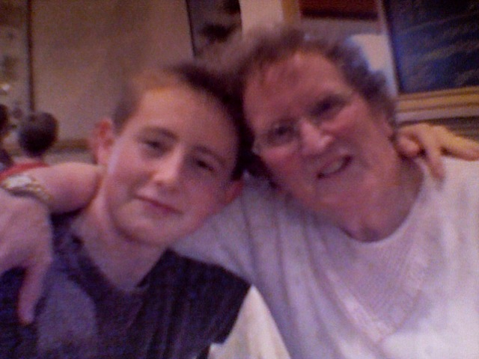
Pass this on to the people who have made a difference in your life!
I would like to keep this sense of pleasure and the connection with the description of the activities that constitute my practice with what is important in my life as I launch into the chapter on Living-Educational-Theory praxis.

Chapter 2 Living-Educational-Theory praxis
In this chapter I offer an argument for Living-Educational-Theory (Living-Theory) praxis as a particular form of praxis that evolves through educational research within living-boundaries. The difficulty I have is to communicate a relationally-dynamic and multidimensional understanding in the form of a narrative, which by its nature is linear. I ask you to keep that in mind as I clarify my meanings of Living-Theory praxis.
I begin by introducing the notion of living-boundaries. By using the term ‘living-boundary’, I emphasise the notion of space where there are expressions of energy-flowing, life-affirming and life-enhancing values, within a boundary. There are many boundaries, such as between the individual and collective, between the world of the Academy and of practice, and the conceptual worlds of the social scientist and the educational researcher. These boundaries are often conceived of as places of separation to be transgressed, dissolved, moved, removed or defended. Rather than a metaphor of boundary, I offer a metaphor of a living-boundary within which gifts of knowledge can be co-created, offered and enjoyed freely, without imposition or expectation, but with the hope of contributing to evolving a better world to be. I use ~ to indicate where a space may be transformed as a living-boundary, for instance between theory and practice, expressed as theory~practice.
This thesis can be conceived of as a boundary between us where we can meet to transfer or exchange information or knowledge: a place for give and take. However, if we move to co-create, offer and enjoy understandings as gifts of knowledge educationally within the boundary, it is transformed as a living-boundary. A living-boundary is also a living space in the sense that it changes in response to the actions and intentions of those who form it.
Keeping the notion of living-boundaries in mind I clarify the distinction between educational and education research and practice, the relationship between educational research and educational practice, and praxis as theory held together with practice and a moral intent. I am seeking to distinguish the purpose and forms of enquiry employed by social scientists and educationalists, which form their praxis, in an educationally helpful manner. An important shift in my thinking and practice has come from understanding these differences, and the possibility of enquiring within the living-boundaries they form. I offer an explanation with respect to enquiring as a Living-Theory researcher and the implications that follow from this.
Finally I clarify what I mean by Living-Theory praxis bringing together notions of Living-Educational-Theory research, praxis and living-boundaries as an original and significant contribution to the development of educational research.
Sections as signposts in this chapter
2.1 Living-boundaries
2.2 What is educational practice and research?
2.2.1 What is educational about my practice?
2.2.2 What is educational about educational research?
2.2.3 A question of ethics
2.3 Praxis
2.4 Living-Educational-Theory and living-educational-theories
2.5 Living-Educational-Theory praxis
2.6 Postscript

2.1 Living-boundaries
The notion of boundaries in psychology is common and it is this notion I am using to describe the interface between, for instance, others and myself, different worlds such as those of practitioners and academics, and different disciplines or ways of thinking. ‘Interface’ however conjures up an image of a defined surface. ‘Interface’ implies a meeting place that allows a flow of communication but it does not suggest a space where tensions might have a catalytically, co-creative and productive influence. A line is not a place of clear separation when you go into the boundary rather than being at it. I have tried to make this clearer in Figure 6. The line, appears as a place of disconnection, a clear this side or that. Look into the line, and the boundary, as a co-creative space, is distinguishable by the co-creative possibilities of black and white expressed together.

Figure 6 Moving from at a boundary to within a living- boundary
Those who enter the boundary between them to respectfully co-create, transform the boundary in the process to that of a living-boundary. I use the term ‘living-boundary’ to communicate a respectful and trustworthy space for the pooling of energy, for learning journeys or adventures to be embarked on cooperatively, collaboratively or alongside. A living-boundary is formed between people entering with a hope of co-creating new knowledge, which may have a generative and transformational influence on the persons and worlds that form the living-boundary.
The term ‘living-boundary’ suggests to me a space flowing with energy and a space for choice, which may have life- transforming implications, as expressed by Covey (2004):
‘Between stimulus and response there is a space. In that space lies our freedom and power to choose our response. In those choices lies our growth and our happiness.’ (p. 43)
I may not always be in a position to choose what I do. I, like everyone else, live and work with constraints and impositions I do not choose, but that is not to say I have to relinquish my responsibility for my response. I can choose to develop a story of blight or hope to explain what is happening to me. I can also choose to ‘gently put aside’ experiences, relationships or stories that carry blight. I take the phrase ‘gently put aside’ from Jack Whitehead in conversation. Problems and painful experiences are not ignored, denied or dismissed, but rather, ‘gently putting them aside’ to allow new possibilities to emerge. I liked the way Andrew Henon put it to me when we were talking. He explained it is not ‘pain’ that is the place of learning but where you go to as a consequence. I will return to ‘pain’ and stories that blight or offer hope and sources of tension and contradictions later, but first I want to explore more fully what the metaphor of living-boundaries can offer.
Sonia Hutchison is a member of the professional development group I support and facilitate with Jack Whitehead. Her representation (reproduced with her permission) of the pooling of energy, offers an image to represent some qualities of the space in a living-boundary.
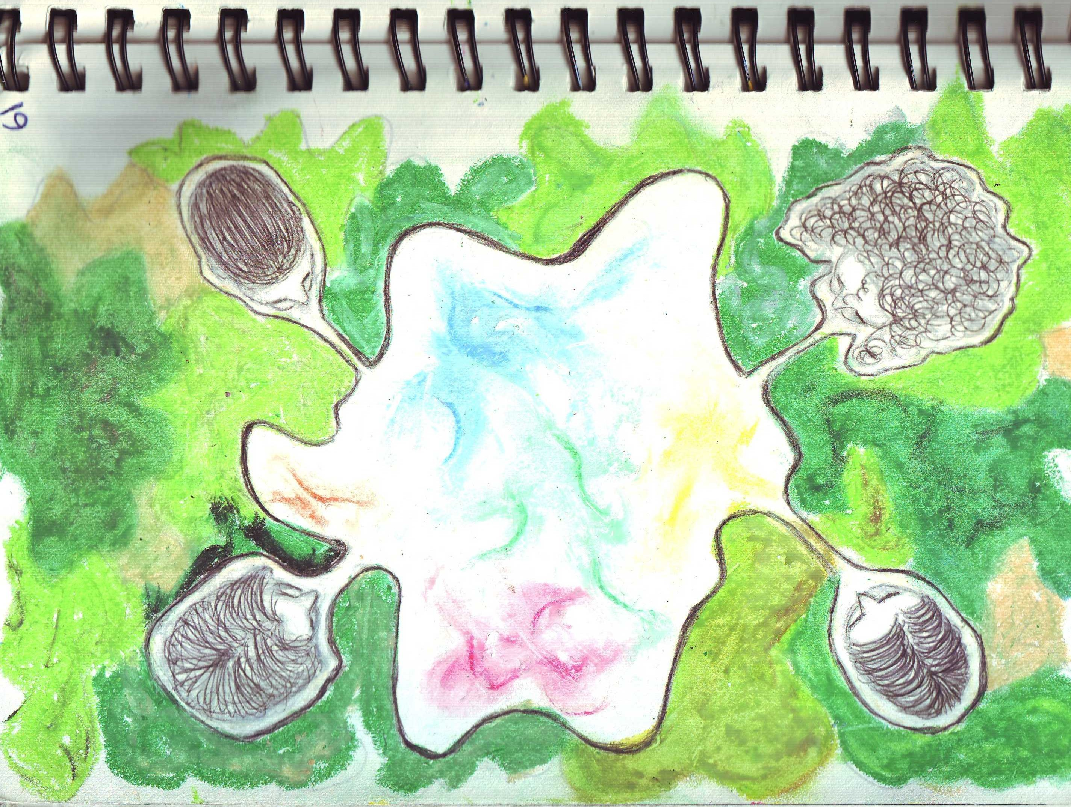
Figure 7 Sonia Hutchison’s picture of pooling energy

Her image communicates a feeling to me of a vibrant flow and pooling of life-affirming and life-enhancing energy, without expectation or imposition. It feels similar to the notion of the ~ space described as an inclusional boundary in an i~we relationship, in the first paper I created with Jack Whitehead:
In our use of i~we, we are doing more that representing a resistance to imposition. We are also acknowledging that something is created that is beyond the individual but is in the space between ~ it is what is formed at the inclusional boundaries between us, a place of meeting rather than separating, a space for co-creation rather than a void. (Whitehead and Huxtable, 2006)
The idea of an inclusional boundary draws on Alan Rayner’s work illustrated by the paper dance I referred to earlier. However, the hinge or tape that creates a living-boundary is not just the resolution of the problem caused by two poles, rather it is an active place of living learning. In our 2006 paper, we were beginning to explore the idea of meeting in the boundary rather than at the boundary. Eighteen months later Whitehead (2008d) presented a paper at the ‘Cultures in Resistance’ conference, and caught my imagination when he wrote:
‘By the ‘living boundaries of cultures in resistance’ I am meaning that that there is something expressed in the boundary sustained by one culture that is a direct challenge to something in the other culture.’
Describing the boundaries as living emphasises that the space is flowing with hopeful, creative energy. Resistance at a boundary causes me to think of defending barriers, whereas resistance in a boundary gives me a sense of a space flowing with energy and creativity that carries hope and can be described as living. This brings to mind the metaphor of an elastic band, which when put under tension stores energy that can be released creatively. There is no tension and no energy without resistance. Whitehead’s notion of experiencing self as a living contradiction and living a contradiction, acknowledges the tensions that a person experiences when their values are negated in practice. Living-Theory research focuses on acting to resolve a situation with energy that is life-affirming and life-enhancing. Energy that is creative rather than destructive. ‘Boundaries’ as a metaphor can be understood in many different ways. Eddy Spicer and James (2010) point to the difficulty this can cause:
‘Describing social systems as bounded and social processes as bounding is to equate multidimensional social reality with two- or three-dimensional physical place. ... As Morgan (2007) highlights in the introduction to ‘Images of Organisation’, “The use of metaphor implies a way of thinking and a way of seeing that pervades how we understand our world generally” (p. 4)…
… Organisational boundaries are points of dissimilarity, distinction and interruption (Heracleous, 2004). They are variable, unclear and, to differing degrees, permeable (Weick, 1995) and are thus problematic and difficult to characterise (Paulsen & Hernes, 2003).’
Their use of two- or even three-dimensional physical boundaries, as a metaphor to denote an edge of an organisation, makes it difficult to use to develop generative and transformational understandings of a multidimensional and changing social reality. Connelly and Clandinin (1999), show how the metaphor of a physical boundary can be useful but can also become problematic:
‘A landscape metaphor helps us to see the possibilities of borders that divide aspects of professional knowledge. There are borders, dividers, spaces that demarcate one place from another…
In schools, these borders, these places on the landscape, are made institutionally, and respected by the individuals who live their stories out within the institutions. Indeed, for most individuals, they are so taken for granted, so embodied in one’s sense of living on the landscape, that they are not noticed. It is only when someone is new to the landscape or when something has changed about the landscape that we awaken to the borders. When new policies are enacted that somehow threaten the borders, threaten to change the nature of knowledge within each place on the landscape, or both, we become most awake to borders.
Borders mark the dividing places.’ (pp.103-104)
This shows how the metaphor can help us to communicate our understandings of what is happening and point to where problems and opportunities for change may occur. This quotation also illustrates how borders can be created, which inadvertently bring bounded worlds into existence with unintended consequences. Their description of ‘almost impenetrable boundaries’ (p.109) the introduction of a master timetable created in one school, is an example:
‘… what may appear on a curriculum planner’s desk as a linear temporal structure of schooling is experienced by teachers and others as a cyclic temporal order.’ (pp.104-105)

Connelly and Clandinin (ibid) then sum up the source of the unwitting collateral damage with long-term consequences for the emotional well-being of those involved:

‘Given that we know that teacher knowledge is embodied and carries with it moral, emotional, and aesthetic dimensions, the difficulty of crossing and modifying borders is not surprising. A very large part of a school’s moral and ethical life is constructed around adherence to temporal cycles and to the maintenance of their temporal boundaries. Teachers who do not start their classes on time, or students who come late, are judged to be not only in violation of school rules but morally wanting: lazy, inconsiderate of others, selfish, incompetent.’ (p.105)
Our gaze and imaginations are directed to borders contextualised by the concept of landscape, which is tangible and three-dimensional. These borders in a landscape transform easily to become barriers that when erected elicit action to defend them. Similarly, metaphors can also transform unnoticed from a means for sharing and creating generative and transformational understandings, to defining and confining thinking.
Lakoff (1993) sums up another reason why I am concerned to clarify the images and feelings that my metaphors evoke, and check that we share an understanding, when he writes, ‘The metaphor is not just a matter of language, but of thought and reason.’ (p.208). The images, feelings, thoughts and reasons not only form a vehicle for communicating concepts but can slip to informing them as they are brought into being as the quotations above from Connelly and Clandinin (1999) show.
When I began to create the metaphor of living-boundaries I was trying to communicate and understand a sense of recognisable yet indefinable, fluid, multidimensional, co-creative and cooperative places, where gifts of knowledge could be freely offered and respected. Although I had an image of a boundary contextualised by a landscape, I imagined one that was distinguishable but undefined. I had an image of the snow-touched landscape of the ‘no-man’s land’ at Christmas during the First World War, when troops left their trenches to share a few moments together as persons sharing a common humanity. The boundary, even though temporary, was distinguishable and offered a cooperative space for co-creation without expectation or imposition. Looking for an image that communicates the sense I had, I found Christmas Truce 1914 – A History Major’s Holiday Gift (http://tinyurl.com/68m2u8j).
This seemed most apposite as someone who shares his story of ‘reaching life long goals as a non- traditional student’ offers it as a gift. Following one of the links I found a 7minute 40 seconds video uploaded in 2007:
Video 5 WW1 Christmas Truce 1914 uloaded by gail242000's http://tinyurl.com/7hyysew
‘A tribute to our troops at Christmas and a memorial of the Christmas Truce of 1914. A project for Mr. Cutler’s grade 6 class. ‘Christmas in the Trenches’ is sung by John McCutcheon’

I thought about the class of children as I watched the images, listened to the music, lyrics and the accent of the singer that accompanies the video and read some of the postings such as this one:
‘My Grandfather was there that night. Every Christmas he left our house at midnight and we could hear him singing in the cold remembering his war.
Christmas 1968 I sang that song in Vietnam and felt the pain of grandfather.’
I could feel the hair standing on the back of my neck with a physical experience of an empathetic resonance with the gift of humanity those soldiers had co-created and offered in 1914, flowing across time, space and cultures.
I do not want to create metaphors of conflict, for instance boundaries as barriers to be defended or transgressed. Rather, as I have said before, I would like to use generative and transformational metaphors such as creative tension in living-boundaries with room for cooperation. In tension there is energy, and in that energy there is the potential for movement. It is not necessarily possible to pre-determine the direction of movement or that it will be transformational and generative – but I can hope, and I must challenge myself not to replicate the past but rather evolve a future. So I want to leave behind a notion of boundaries contextualised by a three-dimensional landscape for a notion of boundaries contextualised by a multidimensional cosmos where boundaries are obviously diffuse and ‘traditional’ understandings are set aside.
One of the living-boundaries within which my praxis evolves is between the worlds of the academic and the practitioner. It is within that boundary that my understanding of the distinction between what is educational research and practice, and what is research and practice in education, is created and offered.

2.2 What is educational practice and research?
I first came across a distinction between ‘educational psychology’ and ‘the psychology of education’ when looking for a Masters programme when I was teaching. At that time the difference, as I understood it, was between completing a Masters course that qualified me to work as an educational psychologist and one that did not. I did not realise the profound difference until Jack Whitehead apprised me of a distinction between research in education and educational research. Educational psychology research appears to be the concern of the world of academia, while the work of an educational psychologist appears to be the concern of the world of practice. Rather than searching in either world for an answer to, “how can I improve my practice as an educational psychologist?” I am postulating more fertile ground may lay in a living-boundary between these two, often bounded, worlds, for me to research to evolve my living-theory praxis.
To understand a living-boundary means I have some understanding of the worlds that form it. So, I want first to explore the meaning I give to educational practice and then what I mean by educational research.

2.2.1 What is educational about my practice?
I have always conceived of my practice as that of an educational psychologist. This may seem straightforward but there is no unequivocal understanding of what the practice of an educational psychologist is or what distinguishes it from, for instance, the practice of a school, clinical or child psychologist. I believed it to be more than a reflection of the employing establishment or organisation but I was unclear about what distinguished my practice as educational.
When I began working for the Birmingham Child Guidance and School Psychology Service as an educational psychologist I tried to contribute to improving the learning of children and young people referred by a concerned adult, commonly a teacher. The child or young person did not refer to me; an adult referred them and often without their knowledge. This raises the issues as to who has the problems; to whom have educational psychologist responsibility; and what should be the nature of support and why. These important problems I believe the profession still has not resolved, but I digress.
I tried to devise approaches that teachers could use to help children acquire and apply, quickly and painlessly various skills, usually literacy, numeracy or social skills. Teachers, parents and I, understood success in terms of the rate of skill acquisition that could be measured. For instance, an increase in a score on a reading test would be taken as indicative of a child progressing in learning to read. No assessment was made of whether the child was finding reading or learning more pleasurable or was developing their own strategies to improve their learning. Everyone was delighted when a child did show pleasure in developing reading skills but that was not the purpose of the intervention. I cannot remember a situation where a teacher asked for support to improve their intervention for a child who read fluently but hated reading, or for a student who was getting good grades but had no apparent pleasure in learning for him or herself.
It began to dawn on me that effective instruction and teaching to objectives could increase a test score but often skills were not generalised or adapted to deal with other challenges as described by Haring et al.’s learning hierarchy (1978). Further, it did not necessarily enable the child to become a more confident, happy and independent learner or person. For instance, young people in Observation and Assessment Centres for young offenders were taught social skills. Good instruction could improve how they behaved within a small group setting but they did not often demonstrate more competent or appropriate social behaviour outside the centre or show they had developed as more community spirited citizens.
I also became increasingly concerned that children and young people appeared to be less confident and took less responsibility for their learning and life as a result of intervention. They learned specific skills but did not seem able to learn in a classroom without an adult by their side. I have heard a similar concern increasingly expressed in recent years by teachers and tutors alike in primary, secondary and higher education settings. Irrespective of the setting they complain that an increasing number of learners take no responsibility for their learning, and show no initiative when faced with even a slightly novel problem or task. I have also heard pupils and students complaining when they have not been told exactly what and how to learn, or when they do not find the lessons ‘fun’. From my own experience of providing workshops I have found a disturbing number of teachers behaving similarly.
These were just a few of the concerns I was recognising when I began to take an interest in the development of ‘high ability’ in B&NES 20 years later. My interest in high ability focussed me on what was educational about education and the difference I wanted to make through my practice. It took me some time to understand what was ‘educational’ about educational psychology and the connection with why and how I have increasingly sought to resolve the tensions I experience in doing what I believe to be ‘right’, amongst the ever-growing constraints and limitations arising from Government impositions and controls since the mid 1970s in England.
I am not suggesting that as an educational psychologist I should not contribute to developing effective and efficient instruction or enabling learners to enjoy learning in school. What I am saying is that I now realise, and am able to articulate, what more I could and should contribute if my practice is to be understood as educational. I began to explore this in a paper (Huxtable, 2006b) presented to the BERA 2006 annual conference on the role of an educational psychologist. My thinking has progressed since then but sometimes a short trip along memory lane can help clarify the present. This is what I wrote five years ago in 2006:
‘When I started this description might have served to describe what I thought I was doing:

…applying psychological theories, research and techniques to help children and young people who may have learning difficulties, emotional or behavioural problems. (based on the Association of Educational Psychologists definition of Educational Psychology)

Through writing this paper I now understand and research my practice as a senior educational psychologist:

‘… working within the education system with the educational intent of engaging with others to generate and research their own living educational psychological theories, so we might each influence our own learning, the learning of others and the social formations in which we live and work’

I am currently understanding educational psychology as:-

‘comprising a living body of knowledge, skills, understandings and values concerning how, why, when, where and what humans learn, expressed and researched with an educational intent through the generation of living educational theories and practice.’
I draw on the language and knowledge base of education research to improve instruction, training and schooling but need to be clear how I use them to improve educational relationships, space and opportunities. For instance, when children first begin school they are proficient at acquiring a variety of highly complex skills and a vast range of concrete and conceptual information. Some have acquired more of some aspects than others but none-the-less young persons have an amazing facility to acquire skills and information and to learn. However, ‘learning’ has many meanings as eloquently expressed by Biesta (2006), a philosopher in education, when he writes:
‘Learning theorists of both an individualistic and a sociocultural bent have developed a range of accounts of how learning – or more precisely, how the process of learning – takes place. Although they differ in their description and explanation of the process, for example, by focusing on processes in the brain or legitimate peripheral participation, many of such accounts assume that learning has to do with the acquisition of something “external,” something that existed before the act of learning and that, as a result of learning, becomes the possession of the learner.’ (p. 26)
I am distinguishing learning as a process of creation and not simply one of acquisition. The creative learning process I am particularly concerned with is educational, that is, learning concerned with what it is for a person to live a loving, satisfying, productive and worthwhile life, a life that expresses their best intent informed by their values. I have qualified ‘values’ as those that are life-affirming and life-enhancing as I realise that some people have values that give meaning and purpose to their lives that are only self-serving, with no concern for the well-being or well-becoming of other people, or creating a world where all might have the opportunity to flourish. I will return to ‘values’ when I clarify my understandings of praxis and Living-Educational-Theory. If my practice is to be understood as educational it should contribute towards the growth of an educated person. I understand an educated person to be someone who knows themselves and what it is for them to live a loving, satisfying, productive, and worthwhile life for themselves and others.
Education concerns the whole person not just a bit of them. There is often an implied separation of head, heart and body in schooling as Robinson (2006) points out in his ‘schools kill creativity’ TED talk.
‘We all have bodies, don’t we? Did I miss a meeting? (Laughter) Truthfully, what happens is, as children grow up, we start to educate them progressively from the waist up. And then we focus on their heads. And slightly to one side.‘
The laughter from his audience suggests that they recognise that ‘a true word is often said in jest’. Academics in education seem to often face a contradiction when expected to generate great thoughts cleansed of the messiness of human functioning. Practitioners also often appear to disconnect the head but, rather than venerate it as an academic does, would rather discard it, declaring, “I don’t have time for all that theory stuff” or “Just tell me what to do I don’t have time to think”. This seems to me somewhat perverse, when they say they want their students to think and take responsibility for their learning. The result is a narrowing focus by schools, on the standards and related high-stakes tests set by Governments, rather than on expanding the educational experience they offer their pupils/students.
The pressures created by the increasing emphasis placed on the outcome of high-stakes tests, have almost eliminated space, time and opportunity in schools for learners to create and offer valued knowledge, in an area of their own interest. This in effect disenfranchises people from their own learning and lives. The study by Amrein and Berliner (2002) in the USA exemplifies the argument surrounding high-stakes tests:
‘Although test scores on state-administered tests usually increase after high-stakes testing policies are implemented, the evidence presented here suggests that in these instances students are learning the content of the state-administered test and perhaps little else. This learning does not, however, appear to have any meaningful carryover effect. ‘ (p.57)
And similarly their conclusion on the negating effects:
‘Substantial evidence exists that high-stakes tests do create the negative, unintended consequences about which critics worry and that make high-stakes high school graduation exams objectionable. It is quite possible that the adverse consequences of high-stakes tests outweigh the benefits that advocates claim they have since even the intended benefits, for example increased academic achievement, of these tests are hard to corroborate. ‘ (p.3)
Mansell (2007) in Britain and Sahlberg (2010) in Finland also offer very persuasive arguments concerning the damage that such use of testing has on educational experiences. Borland (2003) makes the argument that many make as to the control that this form of monitoring exerts:
‘In education, according to Susan Gallagher (1999), hierarchical observation is used as a technology of power when educators assume an “aloof and objective position from which they see students more clearly in both a figurative sense and a literal one” (p.77).
One way of doing this is through psychometrics, using measurement as a way to control students not only by quantifying and ranking them, but also by reminding them that they are constantly being observed and measured. This technology of power has emerged in contemporary times in a particularly virulent form in the hands of educational bureaucrats and politicians who use the so-called standards movement – wholesale standardized testing – as a way of exercising control over educators and students, especially marginalized students... In this case, as Foucault (1995) held was the norm in modern life, one’s internal knowledge of being observed and judged, not the external power of the state or its symbolic trappings, is the medium through which power and control are enacted.’ (pp.108-109).
He makes an important point – the effect is on the educators and students, and is contrary to an inclusive, emancipating and egalitarian form of learning that is educational. I know, with a visceral sense of knowing, what he means. I can still feel the same stomach curling angst that I might not ‘measure up’ that I felt every Friday as a child, when faced with the class spelling test, as I had when summoned to present a report of my work to a ‘scrutiny and overview panel’ held by the local authority that employed me.
Pring (2000) describes educational practice to be understood dynamically and relationally:
‘However, no such transactions can be considered in isolation from others, that is, forming a programme of activities that together constitute an ‘educational practice’. By a ‘practice’ I mean a collection of different activities that are united in some common purpose, embody certain values and make each of the component activities intelligible.’ (p.27)
The difficulties seem to arise where the educator loses sight of the educational intent of what they are doing. Pring identifies, as I have, that the same activities may be seen differently:
‘Two sets of activities might, on the surface, appear to be very similar; one might be tempted to say they are the same educational practice. But further probing, revealing different explanations, purposes and values, might suggest the very opposite. Moreover, what appears to be effective within an educational practice, defined in one way, might prove to be ineffective when it is defined in another. Thus, rote learning of historical dates might seem highly effective within an educational practice where the capacity to repeat such dates is seen as part of a broader worthwhile activity, but highly ineffective when the purpose of learning history includes a care for and a love of the subject.’ (p.28)
The situation is more problematic when one activity can negate the other. For instance, in the desire to raise test scores, the love of learning as process and the educational purpose can be destroyed. Perversely, education as an educational experience with a focus on passion-led learning and enhancing the sophistication of learner’s abilities to research, to create, and to offer knowledge as a gift, can at the same time improve test scores.
As I progressed my enquiry into ‘high ability’ learning, there has been increasing pressure on schools by the Government to comply with the standards agenda, which served to make the issue more obvious to me. I knew that I could not understand the efficacy of what I was doing in terms of grades. I heard of students who had A*s grades, went to prestigious universities, and subsequently were so stressed their mental health suffered to the extent they had breakdowns. So, I was becoming clear about what was not educational about their experience, but that still left me puzzling over what in education was educational. I began to realise it was to do with trying to understand the child or young person and enabling them to recognise and give expression to their best intent. I began to clarify my thinking when I wrote on 4 October 2005 (personal notes):
Why do I do what I do? I want children to grow as people who are comfortable in their own skin, knowing themselves, liking themselves, at peace with themselves, knowing what they want to work on, to improve, and to have the courage to change and accept their own stumbling and that of other people as part of the journey.

I believe that an individual learns what they see themselves capable of learning and what is of value to them. The striving for excellence seems to carry with it a hope of personal fulfilment and when that personal ambition coincides with the needs of others, carries with it a hope for the progression of all of us and ‘twice affirmation’ for the individual.

I believe people (young and old) grow their understandings and create valued knowledge through dialogue with themselves and others.
How does this insight help me to improve what I am doing? That came with understanding how to research my educational practice to improve it.

2.2.2 What is educational about educational research?
When I first launched forth on an MPhil/PhD many years ago I began by trying to employ the ‘scientific method’ I was familiar with as a psychologist. I developed a research question to explore and started with a will to create ‘matched groups’, ‘probes’ to measure change in competence of the learners, and forced- choice questionnaires to assess the thinking of the teachers. However, the further I progressed, the more I realised that I could not research what I was interested in, in any meaningful way. I eventually abandoned this it when I moved jobs.
I had learned about some of the flaws in approaches to research used by educational psychologists. For instance, I struggled to find subjects for my groups, even though I was looking for teachers experienced in DISTAR (Direct Instruction System for Teaching Arithmetic and Reading, a trademarked program of SRA/McGraw-Hill, a commercial publishing company) or similar programmes, which were popular at the time in the second largest city in England. I struggled to find ‘subjects’ for my groups, not because of a limited pool to draw on, but because the notion of a matched group design in educational research is inappropriate. By the time I had begun to apply some simple criteria to selecting teachers for my ‘matched’ groups, such as teaching experience, the demographics of their school and pupils, their competence and experience with objectives- based teaching, I was down to a group size of one.
I know that each person is unique and the inter-relationship between each person’s ecology of being, and that of others, is dynamic, continually evolving and highly complex. However, ‘matched groups’ research design is based on the assumption that there are common factors with simple relationships. What is more, the assumption is that the discrete and specific relationships crucial to every person’s learning, have been identified, and those not under examination can, and have been, controlled for. This does not equate with what I know of human’s learning. I see each person as insatiably curious, and. I hear their curiosity expressed through the questions they ask, such as, “What is over the hill?”, “What is it to love?” and “Who am I?”, and their struggle, initially to construct answers they can believe in, and later to construct answers that are well reasoned as well as reasonable.
I can remember vividly seeing my son doing this when very young. In his pushchair, too young to talk, he stretched out his hand to a bush we were passing. We stopped, and with a delicacy of touch and intensity of concentration of an artist painting a hair, he explored. Not the grab I had expected but with the tip of his third finger he touched the surface. I obviously have no idea what sense he was making of what he was doing, but there was no doubt that he was exploring meaningfully and with pleasure. With an adult’s eyes I had thought he was exploring the leaf but I now realise I was taking for granted where he was coming from: he may have been exploring the sensation of his finger tip approaching a surface, the feeling of the colour, or the texture of a speck of dust… The only thing I can feel certain about now is that there was something between his gaze and his touch that still causes me to believe that he was delighting in creating understandings of his world and himself in and of that world. I made assumptions and until now had not recognised how many. Those unwitting assumptions influence the questions I ask, the manner of their asking, and the responses that I construct, and all are intimately interwoven.
As the question is influenced by the answer, the answer is strongly influenced, if not determined, by the question that is asked (Gadamer, 2004, Collingwood, 1991). It is one of the reasons I am attracted to Living-Theory research. There is an explicit acknowledgement that the question arises through the responses created, not in a static link but through a creative, dynamic, responsive-receptive process, which includes the inter-relationship with the complex ecologies of self, other and community.
An approach to research in education, with predetermined hypothesis, matched groups, pre- and post- ‘test’ and statistical analysis of results, gives rise to questions that do not come near to what is of educational interest or to describing a scientific process as Medawar (1969) explains:
‘If the purpose of scientific methodology is to prescribe or expound a system of enquiry or even a code of practice for scientific behaviour, then scientists seem to be able to get on very well without it.’ (p.8)
Such research is about determining whether an answer is right or not right. The question in the hypothesis is of the form, “Do children’s test scores increase if they are taught in this way?” In some respects the hypothesis is not a question but a pre-statement of an answer with the intention of showing it to be ‘true’ or not ‘true’. The question does not integrate the educational intent of education, for instance, “As I teach children to read how do I help them learn to become emancipated in their own learning and life?” Yet all questions concerned with improving practice and provision in education should surely be concerned with the contribution the educator is making, to the learner’s ability to live a loving, satisfying, productive and worthwhile life.
The usual concern of research in education is to develop theories that can be generally applied to explain learning. This is one ‘slippage’ that I believe has damaging implications in education. Having offered an explanation of one small specific aspect of past learning of a few people, it is taken that the theory applied will ‘predict’ all future learning of all people. Description of what has been learned by a group is used to define how future learning will occur, and to prescribe an individual person’s learning trajectory and life. That is the basis of categorising children, notions of ‘best practice’, many national strategies, targets and added-value indicators.
As I reflected on my practice and research, I recognised it was possible to improve instructional techniques but damage the educational experience of a child. Researching cost effective programmes to achieve short-term gains in skill acquisition, behaviours or attitudes does not include researching collateral damage to long-term educational goals. It is not that I find the results of research in education using social science methodology and methods uninteresting or not useful. What I am saying is that they should be used with care. While some of the methods have their uses, such methodologies are not appropriate to explore and create responses to educational questions. Knowing what does not work however does not help me to know what might be more useful. I like the way Medawar (1969) put it:
‘The exposure and castigation of error does not propel science forward, though it may clear a number of obstacles from its path. To prove that pigs cannot fly is not to devise a machine that does so.’ (p.7)
As an educational psychologist I was continually faced with irresolvable questions: “How did I know whether I was making a difference that enhanced the lives of children?”, “How could I improve the advice I gave concerning individual children?” and “How could I contribute to improving the educational experience of children and young people?” I was aware that I could never know, let alone explain, someone else’s life, but I could on occasions help them realise what they already knew, and develop and test their own explanations. This is the basis of a model for clarifying concerns and interventions that I developed as part of a referral and service delivery system described in Levey and Mallon, 1984, and Levey et al. 1986. Therapies such as solution-focussed therapy rest on a similar set of assumptions. I had not made the leap of imagination to realise that this could enable me to research to improve my practice and evaluate my work.
I became aware of action research but I did not find anything that was fundamentally different from many of the approaches I had already been working with. In 2004 I had the good fortune to be introduced to Jack Whitehead by a teacher I was working with. I began to realise that Living-Theory research offered me a way forward as an educational psychologist wanting to research to improve my practice. I moved in thinking from taking and applying research to improve instruction, to researching my educational practice to improve it.
It is unfortunate that ‘education’ is a term that is now used without reference to what is ‘educational’ about education. The 115th issue (Summer of 2011) of BERA Research Intelligence, demonstrates the common confusion between education research and educational research. Most articles variously use the terms without distinction, ignoring the debate that has been on-going in the Association and elsewhere for years. I believe this to be one source of misunderstandings that abound. In clarifying the distinction I make between education research and educational research, I am not intending to imply that one form of research is more important than another. Rather I am setting the scene for this thesis as a contribution to educational research and epistemology.
Whitty (2005) made this distinction between educational research and education research:
‘In this paper, I have so far used the broad term education research to characterize the whole field, but it may be that within that field we should reserve the term educational research for work that is consciously geared towards improving policy and practice…’ (pp.13-14)
I think there is something more that distinguishes educational research from research in education than the politics of power between ‘pure’ and ‘applied’ research. Pring (2000) having made a distinction between research in education concerned with the disciplines and what is educational, says that he sees educational practice as concerned with values:
‘… what makes this educational practice is the set of values which it embodies – the intrinsic worth of the activities themselves, the personal qualities which are enhanced, the appropriate way of proceeding (given the values that one has and given the nature of the activity).
… The practice of teaching embodies certain values – the importance of that which is to be learnt, the respect of the learner (how he or she thinks), the respect for evidence and the acknowledgement of contrary viewpoints.’ (p.135)
However, Pring appears to be talking about educational practice denoted by values that are reified, impersonal and which do not communicate the personal and emotional commitment that is inherent in what is educational about education. He hints at this earlier in the same paper:
‘Central to educational research, therefore, is the attempt to make sense of the activities, policies and institutions which, through the organization of learning, help to transform the capacities of people to live a fuller and more distinctively human life. Such research needs to attend to what is distinctive of being a person – and of being one in a more developed sense. It needs to recognize that the ‘what’ and the ‘how’ of learning those distinctively human capacities and understandings are by no means simple – they need to be analysed carefully. And a fortiori ‘teaching’, through which that learning is brought about, will reflect that complexity.’ (p.17)
While Pring recognises the importance of research recognising, ‘the ‘what’ and the ‘how’ of learning’, he makes no reference to the ‘why’ of the person doing the learning. This might account for Pring’s reference to values giving no sense of the living reality of ‘being a person’ as a unique individual learning to live their own life as fully as possible, rather than an abstract ‘distinctively human life’.
Elliott (2009) claims in 1978 to have:
‘… coined a distinction between ‘Research on Education’ and Educational Research’. I was drawing attention to the difference between viewing research into teaching and learning as a form of ethical inquiry aimed at realizing the educational good, and viewing it as a way of constructing knowledge about teaching and learning that is detached from the researcher’s own personal constructs of educational value. Educational Research, I argued is carried out with the practical intention of changing a situation to make it more educationally worthwhile.’ (p.28)
However, although making reference indirectly to values in citing the ethical nature of educational inquiry and referring to the ‘educational good’, the connection with the persons involved as contributing to understanding what is ‘educationally worthwhile’ is severed. I prefer Whitehead’s (1989a) notion of educational research as research concerned with learning that enhances the ability of a person to live their ontological energy-flowing values as fully as they can. The embodied values Whitehead is concerned with are values that give meaning and purpose to an individual’s life, and are clarified and evolved in the process of researching and theorising their educational practice. He distinguishes between education research and educational research with respect to the disciplines as Pring does, but goes further to distinguish what is educational research by reference to the nature of values and the theory generated.

2.2.3 A question of ethics
The essential features of ethical guidelines from BERA, BPS and HPC related to my professional practice are to have as my overarching concern the well-being and well-becoming of all those I work with. Through my years working as an educational psychologist I am keenly aware of the complexity of recognising and resolving problems when to act for the well-becoming of one can be to act against the well-being of another. Such considerations are beyond the various guidance documents and the expectation of organisations for compliance. The challenge in a Living-Theory research account is primarily not to show how ethical guidelines are followed; rather it is to enable the reader to understand how research as ethical practice is at the heart of Living-Theory research whilst being consistent with ethical guidelines.
As the BPS (2010) states, ‘Thinking about ethics should pervade all professional activity. Ethics can be defined as the science of morals or rules of behaviour.’ (p.6) Living-Theory research is therefore a profoundly ethical form of research and is what I understand it is to be a professional practitioner in the field of education. Living-Theory researchers hold themselves to account for the influence they are having in the learning and lives of others as well as the social formations we are all part of. Ethical research and practice is at the heart of Living-Theory research, rather than at the periphery, as is the case with some other forms of research as implied by point 12 (p.5) of the BERA (2011) ethical guidelines, ‘Researchers engaged in action research must consider the extent to which their own reflective research impinges on others,’
The BERA (2011) ethical guidelines are concerned predominantly with third party, social science research, as is the BPS `(2010) Code of Ethics and Conduct, whereas Living-Theory research is a form of self-study, practitioner research. The Living-Theory researcher researches their own practice to improve it, researching questions of the form, ‘How do I improve what I am doing?’ They clarify their values as they emerge, identify and seek to address contradictions in order to enhance their educational influence. An essential aspect of the research process is the creation of accounts by the researcher, which include their values-based explanations and standards by which to judge their practice, tested against Habermas’s (1976) criteria of validity, and to make their accounts public. Again the exhortation of the BERA guidelines in point 40 (p.9), ‘… the obligation on researchers to ensure that their findings are placed in the public domain and within reasonable reach of educational practitioners and policy makers, parents, pupils and the wider public.’ is integral to this form of research.
This thesis, the papers I have presented, the books I have contributed to and the material I have made available on my website, are examples of my response to the expectation of a Living-Theory researcher to make their work public, or as it is put in the BERA ethical guidelines point 51 (p.10), ‘Educational researchers must endeavour to communicate their findings, and the practical significance of their research, in a clear, straightforward fashion and in language judged appropriate to the intended audience.’
Through my research I hold myself responsible to the community, my employer and my profession, to work to improve the quality of education experienced by children and young people. In researching to improve my practice as an educational psychologist I hold in mind the statement by the BPS (2011) (my emphasis):
‘Ethics guidelines are necessary to clarify the conditions under which psychological research can take place. However, as stated in the Code of Ethics and Conduct, ‘... no Code can replace the need for psychologists to use their professional and ethical judgement’ (2009, p.4, h). Fundamentally, ‘thinking is not optional’ (2009, p.5, k).’ (p.4))
Thinking about the various expressions of ethical practice and research I do not believe it is sufficient for me to be satisfied that I am simply compliant. For instance, the research communicated through this thesis is conducted by me as an educational psychologist employed by a local authority. As such I ensure that those who work with me are aware of the need to work with the well-being of children and young people sharply in focus. This takes me beyond some of the BERA ethical guidelines. For instance, point 29 (p.8) states:
‘Researchers who judge that the effect of the agreements they have made with participants, on confidentiality and anonymity, will allow the continuation of illegal behaviour, which has come to light in the course of the research, must carefully consider making disclosure to the appropriate authorities. If the behaviour is likely to be harmful to the participants or to others, the researchers must also consider disclosure. Insofar as it does not undermine or obviate the disclosure, researchers must apprise the participants or their guardians or responsible others of their intentions and reasons for disclosure.’
In accord with the HPC (2007) Standards of conduct, performance and ethics it is an integral part of my practice as an educational psychologist to make it clear to children, young people and adults I work with that I can not, and would not, keep from disclosing to the relevant authorities any information about something that may be putting the well-being of a child or young person at risk. There are clear procedures within the local authority and I ensure that my practice is informed by the latest requirements but also continually challenge myself and my colleagues to take whatever further measures that may help to ensure the well-being of those we are working with.
The data I collect concerning my practice is often in the form of video, images, emails and feedback forms. Permission to use such data is sought from parents as a matter of course before the opportunities directly involving children and young people I am responsible for, such as the APEX Saturday workshops, the collaborative, creative enquiries, and the APEX Summer Opportunities, for instance video 15 and video 16. At other times, for instance at meetings, I ask for permission verbally and ensure those who do not want to be on video are not in view. Where this could interrupt the flow of the meeting I have kept the video camera only on me, for instance in video 18. Young people are often keen for video to be made public but irrespective only first names of children and young people are used, for instance video 13 and video 14.

2.3 Praxis
To summarise, I understand educational research and practice to be values-based, creative processes, where exploration, questions and responses are dynamically interrelated and offer generative and transformational possibilities. It is the practitioner-researchers’ values, beliefs, theories and practice, as well as their activities that are researched. In contributing to the evolution of educational research, practice and knowledge, I go beyond the challenge that Snow made in her 2001 Presidential Address to the American Educational Research Association:
‘The… challenge is to enhance the value of personal knowledge and personal experience for practice. Good teachers possess a wealth of programs. And having standards for the systematization of personal knowledge would provide a basis for rejecting personal anecdotes as a basis for either policy or practice.’ (Snow, 2001 p.9)
In creating a living-theory thesis, I do not offer a basis for rejecting personal anecdote. Rather I offer a contribution to the evolution of an educational knowledge base where an account of personal knowledge, in the form of a living-theory, can be recognised as a valid and legitimate form of knowledge by the worlds of the Academy, schools, those concerned with education and national policy makers. I also offer my research as a contribution to a new, educational epistemology that was called for by Schön (1995).
I have indicated a dynamic relationship between educational theory and educational practice as I have clarified my understanding of educational research. A relationship between theory and practice with a moral purpose is indicated in some notions of praxis.
I remember coming across the idea of praxis in Je Kan Adler-Collins’ doctoral thesis (Adler-Collins, 2007). I liked the idea of communicating a concept of theory and practice held together in one word. ‘Praxis’ has various meanings as Goff (2011) illustrates in her editorial note introducing the Future Praxis special issue of ALARJ:
‘“Praxis” has origins in both Medieval Latin and Greek. Aristotle saw praxis as being practical knowledge that led to action incorporating ethics, politics and economics. In the action research “field”, Fals-Borda (1991) saw praxis incorporating investigative with ideological and political practices; “the mere asking of a question in the field carries with it the commitment to act” (p.157). Reason and Bradbury (2008) see praxis as changing the relationship between knowledge and practice to provide “a new model of social science of the 21st century” (8). Referencing Kemmis they emphasise the subjectivity of experience and inter-relationships within which our understanding of action become evident.’ (p.2)
Praxis is often taken to include a moral imperative but that is not always clear in the literature. Freire (1972) defines praxis as, ‘reflection and action upon the world in order to transform it.’ (p.79). Similarly Zuber-Skerritt (2001) defines praxis as, ‘… the interdependence and integration – not separation – of theory and practice, research and development, thought and action.’ (p.15). While simple, these do not communicate the importance of values-based explanations, which I believe are core to an educator’s praxis. Carr and Kemmis (1986) provide a description of praxis that articulates these notions more explicitly:
In praxis, thought and action (or theory and practice), are dialectically related. They are to be understood as mutually constitutive, as in a process of interaction which is a continual reconstruction of thought and action in the living historical process which evidences itself in every real social situation. Neither thought nor action is pre-eminent. In poietike, by contrast, thought (a guiding idea or eidos) is pre-eminent, guiding and directing action; theory directs practice. In praxis, the ideas which guide action are just as subject to change as action is; the only fixed element is phronesis, the disposition to act truly and rightly. (p.34)
However, they do not tackle what it is for an individual to account for their practice as they ‘act truly and rightly’. Elliott (2009) also talks at length about praxis in similar terms. However, I am not clear as to what the educational values are that form his educational theory, or the standards by which he judges practice as having changed situations for the better.
So, there are two points I particularly want to associate with my understanding of praxis. First, that theory and practice are held together. Not as theory applied or action theorised but in a dynamic relationship, where praxis is created in the living-boundary between theory and practice. I want to go beyond the importance that Carr and Kemmis, and others give to dialectical relationships in their notion of praxis, to bring into focus, ‘a relationally-dynamic awareness of space and boundaries’ (Rayner, 2005) and educational responsibility. Second, the theory which action is explained by, and the standards by which practice is judged, are grounded in the ontological values of the researcher. To make this clear I have begun to use a notion of ‘Living-Educational-Theory (or Living-Theory) praxis’. To clarify what I mean by Living-Theory praxis I begin by describing Living-Theory and the implications of researching to create and offer living-theory accounts.

2.4 Living-Educational-Theory and living-educational-theories
I have said earlier that I use capitals to distinguish Living-Theory research from an individual’s living-theory. In doing so I am pointing to Living-Theory as an identifiable research methodology and method. In informal discussion concern has been expressed that by identifying Living-Theory research in those terms it may become reified and lose connection with the unique living-theories created by researchers. I disagree. Living-Educational-Theory research is established as legitimate academic research with a coherent philosophical underpinning and epistemology, which practitioner-researchers can draw on and contribute to.
I understand Living-Theory research to hold theory and practice together with a moral imperative, and in that sense it can be understood as a form of praxis. It also has many features in common with some approaches to action research. However, in action research the emphasis is most often on practice and reflection, and not on the researcher as an influential person with embodied, ontological values generating theory, as this quote from Carr and Kemmis (1986) illustrates:
‘Action research is simply a form of self-reflective enquiry undertaken by participants in social situations in order to improve the rationality and justice of their own practices, their understanding of these practices, and the situations in which the practices are carried out.’ (p.162)
A Living-Theory researcher goes beyond simply employing a self-reflective form of enquiry to do what Carr and Kemmis want to do, improve the rationality, justice and understanding of situated practice.
Living-Theory is a form of self-study practitioner research whereby the researcher researches questions that are important to them and in the process generates values-based explanations for their educational influence in learning, their own, other people’s and of social formations (Whitehead, 1993). They do this by clarifying their values, as they emerge and evolve in the process of enquiry, which form their explanatory principles and living standards of judgement in valid accounts of their practice. The values are those that are ontological, energy-flowing, life-affirming and life-enhancing, and as Crompton (2010) describes, are a ‘better source of motivation for engaging in bigger-than-self problems than other values’ (p.9). Crompton, drawing on Schwartz’s work, puts forward two classes of values:
‘Intrinsic values include the value placed on a sense of community, affiliation to friends and family, and self-development. Extrinsic values, on the other hand, are values that are contingent upon the perceptions of others – they relate to envy of ‘higher’ social strata, admiration of material wealth, or power.’ (pp. 9-10)
He argues these act in opposition, and:
‘Intrinsic values are associated with concern about bigger-than-self problems, and with corresponding behaviours to help address these problems. Extrinsic values, on the other hand, are associated with lower levels of concern about bigger-than-self problems and lower motivation to adopt behaviours in line with such concern.’ (p. 10)
In the process of researching to create knowledge of the world, knowledge of improving educational practice in the case of professional educators, the Living-Theory researcher also creates knowledge of self and self in and of the world. The researcher comes to know themselves, the person they are and want to be making a contribution to a world worth living in. The self is studied not as an egotistical exercise or a form of therapy. It is a study of embodied expressions of ontological values that enable the researcher to understand how they are in and of the world in the act of trying to improve it. In the process the researcher brings imagined possibilities of a better future into being in the present. The educational influence of Living-Theory research is not just in learning but also in life, as knowledge is created of self and self in and of the world in the process of creating knowledge of practice/the world.
As Americans Bullough and Pinnegar (2004) said, ‘The consideration of ontology, of one’s being in and toward the world, should be a central feature of any discussion of the value of self-study research.’ (p. 319). Similarly to understand self-study research as practice in a British context requires an understanding of the ontological values that form the explanatory principles and living standards of judgment of the practitioner offered in an account of their educational theories. Living-educational-theories are:
‘… the explanations that individuals produce for their educational influence in their own learning, in the learning of others and in the learning of the social formations in which we live. I usually call such explanations living educational theories to distinguish the explanations created by individual practitioner-researchers from the explanations derived from theories of education (Whitehead, 1989). In the creation of a living theory an individual explains their present practice and influence in terms of an evaluation of the past and an intention to create something better in the future that has yet to be realised in practice.’ (Whitehead, 2011, Bergen Keynote)
This quotation brings together the key features that distinguish Living-Theory research and shows an internal consistency to expressions of inclusive, emancipating and egalitarian values which is missing in other work, as illustrated by this quotation from Pring (2000):
‘One remains ignorant and powerless unless, through learning, one acquires the concepts and knowledge which dispel that ignorance and enable one to understand oneself and others, and one’s obligations and responsibilities. Learning is essential to becoming fully a person. Through learning one acquires the ideals which ennoble and motivate, the standards by which one might evaluate one’s own performances and those of others. Adolescence, in particular, is a period in which young people seek to find their distinctive identities – the sort of persons they are or might become, the ideals that are worth striving for, the qualities that they wish to be respected for, the talents that need to be developed, the kind of relationship in which they will find enrichment, the style of life that is worth pursuing.’ (p. 19)
The learning demanded of a Living-Theory researcher is empowering and transformational because the individual accepts their responsibility for having an educational influence in their own learning, and dispels their ignorance through the struggle to not simply acquire knowledge but to create and offer knowledge of the world and self in and of the world as a gift. By accepting their educational responsibility for themselves, they clarify and evolve the values that give their life meaning and purpose, and understand the living standards by which they evaluate their life as loving, satisfying, productive and worthwhile. I will return to this throughout the thesis, as it underpins the development of inclusive, educational gifted and talented theory, practice and provision, and Living-Theory TASC as a method of enquiry for learners of all ages. The learning demanded of a Living-Theory researcher offers possibilities to people concerned with the transformation of learning and lives as an inclusive, emancipating and egalitarian process, and not just those identified as professional educators.
As my research is educational I need to evolve an educational methodology. Dadds and Hart (2001, p. 166) refer to this as methodological inventiveness. They point out that how practitioners choose to research, and their sense of control over this, can be as important to their sense of identity within the research as their research outcomes:
‘No methodology is, or should be, cast in stone, if we accept that professional intention should be informing research processes, not pre-set ideas about methods of techniques.’ (p. 169)
I have often found methodology and methods confused in the literature. I understand the term methodology to describe the underlying ontological, epistemological, logical, philosophical, assumptions of the research, which should be coherent and internally consistent, and which inform the choice of the methods and understanding of the research. The methodology makes a reasoned and reasonable connection between the why, the what, and the how of the research. I understand the term method to be a tool or procedure. Whitehead helpfully distinguishes between an individual’s living-theory, Living-Theory as a method and Living-Theory as a methodology:
‘A distinction can be made between the uniqueness of each individual’s living theory and a living theory methodology that can be used to distinguish a theory as a living theory. It is sometimes useful for researchers to be able to identify paradigmatic ideas that can be used to identify the research as belonging to a particular community of enquiry. In using the idea of a living theory methodology I want to stress that this includes the unique contribution of an individual’s methodological inventiveness in the creation of a living theory, rather than referring to some overarching set of principles to which each individual’s methodology has to conform, in an impositional sense of the word. There are however distinguishing qualities of a living theory methodology that include ‘I’ as a living contradiction, the use of action reflection cycles, the use of procedures of personal and social validation and the inclusion of a life-affirming energy with values as explanatory principles of educational influence.’ (Whitehead, 2009b),
Whitehead (2011) draws on propositional, dialectic and living logics, to provide a coherent rationale for understanding values and energy as explanatory principles, which emerge through the enquiry and the development of accounts that communicate them. Serper (2011) is mistaken in his criticism of Living-Theory in saying that it is concerned with epistemology at the expense of ontology. As Whitehead and McNiff (2006) point out it is not a case of one or the other, Living-Theory is concerned with both.
The researcher may be sharing an enquiry with another person, a group, or a community. However, unlike other forms of collaborative or cooperative enquiry the individual ‘i’ is not subsumed within, or subordinated to, the collective ‘we’. Each person retains their educational responsibility for themselves and towards others and co-creates in the living-boundary between self~other. Erica Holly, a Masters student, expresses this when she wrote to her tutor:
‘You offer acceptance of me for what I am and push at the boundaries of what I could become. You accept ideas, puzzlement and confusion from me as part of a process of me coming to understand but the understanding reached seems always a new understanding for us both. I think I’ve seen our work as collaborative parallelism.’ (personal email)
Through researching their practice to improve and explain their educational influence, a Living-Theory researcher can come to recognise the educational significance of what they are doing and the standards by which to judge improvement. Medawar (1969) makes this point in relation to psychoanalysts:
‘…it was perhaps a premonition of what the results of such an enquiry might be that has led modern psychoanalysts to dismiss as somewhat vulgar the idea that the chief purpose of psychoanalytic treatment is to effect a cure. No: its purpose is rather to give the patient a new and deeper understanding of himself and of the nature of his relationship to his fellow men.’ (p. 6)
I believe the purpose of education is more than to just bring a student to a new and deeper understanding of him/herself and of the nature of his/her relationship to other people. It is also to enable them to take action to continually enhance their educational influence in their own learning and life and that of others. The emancipating purpose of education can be understood, in part, as students are enabled to develop the means by which s/he may continue to develop throughout their lives those abilities to enhance the well-being of us all. Shaull put it well in his foreword (pp. 9-14) to Freire’s (1972) ‘Pedagogy of the Oppressed’:
‘There is no such thing as a neutral educational process. Education either functions as an instrument which is used to facilitate the integration of the younger generation into the logic of the present system and bring about conformity to it, or it becomes ‘the practice of freedom’, the means by which men and women deal critically and creatively with reality and discover how to participate in the transformation of their world. The development of an educational methodology that facilitates this process will inevitably lead to tension and conflict within our society.’ (p. 14)
Living-Theory research is educational and a self-study of a person’s presence in the world that is generative and transformational in the process of researching to improve it. It is:
- Inclusive - Through the cooperative engagement with others, in the process of creating their living-theories, each researcher develops and offers, talents, expertise and knowledge that are recognised and valued. The unique ‘i’ is valued as distinct from ‘you’ but not discrete within ‘we’
- Emancipating – The researcher as learner is empowered to accept and express their responsibility for the educational influence they have in their own learning and life, that of others and the social formations they are part of
- Egalitarian – Power to create, contribute and benefit from talents and knowledge is by each and all and expressed within an i~we, i~you relationship.
I learned many years ago from my son’s Aikido teacher, that ‘with control comes power’: control and power over self to be the influence in self and the world you want to be. I believe power and control can come with learning to extend your self a loving recognition, developing respectful connectedness within self and expressing an educational responsibility to presence your self to yourself, or as Ghandi might have put it, being as much as you can be the change you want to see in the world.
Noffke (1997) criticises Living-Theory on the grounds that:
‘The process of personal transformation through the examination of practice and self-reflection may be a necessary part of social change, especially in education; it is however, not sufficient.’ (p. 329)
The generative and transformational influence a person has through their way of being, on others and on social formations is however far more complex than Noffke suggests, as the paper by Fowler and Christakis (2008) on the ‘Dynamic spread of happiness in a large social network’ demonstrates:
‘More generally, conceptions of health and concerns for the well-being of both individuals and populations are increasingly broadening to include diverse "quality of life" attributes, including happiness. Most important from our perspective is the recognition that people are embedded in social networks and that the health and well-being of one person affects the health and well-being of others. This fundamental fact of existence provides a conceptual justification for the specialty of public health. Human happiness is not merely the province of isolated individuals.’ (p.8)
Many living-educational-theories, as well as mine, include explanations of educational influence in the learning of socio-cultural formations and answer Noffke’s criticism by contributing to an educational epistemology.
Before moving on to Living-Theory praxis I want to summarise what I believe distinguishes Living-Educational-Theory research and methodology. A Living-Theory methodology is a form of knowledge-creating self-study research of practice to improve practice, where the researcher:
- Accepts responsibility for their practice
- Researches their educational influences in their own learning, the learning of others and the learning of social formations, to improve it
- Recognises that their educational influence comes from the expression of their embodied knowledge and values
- Identifies where and how they are a living contradiction, and/or living a contradiction in terms of their life-affirming and life-enhancing values, to improve their practice
- Studies their self, not an egotistical, self-serving self, or ‘I’, but a loving ‘i’, intending to enhance their contribution to making this a better world to be
- Clarifies and evolves their embodied knowledge and values. Values are understood to be those energy-flowing values that are life-affirming and life-enhancing and give meaning and purpose to life the researcher’s life and work
- Evaluates and offers a theory to account for their practice with their values as living standards of judgement and explanatory principles
- Draws on the knowledge created and offered by others, for instance in the various disciplines or other fields of enquiry, to enhance their research-practice
- Creates and offers reasoned and reasonable accounts as valid educational explanations of educational influence in learning
- Offers multimedia narratives to communicate the relationally-dynamic nature of energy-flowing values
Living-Theory research offers explanations of educational influence in the learning of self, other and social formations. It is a process, which has a generative and transformational influence not only in what is created in the living-boundary but also on the ‘worlds’ that form the boundary. However, it does not explicitly attend to the ~ space, the living-boundary, in the i~you or i~we, and explain the process by which values, theory and practice emerge and evolve as they are clarified there.

2.5 Living-Educational-Theory praxis
I have understood praxis to be about doing what is right according to an impersonal criterion. Living-Theory praxis is about accepting my responsibility to offer valid, values-based, generative and transformational, explanations of the best life I can live for self and others. Values are what I believe to be important and give meaning and purpose to my life, and beliefs are what I believe to be true. Values and beliefs are not always aligned. A person can express a value of inclusion – all people are equally of value - and a belief that ability is innate and therefore some people are born to lead and others to follow. I find such inconsistencies as challenging as finding that I am not living my values in practice.
Living-theory praxis is concerned with recognising and resolving generatively and transformationally such inconsistencies and contradictions. In evolving Living-Theory praxis beliefs and ontological and social values, are researched as they are expressed and evolved within the complex ecologies of living-boundaries and the worlds that form them, such as between i~we and Academy~world-of-practice.
My living-theory praxis research is peppered with social, cultural and historical fragments, stressed by expectations and relationships with power, and buffeted by the ebbs and flows of local demands, as Lee and Rochon (2009) describe in the invitation to submissions for the 2010 AERA annual meeting, which had the theme, Understanding Complex Ecologies in a Changing World:
‘These complex ecologies include people’s participation within and across multiple settings, from families to peer and intergenerational social networks, to schools and a variety of community organizations; and participation within and across these settings may be either physical or virtual. Our attempts to understand and influence such learning often try to strip away complexity for presumed efficiency…’
Retaining the complexity while enabling understanding is important in the evolution of accounts of living-theory praxis. Accounts are valid research narratives created not only to communicate with others, but as integral to the research process. I recognise that different narratives can be created and offered. MacLure (1996) emphasises the importance of including stories of ruin and not just creating smooth stories of self. I am not denying or dismissing the many occasions I fail in terms of what I set out to accomplish. However, reliving those moments as stories of ruin serves to remind me of the pain I experienced. This makes it emotionally challenging to subsequently chose the ‘path less travelled’ (from The Road Not Taken, a poem by Robert Frost).
When I can stand back from the hustle of ‘doing’ in the systematic phase of my research, reflect and ‘meet with Triumph and Disaster, And treat those two impostors just the same (from ‘If’, a poem by Rudyard Kipling) I hope to create accounts with generative, transformational and educational possibilities rather than amplifying and recycling past pain. Maree (2006), from the field of counselling, offers an example - I have substituted ‘educator’ and ‘student’ for ‘counsellor’ and ‘client’:
‘In telling their stories, students come into closer contact with their life experiences. Furthermore, telling expresses meaning and makes that meaning evident to both [student] and [educator]. As [students] tell their stories, their lives start to add up. Story by story, they build the architecture of a larger narrative. Slowly they begin to consolidate narrative lines as they recognise the repetition of themes and, in due course, identify the underlying logic of the progression. As they make implicit meanings more evident, they evoke wider dimensions of meaning; then they may elaborate and revise these dimensions of meaning to push back constraints and open new space for living. This revised narrative states what they already know about themselves and reorganises it into a life portrait that honours intuition, stirs the imagination and reveals intention. At the beginning of counselling, many [students] are strangers in their own lives. At the end, they are able to use work to become more wholes as they infuse their projects with their own purpose and plans.’ (p. 2)
This is not an easy or comfortable process. Leigh (2002) foregrounds the issues and offers a life-enhancing response:
‘Frequent introspective analysis, and mindful design of behaviours intended to achieve progress towards expertise, inevitably involves some difficulty and even perhaps pain. Sporting contexts use the mantra of ‘no pain, no gain’ to indicate this factor. In teaching/learning contexts a frequent refrain in my own repertoire of ‘teaching themes’ is this:
Their question: ‘Is pain essential for learning?’
My answer: ‘No, it is not essential – you can acquire a lot of knowledge without much difficulty. But if you wish to transform how you think and perform as an adult educator, then it is eventually inevitable that there will be pain.’
That is, the extent of any desired progress from ‘novice’ to ‘expert’ will be determined, in part, by your capacity to absorb the ‘pain’ of learning from mistakes, enjoying successes and understanding how they were achieved (this time!) and what just might bring similar results on a future occasion.
‘Progress’ – that is – is a journey, and is continuing. There is no ‘perfect’ place called ‘expert facilitation’ – just as there is no ‘hell’ called ‘bad facilitation’ and there are many ‘purgatories’ (also euphemistically called ‘learning moments’) as we recognise that we did not quite do what we intended and did not get what we had hoped.’ (p. 11)
Brad Paisley also reminds me that not all mistakes need be associated with pain or are stories of ‘ruin’ when he sings, ‘Some mistakes are too much fun to only make once.’ (The chorus to ‘Some Mistakes’, accessed from http://artists.letssingit.com/brad-paisley-lyrics-some-mistakes-vbrwqm5). I know I have repeated what appeared to have been mistakes, not because they were fun, or I have not learned, but sometimes what appears to be a mistake may be a mistimed ‘success’. I take some heart from the response that even those with worldwide reputations like John Lennon have to face:
‘Originally released in 1971, “Imagine” is every bit as poignant today as it was when it was first written as an anti-war song (Vietnam). Because of what was believed to be its Communist message, the song was fairly controversial; it wasn’t even released in the UK as a single until 1975. A 2002 Guinness World Records poll lists this song as Britain’s second favorite single of all time (“Bohemian Rhapsody” took top honors)’. ‘http://television.gearlive.com/tvenvy/article/q107-glees-imagine-hits-the-right-note/
I have been puzzled as to how it is that some people tell generative and transformational stories to account for their life while others, with similar experiences, tell defeating stories that blight their life and that of others. Why do they change their narratives? Berne (1964) in ‘Games People Play’ tells some of the common, blighting stories and shows how these become self-fulfilling prophecies. Dweck’s (2000) work on self-theories attracts me for the same reason and I will amplify on that in Chapter 6 when introduce ‘inclusive gifted and talented educational theories’.
Bookshops are lined with books on how to live a happy life and most detail stories that are energising, productive and bring a sense of fulfilment and pleasure to the teller and sometimes to others. They offer acres of words on how to develop generative stories but I wonder how often readers do more than simply read the books. What is not addressed is having learnt to tell stories of blight, why do people change? It is not easy changing and the immediate emotional and other consequences can be devastating. It takes you to unchartered waters and people often prefer swimming in the same pond even if it is infested with piranha– the devil they know being better than the angel they don’t. But still some people manage to change themselves and many apparently unremarkable people have remarkable stories to tell. I find them fascinating, inspiring and educational and this is another reason that I am taken with accounts of developing living-theory praxis. They offer me insights into people’s motivations and journeys.
Occasionally I find a book where the author recognizes their own story and the moments of ‘shifting’ from one form of narrative to another. Ralston’s (2004) book, ‘Between a Rock and a Hard Place’, is such an example. He was a rock climber who, when trapped on a mountainside, hacked off his hand to release himself and save his life. It was not the description of his courageous act to save himself or even his account of his life that caught my attention but it was this quotation from John Krakauer’s,‘Into the Wild’ that he refers to as reading like a manifesto:
‘So many people live within unhappy circumstances and yet will not take the initiative to change their solution because they are conditioned to a life of security, conformity, and conserveratism, all of which may appear to give one peace of mind, but in reality nothing is more damaging to the adventurous spirit within a man than a secure future. The very basic core of a man’s living spirit is his passion for adventure. The joy of life comes from our encounters with new experiences, hence there is no greater joy than to have and endlessly changing horizon, for each day to have a new and different sun.’ (Ralston, 2004, p.73)
Ralston seems to recognise this curious contradiction that is prevalent and the drive that for him resolved it; the love for life as he felt it most fully expressed. The vision of that life fully expressed might differ from one person to another but having and experiencing it inside and recognising it seems to be something that those who enjoy life to the fullest, and make the greatest contribution to their own well-being and well-becoming and that of others, have in common. It seems to provide a glowing ember inside them that not only sustains them through the most horrendous times but help them grow in adversity.
The brief account that Landau (2007) gives as her personal narrative, ‘Through suffering to joy and meaning’, shows what I mean. The learning she took from her time in a concentration camp during World War II sustained and inspired her work. She identifies the points of learning herself in her text. For instance, she recounts the time her mother pushed her into a niche in a wall to protect her when the soldiers raided their house to violate the women:
‘Years later I discovered the many different ways I used to remain sane in the niche in the rock. Today I teach children always to look for at least one more way to see things and to solve problems. Because there is no frame, narrow and small though it might be, in which thre are no alternatives.’ (p.214)
She learnt from a professor of Art History in the camp who shared his love of art and learning and the lives of others like herself who had suffered and survived with integrity:
‘Many years later at the Uffizi in Florence, in front of this picture, I remembered his legacy and promised him and me to go his way: to enrich and beautify the lives of curious chidren.’ (p.214)
She was reminded years later by a man who as a child in the camp she had spoken to and shared a smile with when he was in despair as others avoided him for fear of contagion,
‘I was glad that I had helped that desperate child. Who according to him, got strength from my smile.’ (p.214)
When helping a soldier in the Yom Kippur War, the only survivor of the tank he was in:.
‘I sat down, held his hand and tried to remember what I had studied, what I knew about how to help him. From my brain I received no answer, but from the depth of my guts came the words: “You feel guilty that you are alive and your friends had to die”. He turned his head and asked “How do you know?” I told him, “Because I too feel guilty that I survived the Shoah [Holocaust] and my friend did not”. He pressed my hand.’:
‘And suddenly I understood that my suffering had some sense. That from my suffering I could help a young man.’ (p.215)
Her conclusion seems to bring it all together when she writes:
‘At all ages the common challenge is to find new alternatives within their own frame, as I discovered in my childhood in that niche in the rock… Existential creativity is not only to burst limits, but to find alternatives within the limits. I am a partner in my destiny, in my life’ (p. 215).
I do like that phrase – that is what I want to do – enable children and young people to become active, influential partners in their destinies and their lives. Many people seem to accept the role of sleeping partner and become a stranger in their own life and a victim to the blighting narratives they create.
Erica Landau was director of The Young Persons’ Institute for the Promotion of Creativity and Excellence in Tel Aviv when she wrote this piece. She seems to have found a place to express her values, the knowledge she has created over her life and her embodied theories, as fully as she can through her work. Sternberg (1998) might describe this as an example of wisdom. He gives his definition of wisdom as:
‘… the application of tacit knowledge as mediated by values toward the goal of achieving a common good…’
How you look at things, the stories you tell yourself to describe and explain what happens in your life, and your ability to recognise and generatively transform your narratives, and your embedded and embodied theories, seem to be key to living a life which contributes to your own sense of well-being and well-becoming and that of others.
The acquisition of skills, information, or whatever competences or even confidence is needed seems to be the secondary problem. It is finding your dream and passion and being prepared to commit time, energy and yourself to realising them that seems to be key. There are many accounts of people who have found ways round, over or through difficulties, learnt skills they never previously thought they could, found the resources they lacked and found ways of dealing with their personal demons when they have that distant focus held clearly and resolutely. One such example is Babar Ali, who at 16 years of age became a Head-teacher of a school in India he established, transforming the lives of hundreds of children poorer than him.
Video 6 Babar Ali, India, world’s youngest Head-teacher

The 2minutes 47 seconds video of the BBC news report http://news.bbc.co.uk/1/hi/8299780.stm needs to be seen to understand what he has achieved by following his life-affirming and life-enhancing passion. I am not familiar with life in West Bengal and it was watching this short video clip that enabled me to literally see what is possible in the most challenging of circumstances by someone who truly lives their values.
The possibility of understanding in practice, more about what influences learning and the influential stories that we each tell to account for our lives has kept me enthralled with psychology and education. It is what has led me to develop my living-theory praxis research with a focus on improving inclusive gifted and talented education.
I want to open children and young people to possibilities they might want to explore and to enable them to develop enthusiasms, skills and understandings, which will enable them to become self-developing. That is why I think it important not to just enable others to create their living-theory accounts but to enable them to learn how to create them for themselves. That is why I have wanted to learn how to support educators on the Masters programme and to find a way of describing and explaining Living-Theory research so others could also engage in Living-Theory research to improve their praxis in living-boundaries. I do not want to impose. I do want to invite them into the living-boundary between us. There I want to stimulate imaginations and the desire and ability of others to improve their own educational influence in their own learning. This is problematic because sometimes people will only venture along a path they have already trodden.
In my experience many people appear to find untrodden paths scary, insecure places inhabited with the demons of past failures. Evolving Living-Theory praxis requires courage to ‘gently put aside’ the narratives of blight to research within living-boundaries. Living-Theory praxis research necessarily includes not just researching my beliefs and theories of education but also my living-educational-theory clarified as it emerges from within living-boundaries. In the process the individual enhances their own educational influence in learning and the contribution they make to their own wellbeing and that of others.

2.6 Postscript
I have clarified what I mean by educational research and the influence that coming to that understanding has had on my thinking and practice. I then went on to describe what I have understood of praxis; theory and practice held together, moulded by a moral imperative. The moral imperative however is an abstraction, whereas Living-theory research develops a form of praxis formed and informed by the researcher’s ‘real’ lived and living ontological values that give meaning and purpose to their lives. In Living-Theory praxis research, these values are clarified in their emergence in living-boundaries as explanatory principles and living standards of what it is to live a loving, satisfying, productive and worthwhile life enhancing the researchers own learning and life, that of other people and that of social formations. Living-Theory praxis makes explicit the integration of the creation of knowledge of the world with knowledge of self in and of the world, in living-boundaries, informed and formed in a relational dynamic mediated by ontological, energy-flowing life-affirming and life-enhancing values.
It might be argued that Living-Theory praxis is a tautology. However, while Living-Theory may express a particular form of understanding of praxis, not all praxis may be in the form of a living-educational-theory. So, in the same way I talk of ‘ a gift freely offered’ to emphasis that what I offer is done so without expectation or obligation, I talk of Living-Educational-Theory praxis to emphasise that:
- My praxis as a living-theory is a form of self-study where ‘i’ is not an egotistical ‘I’ or a discrete entity. ‘i’ is a recognition of a person as real and they have an influence by being
- An account of praxis communicates how the researcher hold themselves to account for their educational influence and for having an inclusive, emancipating and egalitarian influence that enhances well-being and well-becoming of each and all
- It includes an explanation of how they give full expression to their educational responsibility for themselves and towards other people and communities
- The embodied knowledge and values of the researcher are clarified and evolve as they emerge and are articulated through the process of rigorous and valid enquiry in living-boundaries
- The life-affirming and life-enhancing ontological and social values of the researcher/s form the explanatory principles and living standards of judgment of educational influence in learning and life of self, other and social formations
- Praxis is created in the living-boundary, the ~ space in, for instance, i~we and the Academy~the-world-of-the-practitioner
To communicate my living-theory praxis generatively and transformationally to others and myself, I need to find forms of representation that contribute to a relationally-dynamic and multidimensional form of research and enhance the communication of energy-flowing values. I deal with this in further detail as the thesis progresses.
The purpose of Living-Theory praxis as self-study is not to research an egotistical, discrete ‘I’. The purpose is to recognise, value, and make visible the individual, unique contribution each person makes to their own lives and that of other people in living-boundaries. The living-boundaries are those between worlds such as Academia and practice and those in the i~we relationship where ‘i’ is recognised and valued as distinct but not discrete. A living-boundary is one within which something of mutuality and co-creation might be expressed without violating the ‘worlds’ forming the boundary.
In the next chapter, I clarify the meanings of my values from within living-boundaries as they form the basis of my practice, my explanations of educational influence and my living standards of judgment.

Chapter 3 Clarification of my ontological and social values in living-boundaries
In this chapter I will clarify my values, which are at the heart of my living-theory praxis. These are values, imbued with life-affirming and life-enhancing energy, clarified as they emerge in living-boundaries, and forming my explanatory principles and living standards of judgment. They are lived in the sense I unconsciously express them in what I do and the way I am. As I do not exist in isolation, I recognise my values as living as they are held, formed and re-formed in that complex ecological living-boundary that comprises self, other/s and the world. I use three forms of narration: text, image, and multimedia, to communicate as fully as I can the relationally-dynamic qualities of my values. In the process of communicating my ontological and social values I further clarify the nature of living-boundaries I introduced in the previous chapter on Living-Theory praxis.
Sections as signposts in this chapter
3.1 My ontological values of loving recognition, respectful connectedness and educational responsibility
3.1.1 Visual narratives
3.1.2 Text based narratives
3.1.3 Multimedia narratives
3.2 Ostensive clarification of my inclusive, egalitarian and egalitarian social values
3.3 Clarifying values within living-boundaries
3.4 Postscript

3.1 My ontological values of loving recognition, respectful connectedness and educational responsibility
To share with you my meanings of my relationally-dynamic and energy-flowing values is not a simple matter as the vehicles we have for communication through time and space are limited. I make use of three forms: images, text and video. I want to use these different media to offer different lenses to view my meanings. What I am trying to communicate is not simply evidence of values expressed in a moment. The moment can only be understood in context of the complex ecologies of the cultural, social, personal histories and aspirations of individuals and collectives. Shirley Johnson expressed this eloquently:
‘A word carries a life time of experience’ (Shirley Johnson, 2006 - thanks to Kathie Souter, her daughter, for giving me this quote.)
The words I use may not change, but the meanings evolve in the process of living. I experience and understand the present in the context of a re-membered past and imagined futures. I say re-membered to make clear that the past is as fluid as the future, as Bartlett (1932) demonstrated vividly many years ago. His seminal work on memory shows numerous examples of memory as a complex continually reconstructive, dynamic and inter-related personal, sociocultural and sociohistorical process. That memory may also be influenced by imagined futures is an interesting notion I have only recently been introduced to. The notion of ‘memory of the future’ (Schacter, Addis, & Buckner, 2007) draws on neuroscience and is consistent with what I am saying about the multidimensional and relationally-dynamic nature of creating understandings.
The first set of narratives is inspired by photographs I have used often when trying to explain what is important to me. I am no wordsmith and words alone have a tendency to lose connection with the lived and living reality of my practice so I start with these stories because images mean a lot to me. When I think of people I know I do not think of their labels. I think of them as the unique person they are; the images they conjure up in my head, the emotions they evoke within me, and the indistinct interconnectedness of their relationships with people, ideas and the physical world in which I live. When I talk about what is important to me I start there, and then go onto lexical descriptions.
The second set of narratives is text based. I find that focusing on articulating through text requires a precise attention to the words I use, which shape my thoughts, and improve the clarity and logic of my thinking. I believe this is important to enable me to improve my understanding of what I am doing and hence to improve my practice.
The third set of narratives is multimedia. My values flow with energy that is not adequately communicated through ‘fixed’ forms of representation such as image and text. While the meanings created and shared in the here and now, with people physically together, can never be fully communicated through time and space, a multimedia narrative, which uses image, text and video to stimulate the imagination and invite co-creation of understandings, is the best that can be managed at present.

3.1.1 Visual narratives
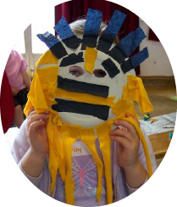
Figure 8 Participants at an APEX Saturday workshop

This picture was taken at a Saturday workshop I organised as part of the APEX programme. I have used it many times on posters and in presentations as it reminds me of the quality of education that is important to me and provides an eye catching challenge to the preconceptions of those I work with. When I look at it, it brings to mind the buzz of small children filling a large school hall with their presence, in contrast to the rest of the school building, which has a hollow emptiness of the weekend. The floor is strewn with colour, fabric, materials, equipment and people. The space echoes with their humour, excitement and enthusiasm for what they are creating and who they are in communion with.
The image communicates to me the complexity of life that schools and authority have so much difficulty in being at peace with, and the surprises, humanity and uniqueness of people, which procedures of accountability seem to remove. That is what I want to achieve – to enable children to surprise themselves and others with the pleasure of creating the person they are and want to be in and of the world, the life they want to live, and the quality of the contribution they can make.
I want children to grow, able to live loving lives they find satisfying, productive and worthwhile. I believe I can contribute to the achievement of that ambition by creating educational relationships, space and opportunities, which support them growing as thoughtful and thought-full learners, knowing themselves, and with informing aspirations and the confidence and competences to pursue them, to contribute to enhancing their own learning and lives and that of others. I want children to experience the pleasure that comes from recognising and valuing themselves and creating and contributing something of worth. I believe that people, being social animals, get pleasure from feeling their unique self recognised and appreciated by others as a valued and valuable part of their lives. I do not think this is part of a barter system – a gift exchange - but a free flow between people where they truly offer the gifts they create and value without fear, veneer or expectation but with pleasure of the creation, and the intention and hope, that they will contribute to the well-being and well-becoming of us all.
It is interesting that on reflection I realise this photograph also represents the tensions and contradictions of the system and organisation in which I work. One of the reasons I use this photograph is because the child is not visible; I have no permissions to get, it is ungendered, and at first glance does not show either age or ethnicity. It is anonymous. Yet the basic values of education I hold concern the recognition of the individual, the valuing of their uniqueness, opening channels of respectful connectedness through which we can contribute our own distinct embodied knowledge and benefit from that of others, to co-create what would not be there without us. How can I express my educational responsibilities towards the other if we stay behind our masks? These are the tensions and contradictions I live and work with; a system driven by prescribed, impersonal targets, with progress described by numbers and teachers trained to train children and deliver received knowledge cost-effectively.
The picture of the child playfully sharing the mask they made in the ‘Colourful Nature’ workshop communicates something of the same qualities I experience looking at the picture below of Eden Charles and Alan Rayner. They are at the Monday evening conversations, facilitated by Jack Whitehead, which were held weekly at the University of Bath for likeminded people to share their values-based work to take their thinking forward.
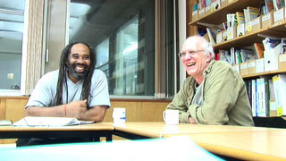
Figure 9 Eden Charles and Alan Rayner in conversation
Here the space is filled with the warmth of the pleasure of people being in communion with each other, enjoying the educational relationships and the diversity of experience and interests each brings, the humour, a sense of being at ease in the flow of a creative conversation. When I bring this picture to mind I feel the delight of being with these people sharing themselves, their academic and intellectual gifts which hold their histories, their cultures, their emotions… their embodied knowledge of themselves in and of the world, the knowledge that constitutes the people they are when they are fully present with themselves and each other. The image brings to mind what I have learnt from and with them, engaging with their ideas, for instance inclusionality (Rayner, 2005), societal reidentification and guiltless recognition (Charles, 2007), and co-creating something new over time. I believe that I am communicating more to you of that space of educational relationships and opportunities by offering this photograph along with the words than would be possible through words alone.
The vibrancy of the space in the image is in contrast to the rest of the university building, which is beginning to darken and quieten with the evening. I want this feeling of an energised educational space, the pleasure of educational relationships, and the satisfaction of co-creating something of value, to be accepted and expected during the normal/regular ‘hours of business’ of establishments concerned with education.
Finally, I offer a collage created for a chapter in an edited book on gifted and talented education (Huxtable, 2008a, p. 295). This is the explanation I gave in a draft, 23 May 2007:
‘…I am not suggesting that life is, or could be, one big smile but I choose to focus on the pleasure as I tend to get what I look for and while I appreciate the inevitability of struggle, frustration, angst, toil… they serve a purpose which for me is in part communicated in these photographs; the pleasure of living a satisfying and productive life in a humane world.

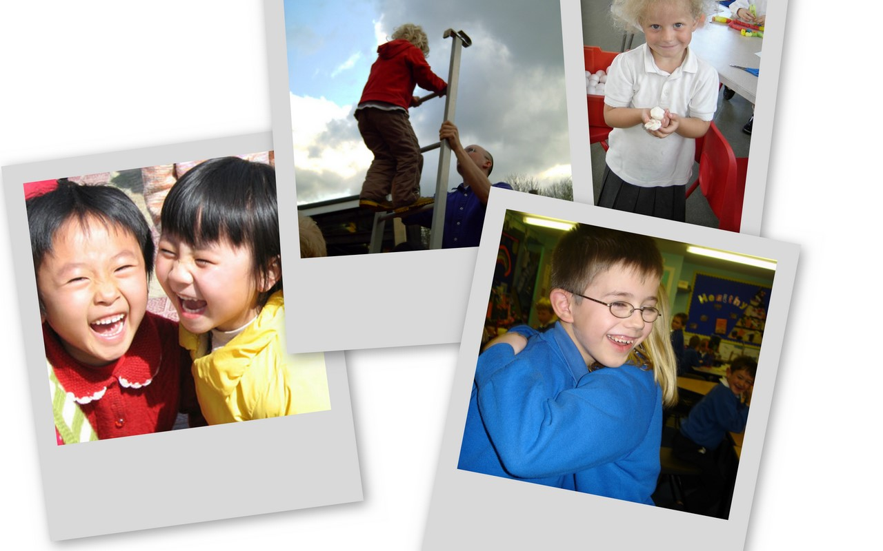
Figure 10 Thanks to Ed Harker, Margaret Dobie in Laidlaw (2006), Joy Mounter and Belle Wallace for their photographs
I ask you to look at the images and experience the pleasure that I feel, and understand that I am trying to show you something of myself and not to comment on the individuals in the pictures. I have selected these images with considerable care; what does that communicate to you about my educational values? Look beyond what for me are delightful images. I did not take these photographs. They represent a focussed intention on the behalf of others to create, value and offer them. I do not believe that could have happened without the sensitivity and the developed talents of the educators who directly and indirectly contribute to contexts where pleasure can be expressed, where gifts can be created, valued and offered, and the requisite talents recognised and developed. I believe these images say more about the educational values and standards of judgement of the educators, including myself, than about the individuals whose images you can see.
These are brief moments, caught and transfixed as images which can be lost at the bottom of some dusty drawer, but I need to remember that the feelings and understandings communicated have become part of a living memory with the power to influence those you see and others, yourself included, who are beyond the lens.
Can I ask you to think how it might transform practice if we were to seek data in the form of photographs or video to enable us to research and communicate the quality of the dynamic and relational, the inclusional, gifted and talented educational experiences we want to hold ourselves accountable to?...
I hope that looking beyond the photographs helps you to understand a little more of what I mean by the space and music of an educational context of quality…’

This photograph (Figure 11), which is part of the collage, also has a personal connection. It was taken by Joy Mounter who I have had the delight of working with for many years. She had digital cameras available in her classroom and had one to hand at the moment when one of her pupils had understood something he had worked hard at, and another child recognised this and expressed their pleasure in the moment. Joy brought the photograph to share at the Masters group and subsequently included it in her Masters account in which she wrote:
Figure 11 Pupils of Joy Mounter

‘This picture for me holds so much emotion and joy. It describes the journey to emotional learning and celebration in my classroom. The moment when two children shared their joy of learning and success at solving a problem with each other spontaneously. For me this is the assignment, ‘the whole world in a grain of sand’, a single moment. Learning independently, "We did it!" Child Q.’ (Mounter, 2006)
I wrote (Huxtable, 2008b) what I felt communicated through this photograph:
‘In this photograph, taken by Joy Mounter in her class, the boy has just learnt something he has been struggling with. The moment is shared and appreciated by the girl who expresses her delight with a hug. In this moment I see the pleasure of loving recognition and respectful connectedness between the children, the children and Joy. I also see this between these two children and Joy as part of the educational community she has created in the classroom. It is not just the physical boundaries that are relaxed but the emotional ones and I can feel the space charged with the emotional energy of pleasure given expression. Joy does not intrude but is included with the history of her relationship with the children. The boy in the background, smiling at the two, is also not intruding into the space created between the children in the fore-ground but is included in the wider space, with space and boundaries neither fixed or discrete. This moment is evidence of the quality of an inclusional gifted and talented educational space that Joy has created, and is, as she put it herself, ‘the whole world in a grain of sand’.’
There is so much expressed in this photograph. For instance, the context is formal, the children are in a school uniform, yet the pleasure and moment is personal. How did Joy bring that about? Without the photograph I do not think the meaning of the energy would communicate, and the humanness of the educational space and relationships that Joy had created, the recognition of the children of each other, and the delight they share in what one child has struggled with and the gift of understanding that he has created, valued and offered himself. Each is offering a loving recognition of them self and the other and there is a respectful connectedness in the expression of an educational responsibility. The intra- and inter-personal living-boundaries may be tested but not violated.

Figure 12 Children enjoying life
This photograph (Figure 12) has also been important to me even though I do not know the children or the person who took it. It expresses so eloquently the mischievous delight of respectful connectedness that transcends time, space, cultures. Moira Laidlaw gave it to me. It connects me to the educational influence she has had in China where she was presented with the national Friend of China Award and made a life-long professor of Ninxia University, in recognition of her contribution to the development of action research with Chinese characteristics. It brings into relief the universality of the qualities I mean by an educational intent. There is a visual, albeit inadequate, expression of the energy-flowing, life-enhancing relationships within and between people. That, for me, constitutes the qualities of education I want to contribute to through improving my practice and the creation and offering this thesis as a gift.

3.1.2 Text based narratives
I re-told the story of my educational values in drafting a contribution to a final chapter of a book (Huxtable, Hurford and Mounter, 2009) which I co-authored with Joy Mounter (who has already been introduced to you) and Ros Hurford, a teacher who I have also had the privilege of working with and getting to know over many years. Both have also worked on the Masters programme with Jack Whitehead and which I have supported. They offer the gifts of the knowledge they created through that programme on http://www.actionresearch.net.
At the beginning of the book Ros, Joy and I each told our story of our creative and philosophical thinking. In the final chapter we shared our learning stories, influenced by writing the book and what had happened to us during the period of writing it, I had to think carefully about my use of language, as the anticipated readership comprises newly-qualified teachers and those who have, for various reasons, not involved themselves with ‘thinking’, enquiry or research before. I am not placing this here as a ‘compare and contrast’ with the other narratives as a form of communication. I am offering it here to contribute to the communication of my meanings of my educational values.
I know there is some repetition of the previous narrative but I have deliberately left this in, as you, like me, now come to those phrases and words anew with the images and thinking of what has gone before. Neugarten (2003) claims there is no first look as we come to the first viewing with a huge cultural background, so that even our first viewing is coloured. His reflection that tabula rasa means an erased tablet not an empty sheet of paper, serves to emphasise there was always something there before. My intention in offering different forms of narrative is to extend the possibility of making what I am trying to say real to you, to creatively engage your imagination to weave generative connections with what is of importance to you as educator with a desire to improve educational practice, as well as to clarify my meanings for myself. This is an extract from a draft:
‘I am reflecting back over what I wrote in chapter 2 [of the book] and the story I wrote which finished,

‘I work from the premise that all children and young people hold within themselves the possibility of living a satisfying and productive life and the ability to make a valued and valuable contribution to their own life and the life of us all. I believe there is no predetermined limit as to what that contribution might be. I do not mean that I believe a child is able to grow up to achieve anything they might choose, rather I believe it is not possible to predict what they might achieve during their lifetime through the combination of opportunity and their determined inclination and commitment to realising their aspirations. My purpose as an educator is to open the imaginations of children and young people to the various possibilities of them living their lives in ways they find satisfying and productive and enable them to develop the confidence and competences to make and act on informed decisions as to what they want to do as they enter the adult world.
I believe the individual is the only one who can determine whether their life is satisfying and productive, and they do so according to their own living values as standards by which to make such judgments.
And that is where I am now – trying to walk my own talk and learn from trying to understand and improve my own theories to explain what I do, contributing to improving the educational experience of children and young people.’

This still works for me. I have had a moment of revelation recently as to what my values are that explain and inform what I do in practice, and which form the basis from which I judge the standard of my work. It might sound odd to you when I admit that I have just begun to understand my values and my living theory but I think I am not alone; I have found many people often don’t really know what they are doing, and this is not only in education. The result is we are in a poor position to improve our practice and in no position to respond to the demands of others, for instance the government, professionally.
I think to ask the question, “how do I improve my educational practice?” makes the implicit assumptions that I know what my educational practice is, can give a reasoned and reasonable account for what I do and articulate the educational standards by which I evaluate it. For me that is the beauty of living theory research: there is an overt recognition that as an educator my values are my bedrock of researching my practice, and emerge through examining what I do. My theories are living in the sense that I am living them, and living in the sense that they are forever evolving in a complex context, which includes me, other people, society and the world. Understandings of living theory, are also living and I encourage those I work with to periodically revisit the http://www.actionresearch.net website and explore online, in print and in conversations, accounts that resonate, to see if they contribute to their own journey and inspire them to offer their own, as I do.
These are the values that have emerged through my practice that I recognise are core to me and which enable me to explain why I do what I do and enable me to hold myself accountable:
- A loving recognition
- A respectful connectedness
- An educational responsibility
I, like you, have constraints and targets, but these three phrases mean something real to me when I think about the quality of education and what I might do to improve my contribution. When I look back over the stories we have given you in this book I can see these qualities expressed, It is how I understand what a good educator does and what happens in an educational space and in educational relationships. I would prefer to be able to show you what I mean but will have to be content here to try to communicate through text, and ask you to use your imagination to think of when you have experienced these qualities yourself as educator and student.
Loving Recognition
What do I mean? I mean recognising the person within, not just the shell but beyond to the possibilities that person may not see of themselves but would value if they did. Gert Biesta (2006) talked about the need for a language of education, and not just learning, and in that context bringing into presence that unique ‘I’, which I understood him to mean what it is that only I can say or offer, when ‘I’ is not replaceable by anyone else.
We spend much time telling children what they will become, their potential, what destiny is set for them, and so concern ourselves with ‘underachievement’ and teaching children to become ‘better’ learners according to some disembodied standard. It concerns me that we then seem to lose sight of the special and unique person within, the person who is more than ‘a learner’, ‘a pupil’, a label of one form or another.
I recognise the importance of stimulating and exciting children to explore and develop their confidence, skills and sophistication as knowledge creators. But somehow there must be a way of providing this in school in a way that enhances the child’s recognition and valuing of themselves and their unique contributions to their own well-being and that of others. Categorising children and treating the labels seems to repeat and amplify the error.
I know when I experience a good educator. They offer me a loving recognition; the personal me inside that is trying, with the best of intent, to be the best I can be, feels recognised and sometimes they offer me an insight into who I am and can be that I do not see or understand myself.
This is what I see in Barry Hymer’s (2007) story that he gives at the beginning of his thesis.
‘In 2002 my book on gifted and talented learners was published (Hymer with Michel, 2002). It opened with a reflection on my last year of full-time teaching, and in particular my memory of an incident involving a Year 5 (ten-year-old) boy, known as Robert in the book:
Robert was a large boy, considered something of a bully by other children and he was challenging in the classroom. He had moderate generalised learning difficulties and he was functionally illiterate. And a few weeks before the end of the school year, I also discovered he was gifted. Not globally gifted, not outrageously or psychometrically gifted, but still gifted. I discovered his gift by accident. Our school had been participating in the WH Smiths ‘Poets in Schools’ scheme, which had brought the poet David Orme (‘Mango Chutney’) to work with students across the entire Year 5 year-group. As one of their poetry-writing exercises, the children had gone out in small groups to explore – in great and close detail - the trees and shrubs adjoining the school’s playing fields. They’d reflected, taken notes, drawn observational sketches, seen the trees and leaves and insects in new lights and from new angles, played with language, laughed and had fun. And then they’d returned to the classroom to knock their thoughts, notes, perceptions and reflections into poems. I’d been with Robert and his group throughout their time outside – mostly to manage his tendency to distract others – but back in the classroom my attention was shared with other members of the class. By the time I got around to Robert’s desk, he’d managed an illegible sentence, in his typically tight, misspelled and dysfluent script. I asked him what he’d written and there was a long pause as he tried to make sense of his work. Then he replied, in a voice so slow and soft I hardly heard him: “Even the winter leaves have their own secret colours”.
That was it. One line. But what a line! It was mid-summer, and Robert had found and studied a solitary, decaying winter-leaf. And in his observations and his slow reflections, Robert captured an image that contained a most deliberate metaphor. He was saying, I’m convinced, “Mr Hymer, notice me. I know I’ve not got a great deal going for me in school, but just sometimes, in some situations, I can do things that will amaze you”. The children’s best efforts were collated and published in-house in an anthology entitled, “Their Own Secret Colours”. With the support of David Orme Robert introduced the anthology to the parents at the official ‘launch’. He later told me it was the first time he’d ever been asked to do something important. Robert’s moment in the sun coincided with a staggering change in his attitude and performance in school. He saw himself as a poet, as someone who – under the right conditions – could amaze with the power of his words. He still struggled to read and write and acquire new concepts at the speed of his classmates but the bullying pretty much stopped, the friendships and peer-respect grew, and Robert walked around the school and playgrounds with a real, deep and growing sense of self-confidence. He seemed caught up in a virtuous circle. And if that was the effect of Robert’s self-perception, who was I to disillusion him? A few weeks later the term and school year ended. I left the school and the area and I’ve no idea what became of him.’
Fukuyama (1992) wrote:
‘Human beings seek recognition of their own worth, or of the people, things, or principles that they invest with worth. The desire for recognition, and the accompanying emotions of anger, shame and pride, are parts of the human personality critical to political life.’ (p. xvii)

I think he was right. I think this was what Albom (1997) was getting at when he described the influence of Morrie Schwartz, his college tutor:
‘I came to love the way Morrie lit up when I entered the room. He did this for many people, I know, but it was his unique special talent to make each visitor feel that the smile was unique.

“Ahhhh, it’s my buddy,” he would say when he saw me, in that foggy, high-pitched voice. And it didn’t stop with the greeting. When Morrie was with you, he was really with you. He looked you straight in the eye, and he listened as if you were the only person in the world. How much better would people get along if their first encounter each day were like this…?’ (p.135)

I know people who can walk into a room and bring sunshine with them. The teacher as a wonderful educator seems to be able to do this and find the sunshine in each child, and enable that child to enjoy what they have within and find the courage and enthusiasm to help it shine out for themselves and others to benefit from.
Respectful connectedness
Perhaps if I start with saying what I don’t mean this might become clearer. In traditional relationships there is a one-way connection between teacher and pupil/s with the intention of transmitting information. In ‘child centred’ classrooms there still seems to be on one-way connection between teacher and pupil/s but this time the power of control over the enquiry has shifted to the child while the teacher serves the function of providing them with information and skills that will enable them to do what it is they are striving to do. This is sometimes described as moving from being ‘sage on the stage’, to ‘guide on the side’. At times these relationships are appropriate, but I would suggest that there is an educational relationship that might be described as a ‘respectful connectedness’ where there is a recognition and respect for the contribution of skills, information, understanding, personal qualities… that teacher and pupils can make to the learning and enquiry where new knowledge is created. There is also a care and respect for each other’s boundaries. These boundaries are living and dynamic and when a teacher offers respectful connectedness they are sensitive to the boundaries of the pupils as well as their own.
This extract by Louise Cripps (2007) illustrates something of what I mean. She and four of her 10-year-old pupils are taking part at a day of collaborative enquiry and she writes:

‘I really appreciate the flow of focused conversation between us all as we try out different understandings. The conversation also requires the learners to be understanding each other and their difficulties with understanding, and so there was a reflective quality built in.
There was no imposition by anyone on the others on the group. I felt that I, as a learner, wasn’t pushed or rushed into being able to do something at the expense of really understanding it, and I also felt that the others in the group felt in the same position although we all had different levels of knowledge or understanding about the task.
Throughout the activity at the time, I was very aware of the way in which the knowledge and understanding was being woven throughout us all. This activity couldn’t have happened without the relational flow between the learners in the group.
There was a real connection between the four of us as learners as the ideas passed from one to another.
Geraldine starts off with the knowledge, but wants to share it. It was her challenge to help us understand.
Louis very quickly shows that he knows what it was all about, and keeps testing what he sees against the ideas already in his head.
Edward quietly watches, and is given the space to keep working out what is happening. I am aware that at the beginning he is as puzzled as I am, but my perception is that he is seeking clarity in the same way as me. This is reinforced for me by watching the video, when near the beginning we unconsciously mirror the same kind of thinking body language. I am aware with Edward of a breakthrough moment when amidst all the chat; he quietly reaches out and picks up the cards to try something out. At that stage I don’t think it quite works out, but Edward I think has found a new theory to pursue.
Also in terms of the dynamic of the group, each respects the learning of the other and makes space for it. I feel too, that there is real respect for each other as well as the learner. This activity isn’t just a polite exchange of ideas, it is real collaboration.
There are separate conversations and exchanges happening throughout as well, but not to the exclusion of others in the group.
I want to know what Louis’ understanding is because I am fascinated by what his thinking is, and he is able to articulate it. He wants to know what my thinking is because he wants to understand where I am, so he can show me more clearly how to understand. Although we all know each other, we haven’t worked in exactly this way together before, and I’m thinking that it makes explicit the quality of relationship which must exist, and which I greatly value as an educator, but which I wouldn’t take for granted.
As I watch the clip, I’m also fascinated about what the other learners bring in terms of their gifts, and I’m challenged about the importance of providing opportunities for the learners I’m responsible for to develop their gifts.
Louis has really appreciated the chance to work specifically with like minded people where he knows his ideas will be understood. Although he had developed an understanding very quickly he was happy to wait to explain what he understood. He gave that to the group, and helped us all develop our understanding in an inclusional way.
Geraldine gave us a clear demonstration, and was also very patient in helping us understand, and gave us clear pointers without feeling she had to dominate or be the one who knew. She too was able to read the group and each of us in it, and give us the space we needed.
Edward had the capacity to stay with the task, to listen and watch, and build his understanding in that way.
I feel pleased by my role in the group, as it’s how I want to be as an educator. I’m very happy learning alongside others. I want people’s ideas to be heard, and I want people to feel valued. I really enjoy engaging with the ideas of others, trying to understand what they’re thinking by what they say. Like Louis, I find it helpful to know where people are in their thinking and understanding. As an educator if I know that, I can more readily help others move forward in their understanding, and as a learner I can move forward in my own thinking and develop my own understanding.’

This is much easier to understand if you viewed the video [Video 7, http://tinyurl.com/3v7nqb5] but I hope this account communicates something that resonates with you. There is a sensitivity that Louis and the children express in their relationships where the connections are channels through which there is a receptive~responsive flow of communication. These are two definitions of ‘respect’ in the Cambridge on-line dictionary
- to treat something or someone with kindness and care
- to accept the importance of someone’s rights or customs and to do nothing that would harm them or cause them offence

There is a quality felt in the connectedness, which I describe asrespectful; there is a gentle warmth and good humour, good manners, an invitation is extended to offer, accept and co-create which can be declined without rancour, there is a consideration for self and the other, with attention for the well-being and well-becoming of all, and an optimism of something fruitful which may emerge from the engagement.
The challenge to the educator is how to exercise their judgment, while being nonjudgmental, as to how they bring their pupils into such a relationship. This takes time, skill, determination, courage and self-awareness on behalf of the educator, and trust and a willingness to contribute by the pupil/s. It also requires a recognition that the teacher’s boundaries have to be much firmer and more distant with some pupils than others, and the boundaries with some children may be much firmer and more distant than the teacher would like, and remain so.
Educational responsibility towards…
If I am expressing an educational responsibility towards another I am acting with their best intent at heart. I will have to do so within the context of the best interests of others but I am focusing on the pupil’s best intent. I know this is different to what as educators we usually say – that we work with their best interests at heart. I just wonder how often that means that what it is the pupil is striving for and their voice in their own learning and lives is ignored. I am still wrestling with that.
I think we often feel under pressure to respond to the demands of the institution or organisation for which we work. I remember vividly as a psychologist many years ago working with a girl. She was very capable of getting good grades in her SATs and I was trying to encourage her to do so. Eventually she turned round and told me she had spent a lot of time looking on the net for information and had thought about it very carefully. She had come to the conclusion that her SATs grades were of importance to the school for their position in the league tables but they were of no importance to her. She said she and her teachers knew the level of her skills and the quality of her understanding in the curriculum and she would get onto the courses she wanted. She was right. However, this is a very complicated and difficult decision to make as to when it is my educational responsibility to ‘push’ a child to do something they may not want to do but is genuinely in their best interest and will equip them with the confidence and competences necessary for them to realise their best intent. I don’t think there is a universally correct answer but I do believe that this is a question that should continually challenge the educator and to which they should be continually checking the appropriateness of their responses in respect to the children in their care.
The distinction I would particularly like to make is between an educational responsibility for and an educational responsibility towards. I don’t believe that I can or should take responsibility for anyone apart from myself but I do believe I have a responsibility towards others by which I mean to help them make and act on decisions that will contribute to their own well-being and well-becoming and that of others and to learn to recognise and keep from harm.’
I have quoted at length from other people deliberately as the form and flow of their writing helps me to go beyond the words to the intangible essence of the values that they are communicating. In sharing with you their stories as stories that touch me and resonate with me I am also sharing with you something of my values and of me.

3.1.3 Multimedia narratives
Joan Conolly expressed the problem presented by text-based narratives:
I am so reminded of Eliza in "My Fair Lady" ...
"Words! Words! Words! Words!
I’m so sick of words! ...
Don’t talk of stars shining above! SHOW ME!
Don’t talk of love ... SHOW ME!"
Perhaps that is why I like Self-Study/Action Research/ Living Theories Methodologies (SS/AR/ LTM) so much! It’s about showing WHAT we do and WHY and with what EFFECT. (posting on the JISCmail practitioner-researcher list 6th April 2010)
So here I want to ‘show you’ the energy-flowing values that form my explanatory principles and living standards of judgment of my practice. As you engage with these narratives I ask you to bring with you the understandings you have created through the visual and text narratives of the three ontological values I have been focussing on:
- A loving recognition;
- A respectful connectedness and
- An educational responsibility
In the construction of a multimedia narrative I draw on text, image and video. As you engage with this section of my thesis I feel a concern. This form of evidence may not be familiar to you and as a consequence there is the risk you may refuse to take the time to watch the videos. However, I do not believe the significance or originality of my thesis can be understood unless you do so.
I hope you will not take it as an aggressive insult if I say this bluntly: I believe that a response to Schön’s (1995) call for a new epistemology requires academics, educators and others to be prepared to take the time to learn the skills needed to meaningfully engage with new forms of ‘literacy’ made possible with 21st century technology. Learning anything new can be a difficult and frustrating process and learning these new ‘literacy’ skills is no exception. As this is new territory there are few established ‘tools’ available, which can exacerbate the problem. However, I hope you find it a pleasure rather than a chore, to travel with me on this multimedia venture despite the additional effort it may require of you.
I will introduce three vignettes. The first is of Louise Cripps with three of her pupils at the collaborative, creative enquiry day for mathematicians that I ran a few years ago, referred to above. I will offer you here what was eventually published in Research Intelligence (Huxtable, 2009b) as I have included the rationale for multimedia accounts, the contribution they make to the creation of a new epistemology and the techniques for engaging with them. The second vignette is of Joy Mounter, to whom you were introduced in the first story, with three of her pupils discussing the TASC Wheel (Wallace et al., 2004) at the end of a busy Friday. The third is of me presenting a paper (Huxtable, 2008b) at the BERA conference where I have told you I was able to articulate my values for the first time.

3.1.3.1 Louise and Louis
The first narrative is within an account published in the British Educational Research Association Research Intelligence. As it is still the best introduction to engaging with multimedia narrative I have created I will share it with you here in its entirety (Huxtable, 2009b):
‘As an educator, my lived and living educational values form the explanatory principles of my practice and my living standards of judgment in appraising my work.
They are at the core of my being, and are unconsciously expressed in what I do and the way I am. I do not exist in isolation and my values are relationally-dynamic being held, formed and re-formed in that complex space between self and other/s. To communicate, those values and the educational influence I am having, requires a form of representation beyond the possibilities offered by traditional academic writing.
I agree with Whitehead (RI105) in responding to Bruce Ferguson (RI102), Laidlaw (RI104) and Adler-Collins (RI104) that enhanced by the diversity of global cultures, what counts as educational knowledge in the Western Academy is gradually transforming. I also agree that,’...the forms of representations used in BERJ are too limited to communicate the energy flowing, explanatory principles that can explain educational influences in learning’ (Whitehead, 2008a, p. 29); new forms are needed which can help us to communicate our understandings and contribute to an educational knowledge base.
My work in an English local authority, coordinating and developing inclusive gifted and talented educational theory and practice, contributes to the realisation of the local authority’s inclusive values expressed in the statement, “We want all Children and Young People to do better in life than they ever thought they could. We will give children and young people the help that they need to do this”.
Education is concerned not with inanimate objects with predefined potentials and fixed relationships, but with emancipating a person, as learner, to improve her/his own well-being and well-becoming and that of us all. My research, and that of the educators with whom I work, is therefore concerned with describing and explaining how we are improving educational contexts, space and relationships, which particularly relate to enhancing the educational experiences of each unique person in our school system.
BERJ in its present form cannot help develop the educational knowledge-base that we, and other educational researchers, are generating in terms of our energy-flowing and values-laden explanatory principles. As Eisner (2005) said:

Human beings are, after all, sentient beings whose lives are pervaded by complex and subtle forms of affect. To try to comprehend the ways in which people function and the meanings the events in their lives have for them and to neglect either seeing or portraying those events and meanings is to distort and limit what can be known about them. (p. 116)

I agree with Whitehead that the BERJ needs to grow into a form in which the representations of these very human qualities that educational research is concerned with can be communicated and understood.
Quinn (1997) talks of the need to decentre: ‘Decentring is a vital idea. It is the achievement whereby I learn what it is that you need to hear or experience in order to share what is in my mind, whether it be a question, an idea or a supportive anecdote.’ (p. 86)
My living educational values are dynamic and relational and are not adequately communicated through ‘fixed’ forms of representation. For me to ‘decentre’ and communicate I ask you to read first the following text and see what sense you make of it. Then read again while engaging with the still image and recognising where your understanding is enabled as your focus moves between the people and the space and the text. Finally I ask you to engage with the text as you watch the video clip with an awareness of where you are pausing and scrutinising a still image, moving the cursor back and forth and replaying sections of the video, re-reading text, and moving between the text, stills and video. It’s complicated. How we make sense and create understandings is complicated. I find it helpful to use Rayner’s (2005) notion of inclusionality; a dynamic awareness of space and boundaries as receptive, responsive and co-creational.

http://tinyurl.com/3v7nqb5

Video 7 Ostensive clarification of ontological values

What follows is part of a video narrative in which I try ostensively to clarify the meanings of my educational values of, a loving recognition, a respectful connectedness, and an educational responsibility, as an example. The context is a day when children and teachers have come together for a day as co-learners, facilitated by a mathematician and an educator, to experience what it is to enquire as a mathematician.
So, to begin.
The video [Video 7] for which ethical permissions were sought and given is on http://tinyurl.com/3v7nqb5
I have watched this 6-minute video many times and each time there is something special about it, particularly in the relationship between Louise (teacher) and Louis (pupil in the foreground). If, using Jack Whitehead’s technique (Whitehead, 2008b), you run the cursor back and forward you may share with me a sense of the flow of a respectful connectedness between them. Each is respectful of the emotional, physical and personal boundaries of each other and the other two children. There is sensitivity between adult and children not to impose but to offer and invite. The space between them changes in a flowing ‘dance’ as they move – back to invite, in to engage. Louise’ loving recognition of Louis, appreciating and valuing his intense desire to share, to inform, to engage the group and particularly Louise, in creating an understanding. I see her loving recognition of Louis as she enables him to express his educational responsibility towards her in his desire to bring her to a point of understanding that satisfies her. In that, Louise is expressing her educational responsibility towards Louis.
I believe that in allowing Louis to bring her to an understanding Louis deepens his own understanding of mathematics and of himself as valued knowledge co-creator. I see Louis expressing a loving recognition of Louise. He does not engage her as authority, teacher or adult, but as the person she is, inquisitive, keen to understand, to enjoy the learning that emerges from uncertainty and the pleasure of being the educator she wants to be sharing a creative and productive space. The space between Louise and Louis is energised by their shared commitment to extending the other’s understanding and the pleasure of being in good company.
I see in this brief clip Louise working to connect with the best intent of the other in mind, to help them understand, express and develop accordingly. (An expression of a person’s best intent may not always be in their best interest; for instance, Korczak’s (Lifton, 1989) best intent was expressed as he chose to accompany the children to the concentration camp and death.) The relationship requires trust, so the child can feel secure that the educator is trying to understand what their best intent might be and to learn, from and with them, as to how they might reach the point of determining their own path to live the life they want to live, mindful of their own best interests and that of others.
This is where I ask you to re-read the above engaging with the still image and text and then with the video and text. I ask you to consider as you do so whether the educational qualities, which I am researching, are communicated more fully as you engage interactively with the multimedia narrative rather than the traditional text alone.
I believe that I have communicated more of the relationally-dynamic qualities of my educational research through inviting you to engage with me in this brief interactive, multimedia narrative, than would otherwise have been possible. I may be wrong but I cannot test my claim in the current form of the BERJ. The e-version of RI, as Whitehead illustrated, is taking advantage of 21st technology, which will influence the educational epistemological transformations going on around the world. Can BERJ evolve a form that can build on this lead? As a contribution to answering this question I do hope that you will find it possible to participate in the keynote symposium at the BERA 09 Conference on Explicating A New Epistemology For Educational Knowledge With Educational Responsibility’. (pp. 25-26)

3.1.3.2 Joy and her pupils creating a new learning theory
I see the same attention and respect being shown in the video of Louise and Louis expressed in the video of Joy and her pupils. These three video clips (below) created by Joy Mounter (2007) and offered in her Masters account, ‘Can children carry out action research about learning, creating their own learning theory?’ have been shown many times around the world. Each time the educators are stunned at the sophistication of the children’s thinking and their ability to articulate their learning theory in the process of creation as they critique TASC (Wallace et al., 2004). These children are only 6-7 years of age and recognise the multidimensional, relationally-dynamic, flow of learning, which is not appreciated in most of the two-dimensional, linear text-based representations of the ‘grand theories’. Joy wrote:
‘The children I had in my class last year consider themselves expert learners, beyond their age, they are confident to lead others and share their thoughts. We have called them ‘Learning Coaches’. The children and I were invited to share our experiences at a day’s training on TASC run by Belle Wallace. The children weren’t worried, rather pleased and excited to be sharing their ‘learning’. Photographs were taken and even a video recording made of their thoughts of the TASC Wheel. This is an incredible short extract of the children developing their thinking, expressing their reflections and clarifying their ideas to develop an adults ‘learning theory’. (Please see appendices two) By expressing their thoughts and feelings to adults, the children felt a sense of value as having something important to say. They received an e-mail from her thanking them and asking for photographs and more details of their work. They glowed.’
Following this we are having visitors in to watch Creative Literacy from our Primary Learning Network. This again the children met with enthusiasm and are becoming more confident that the world outside of our school is listening, really listening to their message. And recognising that it is important.’
In the picture below, you can just see Joy as she listens carefully to the children. She has taken them into her confidence about her own intention of learning with and from them. These 15 minutes on a Friday afternoon can only have happened in the context of the relationship she has already developed with them, the language, skills and understanding of learning they have developed with her support and involvement over time. I hear in her voice an honest respect for the children as valued creators of knowledge as she checks with them what they are meaning. This is the first of three clips where you can see the ideas move between the children. Each responds in a way that is meaningful to them and enables them to communicate with the others.
Video 1 Relationally-dynamic qualities of energy-flowing values

http://tinyurl.com/3ogda8w
“…then you get the question in your head… it is actually the questions you might need to answer not exactly the answers ‘cause you need to think sometimes for yourself.”

I do not believe that a transcript of the videos would adequately communicate either the dynamic quality of the learning theory they are creating or the educational qualities of the space they are contributing to. I ask if you see what I see as you run the cursor back and forth as you watch the videos in QuickTime. I believe I see the dynamic relational qualities of a loving recognition, respectful connectedness and an educational responsibility expressed.

3.1.3.3 Showing myself living my values
I am often accused when I am talking, of starting half-way through what I am thinking. Here I would like to start at the end, so to speak, to set the scene with these notes I made to myself for one of my numerous drafts of this thesis:
‘I think I have understood what I am about. The penny has dropped, the light has come on and the fanfare has sounded – in my head at least! I can explain, rather than just describe, why I do what I do – such as why I choose this psychological theory rather than that, why I bring some people into space and not others… I recognised before that there was a consistency to who and what I related to but I could not give a logical explanation that satisfied me. I think it is that lack of reason that can result in some people hopping from one exciting new initiative to another, always thinking the next holy grail is the answer with no way of discriminating between what is educationally a waste of time or what, with a bit of imagination, could be really useful.
So – I have explanatory principles that I can communicate; the reasons I use to make decisions I believe are reasoned and reasonable. I will return to say what I mean by educational, reasons and reasonable later. But for a moment, enjoy my pleasure at being able to articulate, put into a few simple words, my reasons that enable me to explain why I do what I do as: a loving recognition; a respectful connectedness and an educational responsibility towards the other.
These are my ontological values. Not just any old values but I mean the bottom line – what is really important to me and has no base to rest on other than me saying – this is what I believe and this is where I stand. Not only do they enable me to explain why I do what I do they provide me with standards of judgement by which to evaluate my work. As my values are living so my standards of judgment are living (Laidlaw, 1996). I will come back to that too.
Now with so much living I need a form of evidence that communicates the relationally-dynamic nature of what I am about. I can describe a loving recognition, a respectful connectedness and an educational responsibility towards another, in text. Some poets and novelists can bring those written words to life with metaphor and other devices. Writing however is not my forte and I need other forms to communicate my values expressed in practice to those at a distance, either spatially or temporally; visual images, and particularly video, help considerably to assist the words to reach places otherwise untouched. As Lather (1994) quoted in Donmoyer (1996) points out we can never really represent our reality, but creating a narrative with video comes closer than other forms.
So that is what I mean by creating ‘a multimedia narrative’ to explicate my ontological values as explanatory principles and living educational standards of judgment.
There is rarely a single moment that can be identified, one being connected and influenced by another, but this is one I can identify and provide a multimedia narrative of. It was when I was preparing and presenting a paper at BERA 2008 (Huxtable, 2008b) that I began to recognise and articulate with some clarity my ontological values of a loving recognition, a respectful connectedness and an educational responsibility towards others. I drafted and redrafted the paper many times before the conference, each time inching a little further forward in understanding the question that I had posed and working with the reviews from BERA and the responses of Jack Whitehead and Moira Laidlaw.
The evening before I was to present the paper Jack asked, “what is it you want to say, the key point you want to focus on that excites you and you want to test out with your audience”. Good question! I waffled around a bit, and each time he pressed a bit more, what did I mean by… what am I trying to say that is important to me… the more I realised I didn’t know, until I heard myself saying the same thing over and over, albeit in slightly different words, with increasing exasperation and irritation. I realised that most of it was a description of my practice, not explanation. I realised I could not explain because I had no principles by which to offer such an explanation. As I read and reread what I had written and went around the houses trying to respond to Jack, I finally found what was there and what was not there. What was devastating was the discovery that I had written a nice paper – which did not answer the question in the title. In those depressing hours struggling to rewrite the paper I found what I had been searching for over years, and an appreciation of why I have been so insistent that Living-Theory is not just ‘another approach’ to action research. In the rewritten paper I wrote in the introduction:
‘To ask the question, ‘how do I improve my educational practice?’ makes the implicit assumptions that I both know what my educational practice is, can give a reasoned and reasonable account for what I do and the standards by which I evaluate it.’ (p. 1)
I have known that when I have challenged myself on those implicit assumptions I have not, until now, been able to respond from a place of knowing. I could give a good description of my practice but not an explanation, and it is that which I find to be the weakness in most of the research I come across.
I finished the paper with:
‘I have tried to clarify what I mean by developing inclusive and inclusional gifted and talented educational theory and practice, described the educational gifts of educators, how I seek to enhance their catalytic validity, and how I am supporting educators developing their talents to create, value and offer their educational gifts whilst responding to the national gifted and talented education strategy.
I hope that my paper communicates my understanding of my practice as an expression of a loving recognition, respectful connectedness and my educational responsibility towards the educators, children and young people, in my authority, both as ontological values as explanatory principles and as living standards of judgment.’(p. 18)
It began to dawn on me that I had a found clarity about what I was doing and the basis from which I could explain and judge my practice.
The next ‘AH!’ moment came when I faced a small audience the following morning to present that paper to, including, worst of all, people I knew and respected. To make a fool of myself in front of strangers I will probably never meet again is one thing, to do so in front of those who I know and respect is another. On the positive side, I knew they wouldn’t give me patronising platitudes if I fouled up and their critique would be helpful.
I usually find it extremely difficult to be succinct and clear, particularly if I have to talk without prior scripting of some form. This time the technology did not work and I had to abandon what I was going to do and yet I surprised myself; the words came and I felt that the meaning of my values as I experience and live them communicated beyond the ‘words’ alone. I was told afterwards that I had been comprehensible to others too, including someone who said he now understood what I had been talking about over the years when he was my line manager!
As I got up to present my paper I realised I couldn’t use the few images I had brought, there was no net connection and I had no script. I thought ‘this is going to be a fiasco!’ and didn’t want a record, let alone have to look at the video of it afterwards. I deliberately turned my back to the camera as I got up in the hope that Jack would give up and turn it off. That strategy did not work, and that was just as well, as the data have proved invaluable.
Video 9a Expressing embodied living values
http://tinyurl.com/3fg34wy
As I look at the video clip of my presentation of the paper I begin to experience and comprehend how I might be communicating to others a loving recognition, open channels of respectful connectedness and an educational responsibility towards others.
It is here that I would like to ask you to take time out of reading to look at the video of that session. It runs for 20 minutes in total and while I will analyse one section I want you to have the whole context and a taste of the experience of the participants to place that short clip in. I would like to ask you to attend to not only my words but also to the tone of my voice, the movement of my body in the space and with an awareness of the other participants that form that space. The people I specifically refer to I know well and I see weekly at the Improving Practice Conversation Café.
Eisner (1997) said:
‘How do we display what we have learned? What forms can we trust? What modes are legitimate? How shall we know? Those questions and how we explore them can help redefine what educational research means, how it is pursued, and what we can learn from it. It can enlarge our discourse and widen our conceptions.’ (p. 9)
I believe that the forms of evidence needed include video to help communicate the relationally-dynamic nature of educational values. I find it personally most uncomfortable to have to look at myself but I do so in the belief that if I am to understand what I am doing and how other people experience me I cannot avoid it. I have spent years as a school psychologist using checklists and various approaches to behavioural analysis and found nothing that communicated the real qualities of ontological values.
For the multimedia narrative to communicate I believe I need to work hard to ‘decentre’, as Quinn (1997) describes it. He also points out that this is ‘very, very hard’ and is not often broached in school. I will go further and say it is not often broached anywhere else either. Quinn quotes Wood (1997):
‘Being relatively inexperienced and lacking expertise in the task of analysing and evaluating their own and other people’s verbal communications, most young children assume that failures of communication are necessarily the fault of whoever is listening.’
I suggest that this trait is not just that of young children, I, like many adults, also have a long way to go, and am particularly mindful dealing with an unfamiliar medium. I find that in trying to communicate to others more effectively I am improving my communication with myself and have begun to listen more attentively to what I and others are saying and to keep trying to go beyond the words to the feelings and implicit understandings.
Some people seem to find it hard to accept reflections that show they are negating their values, and some the reverse. Neither response is helpful to improving practice. A major point of learning for me has been to hear reflections that say I am living my values, with the same dispassionate equanimity as being told I am living a contradiction. So, to practice what I preach, I focus on the end of the BERA presentation and offer this analysis in the video (Video 9b, analysis in the video) http://tinyurl.com/3pl23um, revised following Anat Geller’s (an Israeli educator) response. I wanted to excite my audience to comprehend... accept... believe… and engage their imaginations to go beyond the ideas I was offering. As you watch the video do you hear me articulate my ontological values and feel the embodied meanings of those values communicated? Is what you hear, see and sense of my values consistent, or do you experience me as living a contradiction?
You may want to pause here and ask yourself why you do what you do and what values you want to express as fully as you can. What is it that you do that gives you a sense of living a loving, satisfying, productive and worthwhile life? How do you communicate your values? Have I communicated the energy-flowing nature of my values so that we share a developing understanding in the living-boundary between us?
I ask you to hold in mind what, I hope, I am communicating of my values of a loving recognition, respectful connectedness and educational responsibility, as you move onto the next section. I begin with a multimedia narrative to ostensively clarify my meanings of inclusion, emancipation and egalitarian as social values. I next focus on my meaning of living-boundaries and the expression of values within those boundaries. I go on to show how my values form explanatory principles of my practice, improving educational relationships space and opportunities through collaborative, creative enquiry within living-boundaries.

3.2 Ostensive clarification of my inclusive, emancipating and egalitarian social values
I am presenting here a form of educational research that is grounded in a commitment to living citizenship (Coombs and Potts, 2011). By living citizenship, in the context of my research, I am meaning living inclusive, emancipating and egalitarian social values. I show how, in living these values as fully as I can, I am generating the kind of educational knowledge that offers a response to the concerns of national educational research associations: BERA seeking to encourage the pursuit of educational research and its application for the improvement of educational practice and for the public benefit (BERA, 2010); AERA seeking to, ‘advance knowledge about education, to encourage scholarly inquiry related to education, and to promote the use of research to improve education and serve the public good’ (Ball and Tyson, 2011).
The words I use to ‘label’ my values may or may not change. However, the embodied meanings of those words evolve and are shaped by my experience of life and the knowledge I create of the world, myself and myself in and of the world. In that sense my lived values are living and relate to my social values.
There are times I find what I am doing is contrary to my values, either because of my ignorance or circumstances. At those times I experience myself as a living contradiction (Whitehead, 1989a) and feel a dis-ease; I can feel anxious, stressed, angry, distressed… or that vague uncomfortable feeling that things aren’t right but I can not put my finger on it. When I am in a sympathetic context, expressing my values as fully as I can in what I am doing, I can recognise a sense of well-being that Csikszentmihalyi (2002) describes as ‘flow’.
So, context is important, but not only to my sense of self and well-being. It is important in enabling me to understand the world I want to bring more into being by what I do. In other words, to be aware of and to clarify my social values, are integral to me understanding and living my ontological values and living a loving life that is not only satisfying, but is also productive and worthwhile. This is the process of creating knowledge not only of self, but self in and of the world as I research to improve my practice to create knowledge of the world.
I will return to the notion I have of ‘creating knowledge of the world, of self and of self in and of the world later particularly in Chapter 7 when I introduce a relationally-dynamic approach to research and developing praxis. Here I want to focus on communicating the meanings of my social values clarified, as they emerge through my research in living-boundaries. They can be ‘labelled’ as:
  - Inclusive - to signify the importance I attach to each person valuing their own gifts and that of others, as the unique contributions each person develops and offers to enhance their own well-being and the common good
  - Emancipating - to point to the importance of each person accepting and expressing their responsibility to enhance their own learning and life and that of others. While it is only individuals who can emancipate themselves, I recognise there are contexts that enable or disable, to a greater or lesser extent, the discharge of that personal responsibility for enhancing learning and wellbeing
  - Egalitarian - to make clear the value I attach to i~we where the individual is neither subservient nor dominant to another, but each exerts their power with others and self, to co-create knowledge collaboratively to enhance the well-being and well-becoming of each and all
I can see the expression of my social values in my ontological values and vice versa: my inclusive social value is reflected in my ontological value of ‘a loving recognition’; emancipation is reflected in educational responsibility; and egalitarian has resonance with respectful connectedness. I will return to this in the next section but first I want to focus on clarifying my social values.
The narrative below is of a session at the Improving Practice Conversation Café, a weekly meeting for local authority staff and others. In 2005 I was tasked with leading the development and implementation of the action research strand of the local Authority education development plan. As with all plans it has been consigned to history but it provided the ground for the Improving Practice Conversation Café to grow with the inspiration of Nigel Harrisson, Jack Whitehead, Chris Jones and Kate Kemp.
The ‘Café’ has taken place weekly from 8am to 9am in a room in the local Authority offices. There is, and has been, an open invitation to anyone who wants to come along and participate in a way that feels comfortable and productive for them. Posters have been used to make this invitation visible, the images carefully selected by Sandra Harris to reflect our values and attract attention while the legend remains consistent to give an indication of what we do:
Come and join us for creative conversations about projects, ideas and daily work to improve our practice.

We share what is energising us.
We discuss how we are seeking to live our values at work.
We support each other as we develop and research to improve our practice.

People join as they find it of interest, and some leave as their focus changes or they leave the Authority. Some have been active participants over the years despite changing roles and responsibilities. These are the people I want to introduce here.
Video10 An expression of energy-flowing values in relationships and space

http://tinyurl.com/4xzeu8x
The 6 minute 21second video (Video 10) is of the Improving Practice Conversation Café held on 29 July 2010. From left to right: Chris Jones, Sandra Harris, Nigel Harrisson, Kate Kemp and Jack Whitehead. I am behind the camera. Jack is inviting them to look at some video clips of members of the group, which show them living their values in different settings. The discomfort experienced in seeing self on the video is brushed off with humour as people focus on recognising the expression of their values. They are not looking to evaluate or improve ‘performance’ by which I mean how they are seen. The shared intention here is to enable us each to recognise and value expressions of values as living-theory researchers working to improve practice.
I am inviting you to look at a video (Video 10) of this session http://tinyurl.com/4xzeu8x (6.21 minutes if played in real time). I am not concerned here with what is being said but with the qualities of the relationships and space that is experienced so I ask you to watch in a particular way; the way you engaged in the previous chapter. Having loaded the video, run the cursor back and forth and look for points where you experience an empathetic resonance with the values being expressed. I ask you to be open to experiencing the relationally-dynamic qualities of inclusion, emancipation and egalitarian values being expressed. Do you see as I do an expression of the life-affirming and life-enhancing energy of those values flowing in the relationships and space as people create their own opportunities for learning?
For instance as I move the cursor back and forth:
Between 2.15 and 2.20 I experience a delightful flow of pleasure between the people in a space that I feel they experience as inclusive, emancipating and egalitarian. I can see in their gaze a loving recognition and respectful connectedness as they express their educational responsibility to each other.
Between 3.25 and 3.38 they are attending to an image of Nigel and Nigel’s values as a manager of holding people in places of uncertainty. You can see the moment that Nigel recognises how he communicates his values of holding people. Others help to validate his observations by spontaneously mirroring back to him what they see in the video, not simply as hand movements but as an embodied expression of his values.
I see in this video evidence of space and relationships that are creative and collaborative as they enable valued knowledge of self in and of the world to be co-created. I have pointed to Nigel co-creating knowledge of himself in and of the world living his values. Nigel offers values-based explanations of his practice, for instance in his papers presented at BERA. He is working on his doctoral research programme. Chris’s understanding of her embodied expression of values of inclusion is enhanced. She offers her values-based explanations of her practice in her Masters dissertation and also in papers presented at BERA. She has also embarked on a doctoral research programme. I believe you can see Kate living her values of ‘an abiding regard’ and she offers values-based explanations of her practice in her Masters assignments.
Between Sandra and Jack you can appreciate the diversity of experience and expertise held in the relationships and space of the Café. Sandra is a very competent Personal Assistant to the Head of Education Inclusion, Nigel, but is unfamiliar with research and academic work. Jack is an established academic and educational researcher who has been engaged in an ongoing programme researching his practice to make the embodied knowledge of educators public for over 40 years. Irrespective of their differences, Sandra and Jack bring their inclusive, emancipating and egalitarian values and embodied knowledge into the co-creative space of the Café.
Move the cursor back and forth between 2.26 and 2.38 and watch carefully for the speed of creative and collaborative connections made between everyone. This still image at 2.38 illustrates the nature of the connection I am trying to draw your attention to.
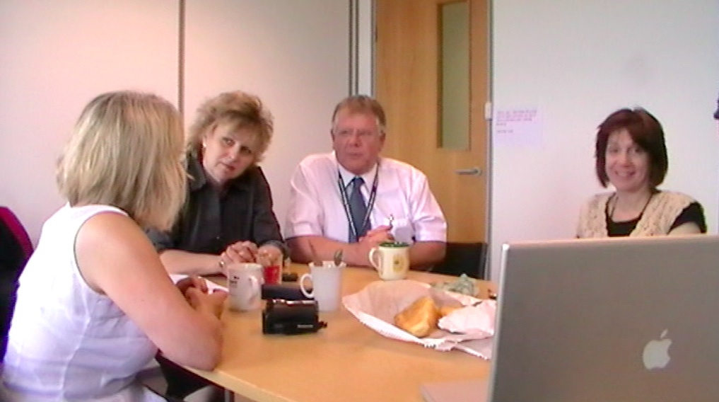
Figure 13 Chris, Sandra, Nigel and Kate
The expression of the inclusive, emancipating and egalitarian relationship is clear to me as I look at the connection between Sandra and Chris. In that moment, frozen in the image above, is an instance of the flow of loving recognition, respectful connectedness and educational responsibility between people. As they enquire as Living-Theory researchers, they co-create knowledge of self in and of the world in the living-boundary between them. The knowledge is embodied as well as intellectual; head, heart and body engaged in the process of enhancing educational learning of each and all.
And me? I live my egalitarian value in contributing to the co-creation of knowledge of self in and of the world as a silent presence on this occasion. You cannot see me, as I am videoing the session, but I hope you can sense my contribution to the creative collaboration, living my ontological and social values. I am expressing my values of inclusion as I ask you to focus on and value each person’s unique gift of their talents and knowledge to enquire collaboratively to enhance practice in the local authority.
In taking and offering this video as an educational gift I contribute to the emancipation of each and all in their learning. I want to stress that this is a gift freely offered as an expression of my educational responsibility. I make no claim of ownership or demand for acknowledgement. To do so would for me be a violation of the love and trust of educational relationships and space I value and want to see expressed more fully in the world.

3.3 Clarifying values in living-boundaries
The Café takes place from 8am to 9am. The timing is not just for mutual convenience. When it began there was potentially destructive criticism by some who did not wish to participate and who did not want the opportunity for others to research to improve their practice either. I will not speculate on their motives but I found it curious that there were adverse comments particularly about the sounds of laughter that emanated from the meetings and the pleasure and energy people brought out with them. The ambiguity of 8am – 9am, as being ‘in’ work time and ‘before’ work, helped to allow for creative, collaborative enquiry in uncharted waters to be developed within a target-driven culture.
Coffee and croissants add a feeling of informality for personal stories to be shared and the relevance to practice understood. I am distinguishing ‘personal’ stories as those expressions of the life-affirming values we each wish to live fully. These personal stories provide respectful insights into self and enable a loving recognition and respectful connectedness to develop within an educational relationship. I understand what is private to be that which a person does not want to be made public. There is no clear, set distinction as to what is private and what is personal. In my context the phrase, ‘too much information’, usually accompanied by a wry smile and shaking head and hand indicates that someone is crossing the line between personal and private.
Most of my practice is concerned with generating educational relationships, space and opportunities in living-boundaries. I shared some of my work in these living-boundaries in this chapter and in the process have begun to give you some insight into my work. For instance, I begin the visual narratives with a picture of a child at an APEX Saturday workshop and try to communicate the nature of the physical, emotional and intellectual space it offers children in the living-boundary between school and life. I begin the multimedia narratives with one set in a collaborative, creative enquiry day where children and teachers are co-learning as mathematicians. If you bring to mind the video of Louise and Louis I hope you have a sense of the living-boundary between them that is flowing with a life-enhancing and life-affirming energy and is inclusive, emancipating and egalitarian. That is the nature of the space I want to create by offering such events.
I have begun to clarify the nature of the social values that are an expression of the impersonal, yet life-enhancing, qualities of the common good that I sense in the description by Lee and Rochon (2009) of a complex ecology. What I think they miss is the presencing of a person living their ontological as well as social values as fully as they can. Similarly when a person talks only of their ontological values and is concerned only with creating a satisfying existence for him or herself I feel they create a barren wasteland in the boundary between self and other, rather than a living space for co-creation of knowledge.

3.4 Postscript
Through this multimedia narrative I have drawn your attention to expressions of my ontological and social values, which form the explanatory principles and living standards of my living-theory praxis.
In the expression of life-affirming and life-enhancing energy in a loving recognition of self and other, establishing respectful connectedness and expressing an educational responsibility for myself and towards others I am understanding what it is to live a loving life.
In developing and offering talents, expertise and knowledge I value as gifts in the process of living my values as fully as I can I understand what it is to live a satisfying life.
In offering talents, expertise and knowledge as gifts that enhances well-being and well-becoming of each and all and making this a better world to be I understand what it is to live a productive life that is worthwhile.
I address gifts and talents as educationally influential notions and the development of inclusive gifted and talented theory, practice and provision in Chapter 5. First I offer you an account of the evolution of my living-theory praxis to exemplify what I mean by Living-Theory praxis.

Chapter 4 My living-educational-theory praxis
So far I have introduced my work and myself in Chapter 1, an argument concerning Living-Theory praxis in Chapter 2 and a clarification of my values in Chapter 3. These serve as the context for this chapter as a meta-narrative of my living-theory praxis. I do not want to confuse what I mean with Lyotard’s (1984) notion of a meta-narrative as a sociological concept. Rather, I want to communicate a notion of a living, values-based explanation that connects my learning journeys, the various activities in the living-boundaries between the worlds that form the complex ecology of my practice and being, and my educational beliefs and theories.
I hold to the injunction, ‘educator know yourself’ as I recognise that my embodied, and often tacit, values, beliefs, theories and knowledge have consequences in my work. This narrative therefore includes some account of my journey of self-education. So, I begin this chapter with a brief résumé to contextualise the development of APEX, which I was employed to develop and coordinate as a senior educational psychologist. I then explore the development of some of my main activities, which evolved in response to questions that have been, for me, generative and transformational. Finally I offer evidence and explanation for the influence I claim to be having in researching my practice to improve what I do as I evolve my living-theory praxis.
Sections as signposts in this chapter
4.1 A brief résumé
4.2 How do I hold myself accountable to my employer and myself?
4.3 What can I do to enable more children and young people to learn to develop as lifelong successful learners?
4.4 How can I enable more children and young people to come to know their passions for learning?
4.5 How do I enable children, young people and educators to experience themselves as experts developing expertise?
4.6 How do I improve support for learners developing as expert enquirers creating and offering valued knowledge?
4.7 How do I enhance the educational possibility and influence of educational researching communities and educational space within living-boundaries?
4.8 How do I evidence and explain my educational influence in learning?
4.8.1 Have I had an educational influence in the learning of others?
4.8.2. Have I had an educational influence in the learning of social formations?
4.8.3 What is the explanation of my educational influence in learning?
4.9 Postscript

4.1 A brief résumé
When I began this research programme in 2006, I knew in one sense what I was doing and how I was doing it, but could not give myself a satisfactory response as to ‘why’: I could not articulate the explanatory principles that underpinned my development of APEX and give a reasoned, reasonable and coherent explanation for why I do what I do. In that sense I could not say that I really knew what I was doing.
Furthermore, I could not give myself a satisfactory response to the question, “Is what I am doing making a difference that matters?” The forms of data available enabled me to monitor but not evaluate my work, and did not enable me to hold myself accountable to standards that were important to me. In the process of evolving my living-theory praxis I now believe I can do the following:
- Articulate what my practice was
- Give a reasonable and reasoned explanation of my educational influence in learning
- Provide a rationale that underpinned and informed the development of APEX
- Illustrate the dynamic creative relationship between my values, theory and practice
- Offer standards by which I can evaluate what I do and hold myself to account
- Provide a form of evidence by which I and others can judge the validity of my claims to be making a difference that matters
My practice is concerned with the creation of educational relationships, space and opportunities for the development of talents, expertise and knowledge as educational gifts. The knowledge with which I am particularly concerned is that created, recognised, valued, offered and worked with by learners of the world, themselves, and themselves in and of the world. With respect to educational gifts I focus on enhancing the educational influence each learner has in his or her own learning as thoughtful, thought-full people, knowing themselves, evolving informed aspirations, and developing the confidence and competences to pursue them and able to contribute to their own learning, well-being and well-becoming and that of others. This, I believe, is consistent with my ambition to contribute to each learner’s ability to evolve responses for themselves to questions of the form, “How do I live a loving, satisfying, productive and worthwhile life?” My prime concern is with improving educational relationships, space and opportunities that benefit children and young people. However, I also have to be concerned with adults. It is they who are significant influences in the lives and learning of the young, and it is they who have the power to determine the intellectual, emotional, physical and social climate of the learning experience and to what relationships, space and opportunities children and young people have access.
I understand my contribution to the quality of that educational experience in terms of enhancing the possibility of each learner to extend them selves a loving recognition, establish respectful connectedness and express their educational responsibility for themselves and towards others. I also accept a systemic responsibility to enable a supportive culture that is inclusive, emancipating and egalitarian.
I have provided ostensive definitions of these terms in the previous chapter. I remind you here of the simple lexical definitions I gave in Chapter 1 where I began to clarify the language of my research, practice and thesis (pages 35-40). By inclusive I mean an educational context where each person is valued, and where there is an intention to enable all to benefit from, and contribute to, their own learning and that of others as fully as possible. By emancipating I mean that each person is respected as responsible for the educational influence they have in their own learning and life, that of others and society. By egalitarian, I mean a culture where there is an expressed belief in human equality and ‘power’ is expressed with rather than over other people to make this a better world for each and all.
This quotation, attributed to Nelson Boswell, explains succinctly the notion I have been developing of talents and gifts from an educational perspective:
‘The difference between greatness and mediocrity is often how an individual views a mistake.’ (http://quotationsbook.com/quote/26686/)
So, with aspirations of great educational learning I will endeavour to narrate my journey informed by my mistakes, and occasional successes and viewed for their generative and transformational possibilities.
I will bring into focus a few key activities that constituted my practice, leading APEX. These relationally-dynamic activities are distinct but not discrete. In communicating the nature of the educational relationships, space and opportunities that I try to form within living-boundaries, in the complex ecology of my improving practice, I will clarify:
- My evolving living-theory praxis enabling individuals to know more of what they want to do during their life, and gain the confidence and develop and offer as gifts, the talents, expertise and knowledge which will enable them to live a life that is loving, satisfying, productive and worth living for themselves and others
- What I mean by developing in living-boundaries educational relationships, space and opportunities that flow with life-affirming and life-enhancing values
- How I live my ontological values of loving recognition, respectful connectedness and educational responsibility and contribute to the evolution of an egalitarian, inclusive and emancipating society, where education enables each learner to have a valued and valuable educational influence in learning and life.
An overview of APEX contextualise the particular activities I will focus on in this chapter. I produced this summary for schools in 2011:
APEX is supporting and promoting the improvement of inclusive gifted and talented educational theory, practice and provision to the benefit of all.
APEX rests on the beliefs are that each person is capable of:
- Valuing themselves as an expert able to develop their expertise in their own learning
- Developing and enhancing talents
- Creating, offering and accepting knowledge of the world, themselves and themselves in and of the world as a gift, to enhance their own well-being and well-becoming and that of others
- Coming to know and give living expression to the values that give their life meaning and purpose and create their own living-theory
The difference APEX is intending to make is one that enables children and young people to develop their passions for learning and knowledge creation, become emancipated in their learning and life and come to know what they want to do, which will enable them to live a life that they judge to be loving, satisfying, productive and worthwhile living for themselves and others.
APEX contributes to the creation of educational relationships, space and opportunities for valued knowledge-creating enquiry in the physical and virtual worlds. The focus is on enhancing the educational influence each learner has in their own learning as thoughtful, thought-full people, knowing themselves, evolving informed aspirations, and developing the confidence and competences to pursue them and able to contribute to their own learning, well-being and well-becoming and that of others.
APEX contributes to improving a supportive culture, forms of educational evaluation and accountability and amplifies the influence of those life-affirming and life-enhancing values by working with educators, schools, FE and HE, communities, organisations and local authority services and departments.
Opportunities are being created with and for children, young people and educators to develop and offer as gifts their talents, expertise and knowledge to improve the educational influence they can have in their own learning, the learning of others and the organisations and communities they are part of, for instance: APEX Saturdays and Summer Learning Opportunities; Masters accredited educational research accounts of learning; the Living Learning Research Project; the Living Values Improving Practice Co-operatively CPD project ; Collaborative, Creative, Enquiries; Improving Practice Conversation Café; virtual researching communities…

Through the rest of this chapter I will focus on the questions that have emerged through my practice over time that form and inform practice, in roughly chronological order. This will help you gain a sense of the evolution of my living-theory praxis and improving practice. I will repeat some details to remind you of the historical context so you can recognise the continuing influence of the past within the present.
I continue to find the picture I developed for keeping a balance in the development of activity useful, and the next sections make reference to this.
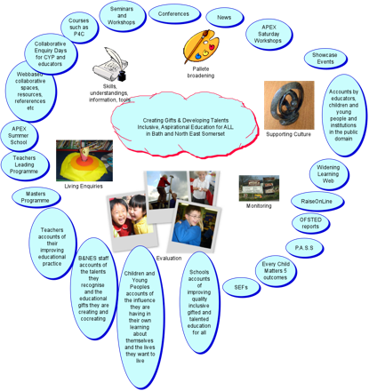
Figure 14 Framework for developing APEX
I wish to be clear that I am not intending to suggest that each activity is developed and then left behind, or the educational value of each can be understood in isolation. Rather, the activities and the continuing efforts I make to improve what I am doing, interweave and contribute to the complex ecology influencing the progression of my work. For instance, I continued these various activities as I explored the implications of researching those questions that the activities generate. This is not a start, stop, and begin again, process. Rather, it is a living process. I have expanded a little on the nature of that research process in Chapter 2 (pages 51-85) on Living-Theory praxis and I do so more fully in Chapter 7 (pages 222-241) where I detail Living-Theory TASC.
I start with one of the earliest questions I asked as I began to develop what became known as APEX. I had asked a similar question as I worked as an educational psychologist in school psychology services.

4.2 How do I hold myself accountable to my employer and myself?
In holding myself accountable to my employer, a public service, I did so with regard to the values expressed in their vision statements, such as these on the Bath and North East Somerset website, 29August 2011:
‘We want all Children and Young people to enjoy childhood and to be well prepared for adult life.’
‘We want all Children and Young People to do better in life than they ever thought they could. We will give children and young people the help that they need to do this. - Our vision. Children’s Services’
Although details changed with time, the underlying values expressed did not. With this in mind the key question, the one that underpinned all my activities, is of the form:
How can I help children and young people learning to live loving, satisfying, productive and worthwhile lives through my professional practice as a senior educational psychologist?
I held myself accountable to my employer with an appreciation of my educational responsibility, towards others and for myself, to have an educational influence in learning of individuals and the collectives they constitute. Through my living-theory research I sought to make the best contribution I could to improving the education of children and young people towards whom the local authority expressed the local community’s responsibility. In holding myself accountable to my employer I also held myself accountable to living my ontological and social values as fully as I could by researching to improve my professional practice.
I believe you can see me holding myself accountable to my employer by my identifying a need, and subsequently the role I took in leading the creation and implementation of the policy adopted by the council in 1999, which has not so far (January 2012) been rescinded:
‘Bath and North East Somerset LEA is committed to a partnership with schools, challenging and supporting them in improving standards and ensuring that all pupils have their abilities identified and promoted.
Bath and North East Somerset LEA is committed to a partnership with parents and the wider community.
It is recognised that many pupils have particular strengths in one or more areas of ability, endeavour or talent. Areas that have been identified include:
- Academic and Intellectual
- Expressive and Performing Arts
- Sports and Physical
- Social, Leadership and Organisation
- Visual, Spatial and Mechanical
- Design, Technology and ICT
Bath and North East Somerset LEA aims to increase the opportunities for individual pupils to explore and develop areas of ability to their own and society’s benefit by:
- Increasing awareness of pupils with abilities and promoting a positive view of their needs by all those involved with children and young people including schools, colleges, the community, and parents
- Supporting schools in extending and developing a variety of responses to meeting the needs of pupils with abilities, improving standards and promoting a culture which seeks, applauds and promotes achievement
- Encouraging and facilitating communication and co-operation between personnel in all areas of the Council and beyond
- Establishing links and forming partnerships with parents, community groups, colleges and universities, businesses, other LEAs and national associations such as NACE (National Association for Able Children in Education)
- Promoting research, development and dissemination of information in the area of meeting the needs of pupils with abilities.’

The development of the questions and responses that follow shows how I continued to improve practice, evaluate my work and to hold myself to account to my employer and myself. I distinguish evaluation as the evidence that enables me to demonstrate the contribution I made to improve the educational experience of children and young people. This relates to my values as living standards of judgment and to the policy statement of my employer. I understand that to be accountable is to be able to give an account with respect to my values as explanatory principles of my practice and the values-based vision of my employer.
I want to repeat that the process of evolving my living-theory praxis is relationally-dynamic and multidimensional: as responses to one question develop they inform the development of each and other responses to other questions. Although the questions roughly reflect a chronology, the development of the activities weaves in and out of time and space. For instance, the policy arose from the work I had already been doing in response to the next question I come to. As the saying goes, ‘The sum of the parts is greater than the whole’.

4.3 What can I do to enable more children and young people to learn to develop as lifelong successful learners?
I spent a great deal of time as an educational psychologist focussing on what children found difficult until, during the mid 1990s, I became interested in what enables people to grow to be adults able to live satisfying and productive lives making outstanding contributions to society. I began to explore what the field of ‘high ability’ had to offer to prepare children to live such futures. After a relentless and increasingly bureaucratic focus on ‘special needs’, many schools and teachers were also eager to refocus on how they might develop their pupils’ ‘strengths’. It was also at about that time the government of the day commissioned the Third Report of The House of Commons Education and Employment Select Committee on Highly Able Children (1999). I made a contribution to this report, which was included in the memorandum (Huxtable, 1998). The findings of the select committee were ignored for the most part by the Government, which went on to develop the Excellence in Cities venture and the National Gifted and Talented Strategy.
The more I explored the subject the more I came to the conclusion that the features of ‘high ability’, thinking, higher order learning, creativity, and successful learning were in essence the same, and were learnable rather than ‘hard-wired’. I developed my own ideas on key features of ‘successful learning’ and the implications for teachers and schools, which I summarised in various papers such as an article entitled ‘Everyone a winner - Towards exceptional achievement of ALL’ (Huxtable, 2005), and in my contribution to, ‘Creative and Philosophical Thinking in Primary Schools’ (Huxtable, Hurford, and Mounter, 2009).
The way I can have the largest effect on improving the educational experience of the majority of young learners is to have an educational influence in the learning of the educators who have daily responsibility for those children and young people. I therefore spread and developed these ideas over the years by running events for teachers lead by leaders in the field, workshops and INSET and through offering to lead on developing and implementing the policy on high ability and related local strategies, such as developing ‘Widening Learning’, ‘Thinking’ and ‘Action Research’. As well as running workshops and INSET sessions myself, I worked with schools and others, developing and implementing inclusive gifted and talented educational policy.
Do I have evidence that I have had any influence in the improvement of the educational experience of children and young people? Some schools are developing inclusive gifted and talented educational policy, practice and provision and others revisit these ideas when inclusion, personalisation of learning and education, rather than schooling, takes priority. Where did I fail to have as much influence, as I wanted? Notions arising from the 19th century (White, 2006) are still those that dominate thinking and practice in schools. This is compounded by the ‘market’ approach to developing education as a commodity (Sachs, 1999) promulgated by successive governments in England and elsewhere.
However, I am not a lone voice. I created the opportunity to amplify the voices of who have similar educational values to myself and offered events for educators to hear and work with leaders in the field. It was not my intention to provide a platform for charismatic speakers to provide edutainment. I wanted to offer inspiring sessions where educators might leave thinking of educational experiences to develop the abilities and life-chances of all their pupils.
Over the years I have invited many such field leaders to share their work, for instance, Belle Wallace (TASC), Robert Fisher (thinking skills), David Wray (Writing Frames), Barry Hymer (Philosophy for Children), Ted Wragg (questioning), Guy Claxton (learning dispositions) Jack Whitehead (Living-Theory Action Research) and many more. I wanted to add to the palette of teachers’ thinking, the slow burn that transforms practice rather than the quick fix that papers over cracks. Using Renzulli’s (1997) idea of different types of learning opportunity, (introduced on page 28 in figure 5) I conceptualised these as learning opportunities for educators to play with ideas and the knowledge being created by others, and reflect creatively on educational theory, practice and provision to imagine possibilities of improving their own.
The success of my venture can be seen in those schools where there is evidence of the deep and profound learning (West Burnham, 2006) that occurred stimulated by these events, often passed on from people who attended years previously. However, I failed to develop my influence with as many Head-teachers as I would have wished. As CPD became a part of national strategies, the less teachers and schools took the opportunity to explore what is not prescribed, and the more they bought into packages promising to quickly and easily improve results.
School-based practice and provision is only one aspect of the educational experience of children and young people. Freeman (2002) shows that people mostly find their passions for lifelong learning outside of school. Pursuing passions for learning often seems to lead to a person living not only a more productive life but also a more satisfying one. Which led to the next question...

4.4 How can I enable more children and young people to come to know their passions for learning?
When I thought about people I knew who had found their passions for learning, they pursued them with a relentless commitment and often made a significant contribution to their own lives and that of others in the process. They often seemed to be introduced to what became a passion, by family, friends of family, a chance meeting, or, occasionally a teacher. I began to think, “what about children who do not know about the possibilities that might be their inspirations for a satisfying and productive vocation because they do not have a family member or teacher who offers them the connections or excites their interest?”, “How can I expand their palette of experiences to draw on which might enable them to come to know their passions for learning?” In 1998, as I developed learning opportunities for teachers and schools, I added APEX Saturday workshops for children and young people in response to my question, “How do I know what I want to do if I do not know what I want to do?” I wanted to give children and young people a taste of themselves as forensic scientist, artist, juggler, engineer… and to cognitively, socially, emotionally, physically and personally go somewhere new, to imagine possibilities and play with ideas and personas. I group these as the sort of learning opportunities Renzulli (1997) refers to as type 1. I laid out my rationale for the APEX workshops in, ‘The Elasticated Learner and the purpose of beyond curriculum learning opportunities in a Local Education Authority’ (Huxtable, 2003).
The programme was eventually fully funded, first by the local Authority, and then by the schools through the DSG.I continue to see a place for APEX Saturday workshops. They offer opportunities beyond those that a school or cluster can offer and are in the boundary between school and life. In running them, I have continually challenged my thinking to improve my understanding of what distinguishes these workshops as quality learning opportunities from others such as classes, clubs or fun activities, and the nature of the educational influence in learning participants’ experience.
I have anecdotal evidence that the workshops created or fed a passion for many participants. I also have the sense of excitement that spills out with the children and young people from the workshops when their parents collect them, and they ‘vote with their feet’: many have been to workshops for years. If numbers communicate anything, in the academic year 2010-2011, 140 workshops offered 3,242 places to KS1-4. 7,564 applications were received. 35% of places were allocated to vulnerable children and young people identified as ‘harder to reach’ at risk of underachieving. Parents, children and young people consistently gave very positive feedback and demand increased.
I have had parents tell me how an experience on a workshop has contributed to a career decision of their son/daughter, or given them confidence, or an insight into the relevance of some of their schoolwork, or they have insisted they share their experience, or they wanted to find out more. Unfortunately parents do not provide written accounts. However listening to the parents tells me that for some children, the experience of learning in the boundary between school and life has opened their eyes to themselves and possibilities to explore.
Teachers have told me that their pupils have communicated their learning and enthusiasm from the workshops afterwards in school. Unfortunately teachers no more want to write than do parents. In some schools, children have had the opportunity to share their experience with other children, which has moved the learning from the boundary between school and life into school.
This is an extract from one note I received that illustrates the sort of influence I am told I have had:
‘Dear Marie
A few years ago you provided me with advice and information which helped me set up a programme of enrichment for able children based around W School in Y. The APEX programme and the Bristol and Bath Mathematics Masterclass programme were the inspirations for the programme…’ (personal email to me through APEX, 20th September 2011)
Teachers told me that young people have other things to do, such as part-time jobs, homework, sports, and sleeping. Young people and parents told me they did not know there were APEX workshops for them, even when they have attended such groups for years in primary school. When young people receive personal letters from their school inviting them to attend, the subsequent take up and attendance has been high.
Demands on school staff concerning target-driven agendas are considerable and increasing. This reduces teachers’ time and inclination for knowing the majority of their students as individuals with unique needs and contributions to make and develop, or facilitate access to, educational relationships, space and opportunities. The affects of the increasing privatisation of education as a commodity are yet to be seen. The development of the APEX Saturday workshop programme as an opportunity for learners and educators to co-learn also arises from my work on collaborative, creative enquiry, which I come to later. As I begin to bring into this account the threads these various questions and responses have led to, I know that I may be confusing, as the relationships are not linear, but accounts are always restricted by their linear nature.

4.5 How do I enable children, young people and educators to experience themselves as experts developing expertise?
To transform dreams into aspirations that are acted on learners have many psychological needs. One is to be able to imagine themselves living their dreams. Professor Pausch (Pausch and Zaslow, 2008), in his moving ‘Last Lecture’ at Carnegie Mellon, gives a good example of what I mean. Another is through the opportunities and support to behave as the expert they want to become. You do not learn to become a champion cyclist by learning to fall off, you learn by practicing the skills, attributes and attitudes of the expert cyclist you are in the process of becoming. Some of the Saturday workshops offer a taste of being an expert developing expertise, but I wanted to extend this. I could not see how a teacher could support their students in this way unless they knew what it was to be an expert developing expertise in an area of their passion. To enable teachers and learners to experience developing expertise in their field of passion I created collaborative, creative enquiry days. Initially I offered opportunities for one teacher to bring four pupils to work with teachers, and pupils from four other schools, as co-learners, developing their expertise as experts in a field of their passion with a field expert. This notion arose in a conversation with Pauline Miles back in 2004 (the notes are unedited):
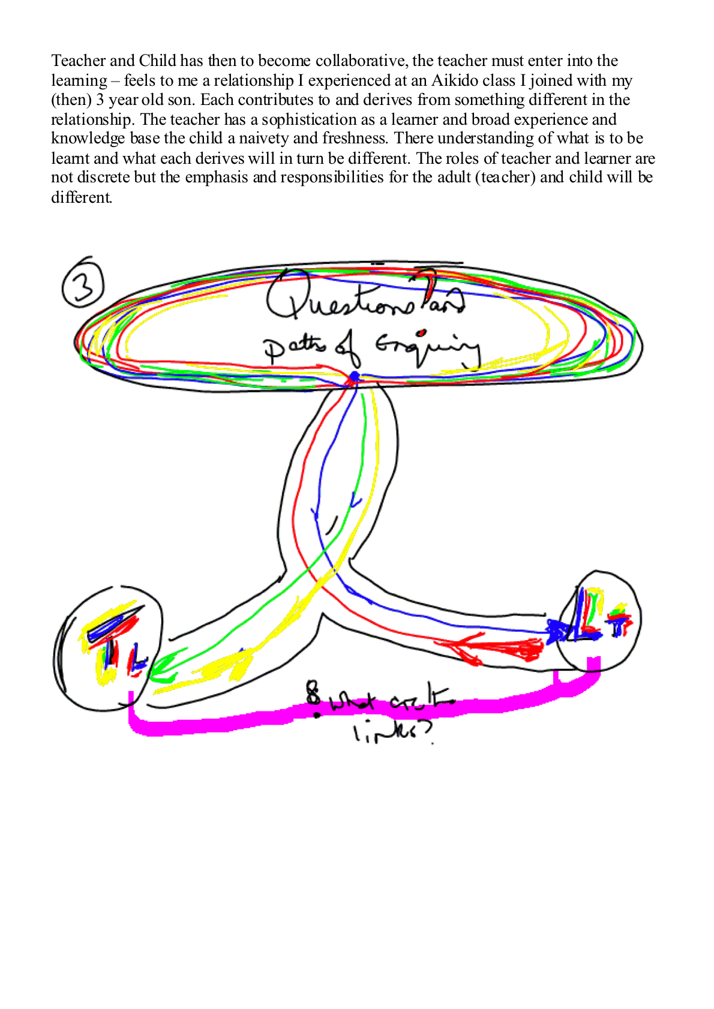
Figure 15 Representation of relationship between teacher, learner and enquiry

In offering these collaborative, creative enquiry days, my intention was not simply to provide the opportunity for adults, children and young people to develop their expertise. I wanted educators, as their pupils and students, to experience themselves as learners creating knowledge of the world, as experts developing their expertise, and for them to recognise the possibility for improving their educational practice. In practice, this also opened the eyes of many teachers to how far their pupils/students were in advance of the ‘diet’ they were being offered in their schools, and some teachers began to appreciate their pupils/students as co-learners. Children and young people were also able to see their teachers as valued co-learners who had expertise to offer beyond the limitations of the school curriculum and beyond the confines of the school.
Evidence, of the educational influence in the learning of the educators and young learners, was provided when some participants led a workshop at a leading teachers day organised by the Local Authority’s Primary School Consultant. The children and teachers worked together using their experience as writers, and the skills and understandings they had developed with the authors on the creative, creative enquiry days, They worked together to engage the audience of leading teachers as creative writers developing expertise as co-learners. The children and adults worked collaboratively to create an inclusive, emancipating and egalitarian culture of learning within the session.
As the collaborative, creative enquiry sessions have preconceived learning outcomes, preconceived by the developer and ‘deliverer’ who is expert in the field, I have thought of them as examples of Renzulli’s type 2: opportunities to develop skills, expertise, understandings, information and tools. Learning opportunities with preconceived outcomes are the mainstay of national strategies developing the given curriculum in various forms: the national curriculum; a curriculum for the 21st century; a creative curriculum; a skills-based curriculum; a curriculum that is irresistible. These are ‘delivered’ using various, often prescribed, instructional and pedagogical strategies. Enquiry and problem-based learning approaches are used in the delivery of these forms of learning opportunities but the learning assessed is inevitably the learning prescribed by the teacher and not the learner.
A form of this type of learning opportunity is the main experience offered to teachers as training to deliver the curriculum. It is hardly surprising that they in turn train their pupils and students. I was concerned to expand the teachers’ palette of learning experientially. As a consequence, I asked Jack Whitehead in 2005 to offer modules for a professional Masters programme. My intention was to provide opportunities for educators to learn to research their own educational practice. I will return to this later. My intention also led me to further develop collaborative, creative enquiry opportunities to develop knowledge-creating research with an insistence that adults participate as co-learners with the children and young people they brought with them.
I have begun to understand and develop this sort of learning opportunity but have some way to go to know how to evaluate the educational influence of such learning. The acquisition of skills, understandings, knowledge and ‘tools’ that already exist is seen to be the most important form of learning by most institutions. This is despite the fact that, for the most part, what most people of all ages learn of importance to them is not what is directly taught or intentionally inspired, but rather what they learn incidentally and through following their interests and developing passions for learning.
There are various ways of understanding whether ‘learning’ has ‘happened’; Bloom’s (1956) taxonomy is one example. The question, “What have you learned?” is often used at the end of an objectives-led workshop or lesson. When it cannot be answered, the assumption is that the participant has learned nothing. However, it is the language of the question that dictates the answer. I think Biesta (2006) is right when he says we have a language of learning and need a language of educational learning. Staring out of the window, playing with materials, appearing uninvolved with the tasks and activities set, are all seen as further evidence of a lack of learning, although the learner may have taken something important educationally from the experience and be engaged in deep and profound learning and creative thinking. What also need to be developed are appropriate approaches to monitor and evaluate educational learning. As assessment and intervention are intimately interconnected, so too are conceptualisation of outcomes and the educational quality of the event. I go into this in more detail in Chapter 5 when I introduce the development of inclusive gifted and talented educational theory, practice and provision. Whitehead’s work on multimedia narratives offers fertile ground here, which I have been exploring (Huxtable, 2009b) and take up in Chapter 6.
The flier (Figure 16, page 134) for a session on 6 October 2010 gives some indication of how this work developed and is interconnected with other types of learning opportunities. These opportunities include those for learners to research to create knowledge of the world driven by their passion. The title, ‘Learning to Research: Learning to Make a Difference That Matters’, was intended to point to the form of research I want to spread more widely.
Ask children, young people and their teachers what they understand by research and most will tell you that is about finding out what is already known and re-presenting it in some form. Although learning may get to the ‘higher’ levels as described by Bloom (1956) or Haring et al. (1978), more often it is no more than extended responses to, “What do you know about…?” I accept there maybe a place for such activity but find no justification for the assumption that it is an essential precursor to knowledge-creating research. Unfortunately the domination of research construed as gathering, organising and re-presenting what is already known reduces the value that many people have for themselves as capable of creating and offering knowledge of worth. Humans come into the world imaginative, creative learners. Their creativity is squeezed out of them, with their confidence, so that many do not pursue their passions and make the contribution they might to enhance their own learning and life and that of us all. I have heard a professor of philosophy in education claiming that it is only at postdoctoral level that knowledge-creating research is possible and even then was restricted to the prevailing paradigms. I found this ironic as I thought of the account by 6 year olds of their research to create their own learning theory.
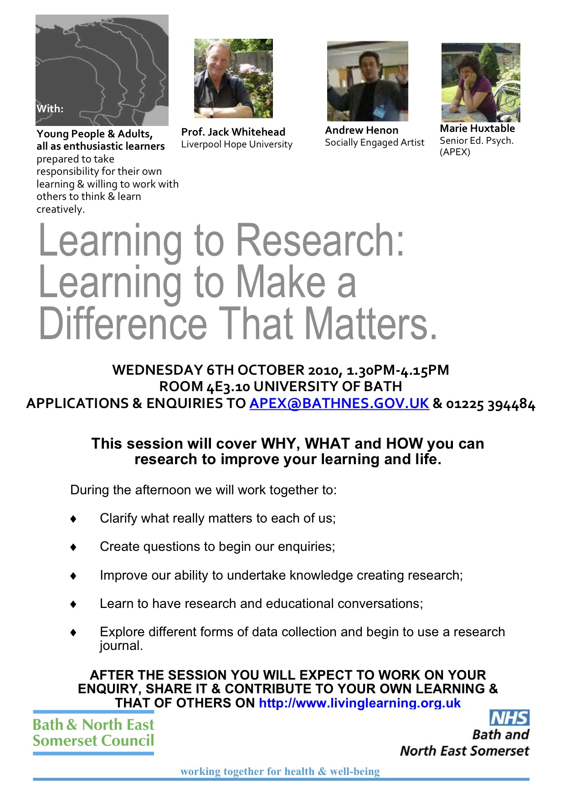
The flier below summarises succinctly the form of research I believe is important and which is not generally taught or supported in schools. It is not only the outcome in terms of the quality of the knowledge created that is important; it is also the quality of the educational experience of the research process. The venue is not simply for convenience. I wanted to place student and teacher outside of their school with its constraints of a given curriculum and established roles, to offer them the opportunity of co-learning in the living-boundary between them.
Figure 16 Learning to Research: Learning to Make a Difference That Matters, leaflet

What evidence is there of the influence I want to have? The collaborative, creative, enquiry days I have offered over the years for writers, mathematicians, choreographers, scientists, artists and action researchers have all met with the same enthusiastic response from adults, children and young people. They are energising and have stimulated unforeseen possibilities. For instance, as a result of the 8 July 2006 day in the Guildhall, more fully described in a paper for the BERA 2008 conference (Huxtable, 2008b), I was told:
‘2 of our girls did a power point presentation to the FULL GOVERNING BODY of our school starting with......WE are passionate about school dinners! STUNNING, AMAZING, SIMPLY INSPIRING! Governors were very surprised but liked the fact that the girls did it! It will be followed through in Sept!!!!!!!!
… The presentation the children did was...wait for it... the VERY NEXT DAY on the Thursday! That is how inspired they were!!!!’ (Extract from personal email from primary head teacher 17 July 2006)
Subsequently those children contributed to the development of the school lunchtime menus. The idea of creating and offering knowledge as gifts through research persisted, and the following year children researched to create a gift to offer the school when they left Year 6.
I believe there is still a role for such days. In using Renzulli’s notion I have realised that there is little, if any, space or time made for ‘type 3’ – researching an area of personal passion to create and offer valued knowledge as a gift to self and others - within the school day for teachers, children or young people. This leads me to my next question.

4.6 How do I improve support for learners developing as expert enquirers creating and offering valued knowledge?
This is the question to which my initial efforts in developing collaborative, creative enquiry have become a stepping-stone to answering. The one-off days for educators, children and young people working with a creative writer, mathematician, scientist, engineer, choreographer, and researcher… were successful in that adults and children went away enthused and inspired to develop some ‘guild skills’ as Chris White (a colleague from Bath Spa University) termed them. What I am still enquiring into is how to:
- Develop support for ongoing disciplined research by learners to create and share knowledge of the world in an area of passion and
- Create a sustaining educational researching community, which is not school-based, to enhance a learner’s educational influence in their own learning, the learning of others and the learning of social formations
These may or may not be resolved simultaneously. I know how to create a learning opportunity to enthuse on the day, and many participants leave wanting to do more. What I have not yet understood is how to create and sustain researching communities in the living-boundaries between the worlds of ‘school’ and the ‘real world’.
During a conversation with Gary Mathlin (an astrophysicist at the University of Bath) who had worked with me on many of the collaborative, creative enquiry days, we touched on what it is that leads people to practice for hours with focussed cognitive engagement to develop skills and understandings associated with a field of enquiry. One question that arose was:
“How can the educator, as an expert in a field or domain, facilitate a learner’s acquisition of skills, understandings and knowledge, which will enable them to develop their knowledge-creating enquiry?”
In the process of facilitating a learner’s efficient acquisition of skills, understanding and knowledge, the ability and inclination to create knowledge can be actively discouraged. The problem appears to be the same irrespective of the age of the learner or the field of enquiry. When the teacher is focussed by predetermined learning objectives, tangential thinking and the exploration of unknown paths are seen as unwelcome distractions and the pupil/student learns to avoid such enterprise. As Gary described how he was developing a lecture for active learning, I was reminded of ‘games’ I was introduced to many years ago by Chris Ashman, then at Norton College. Chris said that he worked on the basis that his students could learn faster than he could teach, and so tried to find ways that did not slow them down. A book he had given me included a paper by Leigh, ‘What is expected of the facilitator of interactive learning? An answer based on consideration of facilitation of ‘open’ simulations.’ (pp. 9-18). In it she asserts:
‘Learning activities that engage the ‘whole person’ do so by inviting participants to bring into the learning space their knowledge and learning goals as well as their values, beliefs and emotions. Such an invitation makes demands on our ‘emotional intelligence’ (Goleman, 1995) which frequently exceed those of conventional teaching contexts. ‘Managing the learning’ in such contexts requires – among other things – courage to avoid acting prematurely, and an ability to attend to what is happening in the moment so that emergent learning is fostered and encouraged – which may even mean abandoning what was intended as the learning focus.’ (p. 9)
Leigh goes on to describe closed and open games in a way that I recognise as distinguishing features between traditional approaches to developing enquiry-based learning and our experimental approach developing knowledge creating research in educational researching communities.

Characteristics of ‘closed’ and ‘open’ simulations (adapted from Christopher and Smith, 1987 by Leigh, 2002, p. 10)

Closed games | Open games
‘This is the problem – how to solve it?’ | ‘This is the situation – what to do?’
‘Focus of Briefing Phase
. . . is on ‘togetherness’ | . . .is on diversity of players – disparity of views
Role of ‘Games Director’ / Educator
a benevolent authority figure. | . . . not a leader (this may be resented).
Rules for the Action
Players all have same rules | Few rules; little detail. Chance events occur on players’ whims.
Scenario / Setting
Play begins at a ‘moment of crisis’. Each step proceeds logically from one before. Action is goal-oriented / forward looking. Stimulus is towards co-operative problem solving / emphasis on outcome. | A journey – multiple plots and diffuse action. Stages not clearly marked. Changes occur because of players’ actions. No clear order and balance. Minor actions spin off in apparently illogical manner. Emphasis on reactions with more diverse happenings. Emphasises behaviour, not outcomes.

Outcomes – Focus of De-briefing
Players derive pleasure from shared experience. There are problems and answers. Conflict can be reconciled. | Players find themselves more thoughtful than pleased. There is a lack of certainty and an awareness of new possibilities.

This helps me see the connection with the second question that emerged from our conversation:
“How can the educator, as expert in the field or domain, help a learner develop their insightful recognition of the ‘nuggets’ of knowledge related to the field they create in the process of learning but lack the sophistication to appreciate and learn from?”
I do not see this being limited by age. I have yet to see anything that persuades me that adults learn differently to children. My growth is not a function of the number of years I have lived, although I hope I am more sophisticated having had more opportunities to learn from experiences and other people than when I was a child.
Schools are less willing than they were to allow staff and pupils off-site to participate in knowledge-creating enquiry with others, despite the enthusiasm of participants, even when there is an obvious curriculum link such as mathematics. Even with the development of the use of computers and better web access in schools, it has not yet proved possible to engage them with an educational researching community even in the virtual world. There is little attention given to the offering, accepting and valuing knowledge created beyond the given curriculum, and little space and support for knowledge-creating enquiry generated by learners wanting to research their passions.
Evidence of the contribution I have made to the development of opportunities and support for learners to develop as expert enquirers creating and offering valued knowledge, is in the accounts of Adrienne Hughes and Megan Morris, St Keyna’s Primary School (Hughes and Morris, 2010) of their passion-led learning project and Rob Sandel, Camerton Primary School (Sandel, 2010) who has developed the use of TASC; his work was commended in a school inspection.
Another example can be seen in the work of Sally Cartwright (2008). Having worked with the Masters group as an educational research community to enhance her own learning through researching her practice, she formed an educational research community to support students working on their AS Extended Project (a national qualification). In Video 11 (page 139) her students can be seen talking to the managers in the Authority of the 14-19 Strategy. In this 5 minutes 18 seconds extract for their 40 minutes presentation. Two of her students are explaining how working with Sally has enabled them to develop as expert enquirers creating and offering valued knowledge and to grow in their understandings of themselves and themselves in and of the world.
You can hear Simon at 1.10 saying how he has learned to communicate to a lay audience the knowledge he has created through his scientific enquiry. In the process he recognised something in himself that affected his future aspirations and in later life he was thinking he would “love” to be in science media. This is said with a confidence of self-knowledge which Louise shows as she explains what she learned from the experience. She begins at 3.00 by acknowledging that everyone’s learning journey is completely different. She describes the skills she learned and then at 4.10 she says and what she gained personally in learning to be able to address an audience. If you run the cursor back and forth around 4.22 you can get a sense of her embodied knowledge communicating with pleasure. Go right to the end of the clip and the pleasure and confidence of Simon and Louise as expert knowledge creators communicates very strongly as Simon says ‘… so thank you Mrs Cartwright’.
Video 11 Pleasure and confidence in knowledge creators

http://tinyurl.com/44of77d
I believe this video shows evidence of the educational influence engaging with an educational research community has in the learning of a student. As I watch the video, I see the students, express a loving recognition of themselves and others, extend a respectful connectedness and express an educational responsibility for themselves and towards each other. I expanded on this in an evidence-based analysis in, ‘Developing Talents to Create and Offer Knowledge of the Self and the World as Educational Gifts’ (Huxtable, 2009a).
Sally and her students showed me that there are two researching communities: one that connects the person with others who share their learning passion or field of enquiry, such as space travel, or AIDS… and one that is educational and connects the person with others with different passions but with enquiring minds involved in co-creating knowledge of the world and themselves in and of the world. These communities are distinct but not discrete, and can comprise the same people with the agenda moving between the two notions.
A disciplines research community offers access to the knowledge base, expertise and energy of that interest. Einstein is reputed to have said, ‘We act as though comfort and luxury were the chief requirements of life, when all that we need to make us happy is something to be enthusiastic about.’ There is a sustaining, creative and productive energy that comes from being with others who share our particular enthusiasms. This offers a community that not only supports the creation of gifts of knowledge of that world but also provides a discerning audience, where gifts offered can be appreciated for the valuable contribution they make.
An educational researching community offers relationships, space and opportunity in the living-boundaries between the various worlds that we each belong to, to co-create knowledge of self in and of the world; I mean here not the world of a particular interest but the world we want to make a better place to be. An example is the CPD/Masters group that I have supported with Jack Whitehead. Although the common denominator is a passion for improving education participants are from diverse settings and disciplines, for instance, an early years class teacher, the chief executive of the carers service, a socially engaged artist, school head-teachers and so on.
An educational researching community is created by people with shared values, who are both open to recognising, valuing and working with the gifts of unimagined possibilities that others offer, and also have the generosity of spirit to offer their own presence and knowledge freely as gifts. I recognise such a community when I sense an expression of my ontological values of a loving recognition, respectful connectedness and educational responsibility. I also need to experience the community as inclusive, emancipating and egalitarian. You may of course have a different way of recognising an educational researching community, which reflects your own values.
The space that APEX created for inclusive, collaborative, creative enquiry as researchers with Jack Whitehead has evolved to include something more than support for research to create and offer knowledge of the world. What I have moved onto, to enable me to develop APEX, is trying to understand the time, space and support which can enhance a person’s ability to learn more about themselves in and of the world and possible future paths to explore in the process of learning to research to create knowledge of the world. I continue to keep in mind that the purpose of education is as much, if not more, to do with young learners learning to learn and create knowledge of themselves and themselves in and of the world, than it is to simply become more sophisticated in creating and offering ‘disciplines’ knowledge.
Researching to understand these communities and the engagement of learners in them, to enhance their educational possibilities and influence, is important to improve inclusive, gifted and talented educational theory, practice and provision. The challenge is to do this with schools dominated by targets and actuarial forms of accounting for the quality of the educational experience children and young people are offered. This leads to my next question.

4.7 How do I enhance the educational possibility and influence of educational researching communities and educational space within living-boundaries?
There is little official requirement for schools to provide space and support for learners, adults as well as younger learners, to create and offer knowledge by researching their passions. I contend there is even less requirement for schools to provide space or support for learners to create knowledge of themselves in and of the world. This is not the space and support that government inspire packages concerned with personal, and emotional development, careers advice, or tutor time, offers. The focus there is on improving the learner’s compliance with predetermined expectations. The focus I am concerned with is on the learner and their learning journeys and adventures as they come to know themselves. The focus is on the knowledge they create of the person they are and want to be in and of the world: the knowledge of what it is that gives meaning and purpose to their life they create as they develop their expertise as experts in their own learning, and come to recognise and value the talents and knowledge they develop and enhance, to offer as life-affirming and life-enhancing gifts.
The accounts created in the course of their Masters programme by the educators working with Jack Whitehead are evidence that it is possible to create and offer educational space and support for learners to come more fully into their own presence, even in the present climate, by developing educational research communities in living-boundaries between school requirements and the educators’ desire to improve their educational practice. Many of these accounts can be accessed from http://actionresearch.net/writings/mastermod.shtml.
Enabling children, young people and adults to collaboratively develop as living-theory researchers offers the possibility of enhancing the educational learning of learners developing and offering talents and knowledge as gifts that improve their own and other peoples’ life chances, well-being and well-becoming. I believe this can be done as Leigh (2002) describes by:
‘…inviting participants to bring into the learning space their knowledge and learning goals as well as their values, beliefs and emotions’
As an educator I am concerned with enhancing the educational possibilities and influence of relationships, space and opportunities. I want, amongst other things, to enhance contexts that encourage young learners to explore themselves as knowledge creators of the world in a wide range of fields. This is so children and young people may learn to answer for themselves what it is to develop expertise for knowledge creation as an expert musician, mathematician, writer, dancer… This provides a palette of experiences for them to draw on to inform their decisions as to what they might find satisfying and productive to devote time and energy to as an adult.
I see living-boundaries offering an opportunity for educators to particularly focus on enhancing the educational learning of the individual, rather than focusing on attainment related learning and the impositions and expectations of other worlds, such as government, parents, communities, and the impositions of different values, beliefs and theories. Andrew Henon’s book, Creativity|WORKS (Henon, 2009), offers an example. He is making visible the educational space in living-boundaries he created through his development and management of the NESA (North East Somerset Arts) project and the creation of the book I particularly want to draw attention to pages 41-53. They show the contribution APEX, in collaboration with other people and projects, has made to creating living-boundaries between the usually bounded worlds of beyond-school learning opportunities, school, curriculum, and the worlds of pupils, students, teachers, academics, socially engaged artists and educational psychologists.
The first living-boundary created as an educational space that I recognise on re-reading Creativity|WORKS is that created by Andrew Henon (a socially-engaged artist), Karen Drews (a photographer), Gill Kenny (the class teacher), Gill’s colleagues and Head-teacher, myself and Gill’s seven-year-old pupils. We were all engaged in a collaborative, creative enquiry for artists
‘The sessions had two aims; to provide an opportunity for children and adults to experience themselves as artists, collaboratively developing talents with an artist, and second, to provide an opportunity for them to develop their talents as researchers creating, offering and accepting gifts of knowledge of themselves and the world.’ (Henon, 2009, p. 45)
The educational space was created in the living-boundaries between worlds of classroom, socially-engaged art and living research, between teachers and learners and educational researchers, and between the individual and community. In those living-boundaries, some of the children and adults recognised themselves as knowledge creators able to offer and accept valued knowledge. Look at the photographs below.

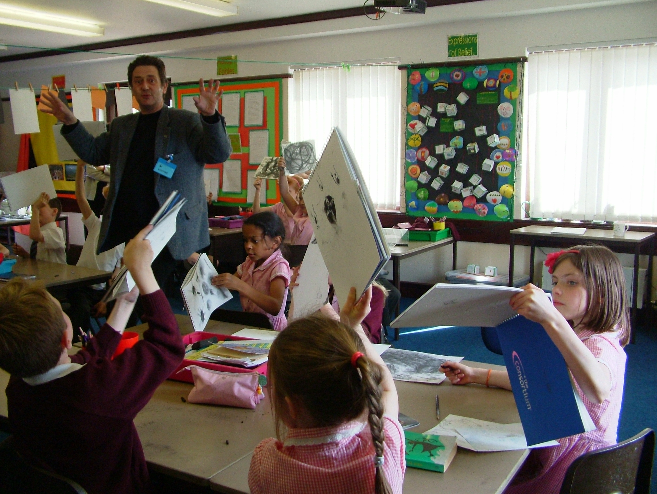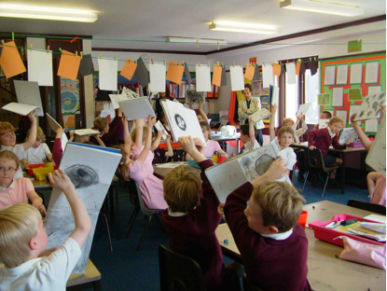
Figure 17 Andrew Henon leading a collaborative, creative enquiry as artists

In the first photograph, I see Andrew Henon inviting the children to share the unique marks they have created, two girls carefully deciding which they want to share, and a boy offering his to Andrew. In the second photograph, I see children offering and accepting the knowledge they have each created with interest and pleasure. Their eyes and books are not all directed towards Andrew. The children hold their books aloft for all to see and their faces are variously turned so they can look at the work of others.
Some of the children had taken responsibility for extending their own learning between the sessions as well as during them. For instance, one of the children had gone to the extent of making charcoal at home and bringing some of it to the workshop.
I wanted to share this venture with you as it was unusually within a school and with a whole class of young children. Up to this point I had only run these sessions outside of the classroom, and generally with older children as co-learners. What is not evident in these photographs is the relational dynamic in the space and the influence on the worlds that form the living-boundaries. This is more easily seen in the brief account of a collaborative, creative enquiry day in The Guildhall, in 2008.
80 children, young people and educators participated in a day held in the Banqueting Room, The Guildhall, Bath, facilitated by Jack Whitehead and myself. This day was also a step into an imagined but unexplored possibility. I had never before managed to create an educational space in the living-boundaries between such diverse worlds: school and beyond school, adult and child, teachers, academics, educational researchers, education administrators and many more.
The collage of photographs (Figure 18) gives you some feeling for educational space and the energy. I can see expressions of loving recognition, respectful connectedness and educational responsibility. I believe I can see in these photographs evidence of those in the space to be living the qualities of an inclusive, egalitarian and emancipating society.
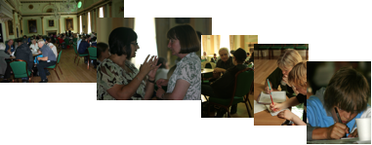
Figure 18 A collaborative, creative enquiry as living-theory action researchers
A better sense of the relational dynamic flow of energy which I am describing as an expression of loving recognition, respectful connectedness and educational responsibility and values of an egalitarian, inclusive and emancipating society] can be seen in this video. It compresses an hour of real time video into a 20 second experience.
Video 12 Relationally-dynamic flow of energy in expression of values in a large space

http://tinyurl.com/42vjdkh
There are a number of ways of engaging with this video. Watching the 20-second video played through communicates the energy that is flowing in the space as a whole. Sometimes individuals are addressing the whole room, sometimes immediate groups or those close by, but as you watch try to keep a relaxed focus so you also see the flow of energy in the whole space. Moving the cursor back and forth around a point is another way, which I detailed on page 99 where I begin to develop a multimedia narrative to communicate my ontological energy flowing values. If you flick the cursor back and forth across a particular point you can get a sense of the energy flowing within living-boundaries. For instance, moving the cursor back and forth at 3.15 seconds of video 12 you can see the movement within the foreground group. Keeping that movement in mind extend your focus to include others to experience an empathetic resonance with the rhythm of the energy flowing in an inclusive, emancipating and egalitarian space.
What I learned from that day was that it is possible to engage a diverse group in collaborative, creative enquiry. I also learned that the power and responsibility for learning is distributed in an educational research community. Each person recognises themselves and others as emancipated, equally valued members of the community or group, making their unique contribution to enhancing their own well-being and well-becoming and that of others. This is rather different to the dynamics of most learning groups where there is often a ‘leader’ and prescribed or negotiated outcomes that serve as a common goal.
This brings me to how I understand what I am doing as I evolve my living-theory praxis and the question…

4.8 How do I evidence and explain my educational influence in learning?
When I talk of ‘my educational influence’ I do so meaning the contribution I make to the progress a person or persons make to giving expression to their best intent, which is informed by their life-affirming and life-enhancing values. An explanation of my educational influence is how I account for my influence with respect to my values. Evidence of my educational influence with explanations is the substance of evaluating what I do, which I come to in more detail in Chapter 6. Here I want to offer some of the evidence and explanation to illustrate what I mean in the evolution of my living-theory praxis.

4.8.1 … the learning of others?
My enthusiasm for what I do comes from my commitment to enabling each person to live a loving life they feel is satisfying as well as productive and worthwhile. The people I work with most productively exude an enthusiasm for improving their own educational learning and a love for what they are doing. They encourage others to take responsibility for their own learning and improving the quality of educational experiences. They stimulate critical and creative engagement with people and ideas, are open to learning from and with those they work with, and show humour and pleasure in being with them. I try to bring such people into contact with the hope that something productive and of mutual satisfaction might arise. This is exemplified by the time I brought Jack Whitehead into conversation with Barry Hymer. Barry was working on a professional doctorate and was not able to produce the thesis he wanted to. I believe Barry offers evidence of my educational influence in his thesis where he writes:
‘I experienced two critical, at the time unnerving and as it turned out, deeply generative conversations during a working visit to Bath & NE Somerset. The first of these, on 12 July 2005, was with a close professional colleague and friend, Marie Huxtable. The second, the following day, was with Jack Whitehead, originator of the living theory approach to action research and the person who was shortly to become Marie’s doctoral studies supervisor. These conversations were good-natured and disinterested, but they challenged me to confront my qualitative demons, and to consider carefully my intentions and purposes in completing my doctoral studies. In an email to Jack Whitehead the following week, I wrote the following:
Marie and I had had a super conversation the day before – variously wide-ranging and focused .... Marie challenged me (gently, kindly, as is her and I suspect your way) about having been stuck on my doctoral write-up for around four years now. I’ve given her legions of excuses for failing to start the write-up, these mostly involving lack of time, but that conversation seemed to unearth deeper reasons, confirmed in my brief meeting with yourself: I had failed to find a way of connecting my research questions with a methodology capable of doing the job authentically. Whilst I’ve been aware of action research approaches for some years, I’ve never really shaken myself free from my background training (interesting word that – from the Latin traho – ‘to drag’) as an experimental psychologist, steeped in things positivist, and my insecurities about bringing myself into my studies. As of today, I think my doctorate is taking a very different direction. Your work helps me connect my passions with my writing, and validates an account which will, I hope, involve me not as a trainer but as an educator (educere – ‘to draw out, to bring out, to lead’), and which can draw I think on the core educational beliefs and principles set out in my 2002 book. (Email to Jack Whitehead, 18 July 2005)
This email dates the moment I resolved finally to abandon the experimental method, and to use instead the data which had arrived almost unnoticed over many years, and which lay untidily all around me. These data were neither obviously connected to each other nor did they conform easily to the types of scale (Stevens, 1968) that my background training had taught me to collect and work on. They weren’t neutral, and they certainly did “bring me” into the study. They held, I now realized, a potentially rich and fruitful source of evidence. They also revealed gaps in my self-knowledge, which suggested that I needed to collect further data, much more systematically and self-consciously than hitherto. I see the analysis of these collective data in search of evidence and connecting any evidence in a meaningful way, as comprising the purpose of this report, in order to address the central question, ‘How do I understand and communicate my values and beliefs in my work as an educator in the field of giftedness?’’ (Hymer, 2007, pp. 25-26)
Further evidence of the educational influence I believe I have had in the learning of others is in the Masters accounts of educators I have brought into what have now evolved into the CPD project group, ‘Living Values Improving Cooperatively’. A virtual place of this project can be accessed on http://www.spanglefish.com/livingvaluesimprovingpracticecooperatively/. Many of the educators have offered as gifts, on http://actionresearch.net/writings/mastermod.shtml, their accounts, which they successfully submitted as part of their Masters programme. I believe within those accounts is evidence of each person coming to extend themselves a loving recognition, develop respectful connectedness and express their educational responsibility for themselves and towards children and young people. I believe that in the process of creating those accounts and by offering them as gifts each educator is bringing into being a more inclusive, emancipating and egalitarian society.
To illustrate using a particular example I direct you to the work of Sally Cartwright. She is one of those educators who has been part of the Masters/CPD group for a number of years and successfully completed seven Masters assignments. At the time of writing (December 2011) she is working on her dissertation. As a consequence of working with the Masters/CPD group she developed her support for the pilot group of students working on their AS Extended Projects as an educational research community as she had experienced it herself with the Masters/CPD group. The following 9 minute video 13 is of an AS Extended Project student responding to questions having presented his paper to a participating audience. He shows a confidence and pleasure in what he is doing. I can feel him extending himself a loving recognition, making respectful connectedness with his audience and expressing an educational responsibility for him self as he explains his research. He chose the subject of his research, and I feel the importance this has for him with respect to his values.
Video 13 Young person communicating energy-flowing values
http://tinyurl.com/3z6ec8d
I am not intending to imply that the biggest influence in the educational learning of these young people could be attributed to me. Rather I am claiming that I have contributed to their learning by bringing their teacher into the educational space of the Masters/CPD group. There I have worked with Jack Whitehead, to support and encourage participants as they have learned to narrate their learning and create accounts of their living-theory. I have supported and encouraged participants to, in turn, enable their pupils/students to engage in their own educational research in an educational research community.
Another of my activities has been the development of collaborative, creative enquiries I refer to earlier (for example pages 134- 145). Jack Whitehead, Andrew Henon and myself ran such a day in The Guildhall in Bath, 2009 for young people and teachers developing as knowledge creating researchers. Sally Cartwright brought not only her AS Extended Project group but also teachers and students working on their AS Psychology course. I believe you can see evidence of my educational influence in the learning of young people in the 9 minute clip (video 14) of a young person presenting to peers and teachers what she had learned through her enquiry sparked her participation on that day.
Video 14 Young person sharing her passion-led enquiry with peers in school
http://tinyurl.com/4ygf6o8
This young person is sharing the knowledge she has created as a result of having begun to engage in knowledge creating research and an explanation of why it is important to her. I feel the sense of pleasure and confidence she expresses shows her presencing herself to herself as she offers her talents, expertise and knowledge as gifts to her peers, teachers, Jack Whitehead, and myself.
Since 2000 I have led the development of the APEX Summer Opportunities. I offer evidence of the educational influence I have had through this work in the following 6 minutes video clip. Video 16 is of a group of young people who worked with Vicky Tucker as ‘Apprentices Making a Difference’ at the end of APEX Summer 2009 http://tinyurl.com/3lb588z. The young people are presenting what they had learned to an audience of about 500, comprising other ‘APEXers’, family and visitors. I think the video allows these young people to speak for themselves as to the difference they have made to their own learning and life in the direction of their living values.
Video 15 Young people offering their talents and knowledge as gifts at APEX Summer 2009
Video 16 is of a group who worked with Vicky a year later on ‘Unplugged Bath’. I believe this offers evidence of the appreciation of the young people of themselves, their talents, themselves as knowledge creators, their ability and willingness to offer their talents and knowledge as gifts to others.
Video 16 Young people offering their talents and knowledge as gifts at APEX Summer 2010

http://tinyurl.com/3moff2p .
These clips are particularly important to me, as the young people have been researching questions that have brought them closer to understanding their own values and how they may want to make a difference that is important to them. I believe you get a sense of the expression of Vicky Tucker’s values and her educational influence in her own learning and those of young people she worked with. Vicky worked with Jack Whitehead and myself to successfully submit her Masters assignment:
‘A response as to how my involvement with the Gifted and Talented programme initiated by Bath and North East Somerset has made me re-assess my living educational values and beliefs, thus influencing my delivery and provision for the SEBD students with whom I work’ (Tucker, 2008).
She concluded her assignment with, ‘Although this particular account has concluded, the journey for knowledge and educational influence continues and will continue throughout my life.’ Between the videos of the two modules I believe you can see evidence of Vicky’s educational influence in the learning and lives of the young people she worked with and the evolution of her living-theory praxis. She explains in her assignment that she takes this learning into her work with students presenting social, emotional and behavioural difficulties in the special school she works in.
In watching these clips, I feel an empathetic resonance with the pleasure of the children and young people in presencing themselves to themselves in valuing and offering the knowledge they have created of the world, themselves and themselves in and of the world, as a gift to themselves and others. In these videos I believe I can see evidence that my work has contributed to enhancing the life and learning adventures and journeys of these children and young people, learning to living loving lives that are satisfying, productive and worthwhile. This, to me, is to the core purpose of education and the evidence I have offered is how I know I am making a difference that matters to me.

4.8.2 … in the learning of social formations?
What is the evidence that I have had any educational influence in the learning of any of the social formations I work with? Have I had a direct and continuing influence in the work of those worlds? I doubt it. What I can and do claim, is that in working in the living-boundaries I have evidence that some of what I have contributed to is being heard and responded to by those who have power to transform the social formations that form these worlds. So, I here offer evidence that I am contributing to the educational voice that is being heard and responded to by those with power to transform schools and universities as educational contexts.
These Masters accounts are by Head-teachers who have worked with Jack Whitehead and myself, and I believe show evidence of my educational influence in the learning of those who are influential in the educational evolution of school as a social formation. For instance, Gary Williams, Head of a local primary school concludes:
‘I have attempted to make a start on exploring the surplus surrounding gifted and talented education but I recognise that to present my own interpretation as “fact” or “truth” would be to ignore absent voices. One system cannot be replaced with another. Instead, amidst the rubble I have created of gifted and talented education, I hope our beliefs and values can find a meeting place from where we can begin the construction of a more liberated and pluralised educational story that is more meaningful and fulfilling for ourselves and the selves of all our pupils. That, I think, might be an educational story worth sharing.’ (Williams, 2010a)
and:
‘In making my narrative public I have attempted to engage you in that intimate meeting place so that greater regard can be given to the personal narratives of teachers. Through my story I have tried to demonstrate that, whilst I empathise with students like Stokesy, in the end I am not him and do not believe we should smash anyone else’s light or head for the top of the nearest solitary tree. Instead we need to engage with each other’s stories tolerantly and respectfully in a quest to find new meanings. I hope my story has aesthetic merit in as much as it has stimulated your senses by inviting interpretative responses and eliciting reactions (as contrasted with anaesthetic qualities which dull our senses). I would also hope that my reflection on narrative has made a substantive contribution to the construction of knowledge and meaning making.’ (Williams, 2010b)
Lousie Cripps, Head of another local primary school, concludes one of her accounts with:
‘I need to work with the values of the other learners in school, and work with them to form a collaborative understanding of what we’re being asked to do, then formulate actions which will provide educational opportunities for all the children.
Specifically in helping learners to develop talents, our school understanding is to provide opportunities for all learners to show what they can do in the belief that enabling all learners to develop a growth mindset will give them access to developing talents.
I see my responsibility, as Headteacher, in the light of this is to initially work collaboratively with adult learners in school in recognition of their distinctive values, to enable appropriate educational opportunities for all the children in which to develop their talents.
Having continued to reflect throughout the journey of this account, I also need to be able to continue to question the exercise of my responsibility in this area, as further questions and issues are raised.’ (Cripps, 2009)
I offer evidence of the educational influence I have had in the learning of young people in the form of the presentation made by Sally and her students to the Bath and North East Somerset 14-19 Strategy managers. Two of the students are from Sally’s first group of AS Extended Project students and the others comprise the second group. I give an account of this in a paper published in EJOLTS (Educational Journal of Living Theories), ‘Developing Talents to Create and Offer Knowledge of the Self and the World as Educational Gifts (Huxtable, 2009a). Subsequently these, and other of Sally’s students, have presented at the Heads B&NES annual conference. By doing that and allowing their presentations to be made public on YouTube they have been able to have an influence in the learning of those who control and influence schools and the educational experience those social formations offer.
Finally, some schools have incorporated the notion I have offered them of an educational register of talents that their pupils want to develop, have developed and want to enhance, which recognises and values all their pupils as able to develop and offer talents and knowledge of value to themselves and others as gifts.

To bring this full circle, evidence and explanation of my educational influence in learning of social formations can be seen in the policy I instigated in 1999 and continued to realise in the local authority that continues to employ me until September 2012. There is an irony in finding that as I am completing my thesis, so too my employment with the local authority comes to an end, with the demise of local authority responsibility for educational provision for their communities.

4.9 Postscript
Within this account is not only a description but also an explanation of the educational influence in learning I am having. I wish to remind you of my values as explanatory principles and living standards of judgment, clarified as they emerge in enquiry within living-boundaries. They are my ontological values of a loving recognition, respectful connectedness and educational responsibility, and my social values of an inclusive, emancipating and egalitarian society.
Looking back at the diagrammatic summary of ‘successful learning’ I can see how some of the theory of education and the values-based educational theory that I have generated contributes to explaining how I have been developing my practice as I evolved my living-theory praxis.
In writing papers and creating this thesis I have refocused on my practice and the organic phase of my research. I have tried to do this systematically with a detailed care and attention to not only what influence I have had through my practice to contribute to the emancipating learning of others but also to my own. I recognise, if not appreciate, that my enthusiasm and energy for such learning is a talent which I assiduously try to develop and offer as a gift, as I seek to create and offer opportunities for each to recognise, value and work with what is important to them. This will enable them to look back at the end of their days on their lives, and feel that sense of pleasure and satisfaction that comes from having lived a good life well.
Through this multimedia narrative, I have tried to connect with head, heart and body, so as to communicate beyond the possibility that disembodied words allow. In this chapter, I have offered:
- An appreciation of my evolving living-theory praxis enabling individuals to come to know more of what they want to do during their life. This will allow them to gain the confidence and develop the talents which will enable them to live a life that is loving, satisfying, productive and worth living for themselves and others
- Some clarity about what it is to develop in living-boundaries inclusive, collaborative, creative educational relationships, space and opportunities that flow with ontological energy-flowing values of loving recognition, respectful connectedness and educational responsibility
- Some understanding of my contribution to the evolution of education that enables learners to become an inclusive, emancipated and egalitarian influence in their learning, life and world
One aspect of my work that I have not clarified fully so far is the support I have developed for schools confronted with government strategies and initiatives concerning gifted and talented education. The responses I developed have enabled me to make a contribution to the field of gifted and talented education. This is the subject of the next chapter.

Chapter 5 The development of inclusive gifted and talented education from an educational perspective
Having introduced you to the notion of Living-Theory praxis and the evolution of my own, I now want to turn to how I use what I have learned to develop inclusive gifted and talented education from an educational perspective.
Lakoff (2004) shows that the language we use can embed metaphors of particular values systems and worldviews, which are brought more into being by the words we chose to communicate with. The words ‘gifted and talented…’ and ‘gifts and talents’ are exemplars. I understood how loaded these words are when I saw the stony faced response of an audience to my suggestion that Vlad the Impaler had a talent for art. There was no doubt that Vlad demonstrated highly developed artistic expertise but this was clearly not intended for the flourishing of humanity. I realised then that ‘talent’ is a values-laden word, and communicates values that are life-affirming and life-enhancing. ‘Gifts’ is similarly a values-laden word.
In my role leading the implementation of a local authority’s policy on high-ability learning, I have learned to use ‘talent’ and ‘gifts’ as life-affirming and life-enhancing constructs. Through researching to evolve my living-theory praxis I have developed inclusive gifted and talented education from an educational perspective. Inclusive gifted and talented education developed from an educational perspective is concerned with researching educational relationships, space and opportunities which enhance each and all learners abilities to develop and offer freely; talents, expertise and knowledge, as life-affirming and life-enhancing gifts. I want to stress the notion of gifts freely offered. A child observed this is not necessarily a common understanding in our culture when she asked:
‘Why do we expect someone to say “thank you” when we give them something? Shouldn’t we give it to them for free? (Towan, 2004, aged 10, comment during a philosophical enquiry)’ (Hymer, Whitehead and Huxtable, 2009, p. 1)
As in common parlance, ‘gifts’ and ‘talents’ have many different connotations in the literature. However, writers often use the words without reference to the frame they evoke. Clarifying the frames of the researcher and the research contribute to recognising and understanding the normative background of both, the importance of which Habermas’s (1976) highlights.
In this chapter I will illustrate my concern and why I am concerned as I begin to clarify my meanings of inclusive gifted and talented education in living-boundaries, the frame I intend to evoke, and the normative background of my research. I will then describe what I have done to address my concerns by explaining why and how I adopt an educational perspective and explain why I believe engaging with ‘gifts’ and ‘talents’ as educationally influential concepts is important. This perspective includes working to improve inclusive gifted and talented education in living-boundaries, and describes a rational basis for the evolution of my work.
I conclude this chapter with the implications for me, as a professional educator, of researching to create values-based explanations of how talents, expertise and knowledge can be developed and offered in living-boundaries by all learners, as gifts to themselves and others.
Sections as signposts in this chapter

5.1 What is my concern and why am I concerned?
5.1.1 Language and frames they evoke
5.1.2 Normative background
5.2 What can I do?
5.3 Developing inclusive gifted and talented education from an educational perspective in practice
5.3.1 Playful enquiry: experiences, ‘playgrounds’, information, ideas etc to open minds and extend possibilities
5.3.2 Objectives-led learning: courses and masterclasses to develop and enhance skills, understandings
5.3.3 Passion-led research: support for knowledge creating enquiries
5.3.4 A supportive culture
5.4 Summary of APEX
5.5 Postscript

5.1 What is my concern and why am I concerned?

5.1.1 Language and frames they evoke
The use of the words ‘talents’ and ‘gifts’ like ‘education’ are often divorced from their implicit values-based meanings, yet keeping that connection is fundamental to improving educational theory, practice and provision as Crompton (2010) illustrates:
‘… language doesn’t stand alone. It is part and parcel of the institutions and policies that we live with and interact with. Deep frames (and therefore the values that these embody) are activated and strengthened through many aspects of our lived experience – including our experience of living with particular public policies and social institutions.’ (p. 12)
Crompton does not come from the field of education; he is writing on behalf of WWF-UK and four other organisations, ‘to explore the central importance of cultural values in underpinning concern about the issues upon which we each work’ (http://www.wwf.org.uk/what_we_do/campaigning/strategies_for_change/. Bringing his work into the living-boundary between his world and that of education I can recognise the importance of what he says and the relevance to my own field. To do more than live passively within the dominant institutions and policies of education, I believe that I need to be clear about the purposes I ascribe to education that embody my deep frames and develop a language that can help to realise them in practice. For example, Amirault and Branson (2006), clarify the purposes of education with respect to different understandings of ‘expertise’:
‘We witness in the ancient context two unfolding views toward expertise, each vested in a philosophical view of the nature and purpose of education. If one subscribed to the notion that education held innate worth and that its goal was the development of the “inner man” (as did Socrates and Plato), then “expertise” could be seen as the attainment of a general set of inner traits that made one wise, virtuous, and in harmony with truth. If one subscribed to the value of applied skills development (as did the Sophists), then “expertise” could be viewed as the attainment of a set of comprehensive practical abilities.’ (p. 72)
I believe it helpful to name these two unfolding views to make it clearer which are being talking about. Reading Crompton, and subsequently Lakoff (2004) who Crompton draws on, I can see this helps to clarify the frames evoked. I label the view concerned with expressions of wisdom, virtue, and harmony with truth, as talent, and expressions of abilities that may or may not be reflections of values, as expertise. All talents are expressions of expertise, but not all expertise is expressed as a talent.
There are currently (January 2012) concerns being expressed in the English national press about how much men leading banks are being paid. The argument being offered is that unless they are given huge amounts of money England will fail to attract the ‘talent’ needed. Using the word ‘talent’ evokes a frame that communicates a sense of a person of unique social worth. In practice these men have demonstrated considerable expertise in accumulating personal wealth rather than talent to improve banking for the common good, whereas Amadeo Giannini (Founder of the Bank of America) and Muhammad Yunus (Founder of the Grameen Bank) demonstrated a talent. So, using the term ‘inclusive gifted and talented education’ I intend to evoke a frame concerned with enhancing the life-chances of all children and young people judged by qualities of ‘humanness’ rather than simply ‘economic’ worth.
Maturana and Guiloff (1980) were concerned with a similar frame when they explored the biological question, ‘What is intelligent behaviour as a phenomenon proper to living systems and how is it generated?’ (p. 135). Maturana and Bunnell, (1999) summarised their enquiry two decades later by claiming:
‘… that from a biological point of view we humans are all equally intelligent, and this is the case because we live in language. The fundamental neuronal plasticity needed for living in language is so gigantic that we are fundamentally equally intelligent.’(p. 60)
In their paper Maturana and Bunnel also explore the implications in practice of that claim using evocative words such as love:
‘If you want to achieve something that involves other people, you have to accept that we are all equally intelligent or you will not trust that the others will act competently. If you want autonomous and coherent behavior, you need only open a space of love, and intelligence appears there.’ (p. 61)
Again, although they are working in a different field to mine the language they are using evokes a frame similar to the one I wish to evoke in developing a language of inclusive gifted and talented education. Other evocative words have more recently begun to enter the vocabulary of educational researchers, as illustrated by Fredrick’s et al. (2010) paper on fostering passion in Gifted Child Quarterly. They were interested in, and explored the manifestation of, passion amongst a group of young people identified as ‘gifted and talented’ when younger, because the researchers believed, ‘…that developing a passion toward activities is one way to help counter youths’ discontentment and alienation’ (p.18). What I found of interest was that although they were researching, ‘Developing and Fostering Passion in Academic and Nonacademic Domains’, ‘… youth were not asked directly about passion. Instead, we inferred their level of passion from their interview responses’ (p.27). The purpose and conclusions of the research reflect the researchers USA context, which, like the English context, is dominated by economic and technocratic rationalism and is inconsistent with the deep frame that ‘passion’ evokes.
I have previously referred to Biesta’s (2006) identification of a need to develop a language of education, and Lakoff’s (2004) point that language evokes deep frames. However, I can appreciate the reluctance of researchers and practitioners to develop through usage, educational language that reflects the intrinsic values-base of education. It can elicit a very emotional and aggressive response as illustrated by this extract from an email I received from a school governor, ‘… warm, fuzzy, nonsense which encourages people to feel good and to achieve nothing. I have to say I hope my children all grow up to write clear English, and never lapse into this sort of jargonized, feel-good, unfocussed clap-trap.’ He was a parent governor with a high-status profession, which was unrelated to education. The distraction of a small, but vociferous minority, notwithstanding, words such as, ‘passion’, ‘happiness’, ‘well-being’, are beginning to enter the discourse in various fields. For instance, Sir Ken Robinson (2009), influential in government circles, has passion in the title of his book, ‘The Element: How finding your passion changes everything’. Professor Seldon, Master of Wellington School, a prestigious, public (that is private) school, has introduced lessons in happiness and together with others, from various fields, such as Lord Richard Layard, has established ‘Action for Happiness’ (http://www.actionforhappiness.org/). Vallerand’s (2007) presidential address to the Canadian Psychological Association was titled, ‘On the Psychology of Passion: In Search of What Makes People’s Lives Most Worth Living’, and introduced his ‘Dualistic notion of passion’. Researchers who come within the broad field of positive psychology are growing and are bringing new language into being through usage, such as ‘flow’ by Csikszentmihalyi (2002).
Before exploring gifts and talents as educational concepts and developing inclusive gifted and talented education from an educational perspective, I want to clarify further the normative backgrounds of the gifted and talented education field and my own research.

5.1.2 Normative background
Sapon-Shevin (2003) expresses some of the implications of the frames evoked by the normative backgrounds of traditional work in the field in the USA and England:
‘I argue that gifted education as it is currently defined and implemented in this country is elitist and meritocratic and constitutes a form of educational triage. Gifted programs are implemented for students for whom educational failure will not be tolerated (generally the children of White, privileged parents) and are enacted in ways that leave the general educational system untouched and immune to analysis and critique. Focusing our attention and energy on improving education for students identified as “gifted” removes our gaze from the need for more comprehensive, cohesive analysis, critique, and reform of the overall educational system.’ (pp.128-129)
While Sapon-Shevin is challenging gifted education in the USA on the grounds that it elitist and meritocratic, there is no challenge to the theoretical base of identifying students as gifted. I think this important, as the identification is premised, implicitly, on three beliefs. Firstly, that there is a discrete group comprising ‘gifted’ children. Secondly, that these children need to be identified as they have the inherent potential to ascend the heights of achievement beyond the reach of the majority, if given the right instruction. There is a third assumption, but it is unclear as to whether it is that such children should be identified and educated accordingly for their own advancement, or because, in their advancement, they are thought to be capable of making a contribution which most people are inherently incapable of, to the well-being and well-becoming of all. Whichever your political leanings, given the first two beliefs, namely that there are people inherently more ‘gifted’, ‘talented’, ‘intelligent’ (the labels are often used interchangeably) and they can ascend to heights of achievement beyond the masses if only given the ‘right’ conditions, then society’s gaze should be focussed on identifying and meeting the needs of such a group as an important contribution to developing a comprehensive educational system. However, I have yet to find a convincing theoretical basis for such beliefs.
These assumptions represent the notions of intelligence that have been expressed, with little variation, by politicians and educators since Galton first created the idea in 1865 (White, 2006) against a backdrop of a class-ridden, elitist society and a British empire. These notions of intelligence are not universal. I explored the roots of the dominating thinking in an English context and in other cultures in a paper presented at the BERA 2008 conference (Huxtable, 2008b):
‘While White (2006) asserts that there are no solid grounds for innate differences in IQ or the traditional subject-based curriculum, which underpin the national gifted and talented strategy, and traces the roots of traditional notions of intelligence to Galton, whose theories reflect the values and beliefs of his 19th century world of empire and class, Freeman (2002) points out that the concepts are not universally accepted:

“The major cultural dichotomy affecting educational provision for the gifted and talented is between the largely Eastern perception - ‘all children have gifted potential’ - and the largely Western one - ‘only some children have gifted potential’. (p. 9)

Sternberg (1998) in his observation about the different conception of intelligence and its relationship with wisdom also shows that a large part of the world already operates with a different way of thinking:

‘Interestingly, the conception of wisdom proposed here is substantially closer to Chinese conceptions of intelligence than to many European and American conceptions of intelligence (Yang & Sternberg, 1997a, 1997b). Indeed, one of the words used in Chinese to characterize intelligence is the same as the word used to characterize wisdom.’ (p. 360)

Professor Moira Laidlaw of Ningxia University, helped me with this further when she reflected on this quotation from Sternberg:

‘Yes, it’s 智慧 with the first character meaning knowledge, but it’s put with 慧 which has connotations of feeling: this shape at the bottom: 心 literally means heart. In Chinese there are words like 想 that mean think and feel. In fact sometimes, Chinese have huge difficulties differentiating,’ Personal correspondence 11th August 2008

While Eastern concepts of intelligence may be seen as expressing inclusive values they might also be seen to be expressing inclusional ways of being.
Inclusional gifted and talented education
Eastern logics and ways of being are similar to those that I have come to understand as inclusional. A living logic, while new to the Western Academy, is familiar to those coming from many Eastern traditions (Punia, 2004).’
Even in a Western context the normative background against which educational theory, practice and provision is developed varies. For instance, Sahlberg (2007) shows:
‘The Finnish approach to improving learning and achievement of all students, by contrast, is based on a long- term vision and a set of basic values that have been accepted by Finnish society.’ (p. 166)
Those values include intrinsic values concerned with equity and equal opportunities, cooperation, responsibility, trust, and democracy. It is curious that Finnish education is achieving success on the high-stakes tests it does not use in the manner advocated by England and the USA as to do so promotes competition and compliance. One argument is that Finland’s education system is currently successful because it matches ends with means:
‘Teaching is a profession that is typically driven by ethical motive or intrinsic desire, just as nursing, the performing arts and humanitarian services are routinely driven. Most teachers, therefore, expect to teach in congruence with their moral purpose, i.e. so that students would understand and learn to promote their personal development and growth, not only for favourable exam scores or other externally set conditions of progress.’ (Sahlberg, 2010, p. 49)
Those working within the education system are accorded the same respect; responsibility and support, expected for children and young people and the standards, by which practice and provision are judged, are educational. As I want to contribute to bringing an inclusive, emancipated and egalitarian world into being I see that I can learn from the Finnish work, whereas I struggle with a lot of the research of England and the USA, which reflects the normative background of extrinsic values reflected, for instance, in the promotion of competition, self-interest and economic rationalism.
I accept that some people appear to develop some talents, expertise and knowledge faster and easier than other people. I do not know why this should make them as a person any more valued or valuable. There are some who challenge this notion of fast is best but ‘I do not have time to think - I have too much to do’ is a common cry from educators and in turn their students. Other cultures are not so preoccupied with activity as a standard of judgement. For instance, traditions of mañana and siestas, and the Buddhist notion of mindfulness and being fully present in the moment, point to the value in other cultures of a sense of well-being and living life well rather than simply fast.
I want to stay with this point just a little longer, as it points to a contradiction between the normative values of English society and my own. A purpose of traditional gifted and talented education is to promote rapid acquisition of skills and understandings and early performance by individuals. Success of the provision is judged by the advancement to wealth and status of the individuals identified. The purpose of inclusive gifted and talented education is to enhance the educational influence a person has in their own learning and life, that of others and social formations. Success of the provision is judged by the advancement each and all individuals make towards becoming an educated person. An educated person is not simply someone who has and creates knowledge of the world. But someone who also recognises and values themselves and others, knows what it is that gives their life meaning and purpose and how to live a loving, satisfying, productive life that feels worth living. The effectiveness of inclusive gifted and talented education can in part be understood in the contribution made to children and young people developing their ability to emancipate themselves in their learning and life, to live the best life they can for themselves and others. I will come to this again in Chapter 6 where I deal with evaluation.
Fukuyama (1992) identifies a core drive within humans when he writes:
‘Human beings seek recognition of their own worth, or of the people, things, or principles that they invest with worth. The desire for recognition, and the accompanying emotions of anger, shame and pride, are parts of the human personality critical to political life.’(p. xvii)
Status confers one form of recognition, and responsibility. I believe living a worthwhile life is concerned with feeling recognised and valued by self and others, and feeling the unique gifts we each and collectively create and offer are recognised and valued as making a valuable, worthwhile contribution to the common good as an expression of our educational responsibility.
A considerable amount of time and resource is allocated to teaching children how to live a productive life. Comparatively little attention is paid to educating children to live a loving, satisfying and worthwhile life. The implications for my practice of working with educational notions of gifts and talents are to develop relationships; space and opportunities, that enable each learner to develop their own values-based explanations and standards to judge their life as well lived. I am not neutral. I wish to influence children and young people to grow to be adults who contribute to a loving, inclusive, emancipating and egalitarian society.
I believe the experiences of a child during their school years can have a profound life-long influence on their emotional, personal, social, intellectual and physical well-being. While the contribution an individual makes is not determined by early experiences, those experiences are often very influential, for better or for worse. Whereas ‘success’ or the ‘value’ of a person’s contribution cannot be measured, I do believe that we can develop a better understanding of what we mean in using such words and phrases, and in so doing can improve the quality of the educational contexts we create. I will come back to this in Chapter 6.
Labelling an ability or skill as a talent and labelling an artefact or abstraction as a gift identifies them as socially desirable. In a neat, yet invisible move, the value is often then transferred from the skill, ability… to the person: that person is then seen as more talented, gifted… and more valued as a consequence. If such a statement is part of the embodied belief system of an educator, then the way that such an educator will engage with their pupils or students is different in terms of the educational relationship space and opportunities they will create with and for children and young persons, than if they believe that only a few people are inherently intelligent or have the capacity to develop and offer talents, expertise and knowledge as valuable gifts. Dweck’s (2006) work on the implications of self-theories of intelligence that an educator as well as a learner holds, gives testament to that assertion. Hymer (2011) further develops the implications in his paper, ‘From Cohorts to Capabilities’. What I am concerned with is gifted and talented education. By that I mean educational relationships, space and opportunities that support the development of talents, expertise and knowledge as gifts by all children and young people.
Talent or gift is sometimes used to imply an aptitude. If I say I have an aptitude I mean I find something easy to develop. For instance, if I say I have a musical aptitude, I am taken to mean I find it easy to develop competency, skill and understanding in the field of music. I do not know why an individual should experience something as easy or difficult to learn or believe they have an aptitude, but these are interesting questions that individuals rarely research. It is often presumed that a person should work to develop their aptitude as a talent:
‘Everyone has an aptitude for something. The trick is to recognize it, to honor it, to work with it.’ (Shekerjian,1990, p. 1)
However, this is not invariably the case. What motivates some people to work at learning something may be a pleasure doing something they feel is easy. However it can be the effort required that generates, rather than requires, energy. I believe that educators should be sensitive to the possibility of mistaking something valued by school, such as good exam results, that a child appears to learn without effort, with what that person might want to devote time and energy to developing. Borland (2003) advocates:
‘… that we dispense with the concept of giftedness – and such attendant things as definitions, identification procedures, and, for the most part, pull-out programs – and focus on the goal of differentiating curriculum and instruction for all the diverse students in our schools.’ (p. 118)
‘Curriculum, I would argue, is what the field of gifted education is all about. Differentiated curriculum is the field’s raison d’etre.’ (p. 118)
However, I suggest that gifted education should not be concerned only with curriculum with predefined learning outcomes: a given curriculum, which is devised locally or nationally. In the English context I see the dominating influence of the given curriculum in the AfLstrategy. Clarke (2008) exemplifies the practice being promulgated in her book, ‘Active Learning through Formative Assessment’. The assessment made is for learning the prescribed curriculum, with the political and institutional drive to ensure that expected targets are reached. The consequences of this form of assessment contrasts with those focussed on an intent to enhance assessment for learning by means of a curriculum personalised by children and young people, who have identified that learning which is important to them. This notion of a personalised curriculum and assessment for the learning process it entails, is exemplified by the living-educational-theory research accounts by Clerkin (2009), ‘How can I use Irish language e-portfolios in the assessment for learning approach in my primary classroom?’ and Gjøtterud (2009) ‘Love and critique in guiding student teachers’.
The curriculum of inclusive gifted and talented education developed from an educational perspective is extended to include a personalised curriculum that is responsive to the learning of the child or young person in the process of developing talents, expertise and knowledge as gifts. The knowledge of the given curriculum is the content, skills or dispositions, predetermined by another, and/or by the social formations within which we live. The knowledge of the personal(ised) curriculum, is that created by the individual, in the process of developing and extending their educational influence in their own learning, the learning of others and the learning of social formations.
I believe that as humans mature the sphere of the individual’s educational influence and concern often moves from self to increasingly focus on more distanced and impersonal terrain, until they inclusively embrace self, other, social formations and the world in which they live. What do I mean by mature? A friend offers an excellent description of my meaning when she emailed and referred to a mutual friend:
‘Maturity, I believe, is taking responsibility for one’s self in the world. He does that all the time. He doesn’t project. He doesn’t take on stuff he can’t follow through. He speaks the truth, whether it’s easy or not. He commits to things he’s chosen to commit to. He reasons rather than emotes. And so on. He knows what he is and what he’s doing and he takes account of the effects he has in the world and on others as well as on himself.’ (personal communication quoted in Balchin, Hymer and Matthews, 2009, p. 296)
I do not believe that maturing is simply a case of aging; I have met many 5-year-olds who in this matter are more mature than many 50-year-olds. I also do not believe maturing comprises a series of systematic developmental steps. For instance, some people seem to express a value of the world and yet not for themselves. Given those caveats I still feel:
‘…that one of the most important gifts an educator can create, value and offer their students is an educational space to mature. It is not a passive space. Wine maturing is not liquid doing nothing in vast vats in dark cellars for decades. There are very active transformational processes at work.’ (Huxtable, 2009d in Balchin, Hymer, Matthews, p. 296)
During the fermentation process, the flow of energy in those dynamic processes can be explosive if confined to inert bottles!
Biesta (2006) said that:
‘… education is not just about the transmission of knowledge, skills and values, but is concerned with the individuality, subjectivity, or personhood of the student, with their “coming into the world” as unique, singular beings.’ (p. 27)
Gifted and talented education should also be concerned with enabling people to come into their own presence as fully as possible and learn to be wise as Ackoff and Greenberg (2008) point out:
‘When all is said and done, it is wisdom that we seek more than anything else and that we wish our fellow citizens to possess. We want them to be able to make value judgements, to know the consequences of their (and others’) actions, and to learn from their mistakes.
The only way to develop values and judgement about one’s actions is to be able to exercise judgment and apply values in everyday life, in a way that is meaningful and relevant to you. Wisdom is not something that one teaches in a course (or even through the lectures of a person we acknowledge to be wise). If we honestly seek out the sources of wisdom of a person we admire, we absorb some of the experience and attitude that inform that person’s life. But to be wise is to own wisdom, as yours, not as someone else’s, and to do that one must constantly be faced with situations that call forth the practice and application of wisdom – in school, at work, and throughout life.’ (pp. 21-22)
Learning to live wisely contributes to the evolution of the social formations we live in. Some aspects of the knowledge base of social formations constitute the given curriculum. This knowledge is not often offered as a gift inviting creative responses, but rather is imposed with an expectation of learning being concerned with acquisition and replication. This seems to be common across cultures: the given curriculum delivered by the powerful to ensure that the young and less powerful adults accept culturally determined knowledge. The resulting tensions can also be experienced in the work place. For instance, when the demands and constraints imposed by an organisation, or its managers, dominate. In my experience, most people enjoy a sense of well-being when they are enabled to develop and contribute their unique talents, expertise and knowledge as gifts. Gifts that are valued and improve the well-being of the organisation that employs them, and/or the world and the social formations in which they live. Educators do not appear to be an exception. I wonder if there is something about performativity that is disconnected from a delight and pleasure in the loving humanity we can enjoy through developing and offering our unique talents and knowledge as gifts to make the world a better place to be.
For ability to be recognised as outstanding it often has to be within the accepted norms of those dominating the field. The quality of the gifts offered by pioneers who lead the field are often not valued at first and the pioneer can be ostracised and even eliminated from the field of enquiry. In bygone ages unorthodox thinkers were shown the instruments of torture in appreciation of their originality, now they are shown the prospect of no promotion or even unemployment. Should a child or young person challenge the received wisdoms they risk failing examinations and getting a poor reference, which can have a deleterious effect on their career. Educators need to be prepared to work with the challenge of their pupils’ creativity and hold a space for learning open. In contexts dominated by high-stakes testing that is not easy. Support needs to be developed for educators at every level of the system to feel able to take learning risks to develop their talents, expertise and knowledge as educational gifts for the learners they have a direct and indirect responsibility towards. White (2007), as an established, influential academic, offers such support when he says:
‘It is not enough for curriculum authorities like QCA to present what is called a ‘big picture’ of the curriculum, where this is a one-page mapping of aims, sub-aims, outcomes, learning approaches, curriculum subjects principles of assessment and accountability (http://www.qca.org.uk/17180.html). This is a helpful device, certainly, but not enough. One needs a ‘big picture’ in another sense of the term to make this intelligible – an account of how the aims fit together in a coherent way, the values on which they rest and a defence of those values.’ (p. 23)
Gifts and talents are not neutral words nor is education, but few educators or academics contextualise their theory, practice and research by articulating their own educational values and beliefs or the purpose they ascribe to education. However, it is the articulation of those values and beliefs that help me understand what the writer is offering, and how I can engage with it productively to enhance my own theorised educational practice.
Heng (2003) expresses her values and beliefs clearly, and the implications for developing educational practice and provision:
‘If, indeed, school is to be beyond grades and is to transcend instrumental ends, we must ask the big questions. Do our children have an inner compass? Do they have a sense of purposeful direction and mission that stems from a deep understanding of self as learner as well as self in relations to society at large? Answers to these questions may begin to unfold if educators are encouraged to listen to the inner voices of academically able learners and all learners, to help them bring to consciousness the tacit and to guide them in their search for a gestalt in making meaning of their lives. Only then, perhaps, as Csikszentmilhalyi (1993) envisions, can we liberate our children from mindless competition, narrowly utilitarian pursuits, impoverished lives, and opportunities missed and guide them toward the freedom to discover life themes, to shape, by rational choice and experience, meaningful and authentic life goals.’ (pp. 59-60)
My only puzzlement with this is why educators should not be encouraged to listen to the inner voice of all their pupils, not just those who attain well in the given curriculum. Putting that to one side, I think that Heng shows how posing such questions brings the researcher and practitioner to clarify the educational purpose of school and the values that underpin their research and practice as illustrated by her writing:
‘If school is to be about meaningful rather than merely instrumental ends, educators must help children engage in the constant reexamination and reshaping of self. To be true to the best one is capable of, children must engage in a continual search for self and meaning. The process of soul-searching has never been easy. On the contrary, the process is long and uncertain, and very often fraught with tension, as one contemplates the arrays of the value of one good against that of an equally compelling, valuable good. In the greater scheme of things that looks toward helping children discover and create their life themes as opposed to living life scripted by society, however, it is perhaps timely to consider it a moral responsibility, on our part, to guide children in their first steps as they journey pluralistic paths of excellence that begin and emanate not so much from without, but from within the individual.’(p. 57)
Heng undertook her research in Singapore. My doctoral research programme was undertaken while I was employed within an English local authority to direct a programme to develop gifted and talented educational theory, practice and provision, and thereby contribute to the implementation of my employer’s inclusive vision:
‘We want all Children and Young People to do better in life than they ever thought they could. We will give children and young people the help that they need to do this.’ (B&NES, 2005)
and its policy on high ability, which aims:
‘…to increase the opportunities for individual pupils to explore and develop areas of ability to their own and society’s benefit…’
In that role, I have been faced with expectations from those I work with, such as Head teachers, pressures emanating from National Strategies to promote popular quick-fix packages, and the tacit impositions of the dominating theories of our culture, and the need to comply with the notions of traditional social scientists. I recognise the expectations, pressures and dominating theories can be internally contradictory, mutually conflicting, and/or at odds with my own values, beliefs and theories. However, rather than ignore them, or succumb to tradition or the latest initiative or fashion, I seek to develop a values-based response that is generative and transformational, which brings me to the next phase of an action reflection cycle.

5.2 What can I do?
I began using the words ‘gifts’ and ‘talents’ and the term ‘gifted and talented education’, because of the imposition of a government strategy – it was expedient: by engaging creatively from my values-base it gave an energy and a legitimization to what I was doing in developing APEX. At the same time I was uncomfortable. I felt that the terms confirmed an elitist approach in education to which I do not subscribe, and promoted practices that are not educational. For instance, the National Strategy emphasised teachers identifying students as ‘gifted’ and/or ‘talented’. I have concerns with labelling people, whether by others or self, for what purports to be educational purposes. Dweck (2000), in her work on self-theories, gives examples of the type of explanatory stories people can tell themselves as a result of their labelling, and these stories can blight or enhance their lives and those of others. Berne (1964) in his work on transactional analysis offers other examples. I also felt a tension when expected to promote the identification of a few children and young people as worthy of special attention, as I see each as worthy of personalised attention. However, gifts and talents are amongst the few values-laden words used in National Strategies or policies. I have come to believe that this offers an opportunity for educators to develop and spread the influence of values-based theory and practice to enhance the educational experience of all children and young people. I have taken this as an opportunity by developing inclusive gifted and talented education from an educational perspective in the form of theory, practice and provision under the umbrella of APEX.
There are many definitions and ideas of gifts and talents and gifted and talented education, as I have indicated above. Many that are influential in schools have not arisen from educational concerns. Instead they have often developed from folklore, and as responses to questions of interest to academic psychologists and researchers working within the dominant traditions of the social sciences. They have subsequently been appropriated by those tasked with ensuring that politically-driven policy is implemented in education. I do not intend giving a review or an analysis of the multitude of publications in the field of gifted and talented education. Rather, I want to show that an educator can develop inclusive gifted and talented educational theory, practice and provision, by engaging from an educational perspective, where values and educational responsibility are foregrounded.
First I want to clarify what I mean by ‘theory’. I find Coleman’s (2003) notion of what constitutes ‘good’ theory helpful:
‘Theory is neither the truth, nor the final word. It is not static, not an end point, but a place along the road toward greater understanding…
Theories that fire our imagination and push us to think deeply and clearly are good theories, as are theories that generate new questions that are a basis for long-range inquiry (in my opinion, the highest form of theory is one that has heuristic value and leads to increased understanding about a phenomenon). Moreover, good theory in the social sciences leads to good practice. Or as Lewin remarked, “There is nothing so practical as a good theory.”’ (pp. 62-.63)
Despite his clear statement that theory is not ‘the truth, nor the final word’, it often seems a theory takes a hop from being the best explanation a person can offer of reality at a point in time, to being conceived of as reality itself, and a reality which is unchanging. The main point is what Coleman says about what a good theory should do. A good theory should not only offer a rational and reasonable explanation of what is being researched, but it should also contribute to the development of even better theory and practice. To do that, the normative background, the basis from which a theory is offered, accepted and worked with, has to be considered if the theory and the contribution it could make to improving educational practice is to be understood and worked with.
When I explore the ever-increasing number of titles in the field of ‘gifted and talented education’ I am struck by how few of these have a theoretical base or any rationale. I am not alone. Coleman (2003) comments on the dearth of theory in the field of gifted and talented education:
‘My hunch that little theoretically based scholarship was being produced was confirmed, although I found a range of papers that supposedly had a theoretical bent. In addition it became clear that no unanimity exists about what a theory is.’ (p. 64)
Remember, I take a theory to be an explanation that is not only rational but is also reasonable in relation to my values. For instance, theories of race and intelligence presented by Eysenck and Jensen in the 1970s were considered reasonable by proponents of eugenics, but not to those committed to developing an egalitarian and inclusive society. The theories in which I am interested, are those produced to explain educational influences in the learning of children and young people, to create and offer talents, expertise and knowledge as gifts intended to enhance well-being and well-becoming of all.
Coleman (ibid) offers a metaphor of:
‘… “theory as tool”, which advances the idea that theory should function as a tool not as a goal, for organising disciplined inquiry (Marx, 1963), a tool that may come in different forms.’ (p. 67)
My living-theory is a tool in so far as it offers generative and transformational possibilities, which emerge and are clarified in the process of researching to improve my educational practice. I have in the process of evolving my living-theory praxis developed Living-Theory TASC to help me organise my disciplined, relationally dynamic and multidimensional, enquiry. As I employ this ‘tool’ I critically engage in the living-boundary between different worlds, with, for instance, psychological theories of learning and intelligence generated by academics and knowledge of practice generated in the classrooms. My purpose is to bring knowledge from different worlds/fields into the living-boundary between academic, practitioner and politician, and in that space to work with it co-creatively to improve educational theory and practice. I am not concerned with asking, “Is this a ‘good’ psychological, neurological, sociological… theory?” or “Does this help me implement the latest government strategy?” Rather I am concerned with questions such as, “What do these ideas offer me as an educator researching to improve the educational experience of children and young people coming to know themselves and the person they wish to be?” and, “How does this theory help me extend or challenge my living-theory praxis?”
How can I begin to recognise, amongst the uncountable grains of sand of gifted and talented education, those golden nuggets that I might profitably explore from an educational perspective? I am attracted to nuggets offered by those with whom I feel an empathetic resonance (Whitehead, 2010c). However, at the risk of mixing too many metaphors, sometimes it is the grit that creates the pearl. Dealing with the grit is a good reminder that emotions and the viscera, as well as the head, are involved in learning and it takes a great deal of conscious effort to engage, with equanimity, with work that evokes frames that are the antithesis to mine. Emotions and viscera are also involved when engaging with golden nuggets and can equally override the head but such bias is not necessarily so obvious. Kahneman (2011) labels such fast, intuitive, impulsive thinking as System 1 and slower, effortful, controlled thinking as System 2. This is reminiscent of Claxton’s (1998), ‘Hare Brain Tortoise Mind’. Claxton (Claxton and Lucas 2004) later illustrates how effortful and controlled thinking perversely requires openness and a relaxed focus, activities associated with creative thinking. Subotnik and Rickoff (2010) make a distinction with reference to the application of ‘Big-C creativity’ to expertise in order to develop talent:
‘According to Kaufman and Beghetto (2009), those who exhibit little-c creativity use “unconventionality, inquisitiveness, imagination, and freedom” (p. 3) throughout their daily lives. While not achieving breakthroughs in professional domains, “small-c creatives” concern themselves with linking new knowledge to old knowledge.
In contrast, Big-C Creativity generates path-breaking ideas that lead to international acclaim and recognition, even posthumously.’ (p. 385)
Talent, for me, implies expertise expressed with aspects of small-c and Big-C creativity, creating links between new and old knowledge and generating new ideas. However, these new ideas may or may not be recognised as ‘path-breaking’ and the expression of talent in creating and offering knowledge may or may not lead to international acclaim. Acclaim usually reflects the social, political and historical cultural moment and place that a person is in, as much if not more than, the ‘path-breaking’ quality of their ideas, even with respect to something as prosaic as the vacuum cleaner. The invention of the vacuum cleaner made a major contributed to the change in women’s lives in 20th century England and hence to the change in the political landscape of a 21st century world. Do you know who invented it? It was not Hoover. The invention of modern soap has arguably made the greatest contribution to improving the physical health of human beings in the modern world. Do you know who invented it? It is far harder to give you examples of the contribution of ‘path-breaking’ ideas that challenge those with power to bury them. This is one who survived to tell the tale:
‘The recent Nobel prize in chemistry was won by an Israeli - Dan Schechtman for his discovery of quasi-periodic crystals. When he "noticed" this first - about 30 years ago - he couldn't believe it, and when he announced his work, Linus Pauling - who had by then won TWO Nobel prizes, in different fields - essentially called him a fool and a charlatan. And he was then asked to leave the research group in which he had been working. But he was convinced he was right, and persevered - and the rest is history. Thomas Kuhn wrote that paradigms change, not when others realise they were wrong and change their minds, but when they die (out).’ (Personal email from Michael Neugarten, 4th January 2012)
Despite the lack of recognition, such ‘path-leading’ ideas can contribute to the possibility of something better emerging when the context is less hostile. It is also to be born in mind that no one person can make a difference, no matter how big or small their influence may appear to be to be in a particular time or setting. For soap to make a difference to the wellbeing of all it took a great deal of little- c creativity and Big-C creativity by many people for it to be widely available and used. As the Dalai Lama XIV says, ‘If you think you are too small to make a difference, try sleeping with a mosquito’ (widely quoted, for instance on http://www.goodreads.com/quotes/show/7777). I don’t think that Big-C creativity necessarily leads to, ‘international acclaim and recognition’ but whether that should be a goal of gifted and talented education is a question that connects with the arguments about the language, frames and normative background of research and practice.
I accept that some people develop talents to a level that is described by an appreciative and discerning audience as outstanding – they literally stand out – and that some gifts are more valued in this society than others. Being more valued does not necessarily mean that one gift is more valuable than another. Newton is reputed to have said, ‘If I have seen further than others, it is because I have stood on the shoulders of giants.’ However, those standing on them often render those giants invisible. Shakespeare illustrates that something apparently inconsequential, such as a nail, can be momentous in its contribution to the development or otherwise of something more obviously notable, such as a kingdom. So, one implication of working with educational notions of ‘gifts’ and ‘talents’ is to focus on supporting learners to develop talents, expertise and knowledge as gifts that help them to find an follow their own stars, no matter how small and insignificant they might initially appear.
In English schools in 2012 there is pressure to take every child onto a predetermine life-journey valued by their potential ‘earning power’. Working with educational notions of ‘gifts’ and ‘talents’ is not easy for educators in such circumstances where they experience their values negated. However, it is not impossible and I hope that the framework and research method I have developed in evolving my living-theory praxis demonstrates this.
To develop expertise and talents to a high level, which may become ‘path-leading’, requires a considerable amount of dedicated application of time, energy, resources and thought. The work of Ericsson, Roring and Kiruthiga (2007) and others suggests that in the order of 10,000 hours ‘dedicated practice’ over 10 years is needed to get to the foothills of what we currently consider the paths towards the peaks of extraordinary achievement. To devote so much time and energy requires a clear and strong personal commitment. Motivation may come from without, as Gardner (Gardner et al., 1996) points out:
‘… even seasoned professionals may have a hard time continuing to work, in the absence of at least an occasional acknowledgement or evidence of appreciation. Nonetheless, sustained mastery is a time- consuming and demanding process. Unless the individual gains personal satisfaction that is not integrally tied to some regular public recognition, he or she is unlikely to persevere.’ (pp. 258-259)
However, a crucial point is that it is the worth that a person themselves attaches to what they do that is needed to keep them going in the face of what might at times, appear to be overwhelming difficulties. That worth can be concerned with the expression of a person’s values and recognising what they love to do: the area of endeavour where they gain an aesthetic pleasure creating, enhancing and offering their talents, expertise and knowledge freely as gifts. That worth can also come from enculturation of the educator and learner. Subotnik and Rickoff (2010) ask a very important question concerned with that normative background that is rarely raised in the field of gifted and talented education:
‘As researchers and policy makers, should we focus primarily on serving gifted students' present needs for challenge in the classroom and/or should we develop their giftedness with a goal of attaining outstanding innovation in adulthood?’ (p. 359)
I have not found work that convinces me that it is possible to predict whether an individual will create and offer ‘world leading’ gifts based on definitions and identification. I therefore believe the search for ‘better’ definitions and identification procedures by educators is misconceived. However I do find evidence that strategies, such as personalised and mastery learning, which have been developed in the field of gifted and talented education, can make a difference to the educational experience of children and young people. It is clarifying the purpose served by such strategies that leads me to appreciate Subotnik and Rickoff’s question, which throws into relief the question as to the long and short term goals that researchers developing gifted and talented education are intending to address. It is important as teaching for System 1, hare brain, tends to be more concerned with short-term goals of classroom and performance on the given curriculum, while System 2, tortoise mind, tends to be more associated with long-term goals of life-long learning. Teaching for one can be at the expense of the other. I have tried to bring these together in the framework I initially set out in Chapter 1 (pages 20-50) and 4 (pages 119-153) and which I further develop for my work later in this chapter. The goals of the classroom are met by developing Renzulli’s (Renzulli and Reis, 1997) Type 2 learning opportunities, what I would term ‘objectives-led learning’, and the goals of life-long learning met by the development of Renzulli’s Type 1 and 3 learning opportunities, which I would term playful enquiry and passion-led research respectively.
Subotnik and Rickoff also raise the issue as to whose needs are to be served, the individual and/or society. White (2007) raised similar questions about the aims of the English curriculum. How each country asks and answers such questions informs what their educational perspective is for developing gifted and talented education and how their research can be understood. Subotnik and Rickoff in the USA illustrate the point I am making:
‘… England's national program for gifted and talented education seeks
“to improve pupil outcomes, particularly for the most disadvantaged, in attainment, aspirations, motivation and self-esteem; to improve the quality of identification, teaching and support in all schools and classrooms; and to improve the quality of out-of- school learning opportunities and support for pupils, and support for parents, educators and schools at local, regional and national levels” (Department for Children, Schools & Families, United Kingdom, 2008)…
In contrast, the Singapore Ministry of Education describes its aim for gifted education through an emphasis on “nurturing gifted individuals to their full potential for the fulfillment of self and the betterment of society” (Singapore Ministry of Education, 2008). This “betterment of society” implies that the country not only concerns itself with maximizing student potential, but also focuses on how this potential will contribute to the nation in the future.’ (p. 359)
Traditional research in gifted and talented education in England comes from a focus on improving the performance of individuals on the given curriculum and in life, while Singapore appears to hold those concerns together with a focus on enabling individuals to contribute through life-long learning to their own betterment and that of others.
Maturana and Bunnell (1999) in the introduction to their paper, ‘The Biology of Business: Love Expands Intelligence’, express a similar aspiration and resolution:
‘There is something peculiar about human beings: We are loving animals. I know that we kill each other and do all those horrible things, but if you look at any story of corporate transformation where everything begins to go well, innovations appear, and people are happy to be there, you will see that it is a story of love. Most problems in companies are not solved through competition, not through fighting, not through authority. They are solved through the only emotion that expands intelligent behavior. They are solved through the only emotion that expands creativity, as in this emotion there is freedom for creativity. This emotion is love. Love expands intelligence and enables creativity. Love returns autonomy and, as it returns autonomy, it returns responsibility and the experience of freedom.’ (p. 58)
The purpose of developing inclusive gifted and talented education from an educational perspective is not to improve an individual or collective ability to compete more successfully than others in a global market. It is to enhance the evolution of an inclusive, emancipating and egalitarian society, which is sustainable. In such a society, each person is appreciated as able to create and offer gifts, which are valued and recognised as valuable contributions to the flourishing of humanity in general and the individual in particular.
I recognise that motivations vary. Some people are driven by a lust for power and control, a desire to accumulate resources such as money, land, goods… motives where people are simply acquisitive, egocentric and self-serving with no concern for anyone else’s well-being or well-becoming. Crompton (2010) draws on Schwartz to distinguish between what he calls:
‘… intrinsic or self-transcendent values, and extrinsic or self- enhancing values (Section 2.1 and Appendix 1). Intrinsic values include the value placed on a sense of community, affiliation to friends and family, and self-development. Extrinsic values, on the other hand, are values that are contingent upon the perceptions of others – they relate to envy of ‘higher’ social strata, admiration of material wealth, or power.’ (p. 10)
It is important to me that I encourage motivations that reflect intrinsic values and a passion for learning to live a loving life well for others as well as self. I was therefore particularly pleased to read of Deci’s (1996) work on intrinsic rewards, which was brought to popular attention by Pink (2010). Deci, Pink and others contend that people work to satisfy psychological needs for autonomy (self-directed application of their creativity, expertise and talents to what they are doing), mastery (developing and enhancing expertise and talent) and purpose (making a valued contribution to the common good). In getting these psychological needs met, it is postulated that people experience pleasure and fulfilment in what they do.
I wonder whether Self Determination Theory (Deci and Ryan, 2000) helps to explain the energy some people devote to an endeavour, which might be described as their vocation. Reading biographies and talking to people who have made outstanding contributions to their field of choice, it seems that they commonly develop a passion, which they relentlessly enquire into throughout their lives to develop talents, expertise and knowledge. Sayed (2010) provides an excellent example of what I mean. He was a world-class table-tennis player, and explains his success with reference to a growth mindset (Dweck, 2006) and cognitively-engaged practice (Ericsson et al., 2007), driven by a continual desire to improve as a table-tennis player. I believe that for some people, their desire to offer as gifts, the talents, expertise and knowledge they develop, gives them a sense of vocation. Their vocation adds to the energy need for high achievement that Deci and Pink describe and Covey elegantly expresses:
‘When you are inspired by some great purpose, some extraordinary project, all your thoughts break their bounds. Your mind transcends limitations, your consciousness expands in every direction, and you find yourself in a new, great and wonderful world.’ The Yoga Sutras of Patanjali quoted in Covey (2004, p. 9)
This is very reminiscent of harmonious passion, rather than obsessive passion that Vallerand (2007) describes in his Dualistic Model of Passion. There is a pleasure in producing something of quality, whether a thought, an artefact, or a way of being, which becomes an expression of you – you are the artist, philosopher, psychologist, farmer, craftsman, lover, parent, friend… which is further enjoyed in the pleasure it brings as a gift to yourself and others. Engaging in passion-led research is often not equated with work. We often dismiss it as ‘play’. In this English society, with its puritanical history, if you enjoy doing something then it cannot be good, and you should not be doing it, or as one manager put it, “no laughing in this office – you are here to work!” I see young children, as yet untainted by cultural expectations, totally absorbed in their work, which arises from their passion for learning, and their pleasure in offering the gift they have created. I experience this looking at the photograph of the child offering Belle Wallace her gift that I referred to in Chapter 3 (pages 86-118) when I clarified my ontological and social values iteratively through visual, text and multimedia narratives.
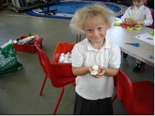
Figure 19 Photo of child by Belle Wallace

It is not just the artefact or idea she is offering, it is a bit of herself, imbued in the gift. I wonder whether as adults we do not realise how much of our selves become woven into what we do, and how much we want our self to be recognised with love. When Samantha Etheridge talked about her values at one of the Masters group sessions what she said resonated deeply:

Video 17 Loving what you do (1min 59secs)

http://tinyurl.com/3vxo3zr
‘I just love being happy I think. My Dad had his own little business and we hardly saw him as kids. When we got a bit older he quit that and just took a little low paid job. He said to us never work for money if you have the choice. Never work for money because you spend the majority of your life at work and if you do not enjoy it and you are only there to earn the cash the life that you have out of your work you’ll never be able to spend the cash you earn so you will never be happy.
If you ever have the choice work for the love of it and so I took his advice and went to work for the health service. I loved it. It was great after I graduated. I’ve always taken that road - I want to be happy and I think everyone should have the right to be happy in what they do and it shouldn’t be something you are ashamed of, loving what you.
When I worked in the Psyche Unit we had to have psychotherapy. We were obliged to be offered it but not to take it but we had this great guy called Neville and we always used to say that the nursing staff had a go at us because we always laugh when we are working and they say that it is detrimental because it shows we are larking about and not concentrating.
But he said that it shows great confidence in who you are and what you do if you can laugh as you are working and maybe it was your own insecurity if you couldn’t laugh at work. So I’ve always thought it was OK to laugh at work at any given point.
So loving what I do being happy and excited being allowed to be creative being encouraged to be creative all those things that’s why I get up and come to work.’
I feel that Sam’s Dad and Sam are saying something important for me: that adults able to work with love and good humour for what they were doing, are able to enjoy, to have a sense of pleasure and well-being, through doing something they value, with the possibility of being valued by others as they live and earn a living. That is what I want for all, not just for a privileged and lucky few.
Sam communicates through the video her sense of self-knowledge and affirmation that cannot be fully appreciated by simply reading the transcript I have provided. She shows an active and creative self-appreciation of the unique qualities of self, and what a person can create that is valued and valuable if they are prepared to commit time and energy. I like the word ‘passion’ as it carries with it a sense of life-affirming and life-enhancing energy. Treffinger et al. (2004) put it as (although I use the word ‘gifts’ in place of ‘talent’):
‘Talent [gifts] emerges from aptitudes and/or from sustained involvement in areas of strong interest or passion.’(p. 2)
I contend that aptitude (what I appear to find easy to learn) can go nowhere without energy, whatever the source of that passionate energy, be it consuming curiosity, dedication to an ideal, family, love… so explanations of educational influence must include explanations that include energy (Vasilyuk,1991). I also concede that the energy for some people – such as greed - may not be from a life-enhancing and life-affirming source. By using the words ‘gifts’ and ‘talents’, I want to maintain a clear connection between learning and education as a life-affirming and life-enhancing values-based activity.
Freeman (2000) observed that if you want to know what a young person will succeed in later in life, look at what they do out of school, and where they choose to spend their time and effort. This leads me to engage with the field of gifted and talented education with research questions from an educational perspective: questions such as, “how do I help learners find their passions in learning?” “how can I enable children and young people develop the talents they want to develop”, and “how do I enable young people to recognise how their passions and interests might help them develop and pursue what might become a vocation?”
Curiously, even the most ardent proponent of Galtonian notions of intelligence would generally agree that cognitive engagement and task commitment are major determinants of the quality of the gift that an individual eventually creates. Ericsson et al. (2007) provide examples of how we can better understand conditions that contribute to individuals developing high levels of expertise and world-leading talents.
I have come to view the literature created by academics, educational professionals and others, as the gifts they offer in a living-boundary between them and me. Creatively accepting in part or whole what they offer does not mean I have to be drawn onto their territory and agree or ascribe to their values, theories or practices. Rather than entering into the world of the person who has created and offered their theorising, I view it as a gift placed in the living-boundary between us. There, I feel I can value what they offer without obligation. I can engage creatively with the tool they have fashioned to see how it might help me enhance my own gift.
For instance, I do not dismiss the theories of intelligence offered by academic psychologists, philosophers or others, simply because they are not educational researchers. I have taken much from the work of academics in various disciplines, particularly psychology. What is incumbent on me is to engage creatively and critically with the knowledge created with their best intent. I do not wish to violate or misappropriate their knowledge. My intention is to look for the generative and transformational possibilities they offer; to focus on the embers that are hopeful rather than what might be blighting in my context if amplified.
I will illustrate what I mean with respect to Howard Gardner’s work on multiple intelligences, which is popular in England. Starting with Gardner’s (1999) own words:
‘I now conceptualize an intelligence as a biopsychological potential to process information that can be activated in a cultural setting to solve problems or create products that are of value in a culture. This modest change in wording is important because it suggests that intelligences are not things that can be seen or counted. Instead, they are potentials – presumably, neural ones – that will or will not be activated depending upon the values of a particular culture, the opportunities available in that culture, and the personal decisions made by individuals and/or their families, schoolteachers, and others.’ (pp. 33-34)
I have no way of testing the validity of Gardner’s assertion of a ‘biopsychological potential’ and my usual inclination is to focus on analysing and criticising work on the basis of such inconsistencies and claims which can not be substantiated. However, I want to try to look beyond what irritates me, to view, with a loving recognition of Gardner as someone who wants to make this a better world for us all, and to accept as his gift, his ideas about multiple intelligences, to then see what generative and transformational possibilities emerge. I find this easiest when I sense an empathetic resonance (Whitehead, 2010a and 2010b) with values and beliefs, as for instance, when Gardner (1999) writes:
‘… I would happily send my children to a school that takes differences among children seriously, that shares knowledge about differences with children and parents, that encourages children to assume responsibility for their own learning, and that presents materials in such a way that each child has the maximum opportunity to master those materials and to show others and themselves what they have learned and understood.
… I cherish an educational setting in which discussions and applications of MI theory have catalyzed a more fundamental consideration of schooling – its overarching purposes, its conception of a productive life in the future, its pedagogical methods, and its educational outcomes, particularly in the context of a community’s values.’ (pp. 91- 92)
Gardner’s notion of creativity with respect to intelligences offers interesting possibilities. He seems to have a notion of intelligences with creativity that is akin to what I understand by talent development for the creation and offering of life-enhancing gifts and concerns small-c creativity and Big-C Creativity referred to earlier:
‘My definition of creativity has revealing parallels with, and differences from, my definition of intelligence. …The acid test of creativity is simple: In the wake of a putatively creative work, has the domain subsequently been changed?
Let me underscore the relationship between my definitions of intelligence and creativity. Both involve solving problems and creative products. Creativity includes the additional category of asking new questions – something that is not expected of someone who is “merely” intelligent, in my terms. Creativity differs from intelligence in two additional respects. First, the creative person is always operating in a domain or discipline or craft. One is not creative or noncreative in general.... Most creators stand out in one domain or, at most, in two. Second, the creative individual does something that is initially novel, but the contribution does not end with novelty… the acid test of creativity is its documented effect on the relevant domain or domains.’ (Gardner, 1999, pp. 116-117)
This is also reminiscent of the criteria for a doctorate – making an original and significant contribution to a field of knowledge, and the tensions created in engaging with the gifts of knowledge of others, as illustrated by Pomson (2010):
‘As doctoral candidates will recognize, most advanced research programs today expect the production of work that is both “scholarly and original.” …
Intriguingly, this dual responsibility of scholarship and originality can be both a burden and a blessing. Literary theorist Harold Bloom has invoked the problem of “belatedness.” He suggests that the more we know about our creative forebears, the more difficult is the challenge of contributing anything genuinely original to their art (Bloom, 1997). By contrast, economist Thorstein Veblen conceived the “advantage of the latecomer.” In his view, coming after others not only relieves us of the costs of starting from scratch, it makes it possible to overtake and move beyond those who came before (Veblen, 1915/1945).’ (p. 97)
To return to Gardner:
‘Intelligence may reflect what is valued in a community, but ultimately it entails the smooth and skilled operation of one or more “computers” in the mind or brain of the individual. Creativity is different. It is obviously desirable to have a well-designed and well-performed cognitive computer (or two or more such neural machines). However, even the best designed computer does not promise creativity.’ (p. 118)
I think there are similarities between Gardner’s ideas that I have just referred to, Sternberg’s (1997) ideas of ‘Successful Intelligence’ and Renzulli’s (1998) ‘Three Ring Conception of Giftedness’ and Freeman’s (1998) ‘Sports Approach’. Each acknowledges to a greater or lesser extent that high achievement requires an ability to think analytically and creatively, a dedicated long-term commitment to developing knowledge and products within a particular domain that is valued by the ‘host’ culture, and the courage to ‘be different’.
To summarise, in the field of ‘gifted and talented education’ many educators, and those involved with implementing policy in education, take and apply theories and practices from other worlds, such as academic psychology, without distinguishing between what might be useful to inform the development of educational theory, practice and provision. Through researching to evolve my living-theory praxis in the living-boundary between the field and my practice, I have developed a notion of inclusive gifted and talented education from an educational perspective. Having outlined what I can do I will now address some of the implications in practice.

5.3 Developing inclusive gifted and talented education from an educational perspective in practice
In Chapter 1 (pages 20- 50) I introduced the framework I have used for planning and describing my work. In Chapter 4 (pages 119-154) I showed how the activities that constituted APEX were developed in the course of the evolution of my living-theory praxis. In the last section of this chapter I brought theory and practice together to clarify my meanings of inclusive gifted and talented education developed from an educational perspective that informs the work of APEX as I bring it to a conclusion. In this section I use examples of activities from APEX; past, present and those planned but yet to be enacted, to illustrate the development of inclusive gifted and talented education from an educational perspective, in practice.
The purpose of APEX has been to enhance each child and young person’s ability to learn to live a loving, satisfying, productive and worthwhile life for themselves and others. My ontological values of a loving recognition, respectful connectedness, educational responsibility, and values of an inclusive, emancipating and egalitarian society, form my explanatory principles and living standards of judgement. The development of theory, practice and provision has been concerned with supporting children, young people and educators to develop and offer talents, expertise and knowledge as gifts to enhance their own well-being and well-becoming and that of others. The context of my work has been primarily in the living-boundaries between the contexts of school and community for children and young persons as learners; between schools, the local authority and government departments as social formations; and between the world of teachers and other educational professionals and the world of the Academy.
The complex ecology within which APEX was established and developed has changed significantly. Governments and legislation have changed, there are no longer local education authorities, changes in public services are now (January, 21012) being driven by a market-place ideology, and managerialism and marketisation characterises education policy much as Sachs (1999) described earlier in Australia. As a consequence the funding for APEX ends August 2012. However, in this section I do not wish merely to showcase activities, like butterflies pinned under glass in a museum. I wish to use the activities from the past, present and those planned for the last few months of APEX, as concrete examples of how inclusive gifted and talented education can be developed from an educational perspective in practice. In doing so I want the creation of this thesis to contribute to the beginnings of a living legacy. Teachers, Heads, parents, children and young people, and others who have been involved with different aspects of APEX over many years, felt that much of value has been created and this could be lost without developing some form of legacy. A ‘legacy’ tends to imply that there is something fixed that is transmitted and imposed. I have used the phrase ‘living legacy’ in an effort to communicate a more dynamic, co-creative and values-based notion.
It is not possible to give a neat account of the discrete contribution that any particular theory, practice, reflection, question or person has made to what I do now. However, I do recognise the significant contribution that some particular individuals and ideas have made to the development of the structure I use to plan and coordinate the development of APEX and the evolution of my theories, beliefs and practice, which underpin it. For instance: Wallace and TASC (Wallace and Chandler, 1993); Freeman and her Sports Approach (Freeman, 1998); Renzulli’s (Renzuli and Reis, 1997), School Wide Enrichment Model, Sternberg’s (1996) ‘Successful Intelligence’; Dweck’s (2000) notion of self-theories and fixed and growth mindset; Hymer (2007) and his notion of gift creation, (Whitehead (1989a) and his notion of Living-Educational-Theory; White’s (2006) ‘ideological roots of intelligence’, and Rayner’s (2005) notion of inclusionality.
I have given a detailed rationale for developing APEX in a number of papers, publications and presentations. See, for instance; ‘The Elasticated Learner: beyond curriculum learning opportunities in a local authority’ (Huxtable, 2003), ‘Everyone a Winner - Towards Exceptional Achievement of All’ (Huxtable, 2005), and ‘Making public my embodied knowledge as an educational psychologist in the enquiry, How can (do) I improve my practice as a Senior Educational Psychologist?’ (Huxtable, 2006b).
Henry Ford is reputed to have said, ‘If you believe you can, or you believe you can’t you are probably right’. However, how do you develop an idea of what you can do that may lie beyond your experience? Also, to believe is one thing, but action is needed to give substance to that belief and for the best intent of a person to be realised. What moves a person to action? What contributes to a person’s ability to develop and sustain their learning journeys to the peaks they aspire to? Those peaks are the standards by which they may come to judge their life. As I am concerned with enabling children and young people to live a loving life that is satisfying, productive and worthwhile, those standards of judgment should be informed by the knowledge an individual develops of themselves and themselves in and of the world. This has led me to develop educational relationships, space and opportunities for children and young people to recognise their best intent and find support to give substance to it as they experience the pleasure of:
- Working productively over time in an area of personal interest, enthusiasm or passion
- Recognising, valuing and developing talents, expertise and knowledge as highly as possible
- Creating and offering knowledge they value as a gift to themselves and others
- Recognising, valuing and co-creatively engaging with gifts they and others offer
In Chapter 1 and 4 I outlined the framework I have used to develop activities that I have supported, encouraged and provided to exemplify the approach I have evolved to develop and co-ordinate APEX. Here I want to show through describing in more detail the organising ‘categories’ I have used in practice working with inclusive and educational notions of gifts and talents. The purpose of ‘categories’ is not to categorise but to get a sense where I might give more or less focus in developing activities that constitute APEX. Most activities serve many functions, but for simplicity’s sake, and this being a text-based thesis, I describe example activities under only one heading each. As you read on, please bear in mind what I have been saying about a multidimensional and relationally-dynamic approach to research and developing practice. No one section is more important than another, and the order in which the concepts are introduced should not be taken to imply a hierarchy or systematic progression from one to another.
Drawing on Renzulli’s (Renzulli and Reis, 1998) notion of three types of learning opportunities I have organised relationships, space and opportunities for playful enquiry, objectives-led learning and passion-led research.

5.3.1 Playful enquiry: experiences, ‘playgrounds’, information, ideas etc to open minds and extend possibilities.
These are opportunities to broaden experience, bump into and play with ideas, concepts, imaginative possibilities, and even to experiment with different personas and ways of doing things, all of which add to the palette of social, personal, emotional, physical, intellectual and cognitive experiences to draw on when creating knowledge. These are opportunities to have learning adventures. While some of these learning opportunities may have preconceived outcomes, the outcomes are intended to be a guide to providers and participants as to the nature of the ‘playground for adventure and experimental journeys’ offered.
The APEX Saturday workshops provide an example of this type of learning opportunity. Children and young people were offered opportunities to intellectually, socially, emotionally, personally, and physically, venture beyond their comfort zone, and see where a path outside of the given school curriculum takes them.
How do you know what you want to do unless you know ‘it’ exists and you could see yourself doing ‘it’? Ask a child or young person what they want to do when they leave school, and they will often tell you about an occupation that is commonly visible, such as hairdresser, footballer, teacher, doctor… or one informed by a family member, a friend of the family, or chance acquaintance. Another response, which is becoming more common, is the name of a qualification they believe they can gain. They are often doing what they have been told to do, rather than looking towards continuing education for the satisfaction of developing talents or creating knowledge they value and have a passion for, to offer as educational gifts to themselves or others.
In running the APEX Saturday workshops I wanted to offer an opportunity for children and young people to bump into other possibilities and in the process to learn more about themselves: their values, what it is that gives their life meaning and purpose, talents they might wish to develop, talents they might not have realised they have developed and find a pleasure in offering. The workshops allowed them to explore interests, enthusiasms and passions for learning, to experience the pleasure of meeting and working collaboratively with a variety of peers and adults learning to offer, as well as to accept, talents and knowledge as gifts. The meetings were an opportunity for them to learn more about what how they want to be in and of the world in the living-boundary between school and the ‘real’ world. While this may sound rather ambitious, it is nevertheless an ambition I wanted to realise.
Some of the authority-wide courses I have run for adults also make this form of learning opportunity available in the living-boundary between ‘school’ and academia. My intention in offering this form of learning opportunity was to extend the ‘palette’ teachers have to draw on in developing and researching to improve their practice, and to afford them a space to play with new and established ideas. Courses and workshops for teachers are increasingly limited to those directly-concerned with delivering the given curriculum, prescribed methods of teaching and behaviour management. Rarely are teachers given the opportunity to enjoy learning as an adventure, to step off-piste. My concern is that their fear of venturing into the unknown is subsequently communicated to their pupils.

5.3.2 Objectives-led learning: courses and masterclasses to develop and enhance skills, understandings
These are courses, workshops, seminars and the like, with a focus on learners deepening their knowledge of a field, to develop and hone specific skills, abilities and expertise. The National Curriculum is the prime example of this sort of learning opportunity.
An example of APEX work here would be the collaborative, creative enquiry days we have held/offered. Many have been run with various experts. One example was that led by Andrew Henon (a socially-engaged artist) for children and adults to collaboratively experience themselves as artists developing their expertise as artists (Henon, 2009). Another example is a TASC (Thinking Actively in a Social Context) Day such as that run by Rob Sandal in Camerton School (Sandal, 2010) where the children were able to develop their abilities as researchers. Another example is the P4C (Philosophy for Children), SAPERE course with Barry Hymer, for teachers developing their ability to facilitate and lead a community engaging in a philosophical enquiry. While opportunities may be characterised by planned learning outcomes, the nature of the teaching can vary depending on what the purpose is.
Remember, I am not concerned with setting up categories, but rather to develop a structure that helps me deciding where to focus my energies. So, for instance, being required to teach something to someone else can be a learning opportunity for the provider to improve his or her own skills and understandings, and as such may be the outcome of the learning opportunity to create knowledge which we come to now. The outcome of one of the collaborative, creative enquiry workshops introducing Research to Make a Difference, by Jack Whitehead offers an example. After one of the workshops pupils from one school introduced what they had learned to the rest of their class and they were allowed half a day a week for a term to develop their passion-led research and make a presentation to children and parents in an assembly. Two years later and those children supported a teacher to introduce another class of children to passion-led research.

5.3.3 Passion-led research: support for knowledge creating enquiries
These are opportunities to enquire as an expert, to create and offer talents, expertise and valued knowledge through disciplined enquiry, within a time frame, and driven by personal interest.
I became increasingly aware as I developed APEX, that there were few opportunities that supported learners as knowledge creators. Yet the literature on ‘gifted and talented’ highlighted that those who develop early beyond the expectations of their age behave as ‘experts’ and thrive where they are supported and encouraged to do so. There were similarly few opportunities for adults to extend their own abilities as knowledge creators through disciplined enquiry.
Sally Cartwright’s (2008) work with AS Extended Project students stands out as a beacon in this regard. This is not something that can be accomplished as a quick fix, but requires deep and profound learning. West Burnham (2010) gives a description of the distinction and what is entailed, in his work on learning to lead:
‘Shallow learning about the process of change would result in a formulaic presentation of the various academic models, the ability to describe personal experiences of change, engagement in the process because of external imperatives and an uncritical and unquestioning acceptance of the process.
Deep learning in this context is manifested in the ability to develop a personal model of the change process which is a synthesis of a range of sources and the ability to translate that model into action. Experience is mediated through reflection, which allows for personal interpretation and a sense of autonomy. Profound learning however results in the creation of personal meaning, integrating principle, values and practice so that behaviour is intuitive and the response to change is creative, challenging, ethically driven and integrative.’ (pp. 2-3)
Many people take a considerable amount of time to develop their knowledge-creating enquiry through passion-led research. They draw on experiences from ‘playground’ learning opportunities, the skills they develop from workshops and courses with planned learning outcomes, and their diverse experiences in living. Their enquiry develops organically not sequentially. As learners research to create and offer knowledge of the world as a gift, they also create knowledge of self. Between the person’s enquiries is a boundary in which knowledge of self in and of the world can be created. In creating and offering a living-theory account, I am suggesting that a learner creates and offers an educational gift to themselves and others, as they extend themselves a loving recognition, open respectful channels of connectedness and expressing an educational responsibility. I will return to this in Chapter 7 (page ) on ‘Living-Theory TASC’.

5.3.4 A supportive culture
We live and learn in a complex ecology. My intention in developing APEX has been to contribute to a culture consistent with my ontological values of loving recognition, respectful connectedness and educational responsibility and values of an inclusive, emancipating and egalitarian society. My intention has also to be to contribute to the development of a learning community that enables and supports people of all ages as learners and co-learners to:
- Ask and answer ‘good’ questions
- Make links between the apparently unrelated
- Go beyond the given
- Search for and construct meaning
- Interact meaningfully with society
- Contribute to and benefit from their own learning and that of others
- Know themselves, make personal choices and research personal passions
- Do things differently
By encouraging and supporting educators and learners to make public the knowledge they are creating, I believe that I am able to help develop an inclusive, cooperative culture of learning. Examples can be found in the Masters writings of the educators with whom I have worked, which can be accessed on http://www.actionresearch.net. Mounter’s (2006) work is an exemplar of the development of knowledge-creating learning community with primary-age children, as is Bogna’s in Croatia (Bogna and Zovko, 2010).
Rarely are educators prepared to share the early stages of developing educational relationships, space and opportunities in the process of their emergence. However, it is work in progress that may offer the most learning for others. To this ends I have established a Living Values Improving Practice Cooperatively: An international Action Research CPD project with Jack Whitehead. This community supports professional educators from diverse contexts researching their practice to improve it. Some are registered with Liverpool Hope University through the Center for the Child, Family and Society so their work can be accredited at Masters level. Details can be accessed from http://www.actionresearch.net/writings/huxtable/LLCCPD/Home.html. The group is also supporting doctoral and postdoctoral research.
Schools have been continually exhorted by the National Gifted and Talented Strategy to identify students to place on a ‘gifted and talented’ register. I have set out earlier why I believe that this is at best irrelevant, and at worst damaging both to individuals and to the context and culture in which they learn. Some schools chose to ignore, others to comply, with the expectation, but neither response offers generative or transformational possibilities. I have struggled with the conundrum of how to help schools develop a response that could contribute to the development of a supportive educational context and culture, while being politically prudent, and came to a notion of an inclusive and educational register of gifts and talents.
To develop an inclusive educational register of those talents that the children are developing and want to develop and would like to offer as gifts, is consistent with the development of personal(ised) curricula and inclusive, emancipating and egalitarian education. Developing such a register contributes to a culture where each learner is recognised as having a valued and valuable contribution to their own learning and that of others. To populate such a register requires that a teacher expresses their educational responsibility for themselves, and towards the learner, by seeking to recognise the child or young person’s best intent and afford them a loving recognition through a conversation with each pupil about what is important to them, what talents they want to develop, what talents they have been developing, what talents they want to offer as gifts to others. In the process, every child and young person has an opportunity to experience the pleasure of developing, and offering their talents and knowledge as gifts to themselves and others and enjoy the affirmation of having their gifts appreciatively engaged with.
In the process of developing and offering talents and knowledge as gifts, learners may deepen their knowledge of their values, passions and the self they are and want to be in and of the world. In making public their work in the progress and learning collaboratively and creatively with others, they may also contribute to an inclusive, emancipating, egalitarian culture of learning. A further example of how this translates into practice is offered by the www.livinglearning.org.uk website.

5.4 Summary of APEX
In the previous section I have tried to show how inclusive gifted and talented education can be developed from an educational perspective in practice. I realise that I might not have communicated sufficiently the scope of the work so I conclude this chapter with a report prepared in June 2011 for the Schools Forum, which managed the funds that paid for APEX.

Introduction to the service:
APEX delivers the Local Authority policy for high ability and contributes to the realisation of the evolving educational vision and policy by the Authority and the Heads.

One full time senior educational psychologist with .3 projects manager work with teachers, schools, governors, Local Authority staff and other partners to support and stimulate the development, research and delivery of inclusive, personalised gifted and talented educational theory, practice and provision in the Bath and North East Somerset learning community. Other personnel and services are contracted as and when necessary.

Over the years teachers and children from every school in the authority have been involved with APEX. The influence of APEX activities is monitored, evaluated and evolved through questionnaires, unsolicited responses, SEFs, discussions with Heads, teachers, parents, children, Children’s Services staff, collection of statistical data and the development of new forms of educational evidence such as multi-media narratives.

Resourcing
Schools forum allocated £138,431 to APEX for the financial year 2011-2012. This will pay for the coordination, management, administration, development, and delivery of activities such as

- Saturday workshops and Summer Opportunities for children and young people
- School based support
- INSET/ CPD
- Learning opportunities for adults, children and young people, e.g., collaborative, creative enquiries
- Web-based access to information, resources and opportunities to develop co-operative learning
- Access to and involvement in local, national and international research communities and networks

In addition the local authority provides the management, administration and infrastructures in which APEX sits such as:
- Management and support for the APEX coordinator
- Finance, payroll, HR and insurance
- IT network and office space
- Integration of support for schools delivered by other departments and services in the Local Authority working with local and national agendas e.g. inclusion, Healthy Schools, lifelong learning, Every Child a Writer, personalisation of learning…
On-going changes to CRB, safeguarding, self-employed and other directives and procedures have increased costs and administration beyond the year on year increase of the budget. These, together with the current changes introduced by the government, will have significant implications for future APEX activity. In previous years it has been possible to generate income and make other resources and funds accessible to schools and teachers through for instance, running courses and conferences, making links locally, regionally, nationally and internationally with universities and organisations, developing partnerships and reciprocal agreements. Changes in funding and government policy are making it increasingly difficult to generate additional funding. The projected activity for the academic year 2011-2012 will be reduced to ensure the programme is delivered within the budget provided by the School Forum. However, it is hoped that during the year creative possibilities will enable the programme to exceed the forecast.

APEX in context, overview of indicative developments and indication of impact

1. The first course for teachers was offered by APEX in 1997. Since then conferences and courses have been offered locally with nationally and internationally recognised speakers, such as Professor Guy Claxton (Building Learning Power), Professor Robert Fisher (Thinking Skills), Belle Wallace (TASC, Thinking Actively in a Social Context), Dr Barry Hymer (P4C, Philosophy for Children), Professor Jack Whitehead (Living Theory Action Research). Schools across the authority have continued to use, integrate and develop over years, ideas introduced by APEX, to raise standards and improve the quality of the educational experience of all their pupils developing talents and gifts.

2. In 1998 the pilot of the Saturday Workshops was launched. It arose from cross service links with the aims of extending the opportunities for pupils to develop their talents, expertise and aspirations in a range of different contexts with peers who share their enthusiasms and to work with experts from various professions and disciplines. Satisfaction from students and parents is high with repeat enrolments and increasing applications. Teachers and parents have consistently reported the enthusiasm of children to communicate what they have been doing and to continue to participate. Demand continues to rise and schools integrate APEX opportunities into their policies. In the academic year 2010-2011 140 workshops offered 3,242 places to KS1-4. 7,564 applications were received. 35% of places were allocated to vulnerable children and young people identified as ‘harder to reach’ at risk of underachieving. To extend and enrich the programme new partnerships and ways to enable young people and adults to offer their talents and knowledge as gifts are being explored.

3 The Summer Opportunity was launched in 2000 to provide opportunities for children and young people to enhance and offer as gifts their talents, expertise and knowledge. The 2010 Summer Opportunity comprised 9, four-day workshops running in parallel for Y4/5, Y6/7 and KS3/4. 178 children and young people from 8 secondary and 28 primary schools from across the authority participated. 34 participants were from the group identified by ‘harder to reach’ indicators. The APEX Summer Opportunity 2011 is providing 8 modules for 200 Y4/5, and Y6/7 pupils

4. A Young People Working-group was initiated this year to inform the development of the 2011 Summer Opportunity for secondary age students. Young people from 5 schools responded to the invitation and informed the development of the Living Learning 2011 Conference for 100 students together with 8 APEX Saturday Research Workshops with 120 places available for young people from across B&NES. Further ways to involve Young People are being explored.

5. In 2004 the first collaborative, creative enquiry opportunity was offered for teachers and their pupils/students to develop their expertise and talents as co-learners with a field expert. This work has developed to provide exciting opportunities for educators, children and young people to co-learn as writers, mathematicians, choreographers, scientists, and most recently as action researchers. This academic year 70 adults and young people from 6 secondary schools and a college have participated as co-learners developing their talents and expertise as researchers, with Prof Jack Whitehead. This experience contributed to the development of successful learning by students on accredited courses such as the AS Extended Project. This work is being extended through the CPD project and the APEX Saturday Research Workshops.

6. 2004 P.A.S.S. (Pupils Attitude to Self and School) was introduced to the schools in the authority through APEX. Schools are using it according to their own need e.g. to improve transition, target interventions with individuals, amplify and evidence Pupil Voice, evaluated Healthy Schools interventions etc. P.AS.S. was purchased by the TAHMS (Targeted Mental Health in Schools) project for 20 schools as an evaluation tool this year .

7. 2005 a Masters program was first offered by Professor Jack Whitehead to support teachers developing their talents and knowledge to improve the quality of inclusive, personalised gifted and talented educational theory, practice and provision in school and contribute to the knowledge-base for schools and the profession. Many accounts accredited through the University of Bath and Bath Spa University can be accessed from http://www.actionresearch.net A Living Values Improving Practice Co-operatively: An Action Research Project has just been launched in co-operation with The Centre for the Child and Family, Liverpool Hope University. Participants can submit accounts of their work for accreditation at Masters level (£250 for 2x30 credit modules).

8. Support for governors has been developed in the form of workshops and contributions to the newsletter. This year 16 governors from 11 schools participated in a workshop and a contribution has been made to each newsletter.

9. Opportunities have been made available through the South West Gifted and Talented Education Network, for instance 30 places for KS4/5 students on the regional Interconnected Learning Conference at University of Bath.

Anticipated activity academic year 2011- 2012
- Develop and deliver within budget:
- APEX Saturday workshops offering 2,200 places
- APEX Summer Opportunity 2012 offering 175 places
- Living Learning 2012 Young People Conference offering 100 places
- Working group and opportunities to improve the voice of children and young people in the development and implementation of APEX
- CPD through the Living Values Improving Practice Co-operatively: An - -- Action Research Project in association with the Centre for the Child and Family, Liverpool Hope University
- School based support and INSET
- Workshop for governors and contributions to the governors newsletter
- Web-based access to information, resources and opportunities to develop co-operative learning
- Access to and involvement of schools, educators, children and young people in local, national and international research communities and networks
- To extend APEX within allocated budget explore/develop:
- Volunteer programme for young people and adults to offer their talents and knowledge to extend the APEX Saturday workshop
- Reciprocal agreements
- Partnerships
- Relationships with new Academies and private schools
- Funding agencies and sponsorships

5.5 Postscript
Inclusive gifted and talented education developed from an educational perspective comprises theory, practice and provision underpinned by a values-based rationale. The language developed through usage is consistent with the intrinsic-values based frame/s evoked. The contradictions between the normative background of the context and the ontological values of the researcher/practitioner are identified and the educator works to resolve them as an expression of their best intent and educational responsibility towards each and all children and young persons.
I have clarified why my living-theory praxis is concerned with gifts and talents as educationally influential concepts and the importance I place on enabling a child and young person to come fully into their own presence. I have also demonstrated the implications of working to improve inclusive gifted and talented education in living-boundaries, and described a rational base to developing my work that has evolved. I have provided examples of how I have developed relationships, space and opportunities for teachers and learners to explore new possibilities, develop and enhance skills and understandings, engage in knowledge-creating enquiry and contribute to and benefit from the development of an inclusive, collaborative and creative culture of learning.
I have dealt with ‘what are my concerns’, ‘why I am concerned’, imagined possibilities and what I have done. In the next chapter, I will deal with the data I collect and how I evaluate what I do. I will show the creative mode of multimedia narratives in researching the meanings of values in living-boundaries, and developing generative and transformational forms of educational evaluation and accountability.

Chapter 6 A creative use of multimedia narratives in researching the meanings of values in living-boundaries and developing generative and transformational forms of educational evaluation and accountability
So far I have focused on using multimedia narratives to ostensively and iteratively clarify my ontological and social values. Here I focus on the creative use of multimedia narratives to understand and communicate (that is, to research) their meanings in living-boundaries. I then show how I use multimedia narratives to develop generative and transformational forms of evaluation and accountability of educational practice that contribute to the evolution of my living-theory praxis in living-boundaries.
Sections as signposts in this chapter
6.1 Multimedia narratives to research meanings of energy-flowing values
6.2 Values researched in living-boundaries
6.3 Multimedia narratives contributing to generative and transformational forms of educational evaluation and accountability
6.3.1 Evaluating what I do
6.3.2 Accounting for what I do
6.4 Postscript

6.1 Multimedia narratives to research meanings of energy-flowing values
University library shelves now groan under the weight of the literature on the subject of narrative and research, and tomes such as Clandinin’s (2007) The Handbook of Narrative Inquiry: Mapping a Methodology confer academic respectability on this research method. However, western academics are latecomers to the field as illustrated by the embodied, oral and scribal traditions of human societies represented by the cave paintings found on every continent of the world dating back to the beginning of research as learning made public. So, nothing is new, except – the advent of 21st century technology, which offers new possibilities to clarify, understand and communicate meanings of energy-flowing values not available to cavemen or to more recent generations of educational researchers.
Educational narratives are the descriptions and explanations created of the learning journey, which in their creation and offering enhance the well-being and well-becoming of the story tellers and audiences. They are narratives of educational influence in learning. This thesis can be read as an account of my educational influence in my own learning, that of others and of social formations. As I continue to engage in my living-theory research, I progressively recognize the person I want to be, in and of a world I want to live in, and developing the competences to contribute as fully as I can to my own learning and life and that of others.
In this section, I begin by clarifying what I mean by narrative and the contribution of multimedia narratives to my research. I use a multimedia narrative to clarify, understand and communicate my meanings of my energy-flowing values in living-boundaries.
The words ‘story’ and ‘narrative’ are often used interchangeably. However narratives are usually understood to be coherent accounts of what has happened (Carter, 1993), whereas stories may be narratives, or they can be disconnected fragments, metaphorical or imagined possibilities. There is no clear-cut distinction in common usage or in the literature, so I use both words and rely on describing my purpose for employing the device to make clear what I mean.
Sometimes the stories I create are initially for myself alone, to remind me of thoughts and feelings to relive another time, and sometimes to examine, reappraise and grow from. These stories often comprise brief notes, images, sketches and video clips that are impenetrable to anyone else but carry deep meaning for me. Sometimes the stories I have created have provided grist to the generative mill of my imagination, and enabled me to work out thoughts, puzzles, contradictions, and imagine possibilities and bring them into being. Sometimes they have provided data to draw on as educational evaluative evidence of my practice, and allowed me to critically reflect so as to deepen my understandings of what I am doing to evolve, rather than revolve, my living-theory praxis.
I also use stories to communicate to others something of importance to me, sometimes for no other reason than to enjoy the pleasure of sharing thoughts and experiences that are meaningful to me. I think I am not uncommon in that desire, although unlike Archimedes I make sure I am fully attired first! Other times I want to communicate what I have learned influentially. The papers I have presented and the articles I have written offer exemplars. I freely offer such narratives as gifts in the sense that I create and offer them in the hope, but not the expectation, that they may be of interest and use to others.
Telling and retelling stories in the creation of narratives that communicate to self and/or others has an influence in forming and strengthening a particular memory, point of view, position held, value and belief – so stories can be transformational. Sometimes they stimulate new thoughts, or new connections, and bring into being what was not there before. If what is brought into being is constructive, they can be generative. I am aware that some stories can carry blight rather than hope. In the creation of multimedia narratives, I have on occasions been able to recognise, or been helped to recognise, and change the nature of the story I am telling myself from one that carries blight to one that is more productive and worthwhile. This has made an important contribution to the evolution of my living-theory praxis and I will return to this when I come to generative and transformational forms of educational evaluation and accountability.
Humans are great storytellers and our stories about the world and ourselves are influential. Stories not only change individual’s lives as they tell them, they also change other people’s lives. I come to the same conclusion that Taleb (2010) expresses succinctly in his introduction to, ‘The Black Swan: The impact of the highly improbable’:
‘You need a story to displace a story. Metaphors and stories are far more potent (alas) than ideas; they are also easier to remember and more fun to read. If I have to go after what I call the narrative disciplines, my best tool is a narrative.
Ideas come and go, stories stay.’ (p. xxi)
In evolving my living-theory praxis I am concerned with narratives that are research narratives. As such they do not just contain smooth stories of self (MacLure, 1996) but there is a care that the ‘stories of ruin’ are not ruinous. They are in an organic relationship with our world and how we experience it. That world, as an ecology of being, comprises my internal world as well as the social and physical environment that I inhabit, shape and am shaped by.
Since embarking on this research programme I have created and told many stories in many forms. Each time I learn something in the narration. I offer some as gifts by making them public in the hope that others might find something of educational use to them. In those cases they are of the form that Carter (1993) describes:
‘… capturing the complexity, specificity, and interconnectedness of the phenomenon with which we deal and, thus, redressed the deficiencies of the traditional atomistic and positivistic approaches in which teaching was decomposed into discrete variables and indicators of effectiveness.’ (pp. 5-6)
Since Carter wrote this technology has developed apace, so that I can now develop multimedia narratives as I exemplified in Chapter 3 (pages 86-118), where I ostensively and iteratively clarified the meanings of my values. This thesis is also such a multimedia narrative, one of many I have created, trying to capture and communicate the complexity and interconnectedness of my living-theory praxis. I use a multimedia form, as I did in Chapter 3, to communicate the energy-flowing values that give meaning and purpose to my life and that form my explanatory principles and living standards of judgment of my practice and evolve with my living-theory praxis. I also employ multimedia narrative to research meanings of my energy-flowing values in the course of evolving my living-theory praxis.
I am not an artist, illustrator or skilled in visual representations or written communication, yet communicating to and with others is a vital aspect of researching meanings of energy-flowing values to improve my practice. I do not believe that images or videos alone, any more than words alone, can suffice to communicate meanings, and telling is no substitute for eliciting shared meanings in the living-boundary between us. So I want you to understand my creative use of multimedia narrative as a generative and transformational approach to researching meanings of energy-flowing values by experiencing something of the use I have made of it.
In the context of what you have come to know of me, the complex ecology of my work and being, and my living-theory praxis, I ask you again to go beyond just using your intellect to engage empathetically via head, heart and body with a video clip taken at a meeting in 2010. I was given half-an-hour to talk about my thesis to people with a professional interest in gifted and talented education. I set up the camera thinking that the video would show me as my usual incomprehensible self but in the hope that I might get some clues as to how to improve.
My stomach was churning as we broke for coffee before my ‘slot’. I had tried to organise my thoughts to present my thesis, but was far from happy or confident with what I had prepared. Over the break I remember deliberately changing the story I was telling myself from, “this is going to be awful” to thinking of my audience as individuals I knew and respected, and what they might be interested in exploring with me concerning my thesis. I thought of the values I had been clarifying, and how I might live them in that space as fully as I could. The effect on me was odd. I felt unusually at ease as I let go of the content I had prepared and focussed instead on how to create an inclusive, emancipating and egalitarian educational space in the living-boundaries between us. I thought about the people as persons, and how in my own terms I might extend to each a loving recognition, open channels of respectful connectedness between us and express my educational responsibility for myself and towards each of them. I set up the video camera opposite where I was sitting and asked someone to switch it on when I began talking, leave it to run and turn it off at the end. I am the only one you see in the video: I did not want to disrupt the space by asking people for permission to film them or to take someone else’s attention away from the conversation to video me.
When I had finished, I thought I had made a complete hash of the whole opportunity that I had so generously been offered. I was surprised when we broke for lunch and a few people independently, privately and in an unsolicited fashion, told me that I had made sense and that they empathised with what I was expressing. I looked at the video later with curiosity, which was unusual for me: I usually dislike looking at video footage of myself. I was surprised by what I saw. I do not think that the ninety or so thousand written words of the various versions of this thesis convey the spirit of what my thesis is as well as that video does. As I create this multimedia narrative as part of the thesis I continue to research meanings of my values in the process of trying to clarify, understand and communicate them in the living-boundary between us.
I ask you here to take time to look at a few minutes of this 10-minute clip on the next page (Video 18).
Video 18 Communicating my thesis
http://tinyurl.com/3jr7jla
As I watch this, it evokes in me the feelings of pleasure I felt at the time of being with creative, professional educators who were making an educational difference to children and young people’s lives by developing and offering their talents, expertise and knowledge as educational gifts. It reminds me of the pleasure of feeling that my work had something of value to offer to educators whom I respect. I believe that in contrasting this to earlier videos I can see evidence that I am developing the talents I need to communicate more effectively the notion of educational theory, practice and provision arising from practice and research explained by energy-flowing values.
Run the cursor back and forth. I want you to share the feeling I have that I am living my values of a loving recognition, respectful connectedness and educational responsibility, as I seek to engage, and not just perform, to those present. I want you to share the feeling I have that I am seeking to connect and appreciate the knowledge and the values each person wants to live more fully through their practice they brought into the space. I am asking you to feel yourself as part of the space to address the questions I pose to you here in the context of what you have understood of my values: “What does the video communicate to you?” “Do you see evidence of me expressing a loving recognition of others and myself, respectful connectedness and an educational responsibility?” “Do you have a sense of an inclusive, emancipating and egalitarian educational space?” “Do you have a sense of the talents and knowledge that I have been working to develop and offer as gifts?” “Do I live the qualities of inclusive gifted and talented educational theory, practice and provision that I describe in the previous chapter?” By focussing your attention through these questions I am intending to enhance my embodied communication and add to your understanding of what I mean by learning to live a loving, satisfying, productive and worthwhile life.
Gadamer (1975/2004) describes a particular form of conversation:
‘To conduct a conversation requires first of all that the partners to it do not talk at cross purposes. Hence its necessary structure is that of question and answer. The first condition of the art of conversation is to ensure that the other person is with us…. To conduct a conversation…. requires that one does not try to out-argue the other person, but that one really considers the weight of the other’s opinion. Hence it is an art of testing. But the art of testing is the art of questioning. For we have seen that to question means to lay open, to place in the open. As against the solidity of opinions, questioning makes the object and all its possibilities fluid. ‘(pp. 330-333)
As you watch and respond to the questions I have offered, I ask you to experience the boundary between us as a living, creative, educational space. I ask you not to try to out-argue me but to go beyond what I have said to test, question and make possibilities fluid.
In developing an educational conversation with you and using multimedia narratives to clarify, understand and communicate the meanings of my values with an educational intent, I am researching the meanings of values in living-boundaries to evolve my living-theory praxis. In that sense some stories can be educational conversations one has with oneself. I use the term ‘educational’ conversation to indicate that my intention is to enable you and me to progress our learning that helps us each to realise (to recognise and achieve) our best intent as fully as possible. How ‘learning’ is understood has implications for what I think my work is, and what constitutes improving practice, which becomes clearer when I consider issues concerning evaluation and accountability. I will come to this later.
The nature of a conversation is that while it may appear that the thread is pursued systematically it is also an organic flow as those engaged in the conversation creatively draw into it experiences, knowledge, feelings, imagined possibilities, beliefs and theories expressed in words, intonation, physicality and presence. This makes it impossible to understand the knowledge created in an educational conversation simply from its transcript. If you doubt this, think of an instance when someone said, ‘yes’ and yet you knew that they were actually saying ‘no’. Sometimes it is not until the speakers have heard themselves that they understand what they meant and recognise the knowledge created in the living-boundary between themselves and others. A video of that conversation is not enough. It requires text to contextualise it with insights into the complex ecologies of those in the conversation, and others coming to it after the event, and to point to the significance of what is being communicated.

6.2 Values researched in living-boundaries
In the previous multimedia narrative, I showed you values clarified, understood and communicated in the living-boundary between educators at the South West Gifted and Talented Education network meeting and myself. Here, I want to illustrate values researched in the living-boundary of an i~we relationship using image and text to create a multimedia narrative. In an i~we relationship, each respects their own and the other’s ‘i’ and an implicitly negotiated sense of ‘we’. For me this is a relationship where the unique contribution of ‘i’ is held within ‘we’ and is neither subordinated nor dominant. It is a relationship that holds the potential for collaboration as a step beyond co-operation. The ~ is a trustworthy, inclusive, emancipating and egalitarian space for knowledge-creating research. Individuals form the living-boundary with a mutual commitment to enabling respectful connectedness and a loving recognition of self and other, and to express their educational responsibility for themselves and towards others and ‘we’.
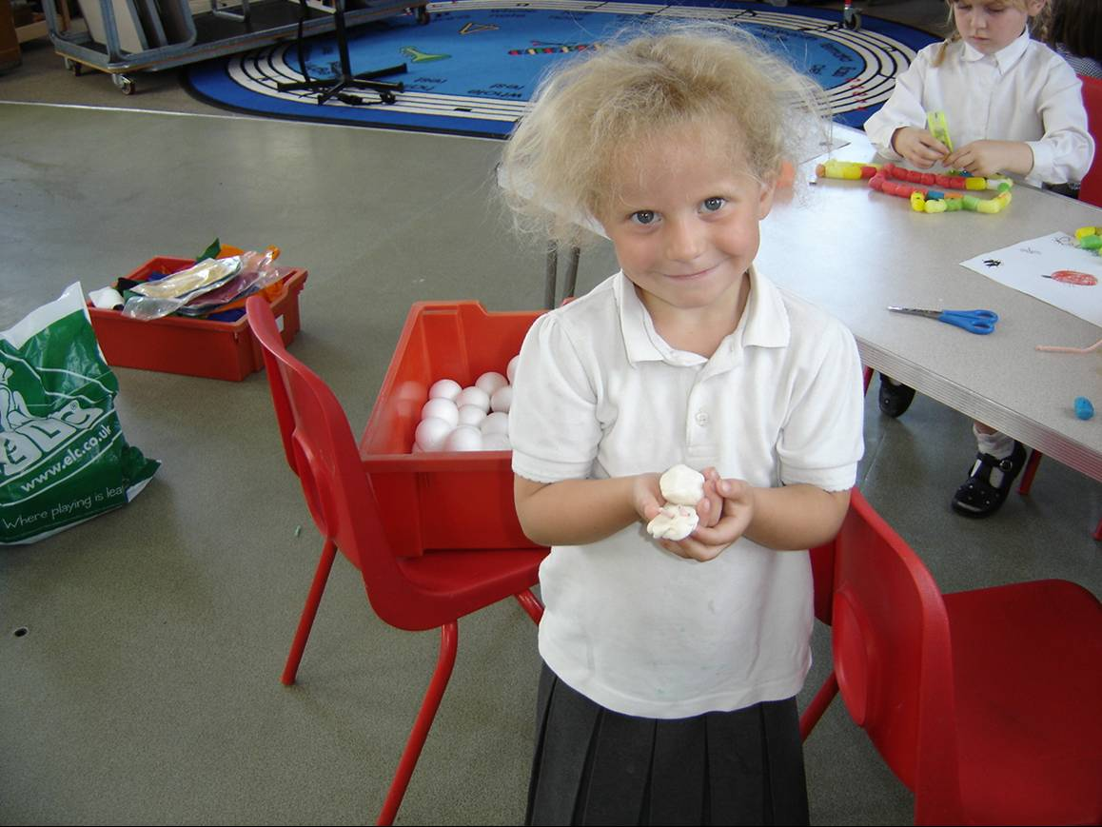
Figure 19 Photo of child by Belle Wallace

I have brought this photo into the thesis twice before: in Chapter 3 (pages 86-118) to clarify my ontological and social values and in Chapter 5, (pages 155- 190) to communicate the notion of developing gifted and talented theory, practice and provision from an educational perspective. I bring the image to you again to communicate a third point and to keep connection with the core thread of improving practice through the multidimensional and relationally dynamic nature of Living-Theory research, Here the photograph (Figure 19) connects two educators (Belle Wallace and Jack Whitehead) who have had a major transformational influence on my own educational journey and on me which I explain here (Huxtable, 2006a)
‘At the NACE conference, October 2005, Belle Wallace shared with me some of the photos she had taken to illustrate her work. One in particular struck me because of the physical response of Belle as she talked to me about it, which seemed to convey the passion for education and the values she held in common with Jack Whitehead and me. I was very mindful of Jack’s phrases ‘the flow of life affirming energy’ and ‘embodied knowledge’ as I looked at Belle as we talked about this picture.
Jack’s response to the photos is given in his Keynote for the Act, Reflect, Revise III Conference, Brantford Ontario. 11th Nov 2005 found at http://tinyurl.com/4xjsdrf

‘Such affirmations and visual narratives can be understood in a conversation between myself and Marie Huxtable. Marie is a psychologist working on educational projects in the Bath and North East Somerset local authority, the equivalent of your School Board. The affirmations of inclusionality felt and understood by Marie Huxtable and me are focused on our responses to the expressions in the eyes, face, body and hands of the pupil below as she shows what she has been working on, to the photographer Belle Wallace. Belle Wallace is currently President of the National Association for Able Children in Education (in the UK) and you can access her biography at http://tinyurl.com/3b3cyjp We both felt a flow of life-affirming energy in our responses to the image and with each other. We recognised this flow of energy between us and affirm that it carries our hope for the future of humanity and our own. For us, the way the pupil shows Belle what she had produced carries two affirmations. There is the affirmation from the pupil that what has been produced is a source of pleasure and satisfaction. There is the affirmation from Belle and ourselves that we are seeking to enable ourselves and others to feel this quality of pleasure and satisfaction in what we and others are producing. I am associating such affirmations with what I mean by living a productive life in education.’’
Together Belle, Jack and I have at times comprised a ‘we’ of an i~we educational relationship. While the living-boundary is a metaphor, the ~ space is not an abstraction. Its meaning is created and living between us as our relationship has developed. .I am intending to communicate a sense of my values of a loving recognition, respectful connectedness and educational responsibility clarified as they emerge in the living-boundary, the ~ space, in an i~we relationship which is inclusive, emancipating and egalitarian.
In previous chapters, I offered examples of how I have used multimedia narrative to research values in living-boundaries between ‘worlds’ rather than between individuals. For instance, in Chapter 4 (pages ), where I outlined the evolution of my living-theory praxis I introduced you to Sally Cartwright and a group of her students and evidence of the educational influence in their learning of engaging with an educational research community. From them, I became clearer about the distinction between a research community and an educational research community, and the living-boundary between them. The AS Extended Project provided a living-boundary between the world of school dominated by the demands of a given, prescribed, curriculum delivered by means of a prescribed pedagogy, and the world of ‘life’ where the young people have some freedom to pursue their own ‘curriculum’ and find and research their interests.
The Masters modules, accredited first through the University of Bath and lately through Liverpool Hope University, offer examples of educators researching their values to improve their practice in the living-boundary between the world of the practitioner and the world of the Academy. Chris Jones successfully presented her Masters dissertation for accreditation through Bath Spa University, ‘How do I Improve My Practice as an Inclusion Officer Working In a Children’s Service?’ (Jones, 2009). She demonstrates that multimedia narratives created by a living-theory researcher researching their values in the living-boundary between worlds of the Academy and practice, is a legitimate form of research.

6.3 Multimedia narratives contributing to generative and transformational forms of educational evaluation and accountability
The purpose of educational evaluation and accountability is to contribute to improving, in terms of values, what is done in the present and future: it is not to simply justify the past. In evaluating and accounting for my practice, I can do so in a way that gives rise to new, hope-filled possibilities and in that sense can be generative. I can also evaluate and account for my practice in a manner that enables me to evolve, not simply replicate my practice in a different form, and in that sense can be transformational. In this section I clarify what I mean, and how multimedia narratives may contribute to generative and transformational forms of educational evaluation and accountability.

6.3.1 Evaluating what I do
My values, clarified in the course of their emergence in my living-theory research, form not only my explanatory principles but also my living standards of judgment. In talking about ‘educational evaluation’, I am concerned with the exploration of data that allows me to see the progress I am making in developing my values-based practice and most importantly, informs action to improve it. The manner of representing data influences and is influenced by what I look for, what I collect and how, and what generative and transformational sense I make of it.
The purpose of many forms of data is to provide evidence to vindicate or justify what has happened. However as Eisner (1985) points out:
‘If we want to understand why we get what we get from our schools, we need to pay attention not simply to the score, but to the ways in which the game is played.’ (p. 5-6)

I believe the purpose of educational evaluation is to understand how we might go beyond the game, and develop generative and transformational values-based practice that goes beyond the limitations of our previous imagined possibilities. Biesta (2007) expresses something similar when he addresses some of the limitations of evidence-based practice:
‘The most important question for educational professionals is therefore not about the effectiveness of their actions but about the potential educational value of what they do, that is, about the educational desirability of the opportunities for learning that follow from their actions (and what should be prevented at all costs is the situation in which there is a performative contradiction between what they preach and what they practice). This is why the "what works" agenda of evidence-based practice is at least insufficient and probably misplaced in the case of education, because judgment in education is not simply about what is possible (a factual judgment) but about what is educationally desirable (a value judgment).’ (p. 12)
Forms of evidence are therefore needed that represent the energy-flowing life-affirming and life-enhancing values that enable us to see if we are practicing what we preach, and clarify, understand and communicate what is educationally desirable about what we are trying to bring more into being. Eisner (1985) recognised the need before the means became available:
‘For educational evaluation this means that the form of the qualities we use: the particular words we select, the sentences we construct, the cadence, tempo, tone, and tenor of our language is a primary means for conveying what our (hopefully) refined sensibilities have revealed to us. We have the task – ubiquitous in human experience – of creating an equivalent in the public world for the ideas and feelings we have construed in the private world.’ (p. 9)
What we do in the ‘private world’ is to extend others and ourselves a loving recognition and open a channel for connectedness trusting that each will respect the space and not violate it. In that living-boundary, understandings of each other and our selves evolve. For instance, we can use holiday snaps and videos as a device, a portal, to invite others to share in our experiences of well-being and well-becoming in a way that the postcard can not. The equivalent in the ‘public world’ of the educator and academic are multimedia narratives that include explanations of our educational influences in learning.
Local and national government policies and practices are part of the context, the possibilities and constraints. They set explicit success criteria, which must be responded to, but should not be confused with the living standards by which I judge educational practice. I also appreciate that they may have a considerable influence in the formation of my values, the principles that give meaning and purpose to my life, and influence how I interrelate with individuals, collectives and my world. However, my contention is that such influences do not form the explanatory principles of my educational practice or the values-based standards of judgement that I am seeking to improve but rather set the context and a challenge to develop successful forms of communication.
Educational narratives offer evidence of changes created and experienced by the individual or group in relation to their values. Processes and approaches to evaluating work to improve education therefore have to do with values as evaluative criteria and recognising and appreciating the creation and contribution of valued knowledge and the unique educational contribution of people to the learning of themselves, others and the organisations and social formations in which they live and work. I have come to the same conclusion as Eisner (1985):
‘Evaluation deals with appraising the value of some object, enterprise, or activity. Evaluation is ineluctably value-orientated. Without a conception of virtue, one cannot evaluate anything. One can measure, one can test, one cannot evaluate.’ (p. 5)
Test scores and other quantitative data, in my mind, may make a useful contribution to monitoring but do not enable me to evaluate my work. The evaluative data that I collect, must reflect the change connected with the values I espouse, communicate the improving quality of the dynamic educational relationships, recognise the uniqueness as well as the collective learning which is life-enhancing and contributes to further improvement.
I live in a culture of ‘action’ and ‘number’, where it is most important to be seen to be doing something, even if it is counter-productive, and the more the better. This is not to say that action is not important, but busy action seems to be more valued than thinking as action. I now generally try to resist the desire to justify my existence by dashing from place to place. However, I feel somewhat defensive because I do not appear busy or successful by many ‘performance indicators’ even though I work harder and, I believe, more productively than ever. Having said that, I think the question I would pose is - how do I show those to whom I account, and myself, that I am more productive in a manner that informs my practice? What is it that leads me to pose the question in that way and how is ‘productive’ to be understood?
As I read what I have written here I am struck by the contrast between the questions that interest me and those posited by traditional forms of evaluation and the literature on the influence of goal-orientation on outcomes. For instance, Bell and Kozlowski (2002) write:
‘Goal orientation is a construct originating in the educational literature that suggests individuals hold either a learning or performance orientation toward tasks (e.g., Dweck, 1986, 1989). A learning orientation is characterised by a desire to increase one’s competence by developing new skills and mastering new situations. In contrast, performance orientation reflects a desire to demonstrate one’s competence to others and to be positively evaluated by others.’ (p. 4)
They conclude:
‘A considerable amount of research in recent years has demonstrated the importance of goal orientation in training and employment contexts. This research has typically found that learning orientation leads to positive outcomes and performance orientation leads to either equivocal or negative outcomes.’ (p. 19)
This work particularly attracted my attention because of the connections with the insights originating with Dweck (2000) that I draw on in other spheres of my work. There should be a consistency in the values expressed and the theories that influence my practice, no matter what the sphere.
The form of these questions, and the orientation of those seeking to develop an educational form of evaluation of their work, are somewhat different from those exemplified in the paper by Muijs and Lindsay (2007) where they consider methods of evaluating professional development. I have quoted at length from this paper as it brings together in two paragraphs many of the problems of traditional approaches to evaluating educational processes and practices:
‘Guskey (2002) suggests that when designing evaluations one works backwards, starting with level 5, both in planning the CPD activity and the evaluation thereof. This ensures that the final goal of improving student outcomes is central to the process. While Guskey suggests five levels of evaluation, we would add a further level, focusing on the issue of cost-effectiveness of CPD. As Belfield et al. (2001) rightly point out in the context of medical practice, CPD should not be undertaken if the costs to the system outweigh the benefits. Also, if other ways of raising the performance of teachers and students are more cost-effective, doubts would have to be raised over the validity of conducting CPD. It would be also useful to know the cost-effectiveness of different modes of CPD, on which we currently possess little information.
This model is therefore predicated on the view that the goal of education and schools is the cognitive, social and emotional development of students, and that therefore professional development ongoing in schools should ultimately result in some benefits to them if is worth pursuing. As a result, while important in itself participant satisfaction is rated at the lowest level while student outcomes are rated higher. This is, of course, a strong and contestable value judgment, and it is clear that this model is not compatible with forms of CPD that have resulted from different value positions. It should be noted that this approach does not address specific content of CPD or the technical quality of the evaluation procedures. These are important considerations but may apply to all levels.’ (pp. 199-200)
The understanding of learning is limited to skills and knowledge acquisition through discrete activity and application in the short term. An indication of this is given in the disembodied phrase ‘student outcomes’. The development of the educator is mechanistic and impersonal as is the development of the students. The process with which Muijs and Lindsay appear to be concerned with might be better described as instructional rather than educational, as there is no recognition or consideration of the centrality of intra- or inter-personal multi-dimensional dynamic educational relationships and values as evaluative criteria. Their statistical analysis is extensive but the sense of person and the complexity of the contexts are lost in the categories. Bell (1998) put this well in his paper:
‘We often do not take ourselves seriously; often we do not reflect adequately upon our social context (the baggage we bring in and bring in and the contrast which we perceive) and we have problems in recognising the complexity of the environmental context…
Reality is complex and no single view will be adequate to explain the nature of the complexity within and around us.
In quoting Donald Schön, Chambers (1997 p.190) says,
“In the varied topography of professional practice, there is a high, hard ground overlooking a swamp. On the high ground, manageable problems lend themselves to solution through the application of research-based theory and technique. In the swampy lowland, messy, confusing problems defy technical solution. The irony of this situation is that the problems of the high ground tend to be relatively unimportant to individuals or society at large, however great technical interest may be, while in the swamp lie the problems of greatest human concern. The practitioner must choose. Shall he [sic] remain on the high ground where he can solve relatively unimportant problems according to prevailing standards of rigour, or shall he descend to the swamp of important problems and non-rigorous enquiry?”
The evolving paradigm turns this on its head, as Schön perhaps would wish. His high ground describes the conditions of normal professionalism, but a new professionalism is taking over. The imagery is upended: the swamp becomes the new high ground.
In the new paradigm of understanding, the “swamp” or mess becomes the primary ground of understanding and learning. The challenges for the researcher grow; the sense of vulnerability and anxiety (as well as excitement) grows. Non-self-reflective practitioners have for many years focused on the manageable and the limited type of problem on which their discipline focuses…’ (pp. 181-182)
White (2007) also raises the conundrum that faces all educators: how do we know whether what we are doing is what we should be doing, and, how do we know if we are doing it well? Do not we strive to enable all the children in our care to grow to be successful, fulfilled adults? And White identifies this as the challenge: what is it to be a successful, fulfilled adult? This has been one of the questions that have occupied me for a long time.
The purpose of educational evaluation is to contribute to improving, in terms of values, what is done in the present and future: it is not to simply justify the past. Being held to account, often means to feel the pangs of guilt, as looking back I will always have wished I had done things differently. That is because I now have the benefit of hindsight; that most exact of sciences. To say that I can live today with tomorrow’s knowledge is obviously absurd, but that is precisely what many approaches to evaluation imply.
By asking why I should want to evaluate and account for what I do, I have to go beyond the glib response: ‘that is what I am told I have to do’. The question takes me back to re-clarifying and understanding the purpose of my research in the context of the knowledge created through that research. The purpose of my research is both to improve my educational practice and generate educational knowledge. Creating multimedia narratives as generative and transformational forms of educational evaluation and accountability holds the possibility for me to come to a deeper understanding of the meaning of what it is for me to improve my living-theory praxis.
It is the point of reflecting on, rather than in action, that provides a further opportunity for me to learn from what I have been doing. In making my account public, I have to be mindful of my audience and this requires that I look at my work through a different lens. This is not comfortable. I feel exposed and concerned not to be misunderstood, and this forces clarity where I have previously skimmed over issues. The validity of what I am expressing is checked with others, and in those conversations, opens up the possibility of the creation of new knowledge for me and for them.
Evaluation then takes on a different purpose other than to justify, to protect, to form a shield to withstand criticism. It is to communicate with a view to improving what is happening, with values foregrounded as the evaluative criteria. So, the educational narratives I offer here as evidence of my educational influence have my values as explanatory principles, and as living standards of judgement, clarified as they emerge in living-boundaries.
Evaluation that shows progress in terms of values as living standards of judgment has an educational influence in my own learning, and that of other practitioners and policy makers, by contributing to the educational knowledge base. The evaluative evidence I seek is that which will help me understand how I have contributed to a person emancipating themselves in their own learning and lives, and the systemic contribution of that learning, and offers me insights into how I may advance further.
I am clear that in developing an educational evaluative approach I seek evidence of educational influence, not of a causal relationship between what I do and someone else’s actions. I do not want to replace one set of impositional power structures with another, not even my own. I want people to take responsibility for their own actions, and their own educational influence in their own learning, which is what I see as emancipating and liberating.
Nothing stays the same, no more than the same place can ever be visited twice, but somehow the prevailing power reproduces and persists, and the oppressed becomes the oppressor. Charles’s (2007) shows how it is possible for individuals to break free of such a cycle to emancipate and liberate themselves. In researching his question, ‘… how I can improve my practice as someone seeking to make a transformational contribution to the position of people of African origin’, as management consultant, educator and father, he explains how he works free of replicating and inflicting on others, what he has suffered as a result of the racial prejudice of others. Through his living-theory research he brings Ubuntu, guiltless recognition and societal re-identification as living standards of judgment into the Academy.
There may be moments of epiphany, but for the most part, educational influences that contribute to transformational change takes time, effort and a creative, uncertain journey along a foggy, often indistinct and multidimensional path. I have been clear for a long time that the forms of evaluation I have been expected to use on occasions might help ‘prove’ what I have done, but they do not help me improve what I am doing. Biesta (2007) talks of something similar when he writes:
‘Research can only tell us what has worked in a particular situation, not what will work in any future situation. The role of the educational professional in this process is not to translate general rules into particular lines of action. It is rather to use research findings to make one’s problem solving more intelligent. This not only involves deliberation and judgment about the means and techniques of education; it involves at the very same time deliberation and judgment about the ends of education — and this in a strict and conjugate relation with deliberation and judgment about the means.’ (pp. 20,22)
I rather like some of the ideas Johnson (2006) expresses in his book ‘The Present’ where he talks of being fully in the present, learning from the past and helping to create the future, which are tied together through realizing your purpose in life, what it is that makes your work and life meaningful. He describes what I think I am coming to understand describes living a successful life:
‘Being more successful means becoming more of who you are capable of being. Each of us defines for ourselves what it means to be more successful.’ (p. 78)
If I am successful here, then I will offer something that is open to evolving and creative influences, and does not simply revolve and recreate the ‘old order’. Through this thesis I want to find a way of communicating to, and with, others and myself, in a way that is open handed: a gift offered rather than given, which might be responded to in the same open-handed manner as an invitation to engage which may be accepted rather than taken. A closed hand of give-and-take too readily becomes a fist. I therefore offer as a gift these living educational narratives, holding together description, explanation and appreciation of progress, as evaluative, generative and transformational evidence of my influence. I wrote in the BERA 2008 paper (Huxtable, 2008b):
‘I see a ‘gift’ as one offered freely, not in order to gain furtherance in some form of the person offering the gift but in the hope of making a contribution to the well-being or well-becoming of others. That is not to say there is not a sense of self affirmation in the creation and offering of something they value, or that a gift accepted and which proves to be valuable, as well as valued, is not affirming or may even bring with it personal gain, but rather that is not the prime intention. The idea of catalytic validity is useful in extending my thinking about gifts in general and educational gifts in particular.

‘Catalytic validity represents the degree to which the research process re-orients, focuses and energizes participants toward knowing reality in order to transform it, a process Freire terms conscientization. …The argument for catalytic validity lies not only within recognition of the reality-altering impact of the research process, but also in the desire to consciously channel this impact so that respondents gain self-understanding and, ultimately, self-determination through research participation.’ (Lather, 1991, p. 68)
In this spirit, I wish to create and offer multimedia narratives as a generative and transformational form of educational evaluation and accountability of what I do as educational gifts to others and myself.
Berger (1972) in his book, ‘Ways of Seeing’, describes the complexity of sharing with you what I ‘see’:
‘The way we see things is affected by what we know or what we believe…
Yet this seeing which comes before words, and can never be quite covered by them, is not a question of mechanically reacting to stimuli. (It can only be thought of in this way if one isolates the small part of the process which concerns the eye’s retina.) We only see what we look at. To look is an act of choice. As a result of this act, what we see is brought within our reach – though not necessarily within arm’s reach. To touch something is to situate oneself in relation to it. (Close your eyes, move round the room and notice how the faculty of touch is like a static, limited form of sight.) We never look at just one thing; we are always looking at the relation between things and ourselves. Our vision is continually active, continually moving, continually holding things in a circle around itself, constituting what is present to us as we are.’ (pp.8-7).
If I am to offer authentic educational evaluative evidence, it is important that I be aware of the underlying tensions I experience, and be alert to unhelpful and subliminal strategies I develop. One, for instance, is my resistance to making visible the ‘stories of ruin’ (MacLure, 1996) from which I could learn. At the same time I acknowledge the real threat that can arise from making such evidence public where it runs contra to the dominant theory and practices espoused by those in powerful positions.
So, while I seek to develop educational evaluation, I am aware it would be most imprudent and naïve to believe that all evidence can be made public in all forums. I am not the first to recognise this. The phrase ‘lies, damn lies and statistics’, is well known. What is evidenced with statistical data relates to the intention of those using it. An illustration of this is the school that received a congratulatory letter from the government department concerned with schools, as one of the most improved schools in the country and in the same year received another telling them they were a ‘challenge school’. A ‘challenge’ school was a school that was below the standard the department set as acceptable. The data had not changed, just the intention of those using it.
My forays into evidencing my influence are fraught with anxieties. I want to know that I have had an influence, but am fearful that what I might find is evidence that I have wasted time, resources and energy or even worse, that what I have done has had a negating effect. I can have all the notions in the world about how things should be done, but if what I do makes no difference to improving the quality of the educational experience of children and young people, then I have not done what I intended. One tension arises from wanting and needing honest evidence of the influence I have and being prepared to face myself living a contradiction and in effect negating my values. Can I, as Belle Wallace has put it, face myself without fear or veneer?
Another source of tension arises from dealing with the response of others. In making a claim to have had an influence, some people interpret this as smugness, self-congratulating, and self-serving. The problem is not one of facing honest criticism, but in dealing with the disquiet arising from that element of self-doubt that such comments cause to surface.
There is an ironic humour here, as I find that authentic and educational forms of evaluation and research require me to make something of myself public, which is something I am uncomfortable with at the best of times. Bell (1998) discusses three contexts of vulnerability, the personal, the social and the environmental. He sums up some of the issues of living with, rather than avoiding, these emotional challenges of reflective self study research methodologies as follows:
Problems and Prizes of Vulnerability Bell (1998, p. 190)
Problem of non-self-reflective vulnerability | Prize of self-reflection with vulnerability
Unrealistic quality standards  Paranoia  Doubt  Self-preservation  Incessant self-expression  Undue self-assertion  Out of my depth  Out of my context  Keep it out! | Realistic expectation  Tolerance  Humility  Self-giving  Listening  Self-containment  But I can learn  But I can experience  But I am already part of “it” and “it” is part of me

It is interesting that social scientists spend much time trying to remove the influence of the ‘personal person’ as the source of unique variance from their study, yet in educational research this influence is pivotal. What distinguishes education from schooling, and educational research from education research, is the concern with understanding improving practice in the context of the unique, ontological values related influence that individuals have in their own learning and in the learning of others, and the contribution the ‘personal person’ makes to their own well-being and well-becoming and that of others. In the educational evaluation of my educational practice, I am relating narratives that contain evidence of the systemic influence of my practice.

6.3.2 Accounting for what I do
I refocus here on the distinction between evaluation and accountability. I have addressed what I think is useful to me in terms of evaluation – an educational form of values-based evaluation, which contributes to improving the journey rather than justifying where I have been. So what is different with accountability?
I touched on the issue of accountability previously in this thesis (page 23) when I wrote:
‘I understand as a professional educator I account to others, to the ethical standards of my professional body and the requirements of my employer, and I hold myself to account, to my own values. I believe as a professional educator I am responsible for my practice, and it beholds to me to seek ways to understand to improve my educational theory and practice.’
Here I intend to clarify further approaches to developing forms of accountability, which I have developed in the course of researching my practice to improve it. The Cambridge on-line dictionary offers an example of the everyday usage of the term ‘accountable’, namely:
‘Someone who is accountable is completely responsible for what they do and must be able to give a satisfactory reason for it.’
There are two clear distinctions made here that are not overtly addressed by evaluation – accepting responsibility for my actions, and giving satisfactory reasons, a valid explanation, for what I do. Perhaps there is one further point that distinguishes between evaluation and accountability: namely, to hold myself accountable I must be able to make valid, evidence-based judgements about whether I am doing what I say I am doing. The forms of evaluation I have considered enable me to hold myself accountable as I accept responsibility for what I do, and create values-based explanations for why I do what I do, and recognise that I have an emotional investment in telling ‘smooth stories of self’ (MacLure, 1996, p. 283).
I can talk with increasing excitement about my work to anyone who is rash enough to appear interested. At times people have even told me they understand what I am trying to communicate: I am not sure who is more surprised on those occasions – them or me. Each time I talk with, rather than to, someone, I feel that my thinking has taken a step forward, and the need to improve how I communicate is more evident.
To communicate beyond an individual encounter requires I produce a narrative, which lasts beyond the ephemeral moment – and that is where I have been so stuck. Having failed, I redouble my efforts. A rather dumb thing to do, since it was not effort that was lacking in the first place
I enjoy talking with people, not to them but with them, where I have a sense of a co-creative communion. This is how I can understand being in an inclusive collaborative, creative, educational relationship. I can feel myself and the other person/s come alive as we mutually enjoy a productive intellectual ‘dance’ about something that matters to us. You can see evidence of this in the video of Chris Jones and I working together, which we presented in a paper at the BERA 2006 conference (Jones and Huxtable, 2006) and in this extract from Chris’s commentary on the video http://youtu.be/RIbR0X67DtY:
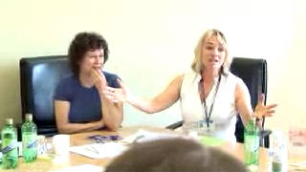
Figure 20 Extract from BERA 2006 paper
‘Can anyone see what I see? Does anyone feel as I feel? As I watch the flow of interaction between one and the other, I am reminded of Rayner’s Paper Dance of Inclusionality (http://www.jackwhitehead.com/rayner1sor.mov) and O’Donohue’s ‘web of betweenness’ (2003). I am looking at inclusionality in action of which I am a part and I am seeing the flow of life- affirming energy between Marie, the group and me, and as I watch, I am feeling the joy of what for me gives life meaning – the flow of interaction between one and the other and the pleasure of that co-dynamic relationship. I am reminded of these feelings of joy when I was a teacher interacting with the class: I am learning from them; they are learning from me; we are all learning together in a co-creational relationship which could not happen without one or the other within that moment in time.’
As you run the cursor back and forth watching the flow of energy in the living-boundary between us, and read Chris’s words, do you feel any connection with why you do what you do as an educator? Within that feeling for me lie the standards by which I judge my work. It is that which drives my planning, and it is that, which for me is lost, and at times denied, by the approaches to evaluating, planning and accounting for my practice which I am often expected to use.
Through coordinating and developing APEX I want to hold myself accountable for contributing to my employer’s vision, which I repeat here:
‘We want all Children and Young People to do better in life than they ever thought they could. We will give children and young people the help that they need to do this’ (Bath and North East Somerset Children and Young People’s Plan 2005)
I have become increasingly aware that ‘measures of impact’ of activity do not enable me to hold myself to account, and at times such immobile procedures can distract from what is important. What then can convince me that I am doing what I believe is worthwhile?
I am required, by those I report to, to provide statistics, and numerically driven forms of data, but I am not convinced by those figures that I have done anything useful. There are huge databases set up to tell the government how many children have this grade or that, how many are on this register or that, but even if all the children in the Authority attended school 100 per cent of the time and had above the national average SATs, GCSEs, and A Levels I would not be convinced that I had contributed to a world of educational quality: even if I could do the impossible and demonstrate a direct causal link between anything I did and those figures.
Local and national government policies and strategies are part of the context, the possibilities and constraints of my practice. These policies set explicit success criteria, such as ‘standards’ described by high-stakes tests, which must be responded to. However, they should not be confused with, the living, values-based standards that distinguish education and educational research and associated forms of evaluation and accountability. Michelle Paule expressed something of my feeling when she said in her keynote at the NACE 2007 annual conference that the exams are:
‘…a test not of what they can do but what is to be done with them.’
The evidence I seek of whether I am making a worthwhile contribution is intimately interrelated with understanding what I am trying to do and why. As a psychologist, I know that assessment and intervention exist in a dynamic relationship; the one informs the understanding of the other. We usually talk of assessment and intervention, learning and teaching, without reference to the intention, the values, the bigger question of ‘why are we doing this?’. For the most part there is a unidirectional short-sighted focus on behavioural objectives which resolves itself into a ‘plan, do, review’ approach often expressed in neat diagrams where activity is entered into discrete boxes (see Figure 21 below)
Plan

Review
Work planned
Targets set
Activities timetabled
Calendar of events

Do
Activity to monitor activities, use of resources, progress towards targets,
Schedule revised in light of progress
Evaluation in terms of pre-set targets reached, impact of activity measured in terms of pre-set outcome indicators
Report written and delivered
Figure 21 A generally-expected form of plan, do, review formats
There are variations on this theme but they share these basic features. There are no feedback loops that allow receptiveness to the information collected through practice with evolutionary responses. Details might change, for instance the timeline or the use of resources, but the targets, once set by the Local Authority/Government, take on an importance all of their own. It is rare that abandoning targets or altering them in the light of practice is possible. Should targets not be met, this is seen those who set them as a failure of the plan or its implementation, rather than as a positive, creative, development, arising from practice. Targets are treated as reified destinations and are not used as sighting posts offering a direction towards a distant horizon. Time and energy are devoted to ‘getting somewhere’, rather than in attending with continued curiosity and creativity to the point of travelling, the nature of the journey, the pleasure of exploring the ‘here and now’, or in creative conversations with fellow travellers.
I have found that too often targets are achieved, but have lost any connection with real life. Where in the plans, targets or statistics is there any communication of what it is for a child to get to know the person they want to be? Where is the value placed on improving the educational quality of the space for a child to reflect on the knowledge they are creating of themselves and the world they want to live in? Where is the importance recognised of the opportunity for a child to create, value and offer their gifts, appreciate their talents as they develop them and receptively respond to those of others? Where is the valuing and the possibility for me to offer the knowledge I am creating through theorising my practice?
Perhaps the disconnection between reality and what is demanded on paper arises because the purpose of many forms of accountability is not so much to enable a person to be held accountable to living their values, but rather to say whether they completed a specified task. The form of representation reflects this. A recurrent theme in my work-plans over the years has been:
‘Developing evaluation, monitoring and accreditation procedures and approaches which overtly value the learning and learners indicated in the policy statements.’
I have been acutely aware of how inadequate the forms of representation are to enable me to communicate the educational qualities that I am seeking to hold myself accountable to, and how disconnected they feel from what happens in practice. The way things are happening comes from methods rooted in fixed logics and epistemologies, where a hypothesis is offered in terms of an answer, and the test is whether the answer is ‘proven’ at the end of a given time period to be right or not. From that answer, gross generalisations are often made as to how and what populations should learn, how they should learn and how they should be taught. There is no room for creative responses: any learning or theorising is incidental, and communicating what is being learnt by an individual or a group is discouraged as dissent. Pace, challenge and stretch targets are part of the accepted language. Correlations are taken as causal relationships and ‘normal’ is a statistically-driven label disconnected from an individual’s reality or needs. There is no place for a living form of research or accountability with a warm, nurturing, creative space for querying the ‘rightness’ of the question, or for evolving diverse answers that respond to the diversity which describes human beings.
On the other hand, I can and do relate videos, pictures, or moments in videos, such as the example given here, to the educational values, which I began to clarify in Chapter 3. I introduced a video in Chapter 4 (page 139) to show the educational influence researching my practice to improve it has had. I bring it into the thesis here both to strengthen the connection with the narrative thread and to emphasis the relationally dynamic and multidimensional nature of Living-Theory research. I also present it as evidence as I hold myself accountable to living the educational values that form not only the explanatory principles but also the living standards of judgment of my practice.

Video 11 Pleasure and confidence in affirmation of knowledge creators

http://tinyurl.com/44of77d
You may remember this is a video of a group of AS Extended Project students who worked with Sally Cartwright, a member of the Masters group I supported. They are talking to a group of 14-19 strategy managers about their experience of working in a research group. A fuller account is given in an article in the Educational Journal of Living Theories (Huxtable, 2009a). I invite you again to watch this 5 minute extract of the 40 minute video, and ask whether you see as I do the pleasure and confidence flowing in the affirmation of valued knowledge created by self and other and in the camaraderie of creative learners in productive conversations. I see focussed attention and effort to creating knowledge and understanding, and pleasure and enthusiasm. I see the young people extending themselves and others a loving recognition, opening channels of respectful connectedness and expressing an educational responsibility for themselves and towards others. In making their knowledge public in such a forum they are contributing to the learning of the social formation that influences beyond their own school. By allowing the video of their presentation to be made public on YouTube, they offer an educational gift to others beyond their immediate locality. They also offer it as a gift to me as they enable me to account for my practice as I accept responsibility and give a values-based explanation for what I do.
As the form of evidence influences the activity that is valued and engaged in, I have to find a form of evidence that communicates what I value. The manner of planning is influenced by its framing, and so I must find a dynamic form which is intentionally receptive, and communicates a flowing responsiveness to information that arises from action. When I look at the most recent work of Whitehead creating multimedia narratives (Whitehead, 2011a) I can see such a form, which communicates and informs practice and provides evaluative evidence, which is valid and rigorous. In the accounts, which Whitehead creates as he accounts for himself and his work, I see a living, dynamic work-plan where the processes and evidence of monitoring, evaluation and accountability contribute to the plan because they are part of, not apart from, it. The creation of these accounts is in the public space, which invites engagement, and as they accumulate, each becomes part of the terrain for the next. As the accounts are presented on the web, there is also the possibility of making connections using hyperlinks and integrating video clips too.
In a reflective conversation about my work, I ask myself ‘how well am I doing?’ I also ask ‘what would convince me, or enable me to believe that I am doing anything useful?’ As I watch these videos and those of the Masters group, the Improving Practice Conversation Café, as I visit the Saturday workshops… I begin to feel that I am contributing to a world of educational quality. What gives me that feeling? People tell me that they would not be doing what they are doing if I had not done what I have done; I am still puzzled about what that is. I can feel the connection with all those who contribute, not to my work, but to the success of APEX. I therefore want to recognise and broadcast the work of those, like Joy Mounter, who give living meaning to what I value. Her accounts can be accessed from http://www.actionresearch.net/writings/mastermod.shtml. This is her work, not mine, yet I feel I can recognise something that I did that may have contributed to her thinking and work, and ultimately to that of the children. So, in her account, I find evidence I can draw on to evaluate and be accountable for my own.
Are numbers important? Of course, a thousand whispers might be heard where one can be lost on the wind. However, the mistake that must never be made is to think that quantity can stand in place of quality – the quality of the unique gift created and offered by each human being as a contribution to the flourishing of humanity.
I find that the imposition of standards, related to predefined learning outcomes, and forms of representation, which are reduced to text and statistics, dulls creativity and limits educational possibilities. This assertion is based on my own observations. The work of psychologists such as Deci and Dweck give insights into why this may be the case.
Deci (1996) draws on 25 years of work with his colleague Ryan on intrinsic and extrinsic drives, and the integrated and authentic self. He concludes, ‘… self-motivation, rather than external motivation, is at the heart of creativity, responsibility, health behaviour, and lasting change.’ (p.9). He offers a reframing of a common question posed in schools, ‘how can teachers motivate their pupils?’ to an educationally influential one when he says that the ‘proper question’ is, ‘how can people create the conditions within which others will motivate themselves?’ (p.10)
Dweck’s work on self-theories also points to the impact of an over concern with performance goals. She postulates two different theories that people hold to account for intelligence: an entity theory that is associated with a fixed mindset and performance goals, and an incremental theory that is associated with a growth mindset and a focus on learning goals. Put simply, a person can hold a self-theory of ‘I am smart’ (entity self-theory) or ‘I can learn to be smart (incremental self-theory). A person’s self-theory has implications for how they approach learning opportunities, respond to impositions, and maintain or relinquish aspirations faced with failure and external pressures.
Instruction is important at times, and the transmission of knowledge created by previous generations has a place in education. Traditional standards and forms of representation may be appropriate for monitoring the efficiency and effectiveness of the instructional procedures and strategies used. However, I do not believe that the sole purpose of education is to provide cost-effective skills training or efficient transmission of information.
As an educational psychologist, my primary concern now is to develop my practice as a contribution to improving the educational experience of learning. Different forms of evaluating and accounting for my practice are needed. This goes beyond improving an ability to acquire the skills of reading where the evidence of ‘success’ is in terms of a reading score. How do I produce evidence to understand how what I do contributes to that child’s developing an understanding of themselves as: a valued knowledge creator, a contributor to their own ability to learn and to that of others; a communicator able and willing to engage with their own thinking and that of others, or someone able to engage in an educational relationship. I value efforts to improve instructional techniques and strategies for ‘teaching reading’, and in that context believe that quantitative measures can be useful at times. However, this is only part of the story, and as an educational researcher I need to develop criteria and forms of evaluative evidence which reflect my ontological values so as to be able to decide which particular instructional technique are appropriate educationally.
Living research is the process whereby the systematic and organic relationship between questions and responses and the person/s asking them and a rationale, that is, a reasoned and reasonable explanation, are held together. The data I collect has to enable me to reflect on the relationally-dynamic understandings of my praxis. As Hymer (2007) points out, the forms of representation not only contribute to the communication but also shape what is recognised as data and are integral to understanding and generating responses to the evolving questions of living research.
The form of representation of data offers different opportunities to not only provide evidence for claims, but to inform the evolution of those claims. I reflect on emails, reports, papers, memos, notes, workplans, video, photographs and notes of personal reflections. I go beyond Schön (1995) and suggest that an epistemology does not just require new forms of communication; the forms of communication form it. Question, response and forms of communication are held in a dynamic relationship.
In clarifying what is meant by forms of data, I am here clarifying the form of research in which I am engaged– namely, living research – a form that gives explicit recognition to the organic as well as the systematic phases of enquiry and the inter-relational dynamic of data collection with the ‘task’ and ‘question’.
The second reason I discuss data collection here, is due to my concern with evaluation and accountability – the data that forms evidence is intimately interrelated with these two issues just as much as it is with shaping the question and the research journey. What I wish to do, is to enhance the ability of children and young people to improve their learning so as to understand themselves, their worlds and the contribution they can make. This bears unpicking again.
People are a complicated mixture of contradictions – we like the security of the known and sometimes cling to it with a destructive certainty, yet we are driven by a curiosity that can take us from warmth and comfort to uncertain, and potentially fatal, places. What moves us? I do not know, but I think that this is unique to the person and moment. Perhaps that is why I rail against the notion of ‘potential’, because this suggests that there is a preordained path that someone is to follow, and my job as educator is to find it and put them on it. Defining people, early-identification, targets, underachievement, all of these words add fuel to turn my irritation into anger. Perhaps this can give me a clue to the energy I require to leave security behind and ‘boldly go’. Gagne in a presentation to the World Congress Gifted and Talented Conference 2007 drew a distinction between motivation and volition, which might relate to Vasilyuk’s (1991) notion of energy; you may wish to do something, but it requires energy to do something about it.
Workplans are an influential form of data collection: targets become inflexible destinations rather than serving as vehicles or signposts. A workplan can define reality rather than reflect or shape it. Many people appear to find it easy to describe what they do, filling in workplans by dexterously interweaving targets from a myriad of sources. They are able to communicate what they do in the form of one side of a page of A4 paper covered with neat boxes and bullet points. At times, I am also required to make such presentations. But I find those demands emotionally and intellectually challenging, as the gulf between my living experience of my practice and such representations becomes a vivid and yawning chasm. What is the nature of the chasm between these analytic plans and the lived and living experience of my practice that creates such disquiet?
The communication of practice through traditional workplans or reports presents reality as comprising discrete events with predetermined outcomes. By putting events and outcomes in boxes, they are represented as ‘entities’, having no dynamic interconnection or relationship with other activities, or with the people who are involved. The events and outcomes are impervious to the creative possibilities that the multidimensional flowing complexity of ‘reality’ offers. By traditional workplans and reports, I mean to include the ‘tips for teachers’, the ‘packages’, the traditional social science approaches.
A move towards a more fluid, inclusional way of understanding ‘leadership’ and ‘organisational change’ is being made in the world of commerce through the work of people such as Senge and Scharmer (Senge and Scharmer, 2000). In addition, the Introduction, as a set of Frequently Asked Questions, to, ‘A Little Book of f-LAWS’ (Ackoff, Addison and Bibb, 2006) serves as an illustration of these developments in what they say and the way they say it:
‘When American management guru, Russell Ackoff, and his co-author, Herbert Addison showed us their f-Laws, we asked British author, Sally Bibb, to respond in the light of current organizational thinking and best practice. Sally’s is a voice from another generation, another gender and another continent. On every left- hand page we’ve printed Ackoff and Addison’s f-Law with their commentary. Opposite, you’ll find Sally Bibb’s reply. In each case, we’ve retained their spelling, punctuation and ‘voice’.
What do you mean by ‘the best’ organizations?
Sally looks always at how things can be done better. When she talks about ‘the best’ organizations, she’s talking about ones that strive to be: Collaborative ~ Ethical ~ Flexible ~ Innovative ~ Responsible ~ Sustainable ~ Transparent ~ Trustworthy’ (p.2)
Where in education, which should be driven by values, is there reference to values when talking about ‘the best’ practice of school or organisation? I take ‘values’ to communicate what is important to me, and ‘beliefs’ to reflect what I believe to be true. It is important that I am clear and consistent in communicating what I mean by ‘values’ otherwise this thesis cannot be understood, so I periodically reiterate this point.
Traditional approaches are used to create accounts to represent reality, but there is a move that seems to occur when the representation is taken to be reality. A tool then becomes the purpose, signposts become the destinations, and monitoring devices become confused with evaluation of what is of real value.
It is interesting to me to reflect on my change of mind. I began my career as an educational psychologist particularly attracted to behavioural approaches to developing interventions for and with teachers, children and parents. Objectives-based approaches to teaching were being developed in various forms during the 1970s and 1980s. I became competent at creating intervention plans with goals, objectives, starting points, steps and forms of progress monitoring, neatly partitioned and represented in boxes and charts. I devised various such formats, which were used by teachers and myself. (Levey and Mallon, 1984; Levey, Tempest and Knapman, 1986; Knapman, Huxtable and Tempest, 1987.)
Such approaches have their uses. For instance, using them has enabled me to help children establish such skills as developing a basic sight vocabulary, organising themselves with equipment in class, and learning to dress themselves, three dissimilar situations. When used by educators with an educational intent, these instructional devices can be beneficial. However, I now realise that the vehicle too often becomes the destination, and while the child might learn a sight vocabulary they can also learn to loath reading, become instructor-dependent and lose a sense of their own ability to create knowledge of value.
I realised early in my career as a school psychologist that objectives-based approaches to teaching readily slipped into teaching-to-objectives, but I was not aware of just how prevalent this sort of ‘slippage’ is, and the extent of the unintended damage that can result. In relation to work-plans and reports, in one form of report and plan the descriptions and targets are used as ‘servants’ to inform action and to be changed as information accrues. In another, the reports and plans are treated as ‘masters’, forming action, rather than being form in response to action.
So, one of the difficulties in describing my work is the simplistic nature of description encapsulated by boxes and bullet points, and the pressure to attribute causal relationships. To communicate what I do requires a more organic form of representation, which informs my work in an evolving receptively responsive process in the act of communicating it.
The form of presenting National Strategies does not show the dynamic systemic relationships that exist in reality and that are at the heart of evolving the quality of educational practice and provision and living-theory praxis. Occasionally some indication is given that the activity described in one box might influence that in another box, but the relationship is not dynamic. This, for instance, is a common format I have been required to use by the local authority (see Figure 22 below).
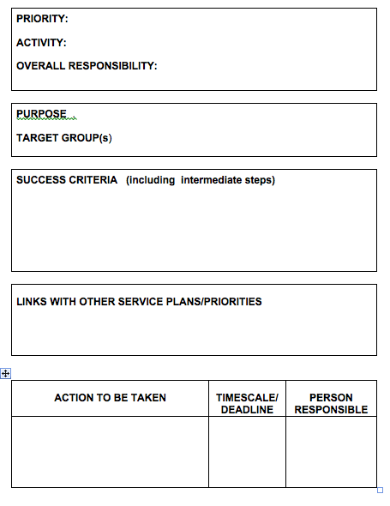
Figure 22 An example form as required by the Local Education Authority
The QCA (Qualifications and Curriculum Agency) in March 2008 made some inroads by offering a more organic representation as illustrated by this curriculum tree. (Figure 23)
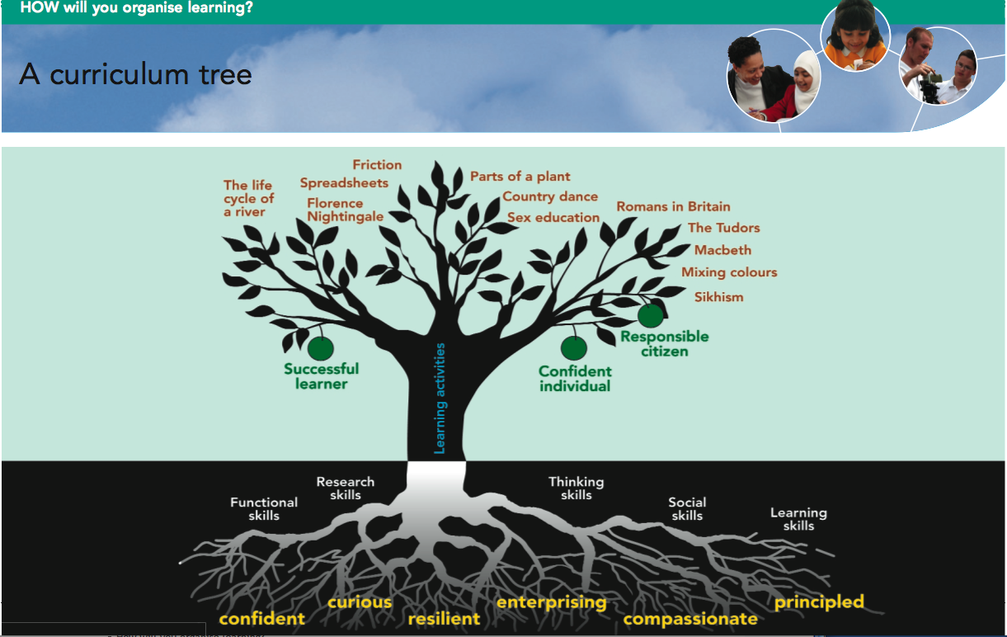
Figure 23 An example of a curriculum tree issued by the QCA, which shows that linear, boxlike forms are not the only possible approach.
However there is no indication of energised systemic and organic relationships, or the flowing multidimensional interconnectedness, within and between contexts, activities or people. Somehow the humanness seems to be missing; the person coming to recognise themselves and what it is that gives purpose and meaning to their lives, the heart and passion of the educator, the educational relationships that are the lifeblood of education, the values that are the bedrock of developing educational practice and relationships. Despite this lone example, I do not see any evidence of QCA’s bold innovation being replicated, let alone being built on, and the form of action plans flowing from central and local government continues in the traditional sterile, and sterilising, mode of representation. It may be no coincidence that after QCA morphed into QCDA (the Qualifications and Curriculum Development Agency) it was terminated by the government.
As my work on ‘high ability’ progressed, I increasingly recognised the dynamic inter-relational, multidimensional connections and influences of different activities. I felt a need to keep the practicalities connected to my evolving theoretical framework and conceptual challenges, and I therefore evolved a different format for my workplan. I described this in the paper presented to the BERA 2006 conference (Huxtable, 2006b):
A picture emerged of the areas of focus for my work, which enabled me to keep in mind the ‘balance’ of what I was doing, the inter-relationships of people and activity, and the ‘vision’ and possibilities for development. I described in Chapter 4 (page 123) how I used the picture to inform the development of opportunities for children and young people and the leading programme for teachers, as I work to improve the systemic influence of APEX.

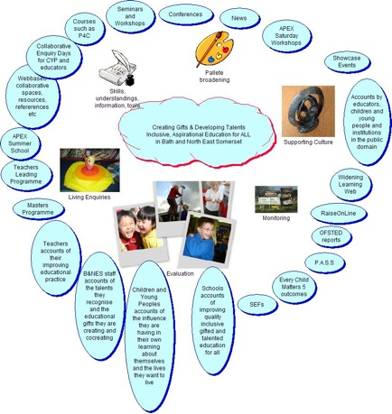
Figure 14 Framework for developing APEX

I have used this form of planning for several years now, and find this representational form to be an improvement over boxes and unidirectional and linear lists. I initially had each activity neatly connected with arrows radiating from the centre, but removed them on the advice of Joy Mounter’s Year 2 class: the children pointed out that the activities were interrelated and connected, and using arrows removed those connections. The quality of the conversations with the children has kept me hopeful: if 6-year-olds can manage to understand a multidimensional, interrelational theory of learning, and help me develop a more inclusional work-plan, then surely as adults we should be capable of going beyond the simplistic and mechanistic approaches that prevail in the national and local education system.

6.4 Postscript
I have been asking you to engage with this thesis as a multimedia narrative and to do so with ‘head, heart and body’. I have explained that I do not think that a simple intellectual engagement with text alone will enable us to create a shared understanding of the energy-flowing values and relationally-dynamic and multidimensional nature of living-theory praxis.
I have shown in this chapter how creating multimedia narratives can also contribute to educational forms of evaluation and accountability, which have generative and transformational possibilities and enhance educational influences in learning. In the process, I have clarified my meanings of and improved my understanding for myself of expressions of my energy-flowing values in living-boundaries. This knowledge becomes embodied and expressed in my practice. I have also shown in this chapter how forms of representation influence my practice, and how making creative use of multimedia can enable me to more coherently clarify, understand and communicate meanings of energy-flowing values in living-boundaries, so as to evolve my living-theory praxis as I evaluate my practice and hold myself accountable.
At the beginning of this chapter, I wrote that some stories comprise fragments of text, images and video that communicate to no one but me. Other stories are more extensive but not published or made public, while others are presented and shared. In the next chapter I will enlarge on how I have used this form of data created in the organic and systematic phases in a relationally-dynamic multidimensional approach to research. This integrates the creation of knowledge of the world, self and self in and of the world. I call this Living-Theory TASC.

Chapter 7 Living-Theory TASC: A relationally-dynamic and multidimensional approach to research and developing praxis
If you have engaged with this thesis by progressing from the preamble through each chapter in turn, I hope you feel you are beginning to understand what I mean by my ontological values of a loving recognition, a respectful connectedness and educational responsibility, and inclusive, emancipating and egalitarian social values. These values form the explanatory principles and living standards of judgment of my improving practice. I have outlined how developing educational gifted and talented theory, practice and provision is an expression of my embodied and evolving values, knowledge and living-theory praxis. In the last chapter, I showed how I make creative use of multimedia narratives in communicating my contributions to knowledge. I now want to explain more fully the approach I have taken to researching and developing my living-theory praxis through Living-Theory TASC.
The difference I shall be stressing between a Living-Theory approach and a TASC approach to research, and a Living-Theory TASC method of researching is the relational-dynamic and multidimensional inter- and intra- connections between the organic and systematic phases of the research. Living-Theory TASC also enables the researcher to recognise, value and work with the knowledge they create of themselves, and themselves in and of the world, in the process of researching to create knowledge of the world. I contend that Living-Theory TASC can be employed by learners of all ages, whether they are young learners researching their passions or adults researching to improve their practice.
I understand a research method to be a tool fashioned and creatively employed to reveal and contribute to developing understandings and knowledge. In the context of evolving my living-theory praxis, the methods I employ need to enable me to understand and change the relationally-dynamic multidimensional nature of my work and to create valid, generative and transformational explanations of educational influence to improve what I do and to contribute to the learning of others and social formations. Drawing on Whitehead’s Living-Theory (1989a) and Wallace’s TASC (Wallace and Adams, 1993) I bring the methods I use together, into what I call Living-Theory TASC.
‘Whether or not a research approach or a means of representing it has been given a name, any format can be sufficiently “valid” if it makes a unique and substantial contribution to understanding the world better or to making it a better place to live, and our dissertation stories have proven this so.’ (Four Arrows -Don Trent Jacobs-, 2008, p.5)
My claim is that this thesis makes such a contribution, and that Living-Theory TASC offers a valid research approach.
Sections as signposts in this chapter
7.1 Overview
7.2 Living-Theory TASC
7.3 Creating knowledge of the world, self and self in and of the world
7.4 Postscript

7.1 Overview
Creating and making public valid accounts of the knowledge created is an integral aspect of Living-Theory TASC research. Sometimes the gift of that knowledge may be offered to an unknown other in the living-boundary between self and the world, for instance as a published paper. At other times, it may be offered to a few people in a negotiated space. Wherever the gift of knowledge is eventually offered, the creation of a research account that can communicate beyond self, offers an opportunity to deepen and evolve learning and research.
The stories in the narrative of improving practice to be told are arrived at through an organic process, birthed and evolved through flowing, complex interconnecting relationships and experiences, between learners and educators as they enquire together. However, to communicate a practitioner researcher has to provide a narrative with their ideas ordered systematically (Carter, 1993). In the process of creating and offering such research accounts a person can come to recognise, value and enhance the knowledge they have created beyond what is possible when it remains ephemeral and unarticulated, or intuitive and subconscious. There is something important about talking the walk, and articulating thoughts clearly enough to create an account that communicates to others beyond the moment. To create such an account, however, takes energy. Energy is often consumed by the stresses and strains of dealing with the daily demands made by others, such as inspectors demanding compliance of Headteachers with government imposed standards, or teachers demanding compliance of their pupils to acquire particular skills or knowledge. As a consequence creating a research account may often be relegated to the backburner, waiting for that fanciful ‘when I have time’, which never comes. A spur is often needed. Making a commitment to creating an account for a purpose, such as accreditation or a journal or conference paper, can be the motivator needed to make time for, and devote energy to, what is important. Where to start, and how to proceed, are two questions that I hope to answer in clarifying Living-Theory TASC.
The research method I have evolved, comprises a synthesis of a Living-Theory approach to action research (Whitehead, 1989, 2012) and TASC developed by Belle Wallace (Wallace and Adams, 1993, Wallace, 2008) and incorporates multimedia narratives as a means of recognising, understanding and communicating energy-flowing values, as I detailed in the previous chapter.
This is the Living-Theory approach to action research from Whitehead on which I draw:
What is my concern?
Why am I concerned?
What am I going to do about it?
What data will I gather to help me to judge my effectiveness?
How does the data help me to clarify the meanings of my embodied values as these emerge in practice?
What values-based explanatory principles do I use to explain my educational influence?
How do I use my values-based standards of judgment in evaluating the validity of my claims to be improving my practice?
How will I strengthen the validity of my values-based explanations of my educational influences in learning?
The diagram below (Figure 24) shows the steps of enquiry of TASC
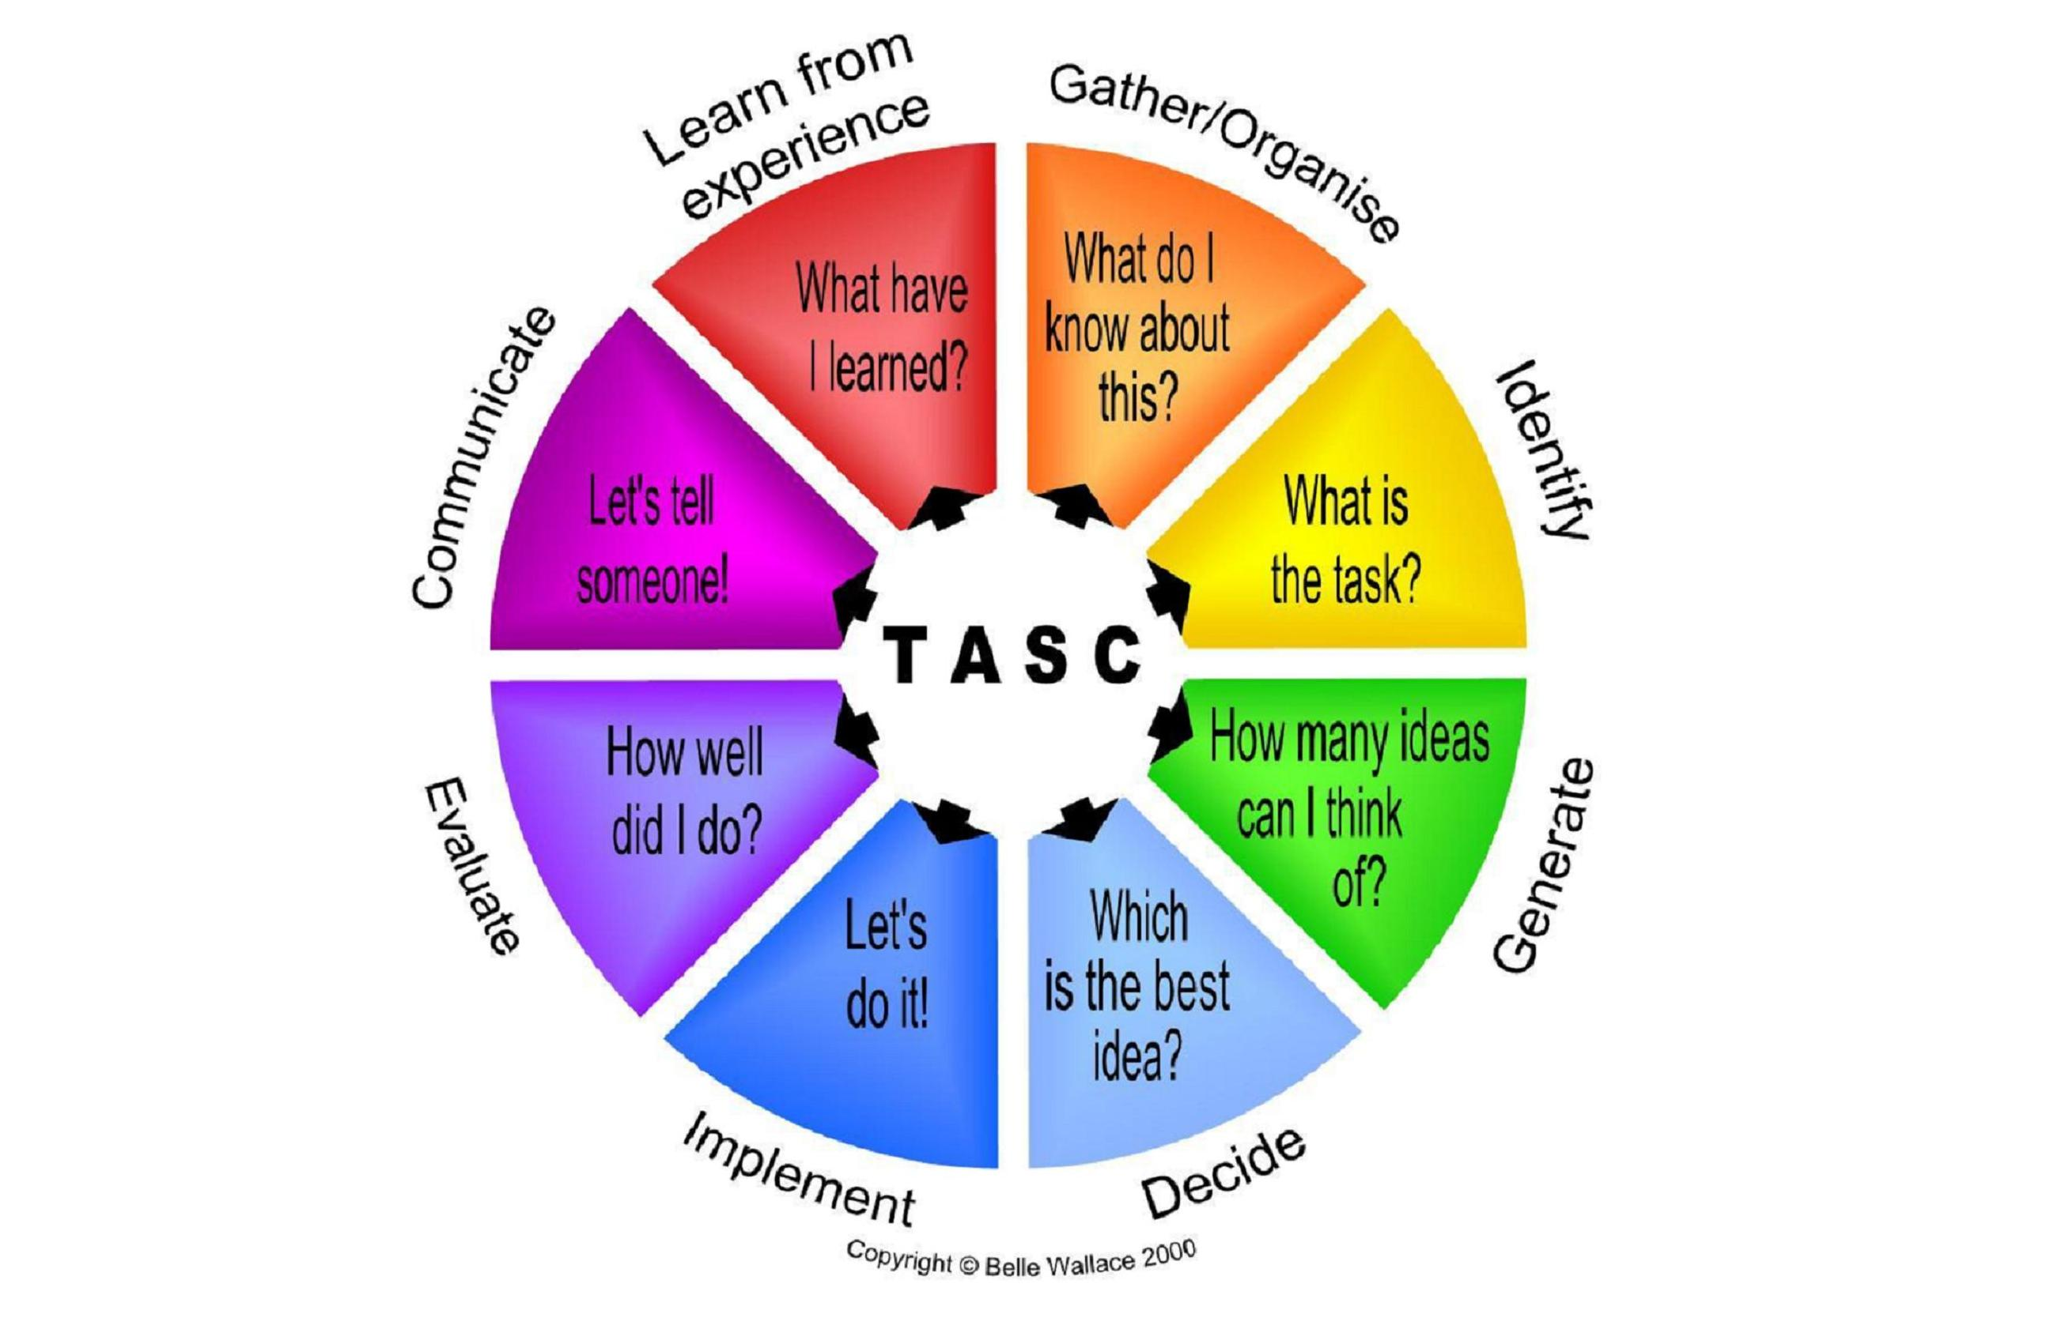
Figure 26 The steps of enquiry in the TASC approach (Wallace et al., 2004)
Through engaging with TASC and Living-Theory research, I have come to understand a disciplined process of enquiry that is comprehensible to children and adults, and is an expression of a pedagogy that resonates with me:
‘Education for democracy can only be developed by education through democracy…’ (Wallace and Adams, 1993, p.2)
The diagrammatic representation of TASC (Wallace et al., 2004) given above in Figure 24 is attractive, neat and colourful. However, the children working with Joy Mounter (2007) I introduced you to in Chapter 3 (pages 105-106) told Belle it does not communicate the multidimensional, interrelated flow that is the actuality of their learning. The children built a model (Figure 25) to communicate such a flow of energy. They used colour to show the flow, and represented the learning and knowledge created erupting up through the centre, the heart of the enterprise, as a shower of sparks on what is in the present and future.
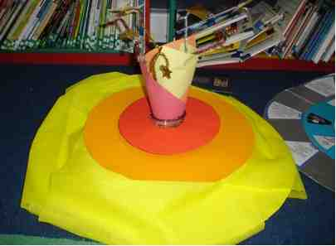
Figure 25 Joy Mounter's pupils' model of their learning

You may have to use your imagination more to understand the systematic aspect of living-theory TASC as a multidimensional zero-spiral knot illustrated in a 2D representation in Figure 26.

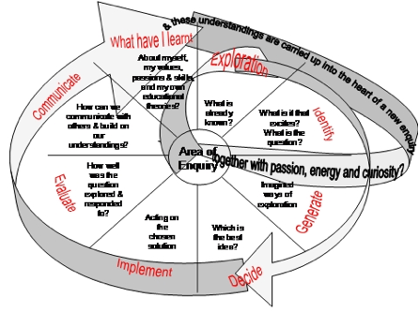
Figure 26 Living-Theory TASC Knot (author’s work)

In the organic phase of Living-Theory TASC I may at various times, or at the same time, be gathering and organising what is known in the field, implementing a plan of action, or clarifying my concern. I may use qualitative and quantitative methods developed by social scientists, and draw on theories and knowledge developed by academics and practitioners in various fields and disciplines. What I use and draw on is influenced by whether it helps me understand and improve what I am doing. I go into more detail about the inter-relationship of the systematic and the organic phase of enquiry later in this chapter.
In bringing TASC and Living-Theory together, I sought to describe a research method that:
- Holds together the organic and systematic phases of educational research in a relationally-dynamic multidimensional manner;
- Connects research to create knowledge of the world, with educational research to create knowledge of self and self in and of the world.
For simplicity I call this method Living-Theory TASC.
Sonia Hutchinson and Paul Falkus (both members of the CPD/Masters group I supported) inspired my notions of learning journeys and learning adventures. The sections of this chapter, and the other chapters in this thesis, can be conceived of as learning journeys within my learning adventure of evolving my living-theory praxis. To travel without a predefined destination I conceptualise as an adventure, or play, whereas to travel with a destination, even if very vague, I conceptualise as a journey. An adventure provides the openness to as yet unimagined possibilities, and journeys may enable the adventure to evolve rather than stagnate. A learning adventure that does not integrate learning and knowledge created and acquired on the journeys may become sterile, repetitive and superficial. I will not go further with those metaphors here, but will leave you to play with them to see if this helps you understand what I am trying to communicate of Living-Theory TASC in the evolution of my living-theory praxis as a multidimensional relationally-dynamic process, formed and informed by the complex ecology of my practice and being.

7.2 Living-Theory TASC
To explain Living-Theory TASC, I will take you through the process step-by-step. However, I do not wish to imply that Living-Theory TASC is a research method to be followed in a step-by-step fashion. Medawar (1969) points out this error:
‘…scientific ‘papers’ in the form in which they are communicated to learned journals are notorious for misrepresenting the processes of thought that led to whatever discoveries they describe.’ (p. 8)
You cannot know where you are going unless either you or someone else has already been there, and this presents a difficulty to those who will not take the first step on a learning adventure without knowing precisely what it is, where it is going to take them, or knowing in advance what they will experience. It is not uncommon for people who come new to the CPD/Masters groups I have run with Jack Whitehead to say they sit for a few weeks in a fog and find it difficult to recognise the structure of Living-Theory research: a penny may then drop even if they can not necessarily articulate what that penny is. The penny may drop in different ways for different people, but I hope in articulating Living-Theory TASC that I might help others to find their own way and develop their sophistication and expertise researching to create and integrate their knowledge of the world, self and self in and of the world.
So, where to begin researching? The short answer is, begin wherever you are. Collingwood (1991) describes something of the fog and struggle with which I empathise, and how he began a new enquiry:
‘There came upon me by degrees, after this, a sense of being burdened with a task whose nature I could not define except by saying, ‘I must think.’ What I was to think about I did not know; and when, obeying this command I fell silent and absent-minded in company, or sought solitude in order to think without interruption, I could not have said, and still cannot say, what it was that I actually thought. There were no particular questions that I asked myself; there were no special objects upon which I directed my mind; there was only a formless and aimless intellectual disturbance; as if I were wrestling with a fog.
I know now that this is what always happens when I am in the early stages of work on a problem. Until the problem has gone a long way towards being solved, I do not know what it is; all I am conscious of is this vague perturbation of mind, this sense of being worried about I cannot say what.’ (pp.4-5)
Rather than trying to impose structure and define a route at this point, I have found that, like Collingwood, allowing myself to be in the fog and writing about what comes to mind at that time often seems to clarify what is important. That then becomes part of the research, even if it does not seem to give rise directly and immediately to the formulation of research questions. The research question that does finally emerge is not one located in an idealised world of tomorrow, which never happens, but in the here-and-now, given all the constraints and tensions of the real world, of which we are a part of and wish to improve.
Graham, who describes himself as an essayist, programmer, and investor, offers a similar insight into how to begin in ‘The Age of the Essay’:
‘… Essayer is the French verb meaning "to try" and an essai is an attempt. An essay is something you write to try to figure something out.
Figure out what? You do not know yet. And so you can’t begin with a thesis, because you do not have one, and may never have one. An essay doesn’t begin with a statement, but with a question. In a real essay, you do not take a position and defend it. You notice a door that’s ajar, and you open it and walk in to see what’s inside.
If all you want to do is figure things out, why do you need to write anything, though? Why not just sit and think? Well, there precisely is Montaigne’s great discovery. Expressing ideas helps to form them. Indeed, helps is far too weak a word. Most of what ends up in my essays I only thought of when I sat down to write them. That’s why I write them.
In the things you write in school you are, in theory, merely explaining yourself to the reader. In a real essay you’re writing for yourself. You’re thinking out loud.’ (Graham, 2004)
Graham points to a first hurdle for someone employing Living-Theory TASC to overcome. The tendency is to want to dash to the end and write to explain yourself to the reader. This is what I am calling a ‘readerly text’. This thesis is in the form of a ‘readerly text’: a text, or multimedia narrative, that attracts and holds the attention of the reader, and communicates the knowledge I have created educationally. By that I mean I want to communicate in such a way that my account of my living-theory stimulates the imagination of readers in a manner that enhances their own learning and research. To create a ‘readerly text’ I begin by creating a ‘writerly text’. I create a writerly text in the first place not with a view to what the readerly text may be but, like Graham, to enable me to recognise, value and work with the knowledge I have created in the process of researching to improve my living-theory praxis. I am not using the phrases ‘readerly text’ or ‘writerly text’ in the form meant by Barthes, which Hall (2001) explains:
‘To summarize, a text can be seen as readerly or writerly depending upon the positioning of the reader. Barthes (1976) described this as follows.
. . . literature may be divided into that which gives the reader a role, a function, a contribution to make, and that which renders the reader idle or redundant, left with no more than the poor freedom to accept or reject the text and which thereby reduces him to that apt but impotent symbol of the bourgeois world, an inert consumer to the author’s role as producer. (Barthes, 1976: 113)’
(Hall, 2001, p. 155)
Barthes is concerned with clarifying the role of the reader. I am concerned in the first place with the role and purpose of creating the account for the creator. I am using the phrases ‘readerly text’ and ‘writerly text’ as I have understood them from observing Jack Whitehead’s use of the phrases as he has supported Masters and Doctoral students researching and making their embodied knowledge public. The beginning of these writerly texts invariably begins with Jack urging “write about what is important to you”, and then, “keep writing until you have written yourself out”. This writing often includes incidences of childhood that have influenced the development of their values as well as current concerns. The researcher is encouraged to share these early writings within the educational research group. When the work is articulated it enables the researcher and others to share and learn from their responses. This co-operative enquiry often helps each person to clarify their ontological values as they emerge in the living-boundary between what is private and personal. It is an important movement for many, when they move from solitary introspection to having the confidence and trust in themselves and others to offer their not knowing in the living boundary, between i~we. This is the point in the TASC process concerned with ‘communicating to and with others’, and ‘what have I learned about myself and my self in and of the world as I have enquired’. As the writings and a focus begins to emerge the researcher draws in work created in the organic phase of their research.
In the organic phase numerous multimedia narratives can be created, which may appear to have no coherence or even relevance at the time. This may not be when they have a focus or even an intention to create an account. The researcher may begin by telling, often apparently disconnected, stories of what is important to them, and a brief autobiographical story to help them begin to clarify their values and beliefs, and recognise their embodied and acquired knowledge. As their thinking progresses they can begin to see where they are living a contradiction, what they need to do differently, and imagine possibilities, act accordingly, evaluate and so on.
The question to be addressed through the research, the data to collect, and the form of the process, are often not known at the beginning, and may only emerge as the enquiry proceeds. Sometimes this is a case of recognising that the enquiry has been going on for years, and the researcher may have unrecognised data scattered about them as Barry Hymer (2007) found when working on his doctoral thesis.
In the organic phase of research, stories may be created variously as time, other commitments and interests move. On one occasion, you may be reading, and find work that excites you and create notes for yourself while working on an action-reflection cycle dictated by circumstances or interest. On another occasion, you may get an idea of something you might do, but do not follow through in action although this took your thinking forward. As you move through life and create trails in the form of narratives, notes, images and videos, when you move from reflecting-in-action to reflect on action, you have data scattered round to draw on as you work on the systematic phase of your research.
This thesis was created in the first place as a writerly text and then I worked with it to develop it as a readerly text. In my head while I type, images and thoughts vie for attention, but even as one is brought into sharper focus, I am aware of the contribution of others. I can look around my room and in focusing on the purring of my cat, the warmth and softness of his body against my elbow, the hues of his fur, I am still conscious of other sounds, senses and sights, which are part of my physical space and all contribute to what I am experiencing. My mental and emotional worlds could be similarly described. There are also other worlds created in the interplay between worlds, as you might recognise as I described the focus on my cat. How much you recognise depends somewhat on how far beyond the discreteness of words you go to allow an image to be created in your imagination. You might guess from my mention of my cat, and the pleasure I experience of his presence, that there is a history between us, and if you can empathise (even if you are a felinophobe) a picture is beginning to form in your imagination of what I might be like, the setting I am in, and so on. However, as Lather puts it when talking of ‘ironic validity’:
‘The text is resituated as a representation of its ‘failure to represent what it points toward but can never reach…. (Lather, 1994, p. 40-41).’ (Donmoyer, 1996 p. 21)
I am aware that as I write any words, I am doing so with my lifetime of experience that embraces my head, heart and body, and you are reading them with your own. ‘A picture is worth a 1,000 words’ as the well-known saying goes. I add a picture of one of the cats, which share my home with me, to increase the possibility of what you experience coming a little closer to mine and so that a readerly text may communicate better.
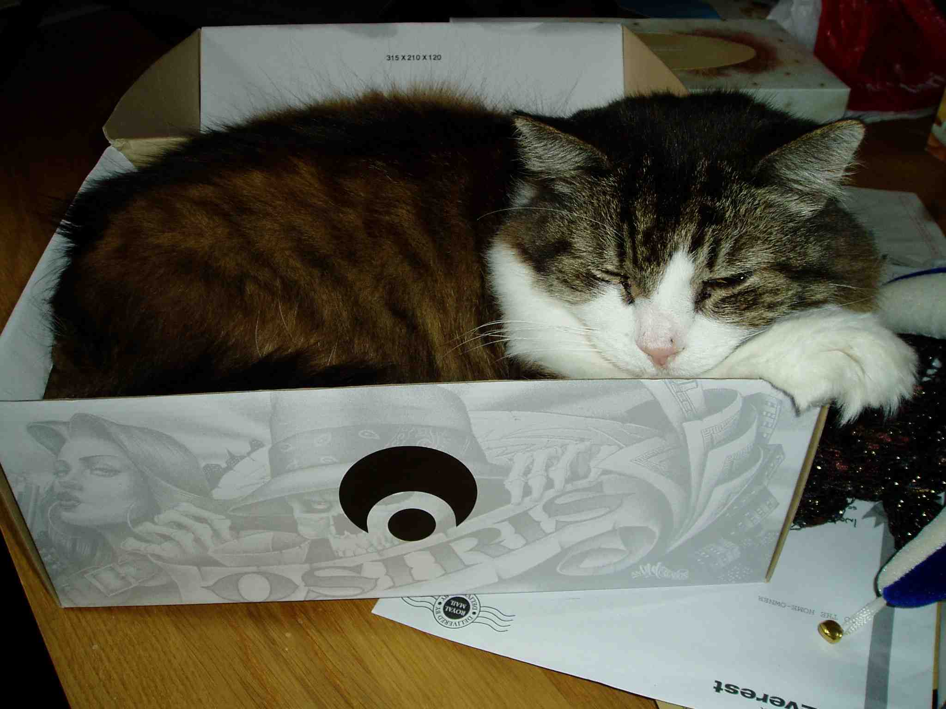
Figure 27 Fatcat!

Working with video and accompanying text to produce a multimedia narrative further clarifies the thinking for reader and researcher.
A metaphor that I like that helps me describe the purposes and manner of developing a readerly text is the one Louise Cripps told me about of an art exhibition. An artist forms various art pieces, sometimes in response to a commission, sometimes as an exploration of the different use of material and tools, sometimes just from idly playing with material, or in response to having seen other artists work or thoughts emerging from conversations or events. Not all pieces are finished or perfected. I have a picture in my head of a room cluttered with clay and canvas, books spilling off shelves, and balanced in precarious towers on the floor in a sea of papers. The image of Andrew Henon’s video in support of his Masters dissertation, ‘The making of art works and the work of art’, (Henon, 2008) comes to mind, as I envisage the artist mindfully preoccupied in mellow mood and music. You can get a sense of what I experience within the first few seconds of video 20.
Video 20 Andrew Henon – video in support of Masters dissertation (16mins 05secs)
http://www.youtube.com/watch?v=7dt2j1DIttE

Then the possibilities of an exhibition emerge, and a systematic phase of research may be embarked upon. Pieces are explored from the perspective of the exhibition theme, gathered together and re-examined as they are organised and rearranged until the focus of the exhibition is clarified.
Various possibilities for the nature of the exhibition are imagined and one decided upon, taking into account the venue, finance, audience and so on. Then the work on the exhibition is undertaken, and its success evaluated. Sitting quietly afterwards with a glass of wine the artist as researcher developing their living-theory praxis reflects back on: What went well and what did not? What have they learned about them self as artist and as the person they are and want to be in the world? Did they express their values as fully as they could? What talents did they develop and what do they want to enhance further and how? What do they now want to do to continue to live a loving, satisfying and productive life that is worthwhile? And so the questions tumble out, and their thinking progresses as they struggle to answer them. However, without making some account, that learning will be lost to the them and to others.
We see what we look for through our continually developing lenses honed by our responses and interactions with the complex ecology of our lives. Elkins (1997) describes the complexity and inter-relational nature of looking. Neugarten (2003) in his paper on ‘seeing’ and ‘noticing’ points to a creative and dynamic process:
‘… it is not so much our eyes that see, but rather our brains. Far from ‘seeing is believing’, what we believe can seriously affect what we see. We shall show that ‘there is more to seeing than meets the eyeball’, and that looking too hard, getting too close, and being too focused is often counterproductive…’ (p.93)
So, we get what we look for. Similarly the way in which I create imaginings of my reality forms that reality and questions can only be formed with a thought for their answers. However the process is subtle in its complexity. In trying to describe a Living-Theory TASC research process I therefore need to use a variety of devices to enhance our communication and share understanding. These devices include words as text in various forms, poetic, narrative, metaphors, photographs, pictures, drawings, video, using different voices and so on. I recognise that the devices of representation themselves are an integral part of the research method and may influence what is researched and the knowledge created. I addressed this issue when I discussed evaluation and the creative use of multimedia narrative in the previous chapter. For now I wish to remain focused on a Living-Theory TASC process.
In communicating to and with my self and others, to make sense of the organic flow of the adventure and journeys I have been on, I begin to understand what I have been doing. I begin to form an explanation emerging from as yet undescribed events. I am seeking to understand and theorise not only what has emerged of my physical and social world, but also to understand myself – the world within - and myself in and of the world. What values have I used to account for and explain my improving practice, what do I understand about myself as a learner, in relation to others, the passions I can now recognise I had, and may want to pursue, which will drive the systematic phase of the research?
I recognise that a common key to Living-Theory TASC lies in the sections, ‘communicate’ to and with others, and ‘what have I learnt’. Whitehead points to the same place in the process when he says that it is often the last thing that is written which is the point that needs to be brought to the front. You may not know, or recognise the significance of what you have done, until you have done it. The act of reappraising is not just a cognitive activity: reappraisal to enhance my educational influence involves heart and body as well as head. It is an act of extending self a loving recognition, developing respectful connectedness within self and expressing an educational responsibility towards others and for self.
Respectful connectedness within my self may sound odd. I am aware of those boundaries within others, intra-personal worlds, and try not to inadvertently ‘lean on the doors of others they do not want opened’. There are boundaries between, for instance, private, personal, public, professional inter-personal worlds. They are fluid, ill-defined, culturally influenced if not determined, but recognisable particularly when transgressed. To use the metaphor with which I started this thesis, sometimes it takes the particles in smoke to make visible the energy expressed as ‘light’ and ‘flow’, which we tacitly know.
There are also internal places that I know I have constructed boundaries around to help me deal with experiences, which may, for instance, be painful or damaging. Much of psychotherapeutic theory and practice is built on such a premise. Some approaches focus on breaking down such boundaries, others on building them up. For me, this is well illustrated by the figure of Dali’s (Figure 28), that Jack Whitehead offered me in a conversation about such matters when I first began working with him. For Dali, opened drawers represent those issues in his psyche that he feels he has explored fully. Closed drawers represent those issues that have not been explored. I believe it is a matter of personal decision whether ‘drawers’ are opened or closed, and I respect my own decision about when, or even whether, to explore issues at the core of my psyche. I try to show the same respect for the decisions of others as to whether they choose to explore such issues and when and whether ‘drawers’ are opened or closed.


Figure 28 Dali’s sculpture Anthropomorphic Cabinet (Image accessed 22nd January 2012 from http://sites.google.com/site/mustbu/anthropomorphiccabinet)

Perhaps this explains why I have been so attracted to the idea of developing generative and transformational possibilities within boundaries, rather than venturing into the worlds that comprise them. I can invite a person into the living-boundary between us without trespassing. There are often times when it is unclear whether to test the timeliness of exploring new drawers, or re-exploring ones that appear opened, but I appreciate that I do not have to live with the consequences of often well-intentioned, intimate, yet naïve enquiry.
As I reflect on what I have learned through my enquiry. I do so with a growing awareness of being respectful of my own boundaries, those between me and other worlds, and those within me, and the co-creative possibilities of acting within those boundaries while not violating them. A loving recognition is appreciative and respectful of those boundaries while offering opportunities within them for creating knowledge of self, and self in and of the world. This holds generative, transformational and life-enhancing possibilities for the places that form the boundaries.
As I have said, I think I go through two phases in researching. I understand research to be about trying to make sense of my worlds in a way that is generative and transformational for me and contributes generative and transformational possibilities for others. I have briefly reflected on the organic phase. As I consider the systematic phase bear in mind that I have written that the form of Living-Theory TASC is relationally-dynamic and multidimensional, within phases and between phases. In the systematic phase, the work does not go clockwise round the ‘wheel’, even when creating an account. This thesis is testament to what I mean. For instance, in the process of trying to produce an account that might communicate to you, I have organised and reorganised the material and reorganised it again as new learning emerges. Such an approach is also to be found in other disciplines, as illustrated by this reflection:
‘I used to be a designer/engineer – you can’t do that if you don’t work iteratively. We also try and develop some of our IT systems in what we call a spiral fashion, tweaking and improving as we go along. Look at how Google rolls out new improvements, versus how Microsoft issues updates. I know which I prefer – iteratively.’ (personal communication from Michael Neugarten, 12 November 2011)
Research is often thought by educators to start with ‘exploration’, laying out what is already known, or as TASC would have it, ‘gather and organise’. I would like to take Whitehead’s ideas of values and embodied living-educational-theory being revealed through researching to improve practice, and suggest a starting place of ‘learning from experience’. As I reflect over what has been, I ask myself questions such as:
What have I learnt about my values, myself, my passions?
What skills and understandings have I extended?
What talents have I developed and which do I need to develop?
How does what I have learnt connect with other ideas?
What knowledge have I created that I value?
How have I affected others?
How have I contributed to and benefited from my own learning and the learning of others?
What are my embodied educational theories and beliefs?
What do I want to explore now?
As I discussed in the previous chapter I am aware that I create stories about my life, which move from descriptions to explanations and shape the life I am living. The creation of a ‘readerly text’ as a form of account that communicates to others is part of the living-theory research process. This serves a different purpose to the traditional research report and is integral to living-theory TASC. Most people, are, unfortunately, not introduced in school to writing to enhance their own understandings, and as adults, have experienced the futility of producing a report of what they have done, for no other reason than that is what ‘ticks the box’. Practically the first response I get from educators when I suggest that they may like/wish to research their practice is, ‘this ... sounds great and I would love to - as long as I do not have to write!’ I sympathise. I too am in recovery from the damage I experienced in my school career. I continue to suffer when required to write a report of what I have done for no other reason than to justify the past. I shudder at the continual damage that is done to countless generations who are taught to equate writing meaningfully for themselves and others and thoughtfully accepting knowledge offered as a gift through literature of all sorts, with what they are taught they should value through the English curriculum and prevailing dominant forms of enquiry in the Academy. Can write, won’t write. Can read, won’t read. And that from educators!
To move on, having considered ‘communicating to and with others’, and ‘what I have learned’, the understandings are carried up into the heart of the enquiry where the questions concerning what is of importance, and why, begin to emerge as the researcher connects with the anticipated audience of the account. The why is an important question to pose and comes directly from the Living-Theory research process. I have seen the affect that posing that question has had on students beginning to enquire into what is important to them. It deepened their understanding not only of the discipline related enquiry but their understanding of themselves and how they want to be in the world. The affect on the research of teachers has similarly been deepened as can be seen in the Masters assignments on http://www.actionresearch.net
I like the way TASC specifically identifies ‘gather and organise knowledge’ particularly relevant to the account. This reminds me explicitly of the i~we relationship, and the value of gifts of knowledge offered by self and others, and the new knowledge generated in the process of organising what is known. The number of rewrites of this thesis offers an example of what I mean here.
The next sections of the Living-Theory TASC are well explored and documented in work on TASC and Living-Theory action research: what is the question/ what do I want to improve; imagining possibilities and selecting one; implementing and evaluating.
The difference I want to stress with understanding a Living-Theory TASC method of researching is the relational-dynamic and multidimensional inter- and intra- connections between the organic and systematic phases. The circle at the top of the drawing shown below (Figure 29) represents the systematic phase with interconnections and with the organic phase represented beneath.
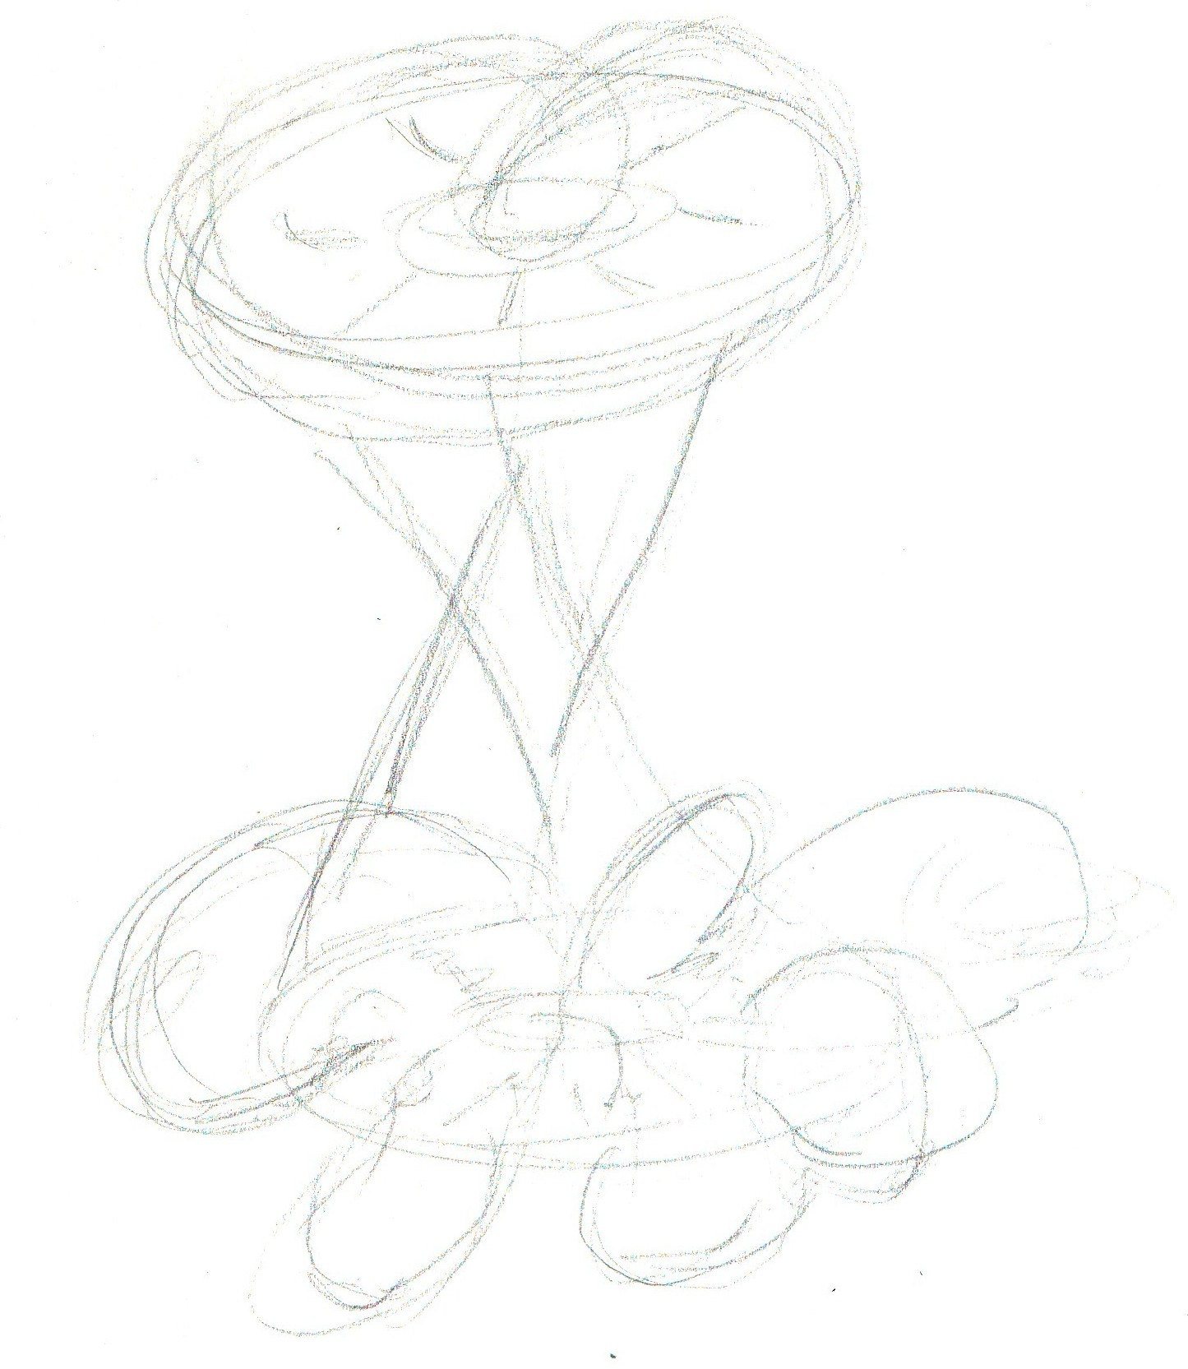
Figure 29 Inter-relationship between organic and systematic phases of research
Claxton and Lucas (2004) offer me a metaphor when they describe how to ‘see’ a stereoscopic picture. ‘To ‘see’ the picture in a ‘magic-eye picture’, you must maintain a point of soft focus beyond the page in order to see what is on it.’ (p.61) When you do that you can then explore what is close. ‘Engage with the whole beyond the sum of its parts, and from that place explore the detail.’ (Huxtable, 2006b, p.4)
They use the exercise of ‘soft focus’ or focusing in the distance, to enable the observer to ‘see’ a stereoscopic picture. The image in the foreground can only be seen if you relax and focus in the distance. As I focus on researching my daily practice, I maintain an awareness of the relational-dynamic and multidimensional connections with people and possibilities past, present and imagined futures and living my values. The picture by Dali (Figure 30) communicates the fluidity of energy flows that are, for me, inherent in being human in and of the world, and the nature of educational relationships, space and opportunities that living-theory research encompasses.

Figure 30 Dali’s, ‘Soft Watch at the Moment of First Explosion.’ (Image accessed 22nd January 2012 from http://blueskies-baller.blogspot.com/2010/12/salvador-dali.html
Before leaving this section I want to stress that creating a living-theory account is an educational process for the creator. In making accounts public a researcher can enhance his or her educational influence in their own learning, that of others and social formations in a co-operative, co-creative process.
In the School Wide Enrichment (Renzulli, 1997) and TASC (Wallace et al., 2004), reflection is primarily concerned with the metacognitive: although Renzulli and Wallace allude to something more the major focus is on ‘learning’ as a process to create knowledge of the world. I value their work highly and want to build on it with a shift of emphasis by incorporating insights drawn from Whitehead’s work on Living-Theory (Whitehead, 1989) with the focus on making embodied knowledge public and giving values based explanations. The integration of Living-Theory and TASC enables me to understand a research method to improve what I am doing as an educator, creating and developing educational relationships, space and opportunities and to support researchers, irrespective of age of interest, to enhance their sophistication as a learner, creating knowledge of the world, self and self in and of the world. This has entailed presenting learners with a challenge many are not comfortable with. Leigh (2002) talks of ‘facilitator’ in a way I recognise ‘educator’. I quote her at length because she describes the complaint I have heard from learners of all ages when an educator behaves as an educator and not as an instructor or traditional teacher.
‘A ‘facilitator’ of open simulations’ does so in particularly complex and intricate circumstances. They are sometimes implored to abandon ‘facilitation’ and take on a ‘leader’ role as participants feel less and less certain of the efficacy of their ‘taken for granted’ habits and seek a return to the stability of the known and familiar – however poor or unproductive it is being revealed to be.
‘What is an ‘expert’ facilitator?
In my opinion, an ‘expert’ facilitator is anyone able to appropriately resist such entreaties in the interests of sustaining the ‘instability’ and uncertainty that precedes emergence of new understanding and insights into personal and/or group behaviour. Conversely they are also able to help participants identify and integrate personal learning moments into the larger whole of their lives. And they may find themselves doing so, moment by moment as awareness of needs and the impact of particular experiences brings new understanding.’ (p.10)
This is also a good example of learning being slow, and sometimes it is only upon reflecting back on a particular place in a journey that generative and transformational learning can take place. This reminds me of Jane Spiro’s story ‘Learner and Teacher as Fellow Travellers’ in her doctorate (Spiro, 2008). The story can be accessed from http://www.actionresearch.net/living/janespiropdfphd/storyepilogue.pdf. It was only when Jane was a long way from where she had been, and when she was in the ‘right’ emotional, physical and intellectual place, that she could appreciate the educational significance of her experiences and the contribution they had made to her current journey and that journey yet to come:
‘… I unfolded all the contents of my travels around me and spread them on the ground. How to fit them together? Surely they could never be crafted into one coherent and beautiful piece?
But as I stared at them hour after hour alone now outside the gates of my destination, it all became clear.’
I read Jane’s story in 2005, and it still resonates with me. I hope you might take the time to read it. It says so much about the way I want to be, how I want adults as educators to be with children and young people, and what I want the personal reflective learning space to be. I have worked in similar vein with Joy Mounter on ‘Spirals’, which is a physical expression of a repository for reflection.

7.3 Creating knowledge of the world, self and self in and of the world
I have endeavoured to give you some insight into how I understand Living-Theory TASC as a multidimensional and relationally-dynamic research method. The description I have given of Living-Theory TASC has been with adults, and particularly educators, researching to improve their practice, in mind. The knowledge of the world, which they create and offer as a gift, is of their values-based practice. In the process, they come to create knowledge of themselves in the form of those values that give their lives purpose and meaning. They also create knowledge of themselves in and of the world, and, to borrow from Ghandi, how they can be more of the change they want to see. The knowledge of their living values emerges in the living-boundary, the ~ space in i~we, as they create and communicate their living-theory account.
I believe children and young people are also, with the support of educators, able to engage in Living-Theory TASC research to create and offer as a gift, knowledge of the world and in the process, create knowledge of themselves and themselves in and of the world. The form of research that is offered to the young, such as Kellett (2005) describes, has the same limitations that traditional forms of social science research confers on educators. I have explored those issues in Chapter 2.
In extending TASC to integrate the insights of Living-Theory research as I have illustrated as living-theory TASC, more time and support is given to the learner to enable them to deepen their understanding of themselves through communicating to and with others what they have learned. This is through their enquiry about themselves and themselves in and of the world. It relates to knowledge of the social and cultural influences on them of the context within which they live, and knowledge and of their ontological and social values, the talents they have and want to develop, their motivations, the nature of the world they want to bring into being through how they are, what gifts they want to create and offer to enhance their own well-being and well-becoming and that of others. The work done with Philosophy for Children (Hymer, 2007) shows that even young children can demonstrate they are capable of:
- Valuing themselves as an expert able to develop their expertise in their own learning
- Developing and enhancing talents
- Creating, offering and accepting knowledge of the world, themselves and themselves in and of the world as a gift, to enhance their own well-being and well-becoming and that of others
- Coming to know and give living expression to the values that give their life meaning and purpose and create their own living-theory.
The work of Joy Mounter with 7-year-olds and Sally Cartwright with 17-year-olds shows that children and young people are capable of developing their living-theory praxis given time, encouragement and the support of a skilled educator to explore their values, talents, expertise and embodied living knowledge as they emerge in the living-boundary, in the ~ space, in an i~we relationship.
Others like Pring (2000), emphasise the importance of self-study as an educational process:
‘One remains ignorant and powerless unless, through learning, one acquires the concepts and knowledge which dispel that ignorance and enable one to understand oneself and others, and one’s obligations and responsibilities. Learning is essential to becoming fully a person. Through learning one acquires the ideals which ennoble and motivate, the standards by which one might evaluate one’s own performances and those of others. Adolescence, in particular, is a period in which young people seek to find their distinctive identities – the sort of persons they are or might become, the ideals that are worth striving for, the qualities that they wish to be respected for, the talents that need to be developed, the kind of relationship in which they will find enrichment, the style of life that is worth pursuing.’ (p.19)
However, Pring is not making the connection with self-study or with practitioners researching themselves to improve what they are doing. Pring goes on to explore questions of the form, ‘who am I?’ I find such questions can become abstract and disconnected from my question as an educator wanting to improve my practice. Frankl (1984) makes this point in explaining his contribution to the field of psychotherapy:
‘One should not search for an abstract meaning of life. Everyone has his own specific vocation or mission in life to carry out a concrete assignment which demands fulfilment. Therein he cannot be replaced, nor can his life be repeated. Thus, everyone’s task is as unique as is his specific opportunity to implement it.
As each situation in life represents a challenge to man and presents a problem for him to solve, the question of the meaning of life may actually be reversed. Ultimately, man should not ask what the meaning of his life is, but rather he must recognise that it is he who is asked. In a word, each man is questioned by life; and he can only answer to life by answering for his own life; to life he can only respond by being responsible. Thus, logotherapy sees in responsibleness the very essence of human existence.’ (p.131)
‘…the true meaning of life is to be discovered in the world rather than within man or his own psyche, as though it were a closed system.’ (p.133)
What I am suggesting is that practitioner self-study does not stand apart from the creation of knowledge of the world. Nor should it be in place of the given curriculum prescribed by school and government. Rather, as I have explained earlier, education comprises various curricula including the living personal(ised) curriculum of each individual child and young person engaged in passion-led learning.

7.4 Postscript
Living-theory TASC is the method I employ to support myself as learner to create and offer accounts of the knowledge I create of my practice, and living-theory accounts of the knowledge I create of myself, and myself in and of the world. I keep my educational intent in sharp focus while not losing focus required by the instructional and training functions that organisations, institutions and practitioners are primarily required by government to concern themselves with. The multimedia narratives as artefacts assessed by and with me as learner, contribute to the educational learning of myself as student, and my educational evaluation of my practice.
In this chapter I have clarified the relationally-dynamic and multidimensional nature of Living-Theory TASC as an educational research method. I have then continued to explain how this might be of use to educators supporting learners to integrate their research to create knowledge of the world with that to create knowledge of themselves and themselves in and of the world, and learn what it might be for them to live a satisfying, productive and worthwhile life for themselves and others. In the next chapter I bring this thesis to its conclusion and offer suggestions of where this may go in the future.

Chapter 8 What have I learned and what now?
The narrative has been, by necessity linear. In this chapter, I bring together my learning journeys to make more explicit the multidimensional and relationally- dynamic nature of my evolving living-theory praxis as a learning adventure. This takes the current leg of my learning journey towards its conclusion.
This journey has been an effort to free myself of my own ignorance. I want to borrow this quote from Nelson Mandela as my inspiration to take the time in this final chapter to rest and look with gentle eyes back over the journey shared:
‘I have walked that long road to freedom. I have tried not to falter; I have made missteps along the way. But I have discovered the secret that after climbing a great hill, one only finds that there are many more hills to climb. I have taken a moment here to rest, to steal a view of the glorious vista that surrounds me, to look back on the distance I have come. But I can rest only for a moment, for with freedom comes responsibilities, and I dare not linger, for my long walk is not yet ended.’
Sections as signposts in this chapter:
8.1 Have I told a good story well?
8.2 What are the main points of my learning?
8.3 And…?

8.1 Have I told a good story well?
This self-study has drawn insights from a number of approaches to educational research. It included multimedia narratives to explicate the meanings of the relationally-dynamic energy-flowing values and understandings that constitute the explanatory principles of educational influences and living standards of judgment in this thesis.
In creating this account I have held these criteria in focus:

- Have I clarified my educational practice, which is multidimensional, and relationally-dynamic?
- Have I clarified the values that give purpose and meaning to my life, which form my explanatory principles of my practice and my evaluative criteria?
- Have I shown how my recognition of my values has emerged through the organic and systematic phases of my living research?
- Am I clearer about what it is for me to live a loving, satisfying, productive and worthwhile life, and the criteria that I use to make such judgments?
- Have I presenced myself and others through my research – extended a loving recognition to myself and others, understood in practice what it is to develop respectful connectedness with others, and express my educational responsibility towards myself and others as fully as I can. Am I more aware of the best intent, aptitudes, and developing and developed talents of myself and others and the gifts others and I create and want to offer and accept?
- In my explanations, have I provided sufficient evidence of my educational influence in my own learning, the learning of others, and the learning of social formations and how I intend to continually improve my praxis?
- Does my form of communication carry life-enhancing, life-affirming, and good-humoured energy and respond to Schön’s (1995) call for a new epistemology?
- Does this thesis make an original and significant contribution to educational knowledge, which emancipates learners in their own lives and learning and enhances their life-chances, well-being and well-becoming and the contribution they make to that of others and to an inclusive, egalitarian society?
To understand my response is not to understand simply the transformation of the words but the growth in the unarticulated, as Polanyi (1967) said, ‘we can know more than we can tell’ (p.4). So I have used image, both still and moving, as well as text, to communicate. In doing so I respond to Schön’s (1995) call for different forms of representing educational knowledge.
In creating and offering my living-theory of my professional practice, I claim to be making an original contribution to educational knowledge. I have done this through making explicit my relationally-dynamic, life-affirming ontological values as explanatory principles and living standards of judgment, which can be used to validate and legitimate my embodied educational knowledge in the Academy.
The significance of this thesis is in the contribution it makes to an educational knowledge base of practice, theory and systemic influence, and the development of an educational epistemology.
This concludes a chapter in my lifelong story of coming to know how I might improve what it is I am doing as a professional in education while living my values as fully as I can. Through researching my practice to create the account of my living-theory I now understand my practice as an educator, creating educational relationships, space and opportunities, which enable a person’s learning, and what it is for them to live a loving, satisfying, productive and worthwhile life, while gaining the confidence and competences to realise their evolving aspirations.
I have contextualised my practice as a senior educational psychologist with a systemic responsibility to evolve and implement an inclusive local authority programme that contributes to improving the educational experience of each child and young person developing and offering talents, expertise and knowledge as gifts. To do so I have necessarily dealt with the education of adults, particularly those concerned with enhancing the educational experiences of the young.

I have given an account of what I understand of what it is to be a professional educator, contributing to the evolution of social formations that are inclusive, emancipating and egalitarian.

I have come to understand a Living-Theory research approach to improving my practice, which enables me to hold myself to account within contexts that on occasions I find antithetical to my values and understandings. I have called my research method Living-Theory TASC.
I have shown why I believe that as a person finds a passion, works with it and values the knowledge they create of the world, themselves, and themselves in the world, which they offer as gifts to themselves and others, they experience what it is to live a life that has meaning and purpose, and can learn to live a more life-affirming and life-enhancing life. I have shown the living meanings I give to contributing to improving educational theory, practice and provision, that enhance the opportunities for each child and young person to find a passion for knowledge creation, become fully emancipated in their learning and life, and come to know what they want to do, which will enable them to live a life that is loving, satisfying, productive and worth living for themselves and others.
I have offered a description and explanation of my practice, improving the understanding, creation and enhancement of educational relationships, space and opportunities, for knowledge-creating enquiry that is informed by living values, which support the development and systemic influence of inclusive gifted and talented educational theory, practice and provision. I have shown how this is based on the following pedagogical assumptions that everyone is capable of:
- Being an expert in their own learning
- Developing and enhancing talents
- Creating and offering knowledge of themselves and the world as a gift, to enhance their own well-being and well-becoming and that of others
- Understanding what it is that forms their explanatory principles and standards by which they judge their unique life as satisfying, productive and worthwhile and living their lives accordingly
What remains is to ask you – have I told a ‘good story’ well?
- Is my story understandable? Do you know what I have done, why I have done what I have done and how I hold myself to account?
- Is my story believable? Do I provide enough evidence to support my claims to know my practice and that I do seek to live as fully as I can the values that give meaning and purpose to my life?
- Are my educational values and the normative contexts of my work clear?
- Do I offer a well-reasoned and reasonable, explanation of why I do what I do?
- In reading this thesis has your imagination been stimulated and contributed anything to your educational journey, as you seek to improve your educational contexts and relationships?
- Does this thesis meet the criteria for the award of a doctorate by the University of Bath: presenting educational research at the leading edge of the field, providing evidence of originality of mind and critical judgement about the evolution of my living-theory of my practice and inclusive gifted and talented educational theory and practice, and material that is worthy of publication?
- Does this thesis encourage further research, study and implementation/practice of the ideas discussed herein?

8.2 What are the main points of my learning?
Through this thesis I have been communicating the nature of the educational relationships, space and opportunities that I try to form within living-boundaries in the complex ecology of my work and being by clarifying:
- My evolving living-theory praxis enabling individuals to come to know more of what they want to do during their life, and gain the confidence and develop the talents which will enable them to live a life that is loving, satisfying, productive and worth living for themselves and others
- What I mean by developing in living-boundaries inclusive, collaborative, creative educational relationships space and opportunities that flow with ontological energy-flowing values of loving recognition, respectful connectedness and educational responsibility (flavoured with good humour)
- How I am contributing to the evolution of an inclusive, emancipating and egalitarian society, by contributing to improving the educational (that is values-based) experience of each learner
In the process of creating this account I have begun to clarify some of the main points of my learning and summarise them here. This is not intended as a definitive or defining list of what I have learned. At best these are visible nodules I can spot in the vibrant, living landscape of my experiences as I gaze from the temporary tussock of today. Neither the order nor the brevity of my reflections is intended to imply a hierarchy of importance to my musings: it merely serves to demonstrate the limitations of the linearity of this form of communication and the constraints of a doctoral thesis with a word count.
So what have I learned? I have learned:
- To recognise the complexity of the intra and inter personal ecologies of my being and context within which I work and live
- How to represent and account for my work in a manner that opens up generative and transformational educational possibilities for further enquiry
- What motivates me, the ontological and societal values that give meaning and purpose to my life
- What my living-theory praxis is, and that I can offer an explanation for what I do which satisfies me and others as reasoned and reasonable
- To engage with notions of gifts and talents as educational constructs to enhance the quality of educational contexts
- How to develop a coherent, rational and reasonable approach to researching to improve my practice which embraces the organic as well as the systematic nature of my research
- That a lot of what I do is developed in living-boundaries
- To develop forms of educational evaluation and accountability that are generative and transformational
- How to engage with national strategies and dominant forms of knowledge in living-boundaries with values-based practice so the energy is generative and transformational, life-affirming and life-enhancing
- How to describe and explain the process of my research which is multidimensional and relationally-dynamic
- To research in a manner that conforms to the ethical principles set out in the 2011 BERA ethical guidelines which is authentic and educational
I have learned through the process of creating an account of my living-theory research that I have an educational influence in learning, where I have:
- Encouraged and supported educators and learners to engage in educational research and create and offer their gifts of educational knowledge to others through creating and offering accounts, presenting at meetings and posting on the web
- Contributed to children and young people experiencing passions for learning through developing the APEX Summer and Saturday programme and inclusive, creative, collaborative enquiry workshops
- Contributed to the experience of school as educational by encouraging and supporting teachers and other educators to open and enhance opportunities for their pupils and students to create, offer and accept knowledge of self, the world and themselves in and of the world, and develop generative and transformational responses to national government policies, strategies and expectations
- Extended access to opportunities in living-boundaries for learners to develop and enhance talents that will be of use to them to create and offer their gifts in their remunerated or directed (curriculum related) work
- Recognised where I am living a contradiction, and tried to live my values more fully and develop my values-based praxis through living-research
On this journey I have come closer to understanding why I have travelled the path I have. Ideas are not rarefied, disembodied ghosts for me. They are abstractions but with a close connection with a sense of people as human individuals, each unique but with commonalities of being human. We are all different, but we are each expressions of a common humanity, which is visceral and emotional as well as intellectual. Maybe that is what attracted me to educational psychology and not to other branches of psychology, why I did not stay as a teacher, or try to embark on an academic career. I like the intellectual struggle and theorising that is concerned with what it is to be human making the world a better place to be in, in practice.
When I began this research, my questions focused on what I could do to improve my practice, which supported children and young people to learn to live loving lives that they would judge satisfying, productive and worthwhile. The inevitable question is – what is it to live a loving, satisfying and productive, worthwhile life? For each person this will be different, their responses being informed by their lives and the sense they choose to make of them. I like this quote from Kagan (1998) as it offers ‘gift’ to communicate the essence of the purpose of education and contributes to the development of a language of education (Biesta, 2006):
‘Life is a gift. Like all great gifts, it is not an object but an opportunity. It is an opportunity to create self by making active choices about who …’ (p. 14)
Through the choices I have made, am I clearer about what this means to me? Yes. Am I clear? No. I think, for me, this is going to be a lifelong question. My response continues to evolve as I learn to presence self, attend more carefully to others, extend them a loving recognition through respectful connectedness and give expression to my educational responsibility.
I am part of ‘others’ in an i~we relationship and so my focus is on the creation of my gifts with others in mind. I offer gifts in an open-handed way with the hope, but not expectation, that others will find them of value. In developing my practice and offering my living-theory of inclusive gifted and talented education, I feel I am living a productive life. I believe that developing values-based practice contributes to making this a better world to be in, and so enables me to feel that my life is worthwhile.
Am I clearer about what it is for me to live a satisfying life? A little. This was an equally important part of my question, but also the most personal. Whereas in understanding my life as productive I hold myself and others in mind, but my focus is on the other, in understanding what it is to live a satisfying life, I still hold myself and others together, but my focus is within myself.
Learning what it is to live a life that feels ‘satisfying’, that makes a life feel well-lived, does not often seem to be addressed in school. With CPD so closely-linked with institutional and organisational development plans and performance management, there are rarer places where educators expect to address such issues themselves. For children and young people there is the occasional lip-service paid through sessions on personal, social, health and education, citizenship, career counselling, and so on. However, these are a long way from supporting the young to develop a full and life-affirming, life-enhancing understanding of themselves, the lives they want to live and the world they want to bring into being.
However, I see what it means to live a satisfying life in the educational relationships where an educator expresses their educational values via their practice. I see and feel this in the video clips I offered in Chapters 3 (pages 86 - 118) where I narrate my values. I hear and feel it in this 1min 10 sec clip of Nigel Harrisson (Inclusion Manager and my line manager at the time) at the BERA 2006 conference explaining the loving values that are at the heart of his practice.
Video 21 Nigel Harrisson at BERA 2006 talking of his loving values.
1min http://tinyurl.com/3hyvv7g
I feel this when I meet people who have a vocation that is also their paid employment. I hear and see it in the account of Professor Pausch (Pausch and Zaslow, 2008) in his Carnegie Mellon University, Last Lecture. This truly was his last lecture as he was suffering from terminal cancer. The video, ‘The Last Lecture: Really Achieving Your Childhood Dreams, is over an hour long so you might not watch all of it. If you do, I think you will find it rewarding as a living-theory account, which carries the energy and passion of a man who loves himself as he loves others, and offered as a gift to his children who will grow up without him. Even watching the first few moments communicates the energy, the passion and the pleasure of a man who has recognised his life as not only productive but is also deeply satisfying – ‘living life well and living life fully’.

Video 22 Randy Pausch’s Last Lecture: Really Living Your Childhood Dreams. 76 mins http://www.youtube.com/watch?v=ji5_MqicxSo
Am I clearer about the criteria by which I judge my life as satisfying? For me this is about being able to work at what I believe in, for my work to be critically engaged with by those I respect, and to feel that I am making a contribution that carries hope of improving life in general and education in particular. It is about putting my unique pebble on the pile which enhances well-being and well-becoming. I have also learnt that the criteria are formed, informed and re-formed by what I choose to learn from experiencing life. Sometimes criteria are crystal clear, sometimes ephemeral and evasive. I have also come to appreciate that what satisfies one person does not necessarily satisfy another and it is difficult for me to listen carefully to their intent and not to what I conceive as being in their best interest.
In trying to lovingly recognise the other, I do so with respect for what they feel is private, what it is that stays within the bubble of the moment. I extend to myself the same respect. This brings the inherent difficulties of clarifying educational standards for improving practice, into focus. How do others and I presence self in an educational account which is authentic, useful and does not violate private boundaries?
Fromm’s (1957/1995) book, The Art of Loving’ is premised on love being an art that requires knowledge and effort. He writes:
‘Most people see the problem of love primarily as that of being loved, rather than that of loving, of one’s capacity to love.’ (p.1)
I am not sure that these are separate. A loving recognition offered as a gift by the educator, free of expectations of the person to whom it is offered requires knowledge and effort, so does accepting such a gift. To accept openly as a gift what another offers of their self is hard, to offer and accept such a gift to and from myself is no less difficult - but equally can be learnt. Does it have to be learnt? Can I offer to others what I cannot offer and accept myself? Which takes me back to the quotation of Hillel I wrote in the introduction:
‘If I am not for myself, who will be for me? And when I am for myself, what am ‘I’? And if not now, when?’
The educational journeys and adventure of my evolving practice have been multidimensional. I have meandered through swamps and glades of jasmine ‘where there be dragons’ of intellectual challenge to thrill and excite. I have staggered along paths riven by vortices of self-doubt and confusion. There have been moments where my vision has been crystal clear and a harmonious life-affirming energy has flowed through me, where ‘I am because we are’ and I feel at one with the world. There have been many times when I have desperately searched for glimpses of hope and humour to sustain me in the looking-glass world of targets, and best value, where the more I do, the less I achieve of value.
Quinn (1997) makes an interesting distinction between academic and intellectual challenge in schools, ‘The ‘academic’ refers to the conventions of a subject, its procedures, and formal material; the ‘intellectual’ refers to the exercise of intelligence.’ (p.7) In doing so he throws into relief the importance of understanding the difference and redressing the balance. He illustrates how absurdly challenging academic hurdles are set for learners in schools while the intellectual demands are often trivial. He focuses on how educators might improve the critical thinking skills of their pupils, help them recognise when their thinking is being manipulated, and practice confidently and rationally expressing themselves, when faced with such pressures. In my terms he is providing type 2 learning opportunities for developing skills, understandings and the necessary behaviours to argue rationally. He demonstrates very well that the intellectual abilities of young children are far in advance of what is expected and what is possible given a quality educational context and relationship with a reflective practitioner researching to improve their values-based practice. Although he overtly points to a close relationship between cognition and affection,
‘The connection I see between cognition and affection is so close that I do not value any cognitive achievement that is not seen by the achiever to rest on feelings. All values, including truth itself, exist in an important respect as response to our feeling needs, responses to the need for regularity (Popper, 1972, p.230), (p.121) to the interrogation of common sense (Pring, 1976), to intellectual Eros (Elliot, 1975, p.66) and to the joy of discovery (Whitehead, 1917, p.3).’ (p.122)
He does not make the connection with the educational process of enabling the learner to recognise and give expression to their embodied, evolving, ontological values, which form their explanatory principles and standards by which they explain and judge their lives as well lived.
I have created this thesis as a multimedia narrative to ostensively and iteratively communicate a sense of a living, multifaceted, relationally-dynamic and multidimensional educational learning journey to improve educational practice, and that educational journeys and practices are concerned with more than simply academic or intellectual progress. Educational matters are concerned with the multidimensional, dynamic, inter- and intra-relationships of head, heart and body of individuals and communities, and energy-flowing values, which give meaning and purpose to life. What I have tried to communicate is the complexity those educational matters hold within the evolution of living-theory praxis.
The last point of my learning has been to move from asking, “what is education?” or, “what is an educated person” to asking, “what is the outcome, the purpose of education for children and young persons and how can I improve my educational influence in their learning?” My current response concerns what I can do to improve practice that enables young learners to launch with confidence on a life-long journey of learning what it is for them to live a loving, satisfying, productive and worthwhile life for themselves and others, able to fashion, value and add their pebble to the pile – when I am no longer employed as a senior educational psychologist leading APEX in a local authority.
I ask you to dwell for a moment, and reflect on your own educational practice and the explanations you give for your influence in improving educational learning. Does what I have said about the personal, emotional and intellectual attributes needed to thrive rather than survive, communicate and resonate with you and influence your practice?

8.3 And…?
What now? How do I contribute to the educational experience of children and young people learning to live loving, satisfying, productive and worthwhile lives for themselves and others, to improve the well-being and well-becoming of each and all.
The values that provide explanatory principles and living standards of judgment of my practice, and provide the basis of evaluation and accountability, are those of ontological values of a loving recognition, respectful connectedness and educational responsibility and inclusive, emancipating and egalitarian social values.
My future work rests on the belief that each person is capable of:
- Being an expert in their own learning and enhancing their expertise;
- Developing and offering talents as life-enhancing gifts;
- Creating, offering and accepting knowledge of the world, of themselves, and of themselves in and of the world, a gift, to enhance their own well-being and well-becoming and that of others;
- Coming to know and evolve their own living educational theory
My future activity is concerned with enabling educational relationships, space and opportunities for children, young people and adults of the education community to develop and offer as gifts, talents, expertise and knowledge: knowledge of the world, them selves and them selves in and of the world.
The space and opportunities can be distinguished as those that are primarily concerned with enhancing:
- Playful enquiry
- Objectives-led learning
- Passion-led research (such as the Living Values Improving Practice Cooperatively CPD project and the Masters modules for educators http://www.actionresearch.net/writings/huxtable/LLCCPD/Home.html )
- A culture of living citizenship, (Coombs and Potts, 2011) which enables and supports people of all ages as learners to:
- Ask and answer ‘good’ questions
- Make links between the apparently unrelated
- Go beyond the given
- Search for and construct meaning
- Interact meaningfully with society
- Contribute to and benefit from their own learning and that of others
- Knowing themselves make personal choices and research personal passions
- Do things differently
Perhaps Schön (1995) should offer the final word, ‘Hence the proper test of a round of inquiry is not only “have I solved the problem? But “do I like the new problems I’ve created?”’ (p.31). My answer? My answer is yes. I like the latest iteration of the problem I have:
‘How do I contribute to each child and young person developing and enhancing talents, expertise and knowledge as gifts to evolve responses life-long for themselves to the question, ‘how do I live a loving, satisfying, productive and worthwhile life, creating, valuing, offering and accepting gifts which contribute to the well-being and well-becoming of myself and others as fully as I can?’

References:
Ackoff, R. and Greenberg, D., 2008. Turning Learning Right Side Up: Putting Education Back on Track. New Jersey: Pearson Education.
Adler-Collins, J., 2007. Developing an inclusional pedagogy of the unique: how do I clarify live and explain my educational influences in my learning as I pedagogise my healing nurse curriculum in a Japanese University? Thesis (PhD). University of Bath. Accessed 18th December 2011 from http://actionresearch.net/living/jekan.shtml.
Albom, M., 1997. Tuesdays with Morrie. London: Sphere.
Amirault, R.J. and Branson, R.K., 2006. Educators and Expertise: Theories and Models. In: K.A. Ericsson, N. Charness, P. Feltovich, and R.R. Hoffman, eds. Cambridge Handbook of Expertise and Expert Performance. Cambridge, UK: Cambridge University Press, pp. 69-86.
Amrein, A. and Berliner, D., 2002. The Impact of High-Stakes Tests on Student Academic Performance: An Analysis of NAEP Results in States with High-Stakes Tests and ACT, SAT, and AP Test Results in States with High School Graduation Exams. Education Policy Research Unit, Arizona State University. Accessed 8th January 2009 from http://epicpolicy.org/publication/the-impact-high-stakes-tests-student-academic-performance.
Balchin, T. Hymer, B. and Matthews, D.J., eds., 2009. The Routledge International Companion to Gifted Education. Abingdon: Routledge.
Ball, F.B. & Tyson, C.A., 2011. American Educational Research Association 2012 Annual Meeting Call for Submissions Vancouver, British Columbia, Canada. Accessed 8th July 2011 from http://www.aera.net/uploadedFiles/Publications/Journals/Educational_Researcher/4004/198-220_05EDR11.pdf.
Bartlett, F.C., 1932. Remembering. London: University Press.
Bateson, G., 1952. The Position of Humor in Human Communication. In: H. von Foerster, ed. Cybernetics: Circular Causal and Feedback Mechanisms in Biological and Social Sciences; Transactions of the Ninth Conference. New York: The Josiah Macy, Jr., Foundation, pp. 1-47.
Bassey, M., 1992. Creating Education through Research. British Educational Research Journal. 18(1), 3-16. 1992 Presidential address to the British Educational Research Association, 29th September 1991 in Nottingham.
Bell, B.S. and Kozlowski, S.W.J., 2002. Goal orientation and ability: Interactive effects on self-efficacy, performance, and knowledge. Journal of Applied Psychology, 87(3), pp. 497-505.
Bell, S., 1998. Self-Reflection and Vulnerability in Action Research: Bringing Forth New Worlds in Our Learning. Systemic Practice and Action Research, 11(2), pp.179-191.
BERA, 2011. Ethical Guidelines for Educational Research. Accessed 1st January 2012 from http://www.bera.ac.uk/publications/ethical-guidelines
Berger, J., 1972. Ways of Seeing. London: Penguin.
Berne, E., 1964. Games people play. New York: Grove Press.
Biesta, G. J.J., 2006. Beyond Learning; Democratic Education for a Human Future. Boulder: Paradigm.
Biesta, G., 2007. Why "What Works" Won't Work: Evidence-Based Practice and the Democratic Deficit in Educational Research. Educational Theory, 57(1), pp. 1-27.
Bloom, B., ed. 1956. Taxonomy of Educational Objectives: Book 1 Cognitive Domain. London: Longman.
Bogna, B. and Zovko, M., 2008. Pupils as Action Researchers: Improving Something Important in Our Lives. Educational Journal of Living Theories. 1(1), pp. 1-49.
BPS, 2010. Code of Human Research Ethics. Leicester: British Psychological Society.
BPS, 2009, Code of Ethics and Conduct, Leicester: British Psychological Society.
Buber. M., 1970. I and Thou. Translated by Kaufmann Walter. Edinburgh: T&T, Clark.
Bonila, A., 2008. Revitalizing the Human Spirit Together: A Case Study of Movimento de Sa´udeMental Comunit´aria do Bom Jardim in Bom Jardim. Fortaleza: Cearp.
Borland, J., ed., 2003. Rethinking Gifted Education. London: Teachers College Press.
Bullough, R. and Pinnegar, S., 2004. Thinking About the Thinking About Self-Study: An Analysis of Eight Chapters. In: J.J. Loughran, M.L. Hamilton, V.K. LaBoskey, and T. Russell, eds. International Handbook of Self-Study of Teaching and Teacher-Education Practices. Dordrecht: Kluwer Academic.
Carr, W. and Kemmis, S., 1986. Becoming Critical: Education, Knowledge, and Action Research. Geelong, Victoria: Deakin University.
Carter, K., 1993. The Place of Story in the Study of Teaching and Teacher Education. Educational Researcher. 22(1), pp. 5-12.
Cartwright, S., 2008. How Can I Enable The Gifts And Talents Of My Students To Be In The Driving Seat Of Their Learning? Masters Module Gifts, Talents and Education. University of Bath. Accessed 23rd January 2012 from http://actionresearch.net/writings/tuesdayma/scgandtnov08.htm.
Charles, E., 2007. How Can I Bring Ubuntu as a Living Standard of Judgment into the Academy? Moving Beyond Decolonisation Through Societal Reidentification and Guiltless Recognition. Thesis (PhD). University of Bath. Accessed 18th December 2011 from http://actionresearch.net/living/edenphd.shtml.
Clandinin, J., ed., 2007. Handbook of Narrative Inquiry: Mapping a Methodology. London: Sage Publications.
Clarke, S., 2008. Active Learning through Formative Assessment. London: Hodder Murray.
Claxton, G., 1998. Hare Brain Tortoise Mind: Why intelligence increases when you think less. London: Fourth Estate.
Claxton, G. and Lucas. B., 2004. Be Creative: Essential steps to revitalize your work and life. London: BBC Books.
Clerkin, M.R., 2009. How can I use Irish language e-portfolios in the assessment for learning approach in my primary classroom? Educational Journal of Living Theories. 2 (1), pp. 32-67.
Coleman, L.J., 2003. An Essay on Rethinking Theory as a Tool for Disciplined Inquiry. In: J. Borland, ed. Rethinking Gifted Education. London: Teachers College Press. pp. 61-71.
Collingwood, R G., 1991. An Autobiography, Oxford; Oxford University Press. First published 1939.
Conolly, J., 2003. Criteria for Rigour in Research into the Oral Tradition aka Indigenous Knowledge Systems. Accessed 6th March 2011 from http://joanconolly.blogspot.com/2010/04/criteria-for-rigour-in-research-of-oral.html.
Connelly, F.M. and Clandinin, D.J., eds., 1999. Shaping a Professional Identity: Stories of educational practice. New York: Teachers College Press.
Coombs, S. and Potts, M., 2011. Enabling Authentic International Continuing Professional Development Learning Through Acts of ‘Living Citizenship’. Presented at Annual BERA conference, Institute of Education, 6-8 September 2011.
Covey, S., 2004. The 8th Habit: From Effectiveness to Greatness. London: Simon & Schuster.
Cripps, L., 2007. How do I improve my educational relationship with the learners I work with, both adults and children? Masters Unit, Educational Enquiry University of Bath. Accessed 18th December 2011 from http://www.actionresearch.net/writings/tuesdayma/louiseeenov07.htm.
Cripps, L., 2009. How can I clarify my responsibility as a Headteacher as I provide opportunities to enable all children in the school to create talents? Masters Module, Gifts and Talents in Education. University of Bath. Accessed 18th December 2011 from http://www.actionresearch.net/writings/tuesdayma/crippslgandta0809.pdf.
Crompton, T., 2010. Common Cause: The Case for Working with our Cultural Values. Accessed 18th December 2011 from http://www.wwforg.uk/change.
Csikszentmihalyi, M., 2002. Flow: The classic work on how to achieve happiness. London: Rider.
Dadds, M. & Hart, S., 2001. Doing Practitioner Research Differently. London: RoutledgeFalmer.
Deci, E.L., 1996. Why We Do What We Do: Understanding Self-Motivation. London: Penguin.
Deci, E. L., & Ryan, R. M., 2000. The “what” and “why” of goal pursuits: Human needs and the self-determination of behavior. Psychological Inquiry, 11, pp. 227–268.
Donmoyer, R., 1996. Educational Research in an Era of Paradigm Proliferation: What’s a Journal Editor to Do. Educational Researcher, 25(2), pp. 19-25.
Dweck, C.S., 2006. Mindset: The new psychology of success. New York: Random House.
Dweck, C., 2000. Self-Theories: Their Role in Motivation, Personality, and Development. Florence: Psychology Press.
Eddy Spicer, D. and James, C., 2010. The development of an organisational boundary analytical framework for the study of educational organisations. Paper presented at the Annual Conference of the American Educational Research Association Denver Colorado April/May 2010.
Eisner, E., 1985. The Art of Educational Evaluation. London: Falmer,
Eisner, E., 1993. Forms of Understanding and the Future of Educational Research. Educational Researcher, 22(7), pp. 5-11.
Eisner, E., 1997. The Promise and Perils of Alternative Forms of Data Representation. Educational Researcher, 26(6), pp. 4-10.
Elkins, J., 1997. The Object Stares Back: On the nature of seeing. New York: Harvest Book Harcourt, Inc.
Elliott, J., 2009. Building Educational Theory Through Action research. In: S. Noffke, and B. Somekh, eds. The Sage Handbook of Educational Action Research. London: Sage, pp. 28-38
Ericsson, K.A., Roring, R.W., and Kiruthiga, N., 2007. Giftedness and evidence for reproducibly superior performance: an account based on the expert performance framework. High Ability Studies, 18(1), pp. 3-56.
Farren, M., 2005. How Can I Create A Pedagogy Of The Unique Through A Web Of Betweenness? Thesis (PhD). University of Bath. Accessed 23 January 2012 from http://actionresearch.net/living/farren.shtml.
Four Arrows (Don Trent Jacobs), 2008. The Authentic Dissertation: Alternative Ways of Knowing, Research, and Representation. Abingdon: Routledge.
Fowler, J.H. and Christakis, N.A., 2008. Dynamic spread of happiness in a large social network: longitudinal analysis over 20 years in the Framingham Heart Study. BMJ 2008;337:a2338. Accessed 23rd January 2012 from http://www.bmj.com/content/337/bmj.a2338.full.
Frankl, V., 1984. Man’s Search for Meaning. New York: Simon & Schuster.
Freeman, J., 1998. Educating the Very Able: Current International Research Ofsted Reviews of Research. London: The Stationery Office.
Freeman, J., 2000. Families, the essential context for gifts and talents. In: K.A. Heller, F.J. Monks, R. Sternberg, and R. Subotnik, eds. International Handbook of Research and Development of Giftedness and Talent. Oxford: Pergamon Press, pp. 573-585.
Freeman, J., 2002. Out-of-school Educational Provision for the Gifted and Talented Around the World: A report to the DfES. Accessed 18th January 2008 from http://www.joanfreeman.com/mainpages/freepapers.htm.
Freire, P., 1972. Pedagogy of the Oppressed. Harmondsworth: Penguin Books.
Fromm, E., 1995. The Art of Loving. London: Thorsons. First published 1957.
Fukuyama, F., 1992. The End of History and the Last Man. London: Penguin.
Gadamer, H., 2004. Truth and Method. London: Continuum. First published 1975.
Gardner, H., 1999. Intelligence Reframed: Multiple Intelligences for the 21st Century. New York: Basic Books.
Gardner, H., Kornhaber, M.L., and Wake, W.K., 1996. Intelligence: Multiple Perspectives. Fort Worth: Harcourt Brace.
Ginott, H., 1972. Teacher and Child. New York: Macmillan.
Gjøtterud, S., 2009. Love and critique in guiding student teachers. Educational Journal of Living Theories, 2(1), pp. 68-95. Accessed 18th December 2011 from http://ejolts.net/node/127.
Goff, S., 2011. Editorial ALARj, Future Praxis Edition: Special Issue. Action Learning and Action Research Journal. 17(1), pp. 2-3.
Graham, P., 2004. The Age of the Essay Accessed 4th March 2011 from http://www.paulgraham.com/essay.html.
Habermas, J.,1976. Communication and the evolution of society. London: Heinemann.
Hall, K., 2001. An analysis of primary literacy policy in England using Barthes’ notion of ‘readerly’ and ‘writerly’ texts. Journal of Early Childhood Literacy. 1(2), pp. 153-165.
Haring N., Lovitt T., Eaton M., and Hansen C., 1978. The Fourth R: Research in the Classroom. London: Merrill.
Henon, A., 2008. The making of art works and the work of art. Masters Dissertation. University of the West of England.
Henon, A., ed., 2009. Creativity|Works. Radstock; NESA publications.
Heng M.A., 2003. Beyond School in Search of Meaning. In: J. Borland, ed. Rethinking Gifted Education. New York: Teachers College Press, pp. 46-60.
House of Commons Education and Employment Third Report, 1999. Accessed 4th January 2009 from http://www.publications.parliament.uk/pa/cm199899/cmselect/cmeduemp/22/2202.htm.
House of Lords, 2009. The cumulative impact of statutory instruments on schools: Report with evidence. London: The Stationery Office Limited.
HCP, 2007. Standards of conduct, performance and ethics. Accessed 1st January 2012 from http://www.hpc-uk.org/aboutregistration/standards/standardsofconductperformanceandethics/index.asp
Hughes, A. and Morris, M., 2010. Gifted and Talented Provision at St Keynas. Accessed 4th March 2011 from http://www.livinglearning.org.uk/article.aspx?rid=383&search=st+keyna&rids=
Huxtable, M., 1998. Memorandum 26, Appendices to the minutes to Third Report of The House of Commons Education and Employment Select Committee on Highly Able Children 1999. London: The Stationery Office Limited.
Huxtable, M., 2003. The Elasticated Learner: beyond curriculum learning opportunities in a local authority. Gifted Education International, 17(2), pp. 140-145.
Huxtable, M., 2005. Everyone a Winner - Towards Exceptional Achievement of All, Gifted Education International, 20(1), pp. 51-69.
Huxtable, M., 2006a. How can I improve my practice through ‘walking the talk’ and ‘dealing with doorsteps’? Masters Module Educational Enquiry. University of Bath. Accessed 22nd January 2012 from http://actionresearch.net/writings/mastermod.shtml
Huxtable, M., 2006b. Making public my embodied knowledge as an educational psychologist in the enquiry, How can (do) I improve my practice as a Senior Educational Psychologist?, Presented at: BERA Annual Conference. Warwick, September 2006.
Huxtable, M., 2008a. Creating inclusive and inclusional understandings of gifts and talents through Living Educational Theory research. In T. Balchin, B. Hymer, and D. Matthews, (Eds.) Routledge International Companion to Gifted Education Abingdon: Routledge.
Huxtable, M., 2008b. How do I improve my educational practice as I support educators who are developing inclusive and inclusional theory and practice of gifts and talents whilst responding to national developments?, Presented at: BERA Annual Conference. Herriot-Watt University Edinburgh, 4th-5th Sept 2008.
Huxtable, M., 2008c. Living Theory and TASC: A multidimensional, inter and intra relational, flowing knot of enquiry. Gifted Education International, 24 (2/3), pp. 190-203.
Huxtable, M., 2009a. Developing Talents to Create and Offer Knowledge of the Self and the World as Educational Gifts. Educational Journal of Living Theories, 2 (2), pp. 215-231. Accessed 22nd August 2011 from http://ejolts.net/node/139.
Huxtable, M., 2009b. How do we contribute to an educational knowledge base? A response to Whitehead and a challenge to BERJ. Research Intelligence. 107, pp. 25-26.
Huxtable, M., Hurford, R. and Mounter, J., 2009. Creative and Philosophical Thinking in Primary Schools. London: Optimus Education.
Huxtable, M. and Whitehead, J., 2006. Creating living standards of judgment for practice-based research in the professions through our question, How do i~we improve our educational practices?, Presented at: BERA Annual Conference. Warwick Sept 2006.
Hymer, B., Whitehead, J. and Huxtable, M., 2009. Gifts, Talents and Education: A Living Theory Approach. Chichester; Wiley-Blackwell.
Hymer, B., 2007. How do I understand and communicate my values and beliefs in my work as an educator in the field of giftedness? Thesis (D.Ed.Psy.). University of Newcastle. Accessed 18th December 2011 from http://actionresearch.net/living/hymer.shtml.
Hymer, B., 2011. From cohorts to capabilities. G&T Update, 90, pp 8-9.
Johnson, S., 2006. The Present. New York: Doubleday.
Jones, C., 2009. How do I Improve My Practice as an Inclusion Officer Working In a Children’s Service? Dissertation (M.A.). Bath Spa University. Accessed 18th December 2011 from http://actionresearch.net/living/cjmaok/cjma.htm
Jones, C. and Huxtable, M., 2006. How can we support educators to develop skills andunderstandings.inclusionally? Presented at: BERA Annual Conference 2006. Warwick, September 2006.
Kagan, J., 1998. The Jewish Self. Jerusalem: Feldheim.
Kahneman, D., 2011. Thinking Fast and Slow. London: Allen Lane.
Kellett, M., 2005. How to Develop Children and Researchers. London: Paul Chapman.
Knapman, N., Huxtable, M. and Tempest, A., 1987. Redecorating Educational Psychology. Educational Psychology in Practice, 3(3), pp 29-33.
Laidlaw, M., 1996. How Can I Create My Own Living Educational Theory As I Offer You An Account Of My Educational Development? Thesis (PhD). University of Bath. Accessed 18th December 2011 from http://actionresearch.net/living/moira2.shtml
Laidlaw, M., 2006. How Might We Enhance the Educational Value of our Research-base at the New University in Guyuan? Researching Stories for the Social Good. Inaugural professorial lecture at Ninxia University, China. 13th June 2006. Accessed 18th December 2011 from http://www.actionresearch.net/writings/china/mlinaugural.htm
Lakoff, G., 1993. Contempory Theory of Metaphor. In: E. Ortney, ed. Metaphor and Thought. Second Edition. Cambridge: Cambridge University Press, pp. 202-251.
Lakoff, G., 2004. Don’t think of an elephant!: Know your values and frame the debate. White River Junction, VT: Chelsea Green.
Landau, E., 2007. Through suffering to joy and meaning. In: K. Maree, ed. Shaping the Story: A guide to facilitating narrative career counselling. Pretoria: Van Schaik, pp. 213-215.
Lee, C.D. and Rochon, R., 2009. 2010 AERA Annual Meeting Theme: Understanding Complex Ecologies in a Changing World. Accessed 27th Oct 2009 from http://www.aera.net/Default.aspx?id=7588
Leigh, E., 2002. ‘What is expected of the facilitator of interactive learning? In: F. Percival, H. Godfrey, P. Laybourn, and S. Murray, eds. The International Simulation and Gaming Yearbook. Volume 11. Incorporating papers from the ISAGA/SAGSET 2002 Conference, Interactive Learning through Gaming and Simulation.
Levey M, and Mallon, F., 1984. Support and Advisory Groups in Primary Schools. Association of Educational Psychologists Journal, 6 (4), pp. 25-29.
Levey, M., Tempest, A. and Knapman, N., 1986. Psychological and Advisory Services - Restructuring Service Delivery. School Psychology International, 7, pp. 237-242.
Lifton, B.J., 1989. The King of the Children. London: Pan Books.
Lyotard, F., 1984. The Postmodern Condition: A report on Knowledge. Manchester: Manchester University Press.
MacLure, M., 1996. Telling Transitions: Boundary Work in Narratives of Becoming an Action Researcher. British Educational Research Journal, 22(3), Post-Modernism and Post-Structuralism in Educational Research (Jun.1996), pp. 273-286.
Mansell, W., 2007. Education by Numbers: The Tyranny of Testing. London: Politico.
Maree, K., ed., 2007. Shaping the Story: A guide to facilitating narrative career counselling. Pretoria: Van Schaik.
Maturana, H. and Bunnell, P., 1999. The Biology of Business: Love Expands Intelligence. Society for Organizational Learning and the Massachusetts Institute of Technology, 1(2), pp. 58-66.
Maturana, H. and Guiloff, G., 1980. The Quest for the Intelligence of Intelligence. Journal of Social Biological Structures. 3, pp. 135-148.
McNiff, J., 2007. My story is my living educational theory. In: D.J. Clandinin, ed. Handbook of Narrative Inquiry: Mapping a Methodology. Thousand Oaks: Sage, pp. 308–329.
Medawar, P.B., 1969. Induction and Intuition in Scientific Thought. London: Methuen & Co.
Mounter, J., 2006. How can I live my personal theory of education in the classroom to promote self reflection as a learner? Masters Module Educational Enquiry. University of Bath. Accessed 20th January 2012 from http://actionresearch.net/writings/tuesdayma/joymounteree.htm
Mounter, J., 2007. Can children carry out action research about learning, creating their own learning theory? Master Module Understanding Learners and Learning. University of Bath. Accessed 18th December 2011 from http://actionresearch.net/writings/tuesdayma/joymounterull.htm
Muijs, D. and Lindsay, G., 2007. Where are we at? An empirical study of levels and methods of evaluating continuing professional development, British Educational Research Journal, 34(2), pp.195-211.
Neugarten, M., 2003. Seeing and Noticing: an Optical Perspective on Competitive Intelligence. Journal of Competitive Intelligence and Management. 1(1), pp. 93-104.
Noffke, S., 1997. Professional, personal, and political dimensions of action research. In: M. Apple, ed. Review of research in education. Washington, DC: AERA, pp. 305–343.
Oancea, A. and Pring, R., 2008. The Importance of Being Thorough: On Systematic Accumulations of ‘What Works’ in Education Research. Journal of Philosophy of Education. 42(S1), pp.15-39.
Pausch, R. and Zaslow, J., 2008. The Last Lecture. London: Hodder & Stoughton.
Percival, F., Godfrey, H., Laybourn, P. and Murray, S., eds., 2002. The International Simulation and Gaming Yearbook. Volume 11. Incorporating papers from the ISAGA/SAGSET 2002 Conference, Interactive Learning through Gaming and Simulation.
Pink, D., 2010. Drive: The surprising truth about what motivates us. London: Canongate.
Polanyi, M., 1967. The Tacit Dimension. New York: Anchor Books.
Pomson, A., 2010. Both Scholarly and Original. Journal of Jewish Education, 76(2), pp.97-99.
Pring, R., 2000. Philosophy of Educational Research. London: Continuum.
Quinn, V., 1997. Critical Thinking in Young Minds. London: David Fulton.
Rayner, A., 2005. Space, Dust and the Co-evolutionary Context of ‘His Dark Materials. Accessed 11th October 2008 from http://people.bath.ac.uk/bssadmr/inclusionality/HisDarkMaterials.htm
Renzulli, J., 1998. Three-Ring Conception of Giftedness. In: S. M. Baum, S. M. Reis, and L. R. Maxfield, eds. Nurturing the gifts and talents of primary grade students. Mansfield Center, CT: Creative Learning Press. Accessed 13th January 2012 from http://www.gifted.uconn.edu/sem/semart13.html
Renzulli, J., and Reis, S., 1997. The Schoolwide Enrichment Model: A How to Guide for Educational Excellence. Connecticut: Creative Learning Press.
Robinson, K., 2006. Schools kill creativity. TED Talk. Accessed 18th December 2011 from http://www.ted.com/talks/lang/en/ken_robinson_says_schools_kill_creativity.html
Robinson, K. with Aronica, L., 2009. The Element: How finding your passion changes everything. London: Penguin.
Ralston, A., 2004. Between a Rock and a Hard Place. London: Pocket Books.
Sachs, J., 1999. Teacher Professional Identity: competing discourses, competing outcomes. Paper Presented at AARE Conference, Melbourne, November 1999. Accessed 18th December 2011 from http://www.aare.edu.au/99pap/sac99611.htm
Sandal, R., 2010. TASC problem-solving at Camerton primary school. Gifted Education International, 27(2), pp. 176-181.
Sahlberg, P., 2007. Education policies for raising student learning: the Finnish approach. Journal of Education Policy, 22(2), pp. 147-171.
Sahlberg, P., 2010. Rethinking Accountability in a Knowledge Society. Journal of Educational Change. 11(1), pp. 45-61.
Sapon-Shevin, M., 2003. Equity, Excellence, and School Reform: Why Is Finding Common Ground So Hard? In: J. Borland, ed. Rethinking Gifted Education. New York: Teachers College Press, pp. 127-142.
Syed, M., 2010. Bounce: How Champions are Made. London: Fourth Estate.
Schacter, D.L., Addis, D.R. and Buckner, R.L., 2007. Remembering the past to imagine the future: the prospective brain Library Nature reviews. Neuroscience, 8(9), pp. 657-661.
Schön, D., 1995. The New Scholarship Requires a New Epistemology. Change. November/December, pp. 27-34.
Senge, P. and Scharmer, O., 2000. Community Action Research. In: P. Reason and H. Bradbury, eds. Handbook of Action Research. Thousand Oaks, California: Sage Publications.
Serper, A., 2011. An Analytical Critique, Deconstruction, and Dialectical Transformation and Development of the Living Educational Theory Approach. Thesis (PhD). University of Bath.
Shekerjian, D., 1990. Uncommon Genius: How Great Ideas are Born. London: Penguin.
Snow, C.E., 2001. Knowing What We Know: Children, Teachers, Researchers. Presidential Address to AERA, 2001, in Seattle. Educational Researcher. 30(7), pp. 3-9.
Spiro, J., 2008. How I Have Arrived At A Notion Of Knowledge Transformation, Through Understanding The Story Of Myself As Creative Writer, Creative Educator, Creative Manager, And Educational Researcher. Thesis (PhD). University of Bath. Accessed 22nd January 2012 from http://actionresearch.net/living/janespirophd.shtml
Sternberg, R., 1997. Successful Intelligence: How Practical and Creative Intelligence Determine Success in Life. New York: Plume.
Sternberg, R.J., 1998. A balance theory of wisdom. Review of General Psychology. 2, pp. 347-365.
Subotnik, R.F. and Rickoff, R., 2010. Should eminence based on outstanding innovation be the goal of gifted education and talent development? Implications for policy and research. Learning and Individual Differences, 20, pp. 358-364.
Taleb, N.N., 2010. The Black Swan: The Impact of the Highly Improbable. Revised ed. London: Penguin.
Treffinger, D.J., Young, G.G., Nassab, C.A. and Wittig, C.V., 2004. Fundamental Tenets and Beliefs Statements. The LoS Approach to Talent Development. Accessed 13th April 2007 from http://www.creativelearning.com/PDF/LoSBeliefs.pdf
Tucker, V., 2008. A response as to how my involvement with the Gifted and Talented programme initiated by Bath and North East Somerset has made me re-assess my living educational values and beliefs, thus influencing my delivery and provision for the SEBD students with whom I work. Masters Module Gifts and Talents in Education. University of Bath. Accessed 4th March 2011 from http://actionresearch.net/writings/mastermod.shtml
Vallerand, R.J., 2007. On the Psychology of Passion: In Search of What Makes People’s Lives Most Worth Living. Canadian Psychology, 49(1), pp. 1–13.
Vasilyuk, F., 1991. The Psychology of Experiencing: the Resolution of Life’s Critical Situations. Hemel Hempstead: Harvester Wheatsheaf.
Wallace, B., 2008. The early seedbed of the growth of TASC: Thinking Actively in a Social Context. Gifted Education International, 24(2/3), pp. 139-155.
Wallace, B. and Adams, H., 1993. TASC Thinking Actively in a Social Context. Bicester: A B Academic.
Wallace, B., Maker, J., Cave, D. and Chandler, S., 2004. Thinking Skills and Problem-Solving An Inclusive Approach: A Practical Guide for Teachers in Primary School. London: David Fulton.
West Burnham J., 2006. Understanding learning: creating a shared vocabulary. In: B. Wallace and G. Erickson, eds. Diversity in Gifted Education: International Persepective on Global Issues. Abingdon: Routledge, pp. 45-55.
West Burnham, J., 2010. Learning to lead. National College for School Leadership. Accessed 8th Feb 2010 from http://www.ncsl.org.uk/media/F7B/52/kpool-evidence-west-burnham.pdf
White, J., 2006. Intelligence, Destiny and Education: The ideological roots of intelligence testing. London: Routledge.
White, J., 2007. What schools are for and why. Impact No. 14. Published by the Philosophy of Education Society of Great Britain
Whitehead, J., 1989a. Creating a Living Educational Theory from Questions of the Kind, 'How do I Improve My Practice?', Cambridge Journal of Education, 19, pp. 41-52.
Whitehead, J., 1989b. How do we Improve Research-based Professionalism in Education?-A question which includes action research, educational theory and the politics of educational knowledge. : 1988 Presidential Address to the British Educational Research Association. British Educational Research Journal, 15(1), pp. 3-17.
Whitehead, J., 1993. The Growth of Educational Knowledge. Creating Your Own Living Educational Theories. Brighton: Hyde Publications.
Whitehead, J., 2008. How are living educational theories being produced and legitimated with cultural diversity from the arts, philosophy, psychology, sociology, education and religion? Presented at: Cultures in Resistance Conference. The 7th Conference of the Discourse, Power, Resistance Series, Manchester Metropolitan University, 18-20 March 2008.
Whitehead, J., 2009a. Generating Living Theory and Understanding in Action Research Studies. Action Research, 7 (1), pp. 85-99.
Whitehead, J., 2009b. How Do I Influence the Generation of Living Educational Theories for Personal and Social Accountability in Improving Practice? Using a Living Theory Methodology in Improving Educational Practice. In: D.L. Tidwell, M.L. Heston, and L.M. Fitzgerald, eds. Research Methods for the Self-study of Practice. New York: Springer, pp. 173-194.
Whitehead, J., 2010a. Creating An Educational Epistemology In The Multi-Media Narratives Of Living Educational Theories And Living Theory Methodologies. Presented at the BERA Annual Conference, University of Warwick, 2nd September 2010.
Whitehead, J., 2010b. Meanings of Empathetic Resonance and Validity in Visual Narratives: A passion for compassion and loving what we are doing. Accessed from 21st January 2012 from http://www.actionresearch.net/writings/jack/jwempatheticresonancepaperopt.pdf
Whitehead, J., 2011a. How do I improve what I’m doing? Living Educational Theory for the African Context. Keynote presentation to the Workshop on Alternative Research Paradigms and Indigenous Knowledge Production, 14th to 17th February, 2011 in the Africa Development Centre, Covenant University, Nigeria. Accessed 4th March 2011 from http://actionresearch.net/
Whitehead, J., 2011. Theories produced by practitioner researchers: contribution to improvement both locally and globally. A keynote presentation to the UH-°©‐nett Vest1 workshop, 16.–17. November 2011 at Solstrand, Norway with the theme of ‘Research on Teacher Education: Past present, future’, in the context of developing an agenda for Norwegian research on teacher education. Accessed 18th December 2011 from http://www.actionresearch.net/writings/jack/jw16-11-11bergen2011.pdf
Whitehead, J., 2012 (in press). Living Educational Theories for Action Research in a Turbulent World. In: O. Zuber-Skerritt, ed. Action Research for Sustainable Development in a Turbulent World. Bingley. UK: Emerald Group Publishing Limited.
Whitehead, J. and Huxtable, M., 2006. How Are We Co-Creating Living Standards of Judgement In Action-Researching Our Professional Practice? In: B. Boog, and M. Slagter, eds. WCAR 2006 Proceedings. Copyright Hanze University of Professional Education.
Whitehead, J. and McNiff, J., 2006. Action Research Living Theory. London: Sage.
Whitty, G., 2005. Education(al) research and educational policy making: is conflict inevitable? Presidential Address. Presented at the Annual BERA Conference, University of Glamorgan, 17th September 2005. Accessed 23rd January 2012 from http://www.bera.ac.uk/publications/presidential-addresses/.
Williams, G., 2010a. A View From The Field: How can my knowledge be of use to other teachers? Back in the garage with my bullshit detector - The Clash. Masters Module, Educational Enquiry. University of Bath. Accessed 4th March 2011 from http://actionresearch.net/writings/module/gwilliamseefinal.htm
Williams, G., 2010b. Who's Kidding Who? How can I use my interpretation of the story of gifts and talents to help children interpret their own? Masters Module, Gifts and Talents in Education. University of Bath. Accessed 4th March 2011 from http://actionresearch.net/writings/module/gwilliamsgandtfinal.htm
Zembylas, M., 2007. Risks and Pleasures: a Deleuzo-Guattarian pedagogy of desire in education. British Educational Research Journal, 33(3), pp. 331-347.
Zuber-Skerritt, O., 2001. Action Learning and Action Research: Paradigm, Praxis and Programs. In: S. Sankara, B. Dick, and R. Passfield. eds. Effective Change Management through Action Research and Action Learning: Concepts, Perspectives, Processes and Applications. Lismore, Australia: Southern Cross University Press, pp.1-20.

APPENDIX 1

Chronological thread of my improving practice narrative through publications and presented papers

Huxtable, M. (2011) How do I contribute to improving educational relationships, space and opportunities? BERA conference, Institute of Education, London, 2011.

Huxtable, M. (2011) How do I improve what I am doing with a living theory praxis Contribution to a symposium ‘Transforming Educational Knowledge through Practitioner-Research’ BERA conference Institute of Education, London, 2011

Huxtable, M. (2011) Generative and transformational forms of evaluation and accountability of educational practice. Presented BERA conference, Institute of Education, London, 2011

Huxtable, M. (2011) How am I, as an educational practitioner-researcher using new technology to enhance educational learning? Presented at the 11th Diverse (Developing Innovative Visual Educational Resources For Students Everywhere) Conference, Dublin City University, 2011 and included in the proceedings

Huxtable, M. (2011) Exploring the creation of my living theory as I explore my systemic educational responsibility. Presented at Value and Virtue in Practice-Based Research conference, St Johns York University, 2011

Whitehead, J. and Huxtable, M. (2010) Contributing to an epistemological transformation in educational knowledge through collaborative action research into improving practice in diverse contexts. Presented at the Collaborative Action Research Network Conference at Anglia Ruskin University, Cambridge, 2010

Huxtable, M. (2010) Educators and learners co-developing as action researchers. Presented at the Collaborative Action Research Network Conference at Anglia Ruskin University, Cambridge, 2010

Huxtable, M. (2010) Children and Young People as Living Theory Action Researchers. A contribution to ‘Action Research in the Function of Professional Development of Teachers. Part IV of, ‘The Influence of Action Research on Educational Practice of the European Workshop’, 17-20 May 2010, Zagreb, Croatia , In D. Kovacevic and R. O. Dominic (Eds) Action Research for the Professional Development of Teachers. Zagreb, Croatia; Education and Teacher Training Agency.

Whitehead, J. and Huxtable, M. (2010) How are we sustaining educational relationships to improve educational practices with teachers and pupils in the generation of educational knowledge? Presented BERA conference University of Warwick 2010.

Huxtable, M. (2010) Educational research: Evolving forms of representation, which communicate relationally dynamic energy-flowing values. Presented BERA conference University of Warwick 2010.

Whitehead, J. and Huxtable, M. (2010) Educational Knowledge and Forms of Accountability Within the Complex Ecologies of Self-Study. Presented AERA S-STEP Castle Conference V111 August 1-5, 2010 Hersmonceux Castle, UK

Huxtable, M. (2009) How do we contribute to an educational knowledge base? A response to Whitehead and a challenge to BERJ. Research Intelligence. 107, pp.25-26

Huxtable, M. (2009) Enhancing Creativity in Educational Practice and Teachers Continued Professional Development Through Contributing to Improving Inclusive and Inclusional Gifted and Talented Educational Theory and Practice. pp.128-141. In L. Bognar, J. Whitehead, B. Bognar, M. P. Kraljik, K. Munk (Eds) Encouraging creativity in education: Collection of papers – a Handbook for Current and Future Teachers, Proceedings of "A Creative Approach to Teacher Education", Pozega, Croatia, 27-30 Sept 2009. Zagreb: Profile International.

Huxtable, M. (2009) Developing Talents to Create and Offer Knowledge of the Self and the World as Educational Gifts. EJOLTs (Educational Journal of Living Theories) 2 (2) pp.43-59.

Whitehead, J. and Huxtable, M. (2009) How do we recognise, express, represent and develop talents in the production of gifts for the educational knowledge-base of education? BERA 2009 conference Manchester University 2009.

Huxtable, M. (2009) How do I improve what I am doing in my professional practice and make an original contribution to the knowledge-base of education? Paper in Keynote symposium. ‘Explicating A New Epistemology For Educational Knowledge With Educational Responsibility, 2009 BERA conference, Manchester University 2009.

Huxtable, M. (2009) How does engaging in living theory research help me to I improve my inclusive and inclusional praxis as a member of a Local Authority Children's Service?: Coming to know and improve what I am doing by walking my educational talk. Presented at BERA conference Manchester University, 2009.

Hymer, B., Whitehead, J. and Huxtable, M. (2009) Gifts, Talents and Education: A Living Theory Approach. Chichester; Wiley-Blackwell.

Huxtable, M., Hurford, R. and Mounter, J. (2009) Creative and Philosophical Thinking in Primary Schools. London; Optimus Education.

Huxtable, M. and Whitehead, J. (2009) How can inclusive and inclusional understandings of gifts/talents be developed educationally? In Montgomery, D. (Ed) Able, Gifted and Talented Underachievers, Second Edition. Chichester; Wiley-Blackwell.

Huxtable, M. (2008) Living Theory and TASC: A multidimensional, inter and intra relational, flowing knot of enquiry. Gifted Education International. Vol. 24 Issue 2/3

Huxtable, M. (2008) Creating inclusive and inclusional understandings of gifts and talents through Living Educational Theory research. In Balchin, T., Hymer, B. and Matthews, D. (Eds) Routledge International Companion to Gifted Education. Abingdon; Routledge.

Huxtable, M. (2008) How do I improve my educational practice as I support educators who are developing inclusive and inclusional theory and practice of gifts and talents whilst responding to national developments? Presented at BERA conference, Heriot-Watt University, 2008

Whitehead, J. and Huxtable, M. (2008) Teacher CPD; an opportunity for teachers to develop their talents and create, value and offer their educational gifts? Presented BERA conference Heriot-Watt University 2008.

Whitehead, J. and Huxtable, M. (2008) The Catalytic Validity of the Living Educational Theories of Self-study Researchers in Improving Practice and in Creating a New Epistemology of Educational Knowledge. In Heston, M. L., Tidwell, D. L., East, K. K. & Fitzgerald, L. M., pp. 313-317. Proceedings of The Seventh International Conference on Self-Study of Teacher Education Practices on Pathways to Change in Teacher Education: Dialogue, Diversity and Self-Study. August 3 -7, 2008 Herstmonceux Castle, East Sussex, England. Cedar Falls, Iowa: University of Northern Iowa.

Huxtable, M. (2007) How do I know whether I am contributing to an educational world of quality, where children and young people develop the skills and understandings which enable them to live satisfying and productive lives? Presented BERA conference The Institute of Education, London 2007.

Huxtable M, and Whitehead, J. (2007) How can inclusive and inclusional understandings of gifts/talents be developed educationally? Presented at the The World Conference For Gifted and Talented Children on From Local Worlds Of Giftedness To Global, 5-10 August 2007, University of Warwick.

Jones, C. and Huxtable, M. (2006) How can we support educators to develop skills and understandings inclusionally? Presented at BERA conference Warwick 2006

Huxtable, M. and Whitehead, J. (2006) Creating living standards of judgment for practice-based research in the professions through our question, How do i~we improve our educational practices? Presented at BERA conference Warwick 2006

Huxtable, M. (2006) Making public my embodied knowledge as an educational psychologist in the enquiry, How can (do) I improve my practice as a Senior Educational Psychologist? Presented at BERA conference Warwick 2006

Whitehead, J. and Huxtable, M. (2006) How are we co-creating living standards of judgment in action-researching our professional practices? Presented at ALARM PAR conference Groenigen 2006.

Huxtable, M. (2006) How can I improve my practice through ‘walking the talk’ and ‘dealing with doorsteps’? Masters Educational Enquiry module, University of Bath.

Huxtable, M. (2005) Everyone a Winner - Towards Exceptional Achievement of All, Gifted Education International 20 (1) p. 51-69

Huxtable, M. (2003) The Elasticated Learner: beyond curriculum learning opportunities in a local authority. Gifted Education International 17 (2) p.140

Huxtable, M. (1998) Memorandum 26 Appendices to the minutes to Third Report of The House of Commons Education and Employment Select Committee on Highly Able Children 1999.

Levey, M., Tempest, A. and Knapman, N. (1986) 'Psychological and Advisory Services - Restructuring Service Delivery', School Psychology International, 7, p.237- 242

N Knapman, M Huxtable and A Tempest (1987) 'Redecorating Educational Psychology' ,
Educational Psychology in Practice, 3 (3) Oct 87 p.29-33

Tempest, A., Huxtable, M. and Knapman, N. (1987) ‘Support and advisory groups: a new initiative in service delivery’, Education and Child Psychology, 4 (3+4), pp.66- 73

Bryans, T., Kidd, A. and Levey, M. (1985) The Kings Heath Project, in: K. Topping & S. Wolfendale,(Eds) Parental Involvement in Children's Reading. London, Croom Helm.

Levey, M. and Mallon, F. (1984) Support and Advisory Groups in Primary Schools, AEP Journal. Vol. 6, No 4, Summer 84 p.25-29

BERA – British Educational Research Association
BPS – British Psychological Society
HPC – Health Professions Council
APEX the acronym that came from the title of the project - ALL are Able Pupils Extending Opportunities
Written permission to use images of children and young people participating in all APEX activities, for publicity, evaluation and presentation, is always sought from parents of all participants prior to the events. On the rate occasion a child or young person appears to be uneasy about photographs or video being taken of them or their work when an explanation is given to them personally, care is taken not to include them.
TASC – Thinking Actively in a Social Context (Wallace and Adams, 1993)
CPD - Continuing Professional Development
CRBs – checks made through the Criminal Records Bureau. The procedures and bureaucracy involved were continually expanding at that time.
B&NES - Bath and North East Somerset Local Authority
APEX – All as Able Pupils Extending Opportunities
NOF - The New Opportunity Fund
INSET - In Service Training
DSG - Dedicated Schools Grant provided the Government
BERA – British Educational Research Association
BPS – British Psychological Society
BPS – British Psychology Society
HPC – Health Professions Council. A board that all educational psychologists must register with to be able to call themselves educational psychologists.
I give a more extensive explanation of this programme on page 127
TASC – Thinking Actively in a Social Context
APEX – (All are Able Pupils Extending Opportunities) the title of the work I was responsible for.
You can get a sense of the experience of the programme on page 87 where I provide a visual narrative to communicate my values.
DSG - Dedicated Schools Grant
I come back to Prof. Pausch in the concluding chapter, page 247
AfL - Assessment for Learning

