How Can I Improve the Quality of My

Teaching in Order to Motivate Year 9

Boys

Jean Bell

September 2002

How can I improve the quality of teaching in order to motivate year 9 boys in Food Technology?

Terms of Reference

To review my role as a teacher of Food Technology.

- To identify issues relating to motivating year 9 boys
- To propose new strategies in my teaching to improve the situation

Objectives/Process

- To review the current situation
- To review examples of good practice in teaching and learning
- To develop new approaches to teaching year 9

Background

I joined Castledown School in September 1996, after a long period of teaching in FE and being engaged in a number of posts connected with Adult Education. I had initially trained as a secondary teacher and was very keen to return to the school environment.
My passion with Domestic Science began long before secondary education, always being encouraged to cook and create at home. This continued at school, and at 6th Form College, where ‘A’ level Home Economics was more of the same, lots of fun, and exciting creative activities. We were passionate about the subject!
The real shock came, when, after raising a family and pursuing a range of different jobs, I returned to full – time teaching. My enthusiasm and passion for what had now become Food Technology was just the same, but the ‘ingredients’ for my lessons – the students, were entirely different – wanting to question and challenge everything, they were much more aware of the world and not happy to just accept their lot for what it was – thank goodness for progress!
Of course, there had been a lot of progress in the world – the microwave cooker was commonplace in every home, cook – chill products were in every store, all homes had a dishwasher, and everything came pre-prepared and pre- packed. Added to this, the cultural ethos of the pupils I was now trying to teach, were enormously different to those with whom I had first shared my enthusiasm for Home Economics in the last century. These students just didn’t seem to want to share my enthusiasm for the subject, and the job seemed doubly difficult.

The National Curriculum for England explains with absolute clarity, the importance of design and technology.

‘Design and technology prepares pupils to participate in tomorrow’s rapidly changing technologies’.

‘ They learn to think and intervene creatively to improve quality of life’.

‘ The subject calls for pupils to become autonomous and creative problem solvers, as individuals and members of a team’.

‘They combine practical skills with an understanding of aesthetics, social and environmental issues, functional and industrial practices’.

‘Through design and technology, all pupils can become discriminating and informed users of products, and become innovators’.
(The National Curriculum for England – Design and Technology, 1999)

Design and Technology is the all – encompassing subject, which offers all students, regardless of ability, culture or social status, the opportunity to succeed.

‘Design and Technology is about making things that people want and that work well. Creating these things is hugely exciting: it is an inventive, fun activity’.

This was the statement made by James Dyson, Chairman of Dyson Ltd., and quite simply explains what all children should get out of Technology lessons – FUN. Why then do I not feel that my year 9 boys find my lessons fun?

Parker J. Palmer identified with this concern by teachers, in his paper ‘The Courage to Teach’ (1).

‘When I ask teachers to name the biggest obstacle to good teaching, they usually reply “my students.” When I ask why this is so, hear a litany of complaints: my students are silent, sullen, withdrawn; they have little capacity for conversation, they have short attention spans; they do not engage well with ideas; they cling to narrow notions of “relevance” and “usefulness” and dismiss the world of ideas’.

This is exactly how I felt about many of my students – in particular, year 9 boys. How could they not be excited about the course I had planned for them? How could they claim to be bored with the video, questionnaire, piece of research, or worse still, the wonderfully creative, productive, practical activities?

Parker J. Palmer continues by reporting on a banner from a brochure announcing a national conference on teaching and learning:

‘It’s a Fact – Many students have no direction and lack motivation. These students have little knowledge of the social skills necessary for teamwork and negotiation. They’re bored and passive in situations calling for action, and belligerent and destructive in contexts requiring reflection.’

In his paper, he continued to refer to the factors used as excuses for the changes in the culture of the young people we endeavour to educate – ‘absentee parents, the banality of television and mass culture, the ravages of drugs and alcohol’. He goes on to question whether social changes alone can account for such dramatic decline. He even suggested:

‘ …the DNA itself has degenerated within the past quarter century!’

Whilst I would not go to that extreme, it has long been my opinion that young people today are bred differently!! How can these students not want to devour every gram of knowledge offered on the plate? How can they be indifferent to the wonderful opportunity to be artistic, creative, and at the same time produce a fantastic cake or pie to take home and share with the family for tea?

With 420 students in the school, and nearly 30% special needs, there are a number of social and cultural issues that need to be addressed when planning a scheme of work for the students, especially when it involves practical work, and demands are made on the parents to provide materials from home. Our children live with absent parents - either because they are single parents for whatever reason, or they have to work every hour they can in order to provide for the ever - demanding family. In other cases, parents are in the forces, and consequently spend long periods away from home. Young people are frequently unable to make any connection between schoolwork and the real world in which they will have to survive. More specifically, they don’t generally sit down to a meal as a family, so there is no exciting prospect of sharing the goodies and receiving praise for ones’ efforts. More importantly, students aren’t asked too often to bake cakes and pies – the National Curriculum is much more demanding than that, besides which, a one – hour lesson severely limits what products can be made in the time available. When looking at the history of the kitchen (all part of an integrated programme) children are surprised to discover that people used to have large store cupboards. In today’s’ modern world, the kitchen is not functional, merely a showpiece that requires little cleaning. It certainly does not provide for a large pantry full of an exciting range of materials with which to create some delicious product for the family meal.

My main concern is that the boys tend not to bring in the materials they need for practical activities. There is not really a problem with the majority of the girls, who happily bring in the materials as requested, and leave them in the classroom at the start of the day. At the start of the year, when requirements are relatively simple and limited, there is not too much of a problem. However, as the year progresses, and the work becomes more complex, participation in practical activities tends to decline. Alistair Smith, in his book ‘Accelerated Learning in Practice’ suggests a format for successful lessons:

‘Change the ratio of talking to doing from 80% teacher talk and 20% students doing, to 20% teacher talk and 80% of students doing. Adopt a policy of no more than 16 minutes an hour direct instruction.’

Alistair Smith is clearly proposing that students would be much more successful if they were in greater control of their learning activities. I firmly believe that practical activities are an excellent vehicle for teaching and learning; the dilemma is how to motive the year 9 boys.

Palmer J. Parker later refers to a conversation with the dean of an experimental college, at the end of which, he came to understand something quite crucial about teaching:

‘ the way we diagnose our students’ condition will determine the kind of remedy we offer’

This statement describes, with absolute clarity, how a programme of study should be designed. It must take in to account the needs of ‘the patient’, and the appropriate ‘medicine’ must be ‘prescribed’. In this specific situation, the ‘diet’ must consist of skills, knowledge and understanding all of which are underlying principles to the KS3 strategy. In the National Curriculum for England – Design and Technology, there is a demand for design and technology to develop key skills, including communication, application of number, IT, working with others problem solving and improving own learning and performance.

Equally, there is a supposition that design and technology provides opportunities to promote spiritual, moral, social and cultural development. To be fair, in Food Technology, this we do frequently, considering peoples needs, and likes and dislikes for whatever reason.

In his book, ‘New Teaching Skills’, Nigel Collins claims that skills are not just things you know, but things you can show, and that skills are developed through practice, ‘deliberate or unplanned.’ In Food Technology, the type of skills developed would be classed as practical or productive. There is often a fixed outcome. Also in Food Technology, we tend to draw on ‘transferable skills’, those skills which can be applied to a number of different tasks. There are many examples – reading, writing, drawing, decision-making, application of number etc. It would be expected that a subject – specific teacher has a very sound, detailed knowledge of his/her subject, and if the student diet has to consist of in-depth knowledge, then the teacher surely must have the required information, and more.

‘ Every subject teacher needs to be aware of the requirement to promote the betterment of their pupils and this can be achieved through curricular areas.’ (Arthur, Davison and Moss, 1997)

In Food Technology a whole wealth of knowledge is there to be shared – the history, the geographical connections, the application of science and Religious studies, to mention but a few. There is also every opportunity for all students to progress. The great fascination with Food Technology is that is encompasses such a very wide range of knowledge. The difficulty is imparting that to the year 9 students of the 21st century, in such a way that they will feel that the diet is rich and appropriate.

Clearly, having diagnosed the student’s condition, the appropriate ‘remedy’ must be one that allows the year 9 male student to make sense of the work in Food Technology, to see a purpose for the effort required, and to make a connection between the task in hand and the world in which he must survive.

Jamie Oliver, ‘Britain’s most talented, exciting and unpretentious young chef, is passionate about food. He started cooking when he was eight, he avoids culinary jargon and any time- consuming process that isn’t justified by the end results.’( Jamie Oliver The Naked Chef, 1999)

In a one – hour lesson, and with limited resources- not least money, this is the kind of approach perfectly suited to year 9 boys. Gone are the days of slaving over a hot stove. Gone are the days of the well-stocked pantry, and definitely gone are the days of triple lessons for Food Technology. So the diet we offer must change to suit the patient. Short, sweet and snappy must be the key!

Oliver goes on to claim:
‘this was where my real passion for food was conceived; surrounded by people who were so much more talented than I was, whose enthusiasm was highly contagious and very inspiring.’

Herein might lie the answer. Whilst the knowledge base is excellent, and the passion beyond question, more than likely it is my enthusiasm that is not as contagious as it should be, to inspire these young people who lack motivation. With the ever-increasing demands being made on the very limited lesson time, the classroom teacher has very little opportunity to allow part of his/her self to show through. Quite clearly, the diet I offer to year 9 must change.

Rather than just covering the syllabus in the time allocated, completing the assessments as and when required and writing reports to meet deadlines, my lessons should leave the students feeling enthused- and yearning for more.

Methodology

I set out to identify some of the possible barriers to learning in my lessons.
Firstly, I used the video to record a ‘typical’ theory lesson. This generated considerable interest for the children, who were keen to be seen on the film! Once settled, the lesson progressed well. Students were on task, they put up their hands to answer questions, they answered questions well, and appeared to be making good progress. There was pace, variation, and input from the teacher as well as from the students.

Secondly, I asked the pupils themselves. I circulated a questionnaire to all year 9 boys, currently participating in Food lessons (see appendix 1). I endeavoured to look at cultural issues and social factors, as well as school influences.

Results

The video portrayed a well – managed classroom and pupils on task. It also gave me gave me a very honest view of myself. Most apparent was my dreadful voice! Not light, friendly, inspiring and fun, but monotonous, flat and almost rasping – see appendix 1.

The survey produced some interesting results – see appendix 2.

Question | % Yes | % No
1 | 67 | 33
2 | 94 | 6
3 | 0 | 100
4 | 56 | 44
5 | 72 | 28
6 | 100 | 0
7 | 61 | 39
8 | 94 | 6
9 | 39 | 61
10 | 83 | 17
11 | 39 | 61
12 | 22 | 78

Discussion

The majority of boys who participated in the survey claimed that they enjoyed Food Technology, but definitely preferred practical to theory lessons. Why then do I only offer 50% practical lessons? Why do the students have to do so much writing? At least half of those surveyed do cooking at home, yet only 1/3 prepared their own materials for school. Too little preparation time, too many ingredients to collect together, issues with money, not very macho to be seen wandering around the supermarket? All of these issues could contribute to a lack of enthusiasm. Virtually all those questioned claimed to enjoy food-tasting activities – not a great surprise, since all teenagers, especially seem to graze their way through life! Why then do we very rarely plan food-tasting activities? With the current culture at home of TV dinners, cook – chill meals and latch –door children with absentee parents, these young people quite possible have very little knowledge of the wide range of food products available – let alone know what they taste like.

A large percentage of the students claim to like watching food related videos – there are currently plenty of TV programmes with chefs sharing their enthusiasm for the skills they have, and are willing to share. How easy to record an appropriate programme and share a short clip at the start or end of the lesson to show that even the modern day ‘cooking’ man can be rich and famous!
It should be quite easy to ‘sell’ the idea of ‘real’ men doing ‘real’ cooking. After all, there’s Jamie Oliver, Gary Rhodes and Ainsley Herriot to name but a few of today’s modern men making excellent money out of cooking. If they can do it, so can years 9! Scientists are important in the development of new food products. With over ¾ of students surveyed claiming to enjoy experiments with food, the inclusion of more of this kind of work can surely only serve to inspire and motivate these young people, helping them to see a real purpose to what they are doing. Over 60% of the students enjoy watching cookery demonstrations. A good idea would be to invite a local chef into school, ask a year 11 student to do a demonstration, or even contact a local 6th form college, to ask if they have any lecturers or budding chefs who would be willing to share their skills and enthusiasm with the youngsters. Very few of the students liked washing up – not a great surprise! However, by asking the students to prepare less - complicated dishes appropriate for the time available might mean that the volume of washing - up could be reduced. This in turn will encourage the students to be more inclined to participate in the lesson, because there will be less preparation, more time to actually make the product, and not so much clearing up to do. Increased use of the dishwasher might also be a possibility.

Returning to Parker J. Palmer’s idea that ‘students are the biggest obstacle to teaching,’ with all the adjectives to describe the ‘average’ student, perhaps, looking at the results of my initial research, this isn’t strictly the case. Not for all students, at least.

Firstly, students were very clear in their own minds, that the current programme forced them to do too much theory – first point to change. Students are not keen to write, they are much happier working on computers, regardless of what we think they should do. With many ‘absentee parents’, a large number of children are left to their own devices at the beginning and end of the day. There is no chance that mum or dad will be around to help students get ready for school. As a result, the ever- caring parent, making their own life easier, and, in their eyes, helping the child out, will prepare the ingredients themselves. The result is, that the student often arrives with a bag, and no idea what’s in it, or they arrive with a bag of goodies that bears no resemblance to what was asked for! Another small problem, is that many homes do not possess weighing scales, hence the reason many students arrive not properly prepared for the lesson. Whilst weighing scales are available in school, this does take up valuable time in an already too – short lesson. It is therefore important, that to engage the student, I need to consider what materials I ask the students to bring to school, or think of alternative ways of providing them!

With a large percentage of the students showing great interest in food tasting, what better way to introduce a range of ‘new’ foods, than to have a five – minute lesson starter – introduce a new food, plus have a corner ‘shopping basket’ display, with information about the ‘new’ food, for discussion, and maybe a short, relevant worksheet for homework.

Pru Leith, from Leith’s School of Food and Wine, understands the value of practical activity.

‘Tell me and I forget – show me and I may remember – let me do it, and I learn. Learning through making works!’.

In their response to my survey, the year 9 boys questioned would certainly agree with this statement – and who am I to argue? After all, isn’t that what Food Technology is really all about – making things and having fun?
Without exception, these students have shown that far from being ‘sullen, withdrawn, and not engaging well with ideas’, they are in fact very clear in their minds what it is they like and dislike, what they would enjoy more, and what would improve their enjoyment of lessons. Clearly, this is a major issue, which I need to address. Another point to consider is that the government, having made these very concise demands on a course, expect all pupils to go some considerable way to achieving all of these targets, through the scheme of work. My task is to plan a programme of study, which not only meets these criteria, to satisfy OFSTED, but which will also please the students, who will find the lessons fun! Without question, the demands of the course are high. The government is looking to raise standards of education, and as a professional, I endeavour to do just that. The dilemma, is how to ‘please all of the people all of the time’.

Conclusion

I am very pleased that I embarked on this task. If nothing else, the students at least now know that I am interested in their point of view. As a result of this assignment, there are a number of approaches that I could easily adopt without too much effort, and without too much change to the scheme of work. In response to the video, I need to wait for silence (the students are very good at listening) and then to speak in a normal voice, like a friend speaking to another.
I should not be afraid of silence. Students need quiet in order to think, and formulate their ideas. Relax, step back, and watch. I do not need to be ‘directing’ all the time. I must allow the children to discuss the work in hand. I was reminded of my own children when they were young – you encourage them to talk, and then, when they do, you ask them to be quiet! Students learn a great deal from each other. Not as Parker J. Palmer said, ‘they have little capacity for conversation’, they have, in my opinion, enormous capacity for conversation, the job for the teacher is to encourage the conversation to go in the right direction. This requires careful planning, clear direction and time limits given for discussion sessions.

As far as practical activities are concerned, I need to plan well in advance, so that families have time to shop, and prepare materials. I need to teach the students how to weigh accurately and speedily (or maybe plan practical sessions that do not require too much weighing, as this takes up too much time.) The products we make need to be much simpler, requiring only a few materials. I must include more food tasting activities, as well as more demonstration sessions. The video is a wonderful teaching vehicle, providing there is a very clear purpose to its inclusion in the lesson. Equally, I need to include more experimental work in the programme – this could solve some of the problems with providing materials from home, since the school could provide materials for practical experiments. The washing up will always be an issue, but with simpler, less complicated dishes, the amount of washing up should be reduced. The timetable is obviously a major influence on the work we do, so it would be ideal to have some ‘double’ lessons, thereby allowing more time for practical activities. The worst thing about having to rush is that there is strong possibility that things will go wrong, and materials will be wasted. I do not feel that this is fair on parents who have worked hard to support the school and me by providing the necessary ingredients.

Alistair Smith quotes Cris Edgell, from Sacred Heart School (Sept 1997) who identified a number of success factors that the school identified as contributing to dramatic improvements. One of these was ‘improved teaching strategies’. I am convinced that if I implement these new teaching strategies to my year 9 classes, then the boys will be as enthusiastic as the girls, and whilst results are not bad, it would be splendid if the number of pupils gaining level 7 at KS3 did improve as a result of the pupil consultation.
Survey to explore the barriers to learning in Food Technology by year 9 boys.

As part of a project to motivate year 9 boys in Food Technology, I would be most grateful if you would assist me in my project, by spending a few minutes answering the following questions. Thank you for your help.

1. Do you enjoy Food Technology lessons? Yes/No

2. Do you prefer practical lessons? Yes/No

3. Do you prefer theory lessons? Yes/No

4. Do you do cooking at home? Yes/No

5. Does your father cook at home? Yes/No

6. Does your mother cook at home? Yes/No

7. Do you prepare your ingredients for practical lessons? Yes/No

- Do you enjoy Food Tasting activities? Yes/No

- Do you enjoy watching food related videos? Yes/No

- Do you enjoy doing food experiments? Yes/No

- Do you enjoy watching food demonstrations? Yes/No

12. Do you like washing up? Yes/No

Question1
YES | NO
  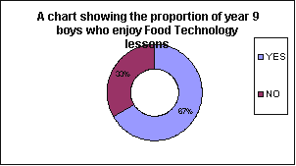
12 | 6
Question 2
YES | NO
  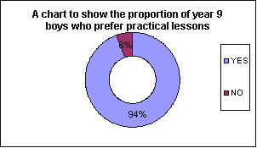
17 | 1
Question 3 |  |  | 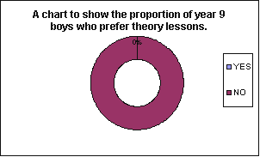
YES | NO
0 | 18
Question 4
YES | NO
  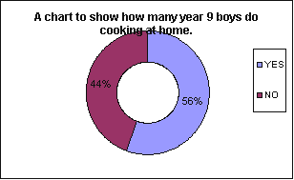
10 | 8
Question 5
  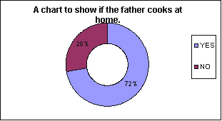
YES | NO
13 | 5
Question 6
YES | NO
  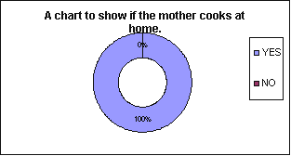
18 | 0
Question 7
  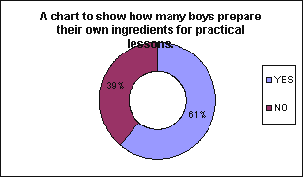
YES | NO
11 | 7
  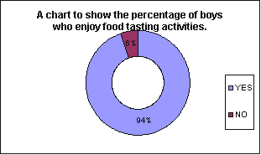
Question 8
YES | NO
17 | 1
Question 9
YES | NO
  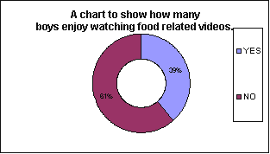
7 | 11
Question 10
YES | NO
  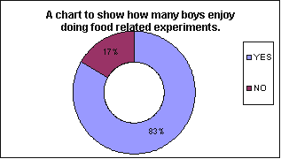
15 | 3
Question 11
YES | NO
  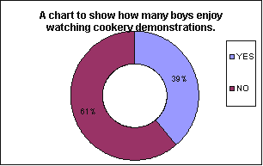
7 | 11
Question 12
YES | NO
  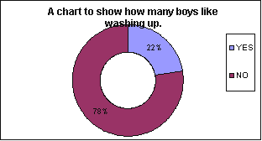
4 | 14

BIBLIOGRAPHY

Arthur, J., Davison, J., and Moss, J. (1997), Subject Mentoring in the Secondary School. London: Routledge

Bullock and Jamieson (1998), The Curriculum Journal: The Effectiveness of Personal Development Planning.

Collins, N. (1986), New Teaching Skills. Oxford: Oxford University Press

Dearing, R. (1994), The National Curriculum Review. London: SCAA

Department for Education and Employment (1998), National Targets for Education and Training. Sudbury: DfEE Publications

Department for Education and Employment, New National Learning Targets. Sudbury: DfEE Publications

Department for Education and Employment (March 2000), PANDA Report – OFSTED. Sudbury: DfEE Publications

Joseph, M. (1999), Jamie Oliver: The Naked Chef. London: Penguin Books Ltd.

Leith, P. (1999), The National Curriculum for England: Design and Technology. Sudbury: DfEE Publications

Palmer, P. J. (1998), The Courage to Teach: Exploring The Inner Landscape of a Teacher’s Life. Califormia: Jossey-Bass Inc. Publishers.

Powell, M. (1980), The Beginning Teacher Education Study: A Brief History of a Major Research Project in: C.Denham & A. Lieberman (Eds.), Time to Learn (Washington, DC, National Institute of Education

Smith, A. (1998), Accelerated Learning in Practice: Brain-Based Methods for Accelerating Motivation and Achievement. Stafford: Network Educational Press Ltd.

